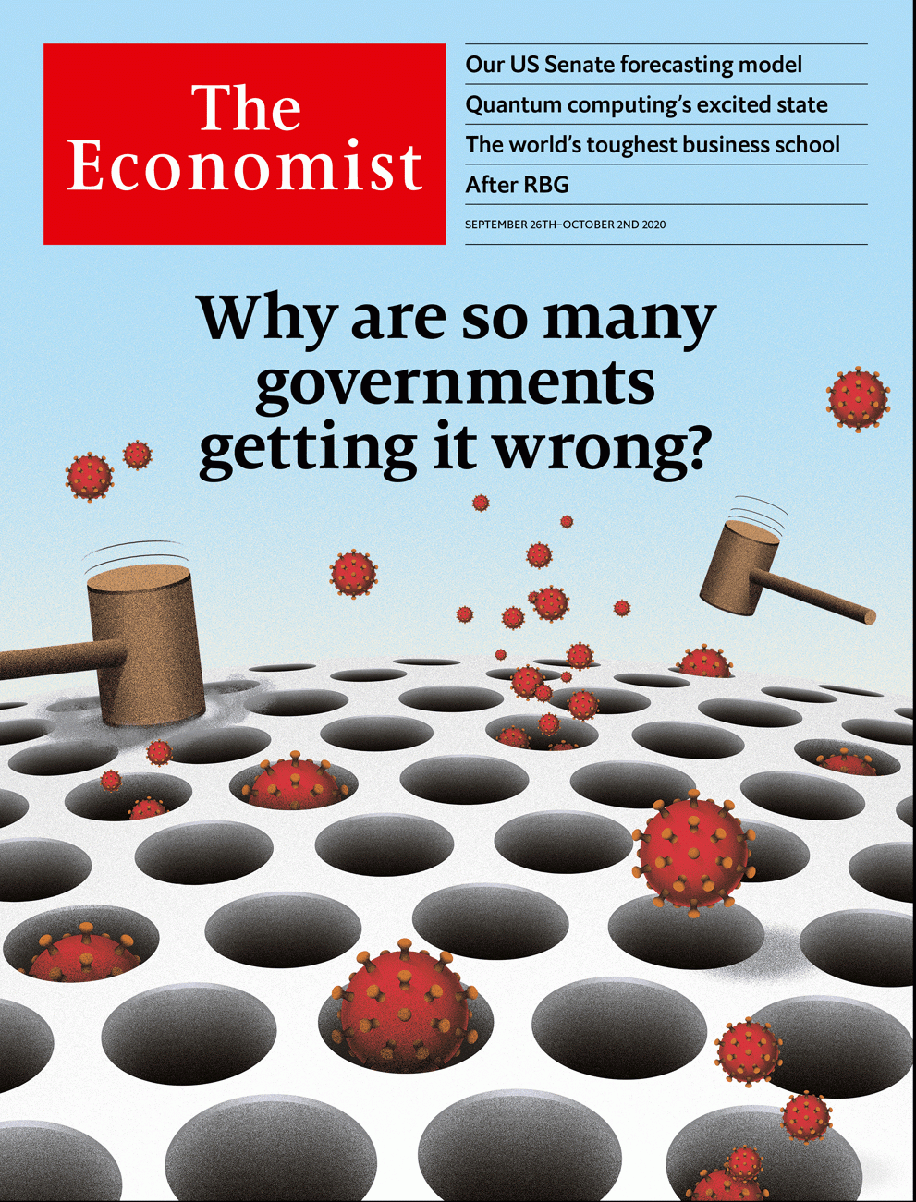

# Table of Contents

The world this week

Politics this week

Business this week

KAL’s cartoon

Leaders

Covid-19: Why governments get it wrong

The Supreme Court: After RBG

Covid-19 and poverty: Failing the poor

The corporate undead: Zombies at the gates

Quantum computing: From cloisters to the cloud

Letters

Letters to the editor: On Abe Shinzo, Venezuela, national ID cards, America, Imran Khan’s pets

Briefing

The covid-19 pandemic: Grim tallies

Asia

Bureaucrats in Indonesia: Rejoice to serve

The monarchy in Thailand: Do you hear the people, king?

Agriculture in India: Yield curve

Malaysian politics: Anwar on the attack

Banyan: Twitchers without borders

China

Climate change: A greener horizon

Ren Zhiqiang: A loose cannon silenced

Chaguan: Tit for futile tat

United States

The battle for the Senate: The donkey’s long tail

Amy Coney Barrett: From RBG to ACB

Rural voters: Signs of the times

The US Navy: AI, Captain

Partisan warring: Courting trouble

Lexington: A double negative

Middle East & Africa

Syria: Despot of deprivation

Lebanon: After the blast, the bulldozers

Social media and war crimes: Accidental cover-up

Gold in Ghana: What’s the rush?

The Americas

Peru: Limping in Lima

Argentina and Uruguay: A mini-war across the River Plate

Bello: Darkness in Mexico

Europe

French diplomacy: Trying to square a circle

Corruption in Ukraine: Lock up the small fry—for a start

Italy: Counter-strike

Switzerland and the European Union: Is it in Europe?

Charlemagne: The right to sell passports

Britain

The Labour Party: Reflections on conservatism

Trans rights: Who’s a woman?

Covid-19: Winter has come

Public transport: The little engine that couldn’t

Conservative protest: Leave.BBC

Income distribution: Importing inequality

Commercial property: A pain in the portfolio

Bagehot: The king in the north

International

Covid-19 and poor countries: From plague to penury

Business

Oracle: Larry’s last stand

TikTok: The principals’ uncertainty

Cola wars: Fire-starter

BP v utilities: The new majors

Bartleby: The toughest business school

Rocket Internet: Coming down to earth

Microblogging: Weibo woes

Schumpeter: Lighting up Japan Inc

Finance & economics

Ailing companies: The corporate undead

Companies in Japan: The return of the living dead?

America’s economy: Snapback

Buttonwood: The bright side

The Vatican’s finances: A holy mess

Free exchange: The mop that never stops

Science & technology

The business of quantum computers: Uncertainty principals

Evolution: Accidental killer

A fossorial fossil: A burrowing dinosaur

Books & arts

Gangs and governments: The monster and the boys

American statesmen: All the presidents’ man

Cradles of civilisation: Pivot of the world

A writer’s life: Cool to be kind

Hercule Poirot: The case of the 100-year-old detective

Economic & financial indicators

Economic data, commodities and markets

Graphic detail

America’s Senate: The Maine reason

Obituary

Ruth Bader Ginsburg: Diva dissenter



### Friday, September 25, 2020

|  |  |
| --- | --- |
| The world this week | 3 |
| Leaders | 5 |
| Letters | 1 |
| Briefing | 1 |
| Asia | 5 |
| China | 3 |
| United States | 6 |
| Middle East & Africa | 4 |
| The Americas | 3 |
| Europe | 5 |
| Britain | 8 |
| International | 1 |
| Business | 8 |
| Finance & economics | 6 |
| Science & technology | 3 |
| Books & arts | 5 |
| Economic & financial indicators | 1 |
| Graphic detail | 1 |
| Obituary | 1 |

|  |  |  |
| --- | --- | --- |
|  | Sections | Leaders |

The world this week

Politics this week

.

Business this week

.

KAL’s cartoon

.

|  |  |  |
| --- | --- | --- |
|  | Sections | Leaders |

|  |  |  |  |
| --- | --- | --- | --- |
|  | Articles | Sections | Next |

# Politics this week

Sep 24th 2020 |

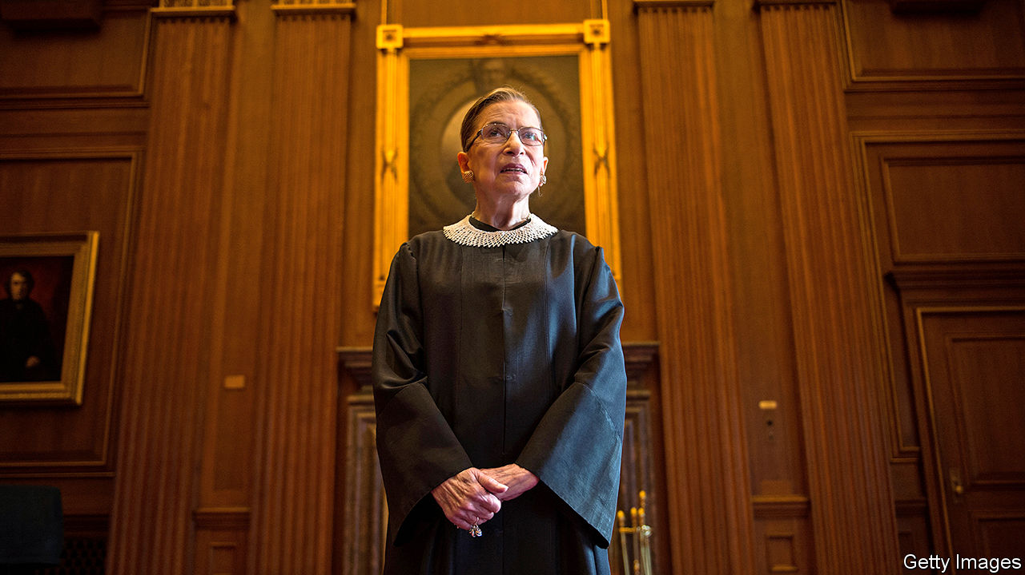

Donald Trump marshalled enough Republican votes in the Senate to consider a replacement for Ruth Bader Ginsburg before the election on November 3rd. Ms Ginsburg’s death gives the party a window to fill her seat on the Supreme Court with a conservative, further tipping its ideological balance to the right. Ms Ginsburg, appointed by Bill Clinton in 1993, was accorded the honour of lying in state in the Capitol building, the first woman to do so. See [article](https://www.economist.com/node/21792045).

A grand jury found no evidence to bring charges against three policemen for the fatal shooting of Breonna Taylor, a black woman, in Kentucky. Around midnight on March 13th police burst into Taylor’s flat without knocking to search for drugs. Her boyfriend, who later said he feared it was her ex-boyfriend breaking in, opened fire. The officers shot back, killing Taylor. No drugs were found. One officer, who fired through blinds, was charged with wantonly endangering the neighbours. After the decision, protests erupted and two officers were shot.

Jeanine Áñez, Bolivia’s interim president, dropped out as a candidate in the presidential election due to be held on October 18th. She said she hoped her withdrawal would boost the prospects of candidates running against Luis Arce, a leftist.

Peru’s president, Martín Vizcarra, survived a congressional vote to impeach him. Opposition politicians sought his ouster because, they claimed, leaked recordings proved that he had tried to cover up ties with a folk singer, known as “Richard Swing”, who had supported him and then received government contracts. See [article](https://www.economist.com/node/21792083).

Alexei Navalny, the main opposition leader in Russia, was discharged from the hospital in Germany where he had been treated since being poisoned with Novichok, a nerve agent, in Russia.

Italians voted in a referendum to cut the size of their parliament by more than a third. See [article](https://www.economist.com/node/21792036).

As cases of covid-19 continued to soar in Spain, the government appealed to residents of Madrid to stay at home. But it stopped short of declaring a state of emergency.

Britain’s prime minister, Boris Johnson, announced new restrictions, as the number of daily covid-19 cases has trebled since the start of September. Last month he was prodding workers to return to offices. Now he says they are to work from home again. Mr Johnson urged people to act responsibly: “your mild cough can be someone else’s death knell”. The government announced a new scheme to safeguard jobs. See [article](https://www.economist.com/node/21792070).

Wildlife officials said that toxic algal blooms in drinking holes caused the previously unexplained deaths of more than 300 elephants in Botswana in recent months. Botswana is home to one-third of Africa’s declining elephant population.

The leader of a coup in Mali appointed Bah Ndaw, a former defence minister, as transitional president. The EU and America have suspended military aid to the country, which is fighting jihadists.

America announced new sanctions on people and entities linked to Iran’s nuclear programme. America also said it was unilaterally reimposing a UN arms embargo on Iran, a move the UN Security Council has refused to recognise.

Protesters in Thailand marched to the royal palace to demand reforms to the monarchy. Many wore crop tops and temporary tattoos to mock King Vajiralongkorn, who did not respond. He was in Germany, where he spends most of his time. See [article](https://www.economist.com/node/21792058).

Anwar Ibrahim, the leader of Malaysia’s opposition, announced that he had the support of enough MPs to bring the coalition that ran the country until seven months ago back to power. But the king, to whom he must present his claim to power, is in hospital. See [article](https://www.economist.com/node/21792060).

Police in Hong Kong arrested Joshua Wong, a pro-democracy activist. He was accused of attending an illegal assembly last year and of violating a ban on protesters wearing masks.

China sent military aircraft across the mid-point of the Taiwan Strait, which had served as a makeshift boundary between Chinese and Taiwanese airspace. The incursions may have been a retaliation for the announcement of new American arms sales to Taiwan. A Chinese government spokesman said it did not accept the mid-point as a demarcation line.

China’s leader, Xi Jinping, said his country would be carbon-neutral by 2060, though he didn’t elaborate on how it would achieve that. Speaking to the UN by video-link, he reiterated a pledge that China’s carbon emissions will peak before 2030. See [article](https://www.economist.com/node/21792057).

A Chinese court sentenced Ren Zhiqiang, a former boss of a state-owned property firm, to 18 years in prison for corruption. Mr Ren had been an outspoken critic of Mr Xi. See [article](https://www.economist.com/node/21792052).

The area of the Arctic covered by sea ice shrank to 3.74m sq km in mid-September, the second-lowest figure in 40 years of record-keeping. The decline was most rapid in early September, caused in part by a heatwave in Siberia. Falling temperatures are helping the ice to return, but the 14 lowest extents of the ice have all been recorded over the past 14 years.

## Coronavirus briefs

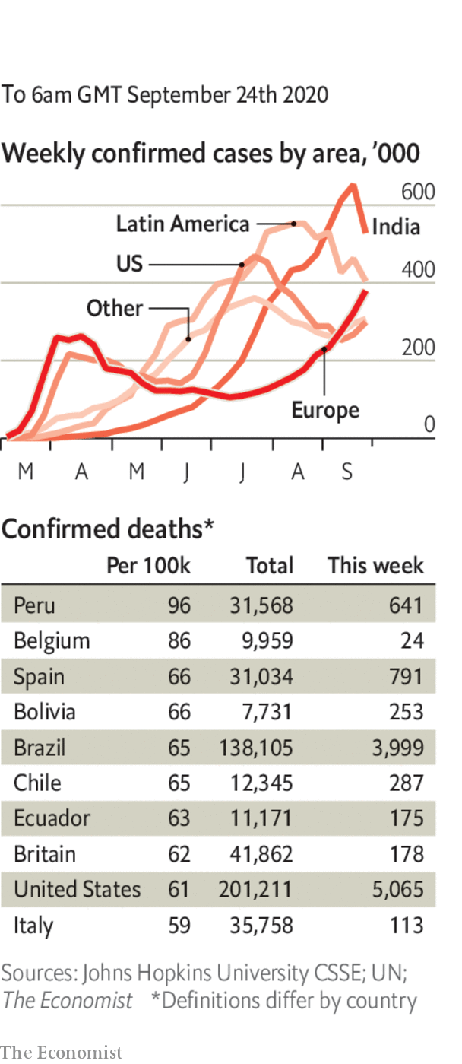

The WHO said that the global number of new infections had reached a weekly high of 2m. In the Netherlands the number of new cases hit a weekly record of nearly 13,500, up by 60% from the previous week. See article.

The number of daily coronavirus infections reached a new high in Israel. Officials say hospitals are approaching their capacity. The government tightened a nationwide lockdown. Iran reported its most cases in a day. Its official cumulative total is now 433,000, though the true figure is much higher.

UEFA, Europe’s football governing body, was criticised for allowing 20,000 fans to attend a match in Budapest between Bayern Munich and Sevilla.

America’s Centres for Disease Control issued advice for Halloween. Trick-or-treating, costume masks and parties are discouraged; carving pumpkins with your family is okay.

This article was downloaded by calibre from <https://www.economist.com/the-world-this-week/2020/09/24/politics-this-week>

|  |  |  |  |
| --- | --- | --- | --- |
|  | Articles | Sections | Next |

|  |  |  |  |
| --- | --- | --- | --- |
| Previous | Articles | Sections | Next |

# Business this week

Sep 26th 2020 |

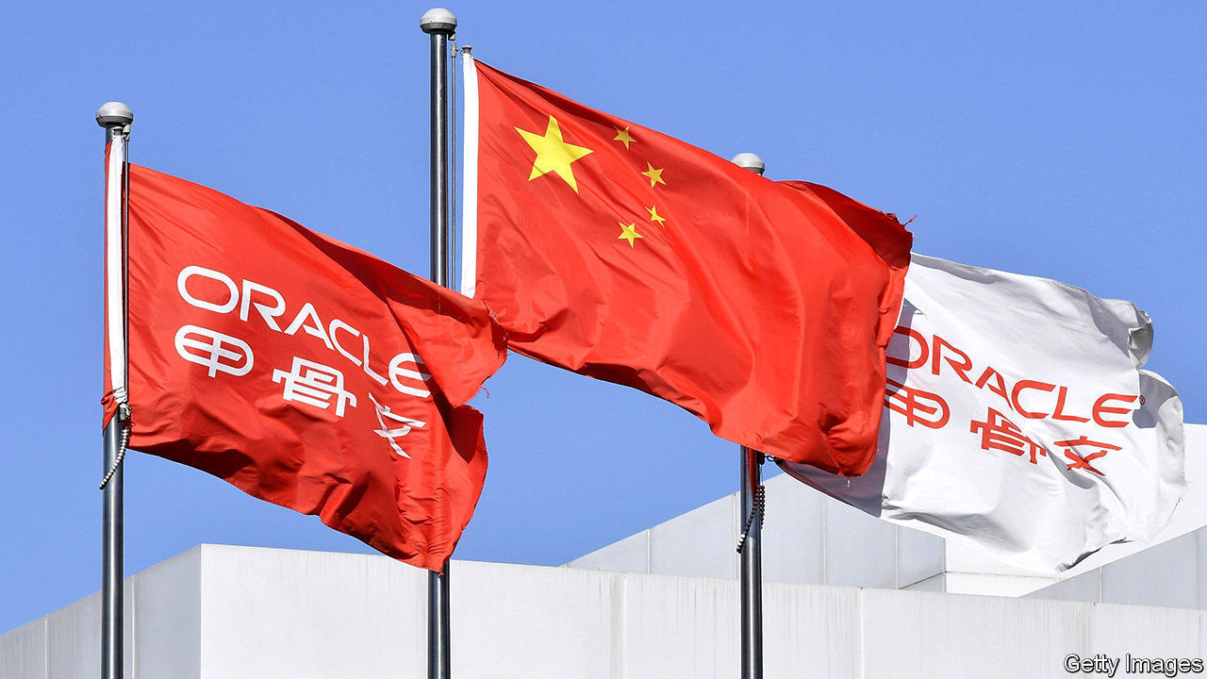

There was some confusion about a tentative deal that will allow TikTok, a video-sharing app, to stay in business in the United States. Donald Trump gave his “blessing” to an agreement that would see Oracle and Walmart take a 20% stake in a newly formed TikTok Global, which would then rely on Oracle to provide it with cloud services. But Oracle and ByteDance, TikTok’s Chinese parent company, issued contradictory statements about the ownership of the new business, with ByteDance describing it as a “subsidiary”. China’s state media raged against the deal, describing it as “bullying and extortion”. TikTok asked a court to block an impending order that will in effect shut its operations in America over security concerns. See [article](https://www.economist.com/node/21792081).

A judge in California issued a last-minute temporary injunction against the Trump administration’s ban on WeChat, another Chinese tech firm that has fallen foul of the government. The plaintiffs argued that prohibiting the social-media app in America would curtail free speech and was aimed at Chinese-Americans. The administration can appeal against the decision.

Microsoft, which had been in the running to buy TikTok before Mr Trump threw his weight behind Oracle’s bid, consoled itself by buying ZeniMax, which owns several gaming firms, publishing hits such as “The Elder Scrolls” and “Wolfenstein”. At $7.5bn, it is one of Microsoft’s bigger acquisitions.

Following weeks of courting, CaixaBank made it official and agreed to take over Bankia, creating Spain’s biggest lender with €650bn ($760bn) in assets. “Getting married in difficult times makes it even more important that you choose the right partner,” said CaixaBank’s chief executive.

In Russia, Yandex, a tech firm that operates one of the country’s most popular internet search engines, struck a $5.5bn deal to buy Tinkoff, an online bank that was founded by Oleg Tinkov and is listed in London.

Deutsche Bank is preparing to close a fifth of its branches in Germany, according to reports, leaving it with 400 branches. The German lender thinks the pandemic has shifted many customers permanently towards digital banking.

## Electric dream machine

Investors were unimpressed by Tesla’s much hyped “Battery Day”, even though Elon Musk tried to dampen expectations. The company did announce an ambition to move all levels of car-battery production in house (rather than just battery packs) and increase the range of its batteries. But there were no specifics about a “million-mile” battery, nor a target, in terms of dollars per kilowatt-hour, to bring down the cost of its electric cars to match petrol-powered ones.

California’s governor signed an order that bans the sale of new petrol and diesel cars by 2035. It is the first American state to adopt such a measure.

Unilever secured the overwhelming support of shareholders in the Netherlands for its proposal to end its Anglo-Dutch dual structure and base the entire group in London. British investors will vote on the measure next month. Unilever wants to unify its structure by late November, but would reconsider its move if the Dutch parliament passes a law before then that would levy huge taxes on any multinational leaving the country.

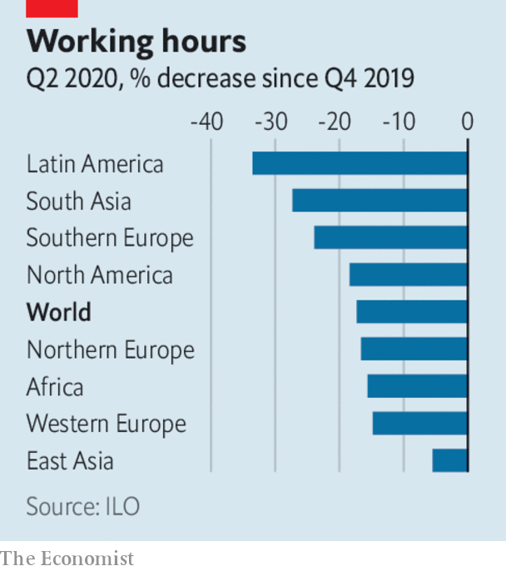

The income of workers across the world will have fallen by an average 10.7% in the first nine months of this year compared with the same period last year, according to the International Labour Organisation. That amounts to $3.5trn. The percentage of working hours lost because of covid-19 is most acute in Latin America, followed by South Asia. The ILO’s outlook for the last three months of 2020 has “worsened significantly”.

Nike reported an 82% jump in online sales for the three months ending August 31st, year on year. Sales at its stores, most of which were open during the quarter, remained tepid because of social- distancing measures.

## The end of the line

The British government scrapped the system of franchising train companies that has underpinned the rail industry since privatisation in the 1990s. A new mix of performance targets and management fees moves operators towards a contracts-based system. With passenger numbers still well below normal because of covid-19, the taxpayer will continue to underwrite the industry’s losses. See [article](https://www.economist.com/node/21792067).

In the latest corporate response to the race protests that have swept America, Mars changed the name of its Uncle Ben’s brand of rice to Ben’s Original and removed the face of an elderly black man from the packaging “to create more equitable iconography”. The image first appeared in 1946. Mars also struck a partnership with the National Urban League, a civil-rights group, to support aspiring black chefs through a scholarship fund.

This article was downloaded by calibre from <https://www.economist.com/the-world-this-week/2020/09/26/business-this-week>

|  |  |  |  |
| --- | --- | --- | --- |
| Previous | Articles | Sections | Next |

|  |  |  |  |
| --- | --- | --- | --- |
| Previous | Articles | Sections | Next |

# KAL’s cartoon

Sep 24th 2020 |

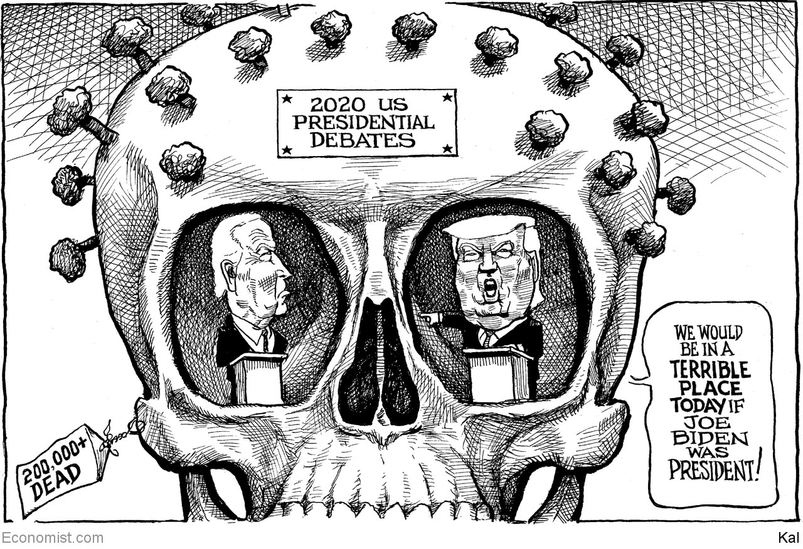

This article was downloaded by calibre from <https://www.economist.com/the-world-this-week/2020/09/24/kals-cartoon>

|  |  |  |  |
| --- | --- | --- | --- |
| Previous | Articles | Sections | Next |

|  |  |  |
| --- | --- | --- |
| The world this week | Sections | Letters |

Leaders

Covid-19: Why governments get it wrong

.

The Supreme Court: After RBG

.

Covid-19 and poverty: Failing the poor

.

The corporate undead: Zombies at the gates

.

Quantum computing: From cloisters to the cloud

.

|  |  |  |
| --- | --- | --- |
| The world this week | Sections | Letters |

|  |  |  |  |
| --- | --- | --- | --- |
|  | Articles | Sections | Next |

#### The pandemic and the long haul

# Why governments get covid-19 wrong

Therapies and vaccines will come, but not for many months. Until then, politicians will have to work on the basics

Sep 26th 2020 |

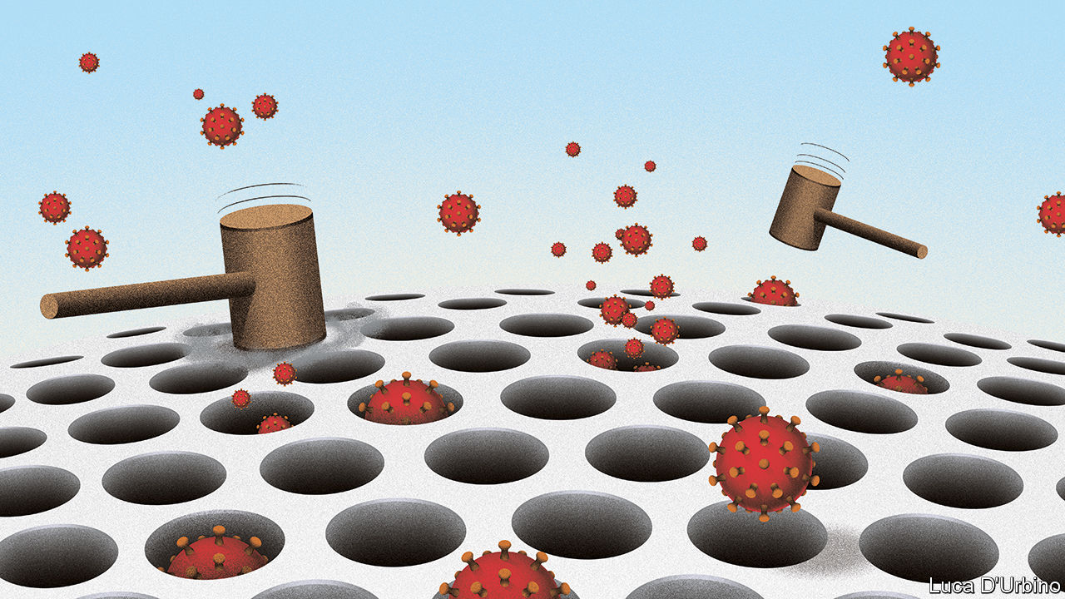

Editor’s note: Some of our covid-19 coverage is free for readers of The Economist Today, our daily [newsletter](https://my.economist.com/user#newsletter). For more stories and our pandemic tracker, see our [hub](https://www.economist.com/news/2020/03/11/the-economists-coverage-of-the-coronavirus)

WITHIN THE next few days the global recorded deaths from covid-19 will surpass 1m. Perhaps another 1m have gone unrecorded. Since the start of the pandemic, nine months ago, the weekly cases logged by the World Health Organisation have been trending very slowly upwards and, in the seven days to September 20th, breached 2m for the first time. The virus is burning through parts of the emerging world. India has been registering over 90,000 cases a day. Some European countries that thought they had suppressed the disease are in the throes of a second wave. In America the official death toll this week exceeded 200,000; the seven-day case total is rising in 26 states.

Those figures represent a lot of suffering. Roughly 1% of survivors have long-term viral damage such as crippling fatigue and scarred lungs. In developing countries, especially, bereavement is compounded by poverty and hunger (see article). The northern winter will force people indoors, where the disease spreads much more easily than in the open air. Seasonal flu could add to the burden on health systems.

Amid the gloom, keep three things in mind. The statistics contain good news as well as bad. Treatments and medicines are making covid-19 less deadly: new vaccines and drugs will soon add to their effects. And societies have the tools to control the disease today. Yet it is here, in the basics of public health, where too many governments are still failing their people. Covid-19 will remain a threat for months, possibly years. They must do better.

Start with the numbers. The increase in Europe’s diagnosed cases reflects reality, but the global effect is an artefact of extra testing, which picks up cases that would have been missed. As the Briefing in this issue explains, our modelling suggests that the total number of actual infections has fallen substantially from its peak of over 5m a day in May. Extra testing is one reason why the fatality rate of the disease appears to be falling. In addition, countries like India, with an average age of 28, suffer fewer deaths because the virus is easier on the young than the elderly.

The fall in fatalities also reflects medical progress. Doctors now understand that organs other than the lungs, such as the heart and kidneys, are at risk and treat symptoms early. In British intensive-care wards, 90% of patients were on ventilators at the start of the pandemic; in June just 30% were. Drugs, including dexamethasone, a cheap steroid, reduce deaths in seriously ill patients by 20-30%. Fatalities in Europe are 90% lower than in the spring, though this gap will narrow as the disease spreads back into vulnerable groups.

More progress is in store. Monoclonal antibodies, which disable the virus, could be available by the end of the year. Although they are expensive, they promise to be useful after someone is infected or, for the high-risk, prophylactically. Vaccines will almost certainly follow, possibly very soon. As different medicines use different lines of attack, the benefits can be cumulative.

Yet, in the best of all possible worlds, the pandemic will remain a part of daily life well into 2021. Even if a vaccine emerges, nobody expects it to be 100% effective. Protection may be temporary or weak in the elderly, whose immune systems are less responsive. Making and administering billions of doses will take much of next year. Early vaccines may well need two shots, and complex “cold chains” to keep fresh. Medical glass could run short. There may be fights over who gets supplies first, leaving pools of infection among those who cannot elbow their way to the front of the queue. Multi-country polls suggest that a quarter of adults (including half of Russians) would refuse vaccination—another reason why the disease may persist.

Hence for the foreseeable future the first line of defence against covid-19 will remain testing and tracing, social distancing and clear government communication. There is no mystery about what this involves. And yet countries like America, Britain, Israel and Spain persist in getting it disastrously wrong.

One problem is the desire to escape a trade-off between shutting down to keep people alive and staying open so that life goes on. The right lauds Sweden for supposedly letting the virus rip while it makes a priority of the economy and liberty. But Sweden has a fatality rate of 58.1 per 100,000 and saw GDP fall by 8.3% in the second quarter alone, worse on both counts than Denmark, Finland and Norway. The left lauds New Zealand, which has shut down to save lives. It has suffered only 0.5 deaths per 100,000, but in the second quarter its economy shrank by 12.2%. By contrast, Taiwan remained more open but has seen 0.03 deaths per 100,000 and a 1.4% fall in GDP.

Blanket lockdowns like the new one in Israel are a sign that policy has failed. They are costly and unsustainable. Countries like Germany, South Korea and Taiwan have used fine-grained testing and tracing to spot individual super-spreading venues and slow the spread using quarantines. Germany identified abattoirs; South Korea contained outbreaks in a bar and churches. If testing is slow, as in France, it will fail. If contact-tracing is not trusted, as in Israel, where the job fell to the intelligence services, people will evade detection.

Governments must identify the trade-offs that make most economic and social sense. Masks are cheap and convenient and they work. Opening schools, as in Denmark and Germany, should be a priority; opening noisy, uninhibited places like bars should not. Governments, like Britain’s, that bark out a series of ever-changing orders which are broken with impunity by their own officials will find that compliance is low. Those, like British Columbia’s, that set principles and invite individuals, schools and workplaces to devise their own plans for realising them, will be able to sustain the effort in the months ahead.

When covid-19 struck, governments were taken by surprise and pulled the emergency brake. Today they have no such excuse. In the rush to normality, Spain let down its guard. Britain’s testing is not working, though cases have been climbing since July. America’s Centres for Disease Control and Prevention, once the world’s most respected public-health body, has been plagued by errors, poor leadership and presidential denigration. Israel’s leaders fell victim to hubris and infighting. The pandemic is far from over. It will abate, but governments must get a grip. ■

This article was downloaded by calibre from <https://www.economist.com/leaders/2020/09/26/why-governments-get-covid-19-wrong>

|  |  |  |  |
| --- | --- | --- | --- |
|  | Articles | Sections | Next |

|  |  |  |  |
| --- | --- | --- | --- |
| Previous | Articles | Sections | Next |

#### After RBG

# How to make American judges less notorious

Supreme Court judges should be term-limited

Sep 26th 2020 |



AT THE TIME of her death, Ruth Bader Ginsburg featured on more than 3,000 pieces of memorabilia which were for sale on Amazon.com. Fans of “Notorious RBG” could buy earrings, mugs, babygrows, fitness manuals and Christmas decorations (“Merry Resistmas!”), all bearing her face. The number and variety of these tributes suggest two things. First, that Justice Ginsburg was an extraordinary woman with an extraordinary place in American culture (see article). Second, that something has gone wrong with America’s system of checks and balances. The United States is the only democracy in the world where judges enjoy such celebrity, or where their medical updates are a topic of national importance. This fascination is not healthy.

Republicans have often lamented that the Supreme Court is too powerful. But faced with the opportunity to tilt it decisively in a conservative direction, the prize is too great for them to resist (see article). The Republican majority in the Senate is likely to push through the confirmation of a replacement for Justice Ginsburg before the election. Since judges have life tenure, the newcomer could still be on the court in 2060.

That is bad for American democracy and for the court. In 2016, when a vacancy came up in a presidential year, Mitch McConnell, the Senate majority leader, declared that “The American people should have a voice in the selection of their next Supreme Court justice. Therefore, this vacancy should not be filled until we have a new president.” Having invented that principle when it suited him, Mr McConnell and friends have abandoned it when it no longer does. The move is as cynical, as it is unsurprising.

For the record, the precedent can cut both ways. There have been 25 Supreme Court nominations in presidential-election years. More than half have been confirmed by the Senate. And yet, no appointment has ever been confirmed this close to an election. Precedent is not really the point here, though. Judicial nominations have become exercises in raw power, where the only real principle is that anything goes, so long as your side has the votes.

For Republican senators this unconservative approach to institutions makes sense, for several reasons. For some who privately disdain President Donald Trump, reshaping the court for a generation was the chief reason to support him. Most conservatives still resent the judicial remaking of America from the 1960s onwards, after liberal courts discovered a right to abortion in the constitution, abolished organised school prayer and enshrined other lefty priorities that should properly have been decided by the legislature. And all members of the Republican caucus believe, with some justification, that Democrats began the breaking of the judicial nominations process, and that this unprincipled act is payback for past wrongs. Better to get their retaliation in first.

Inevitably, Democrats feel the same way, also with some justification. Republican presidential candidates have won the popular vote just once in the past seven cycles, yet Republican presidents will soon have appointed six of the nine Supreme Court justices. The division of American politics along urban-rural lines makes the Senate even more anti-majoritarian than this suggests. The Democratic minority in the Senate represents about 15m more Americans than the Republican majority that will confirm Mr Trump’s latest judge. Some Democratic activists favour levelling things up by increasing the number of judges on the court when their party next has power, an idea that, thankfully, has not yet been adopted by Democratic senators.

This cycle of revenge will not end well, either for the court or America. The Supreme Court is not elected. Yet its power is ultimately founded on the trust and consent of Americans who believe that its decisions are impartial and grounded in law, not party. The more brazenly parties attempt to capture it as the choicest political prize, the less legitimate it will be. Imagine that a court judgment determines who wins November’s election. Or that, if Democrats win both houses of Congress and the presidency, their attempts to reduce carbon-dioxide emissions are struck down by judges chosen by Mr Trump. The referee must not only be fair, but seen to be so.

There is a better way. America is the only democracy where judges on the highest court have unlimited terms. In Germany constitutional-court judges sit for 12 years. If America had 18-year non-renewable terms, each four-year presidency would yield two new justices. It would end the spectacle of judges trying to game the ideology of their successor by choosing when they retire. And it would help make the court a bit less central to American politics—and thus more central to American law. Justice Ginsburg was a great jurist. A fitting tribute to this notorious judge would be to make her the court’s last superstar. ■

Dig deeper:  
Read the [best of our 2020 campaign coverage](https://www.economist.com/us-election-2020) and explore our [election forecasts](https://projects.economist.com/us-2020-forecast/president), then sign up for Checks and Balance, our [weekly newsletter](https://www.economist.com/checksandbalance/) and [podcast](https://play.acast.com/podcasts/2020/01/24/checks-and-balance-our-new-weekly-podcast-on-american-politics) on American politics.

This article was downloaded by calibre from <https://www.economist.com/leaders/2020/09/26/how-to-make-american-judges-less-notorious>

|  |  |  |  |
| --- | --- | --- | --- |
| Previous | Articles | Sections | Next |

|  |  |  |  |
| --- | --- | --- | --- |
| Previous | Articles | Sections | Next |

#### Failing the poor

# Covid-19 has reversed years of gains in the war on poverty

Politicians deserve much of the blame

Sep 26th 2020 |

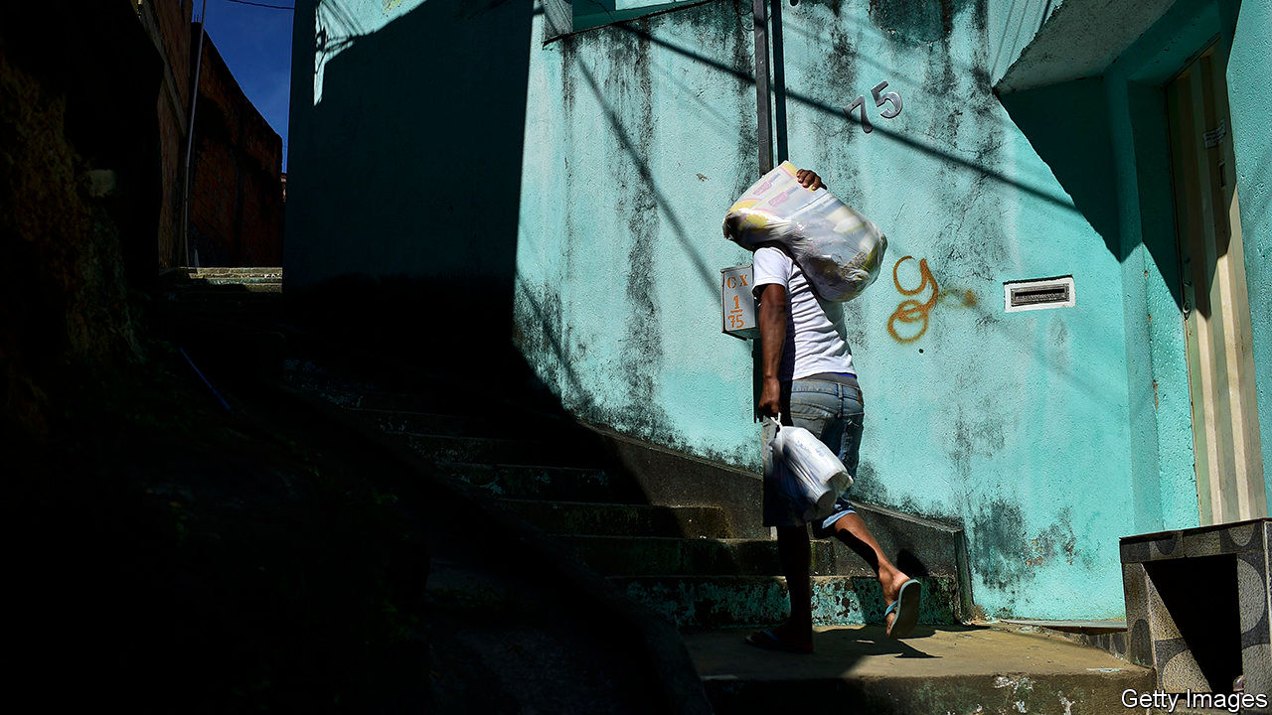

Editor’s note: Some of our covid-19 coverage is free for readers of The Economist Today, our daily [newsletter](https://my.economist.com/user#newsletter). For more stories and our pandemic tracker, see our [hub](https://www.economist.com/news/2020/03/11/the-economists-coverage-of-the-coronavirus)

THIS CORONAVIRUS affects everyone, but not equally. The young often shrug off the virus; the old often die of it. The rich shrug off the economic shock; the poor cannot. Because of covid-19, the number of extremely poor people (ie, those making less than $1.90 a day) will rise by 70m-100m this year, the World Bank predicts. Using a broader measure, including those who lack basic shelter or clean water and children who go hungry, the ranks of the poor will swell by 240m-490m this year, says the UN. That could reverse almost a decade of progress (see article). If a vaccine is found, economies will no doubt bounce back. But widespread vaccination will take years and the very poor cannot wait that long. By then, malnutrition will have stunted a tragic number of children’s bodies and minds.

Governments in rich countries have spent over 10% of GDP to ease the economic pain. Others cannot be so ambitious. Emerging economies have spent just 3%, and the poorest nations less than 1%. Safety-nets in low-income countries are cobweb-thin. Governments there have handed out only $4 extra per person on social programmes—in total, not per day.

Donors should help. Rich countries are on course to cut direct aid by a third compared with last year. The IMF and World Bank have raised lending, but only 31% more of the bank’s money has reached poor countries, says the Centre for Global Development, a think-tank, about half the increase in the global financial crisis, a much smaller shock.

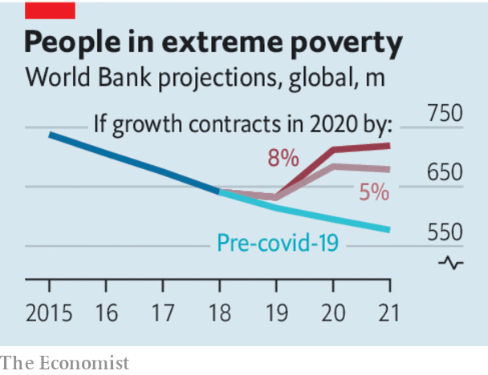

Governments in poor countries, meanwhile, need to spend their money wisely. Too many offer pork for chums and crumbs for the poor. Since the crisis began, Mexico has provided no new programmes for the hard-up but has given Pemex, the state oil giant, tax breaks worth $2.7bn, or $21 per Mexican. India has poured $7bn down coal mines. South Africa is expected soon to confirm another wasteful effort to keep its money-losing airline aloft. Even when money is earmarked for good ends, it is too often wasted or stolen. South African investigators are probing possible fraud in 658 contracts worth $300m for covid-fighting kit. Nigeria’s health ministry bought some masks for $53 each. In a leaked recording, a voice allegedly belonging to a Ugandan official guffaws as she and her colleagues appear to plot to pocket money meant for alleviating suffering in the pandemic.

The best way to help the poor is to give them money directly. The simplicity of this policy makes it less vulnerable to corruption. With a little extra cash in their pockets, recipients can feed their children and send them back to school. They can avoid a fire-sale of assets, such as a motorbike-taxi or a cow, that will help them make a living in the future. One country that has done well getting cash into poor pockets is Brazil, despite President Jair Bolsonaro’s habit of downplaying the effects of covid-19. Various measures of poverty there have actually fallen, largely because the government has sent $110 per month for three months to the impecunious, helping 66m people. A priority for governments should be basic health care, which the pandemic has disrupted so badly that vaccination rates for children have been set back about 20 years.

The crisis requires politicians to make hard choices quickly. Mistakes are inevitable, given how much remains unknown about the disease. But some are inexcusable. India’s sudden lockdown threw millions of migrant workers out of their urban jobs and lodgings, forcing them to head back to their villages on foot or crowded trains, spreading the virus far and wide. South Africa barred people from leaving home at night but then evicted tens of thousands of squatters from shacks on public land, with no place to go. Politicians governing remotely from their comfortable home offices should think harder about how their decisions might affect those whom covid-19 is plunging back into dire poverty. It is shameful when their responses to the pandemic add to the suffering of the least fortunate. ■

This article was downloaded by calibre from <https://www.economist.com/leaders/2020/09/26/covid-19-has-reversed-years-of-gains-in-the-war-on-poverty>

|  |  |  |  |
| --- | --- | --- | --- |
| Previous | Articles | Sections | Next |

|  |  |  |  |
| --- | --- | --- | --- |
| Previous | Articles | Sections | Next |

#### The corporate undead

# What to do about zombie firms

Without care, measures taken during the pandemic will keep alive firms that ought to be put out of their misery

Sep 26th 2020 |

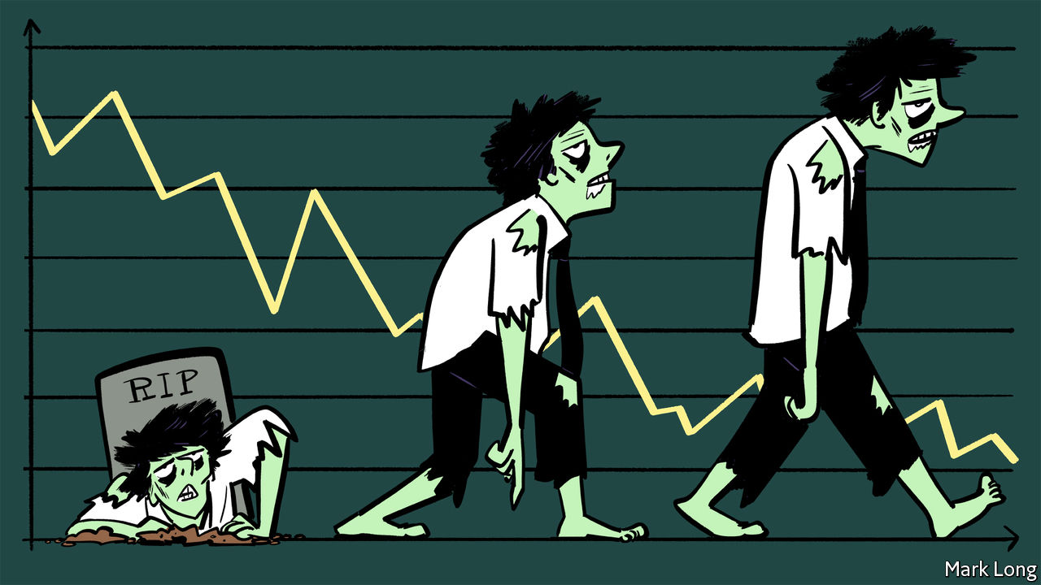

FOR YEARS economists have argued about whether governments and central banks in the rich world have mistakenly prolonged the lives of “zombie firms”. The corporate landscape, it is said, has turned from one filled with red-blooded creatures of creative destruction to a grey zone of the living dead, incapable of innovation or dynamism. Now the debate has new importance. The pandemic could lead governments to prolong the life of many undeserving firms. Keeping the growth of the undead in check will be vital to the long-term economic recovery.

Marginally profitable firms were central to Japan’s “lost decade” in the 1990s, when banks, unwilling to recognise losses, kept credit flowing to otherwise insolvent borrowers. Zombie-infested industries suffered from inert labour markets and lower productivity growth. Since then, the rich world as a whole has begun to look more zombified (see [article](https://www.economist.com/node/21792063)). In advanced economies the share of listed firms with low market capitalisations given their book value, and whose profits are insufficient to cover their interest payments, grew from around 4% in the mid-1980s to 15% in 2017, according to the Bank for International Settlements. The OECD reckons Italian and Spanish productivity levels would be over 1% higher were it not for the growth of zombie firms, which are alleged to have crowded out would-be rivals.

The evidence for zombification in the 2010s is incomplete: the world economy displayed few signs of capital or labour shortages, which you might expect to see more of if zombies were hoarding resources. Many firms were marginally profitable because aggregate spending was weak. Yet the pandemic is creating a greater risk of extra zombification. Governments have intervened in the economy on an enormous scale in order to keep firms alive. A combination of furlough schemes to reduce wage bills, state-backed loans to provide liquidity and laws or other measures to stop bankruptcies has prevented a wave of company failures. The danger is that, as economies emerge from the pandemic with new wants and needs, some firms that should be allowed to fail are instead kept going.

The march of the undead can be kept in check. Governments should support workers not jobs, and intervene more surgically. Furlough schemes keep workers tied to companies; it would be better to offer generous unemployment benefits. State-backed loans should not be rolled over indefinitely, but instead be subject to gradually increasing interest rates, encouraging borrowers to rely on private finance. If governments truly believe that the disruption to the hospitality industry will be only temporary, then their support would be justified. But because the industry will never recoup the income that it has lost during the pandemic, it will need grants, not loans—a shift that would help concentrate politicians’ minds.

Another priority is to avoid a banking crisis. Lenders with stretched balance-sheets have an incentive to keep funding their existing customers, masking past lending mistakes with yet more loans. In the short term this avoids recognising losses, in the long term they are funnelling capital to firms which squander it. Regulators must be alive to the risk of these zombie assembly lines. Banks should be kept as strong as possible during the pandemic, to reduce their incentive to conceal losses. That is a reason to limit their ability to pay dividends.

Last, ensure that firms can fail quickly and efficiently so that they can either be recapitalised or their assets and staff redeployed. Bankruptcy courts must be able to revive firms with reasonable prospects, or liquidate assets that can find new productive uses in other hands. Making the process faster and clearer will reduce the incentive of creditors to seek scorched-earth liquidations, especially for small businesses. Suspending bankruptcies for long periods, as Australia and Germany have done, is to deny reality. America, with its unsentimental approach to resolving ailing firms, sets a much better example.

All-but-indiscriminate aid to support firms and workers was a necessary feature of this year’s economic rescues, which took place amid widespread lockdowns of the economy. However, aid has become a threat to dynamism. As economies recover, the market should be allowed to play its proper role of determining winners and losers.■

This article was downloaded by calibre from <https://www.economist.com/leaders/2020/09/26/what-to-do-about-zombie-firms>

|  |  |  |  |
| --- | --- | --- | --- |
| Previous | Articles | Sections | Next |

|  |  |  |  |
| --- | --- | --- | --- |
| Previous | Articles | Sections | Next |

#### Quantum computing

# What quantum computers reveal about innovation

Venture capital is often the last guest to arrive at the party

Sep 26th 2020 |



IT IS HARD to choose one moment as marking the birth of a technology. But by one common reckoning, quantum computing will be 40 next year. In 1981 Richard Feynman, an American physicist, spoke at a computing conference, observing that “Nature isn’t classical, dammit, and if you want to make a simulation of nature, you’d better make it quantum mechanical, and by golly it’s a wonderful problem, because it doesn’t look so easy.”

Entering middle age, quantum computing is at last becoming a commercial proposition (see [article](https://www.economist.com/node/21792017)). Until recently the consensus was that practical applications would have to wait for large, stable machines, probably at least a decade away. Not everyone agrees. Venture capital is beginning to flow into companies built around quantum computers, as investors make a bold—possibly foolhardy—bet that even the limited, error-prone, unstable machines that make up the state-of-the-art today may prove commercially useful.

If those bets pay off, it would be good news, and not just for investors. Quantum computers can perform some sorts of mathematics far faster than any classical machine. Building them could open up entirely new vistas. They may, for instance, revolutionise chemistry. Most reactions are too complex for existing computers to simulate exactly, blunting researchers’ precision. Quantum machines could cut through the mathematical tangle, with applications in materials science, drugmaking, batteries and more. Their facility with optimisation problems, which are likewise a struggle for non-quantum machines, could be a boon for logistics, finance and artificial intelligence.

The field’s progress is interesting for another reason. Quantum computing offers a worked example of how complicated technologies develop in industrial societies. The chief lesson is to attend to every part of the process. The frenzy of innovation around classical computing, concentrated in Silicon Valley, has focused attention on the world of startups, venture capital and IPOs. But these are things that happen late in a technology’s development, when swift commercial returns are, if not certain, then at least plausible. As Mariana Mazzucato, an Italian-American economist, has argued, the biggest risks are taken earlier, when it is unclear whether a technology will work at all.

The state can be one such risk-taker. The first step in building a quantum computer was to conduct plenty of abstruse mathematics on university blackboards. Collectively, governments, including those of America, Britain, China and Germany, have thrown billions of dollars at funding quantum research.

Other early work was done in the sorts of big, boring companies in which no self-respecting disrupter would be seen dead. The first useful quantum algorithm was discovered in 1994 at Bell Labs, which began life as the research division of America’s telephone monopoly. Another early pioneer was IBM, which also has a buttoned-up reputation—but whose researchers have, over the years, earned six Nobel prizes. Today Google and Microsoft are playing a big role in developing quantum technologies.

The trick for such super-early-stage investors is to know when to stick with a risky prospect and when to call it quits. Good venture capitalists are ruthless about culling underperforming bets and focusing on those that seem to be paying off. Their proximity to markets makes such judgments easier. But governments—which are, after all, spending public money—should strive for the same outlook. If the state is to back technologies that are too risky for other investors, then a high rate of failure is both inevitable and desirable.

There are other lessons, too. Quantum computing has come as far as it has on the backs of thousands of mathematicians, experimental physicists and engineers. That is a reminder of the limits of “great man” theories of innovation, exemplified by the cult of Steve Jobs, a founder of Apple. The popular image of innovation as a “pipeline”, with a stream of individual technologies proceeding smoothly from ideas to products, is likewise too neat. Progress in quantum computing depends on progress in dozens of other fields, from lasers to cryogenics.

None of that is to deny the importance of the people who run the last few miles, taking nascent technologies and trying to spin out profitable businesses. But those who want to see more of that success should keep in mind that a great deal of less celebrated, less glamorous work must come first. ■

This article was downloaded by calibre from <https://www.economist.com/leaders/2020/09/26/what-quantum-computers-reveal-about-innovation>

|  |  |  |  |
| --- | --- | --- | --- |
| Previous | Articles | Sections | Next |

|  |  |  |
| --- | --- | --- |
| Leaders | Sections | Briefing |

Letters

Letters to the editor: On Abe Shinzo, Venezuela, national ID cards, America, Imran Khan’s pets

.

|  |  |  |
| --- | --- | --- |
| Leaders | Sections | Briefing |

|  |  |  |  |
| --- | --- | --- | --- |
|  | Articles | Sections | Next |

#### On Abe Shinzo, Venezuela, national ID cards, America, Imran Khan’s pets

# Letters to the editor

A selection of correspondence

Sep 26th 2020 |

Letters are welcome via e-mail to letters@economist.com

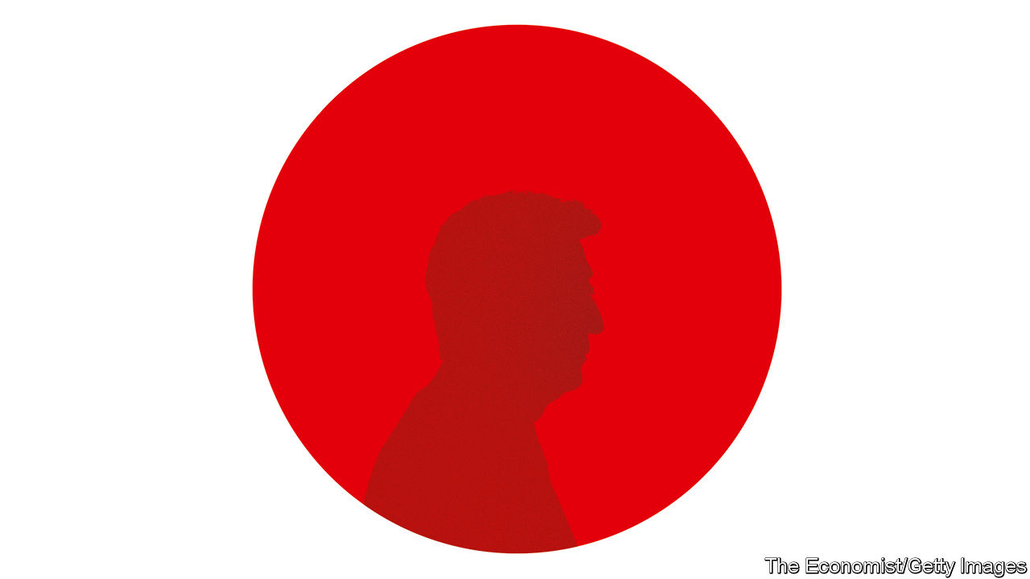

## The aftermath of Abenomics

Alas, how different you are in evaluating the legacy of Abe Shinzo from the people of Japan (“[How Abe Shinzo changed Japan](https://www.economist.com/leaders/2020/09/03/abe-shinzos-legacy-is-more-impressive-than-his-muted-exit-suggests)”, September 5th). You praised Mr Abe as a great neoliberal reformer during his time as prime minister, who opened Japan’s market, enhanced productivity and concluded free-trade agreements. Consequently, however, Japan has many more unstable part-time jobs, with lots of women forced to work.

True, some people and companies praise him because they benefited from the increases in productivity and the stockmarket. But the vast majority of Japanese people see things differently, because their standard of living has either not changed or deteriorated. Don’t you see the same soil that invited Brexit?

Worse, you applauded Mr Abe for making Japan “more governable”. Indeed. He shifted political power to the prime minister’s office, making decision-making faster. As a result, today a handful of officials decide policies without discussions among bureaucrats, let alone with the voters.

Inequality in society and such a policymaking process were exactly what Japan had before starting the Pacific war. We need to remember that.

FUMIKO SASAKI  
Adjunct assistant professor of international affairs  
Columbia University  
New York



## Capriles capitulates

Bello’s column on Venezuela’s divided opposition was uncharacteristically unbalanced ([September 12th](https://www.economist.com/the-americas/2020/09/10/no-good-options-for-venezuelas-divided-opposition)). Henrique Capriles was described as a moderate, but Juan Guaidó was presented as a radical, linked implicitly to the push from radicals for military intervention by the United States to end Venezuela’s crisis.

Bello is right that the continuation of the outgoing assembly, and therefore the interim government, has no constitutional basis. Yet neither does a dictatorship. Mr Capriles’s strategy of participating in the legislative election, which breaks with the bulk of the opposition (moderates and radicals alike), not only contradicts the notion that you can’t hold a free election when a despot controls the electoral authority and the courts, it also threatens to erode the international backing for Mr Guaidó’s interim government. After many stolen elections (including Mr Capriles’s presidential bid in 2013) and the neutering of the opposition-controlled legislature, Mr Capriles has yet to explain how he intends to counter election fraud or make the opposition effective. The only workable option continues to be to increase internal and international pressure, in the form of sanctions, to force a democratic transition.

HUMBERTO ROMERO  
Pompano Beach, Florida

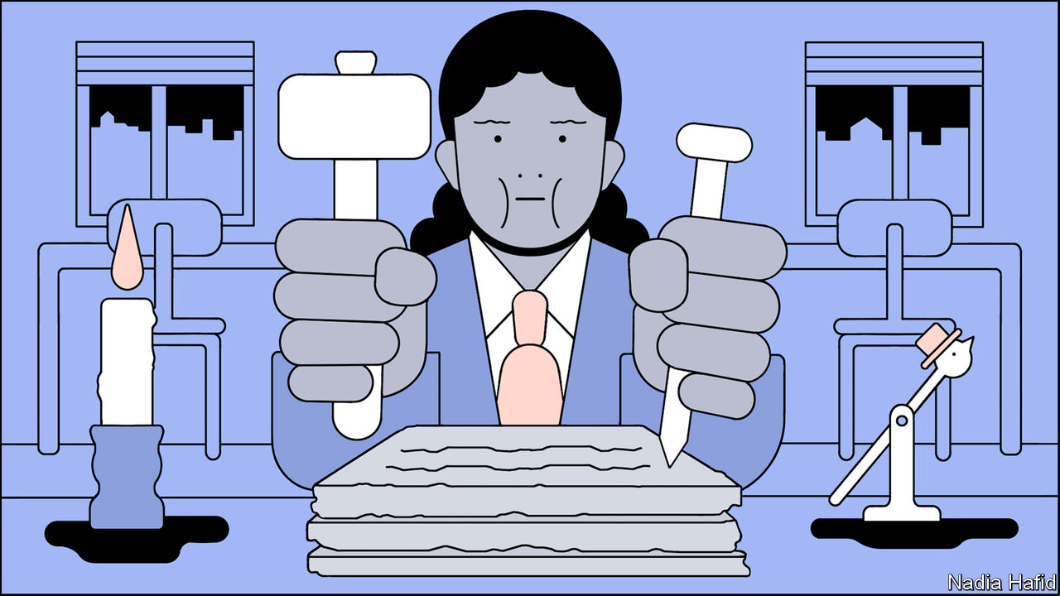

## No need for national ID cards

Your article on covid-19 spurring the digitisation of government asserted that a single digital identity for each person should underpin public services, such as track and trace (“[Paper travails](https://www.economist.com/international/2020/09/01/covid-19-is-spurring-the-digitisation-of-government)”, September 5th). This is not needed. The British government, for instance, has digitised dozens of its services without introducing national identity cards.

The parts of government that provided a competent online response to the pandemic (universal credit, taxes, the health system’s sick-note service) invested in strong internal teams supported by contractors. Over the past six months 3,184 public services have used the government’s Notify platform to send nearly 1bn letters, texts and emails accurately to 80% of the population. This contrasts with buying magical-thinking from consultancies and outsourcing the state’s responsibilities, as it has for track and trace.

It is true that different government records are “isolated” in different departments. Data are isolated because of departmental sovereignty: 1,882 central-government websites existed in Britain before they were consolidated in the GOV.UK site.

The challenge is not one of ID cards. It is one of government. Centralised national identity schemes can be dangerous points of weakness for fraud and hacking, as shown recently in South Korea and Estonia. More urgent is the reform of the Victorian structure of government and its antiquated working practices. Calls for identity schemes often arise to avoid doing this hard work of resetting government for the digital age.

MIKE BRACKEN  
Partner  
Public Digital  
London

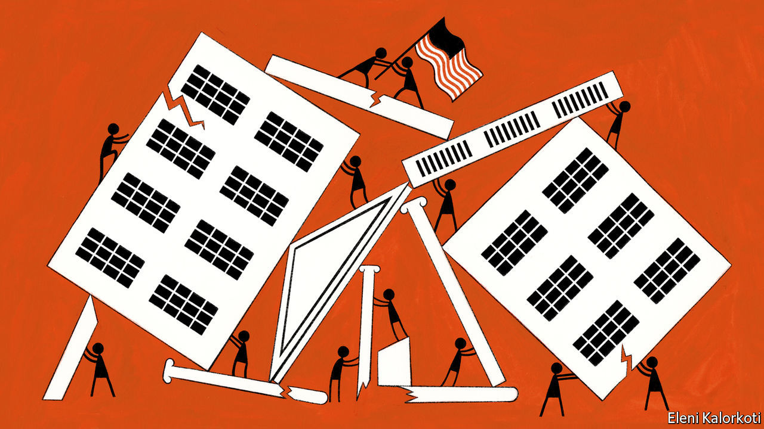

## America’s voting laws

“[A house divided](https://www.economist.com/briefing/2020/09/03/covid-19-and-an-atmosphere-of-distrust-pose-grave-risks-to-americas-election)” (September 5th) implied that laws barring foreigners from voting in America are based on the constitution. That document grants states the power to set the “manner” of elections to Congress and allows states to appoint members to the Electoral College in any way they choose. Beyond that, it is silent on the process of running elections.

This is not just an academic exercise. Several states have at one point or another granted suffrage to foreigners. The Illegal Immigration Reform and Immigrant Responsibility Act of 1996 does ban non-citizens from voting, but that is an act of Congress, not a feature of the constitution.

BLAKE HAYES  
Peachtree City, Georgia

Your list of the potential for trouble on America’s election night omitted remarks made by Hillary Clinton on August 25th: “Joe Biden should not concede under any circumstances because I think this is going to drag out, and eventually, I do believe he will win if we don’t give an inch and if we are as focused and relentless as the other side is.”

PAUL MITCHELL  
Weilerbach, Germany

In 2016 rioting broke out in Oakland following the election of Donald Trump. I don’t recall any such unlawful behaviour from Republicans after losing a national vote.

PAUL SHANNON  
Doncaster, South Yorkshire

Let’s be clear: Joe Biden is the conservative candidate in this election. He values established institutions and alliances. He recognises the need for change, but calls for a moderated, considered approach rather than radical upheaval. He has a strong sense of personal morality and ethics, and holds to a tradition of dignity and respect in political discourse. He values the rule of law. The incumbent, and the Republican Party in general, value none of these things.

ED KENSCHAFT  
Annandale, Virginia

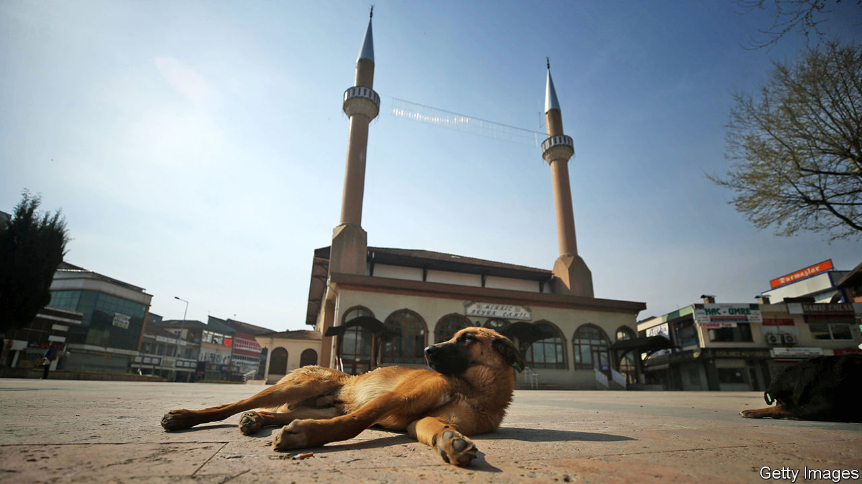

## Hounded in office

The dogmatic debate in Islam over canines (“[Bone of contention](https://www.economist.com/middle-east-and-africa/2020/08/27/are-dogs-acceptable-pets-muslim-scholars-ask)”, August 29th) even extends to Imran Khan’s love for pooches, especially “handsome” ones. Mr Khan has owned at least five dogs, earning them an entry in Wikipedia. The Pakistani prime minister has been criticised for his puppy love, such as when a prominent member of the Muslim League objected to one dog, Sheru, being allowed into the house, as this went against cultural and religious values. The matter came to a head when a newspaper accused Motu, another of Mr Khan’s pets, of causing a spat with his wife by interrupting her religious activities. Luckily, Motu was cleared of any wrongdoing, and was seen months later at a meeting between Mr Khan and Iran’s ambassador, indoors, of course.

NOLAN QUINN  
Parkton, Maryland

This article was downloaded by calibre from <https://www.economist.com/letters/2020/09/26/letters-to-the-editor>

|  |  |  |  |
| --- | --- | --- | --- |
|  | Articles | Sections | Next |

|  |  |  |
| --- | --- | --- |
| Letters | Sections | Asia |

Briefing

The covid-19 pandemic: Grim tallies

.

|  |  |  |
| --- | --- | --- |
| Letters | Sections | Asia |

|  |  |  |  |
| --- | --- | --- | --- |
|  | Articles | Sections | Next |

#### One million and counting

# The covid-19 pandemic is worse than official figures show

But some things are improving, and it will not go on forever

Sep 26th 2020 |

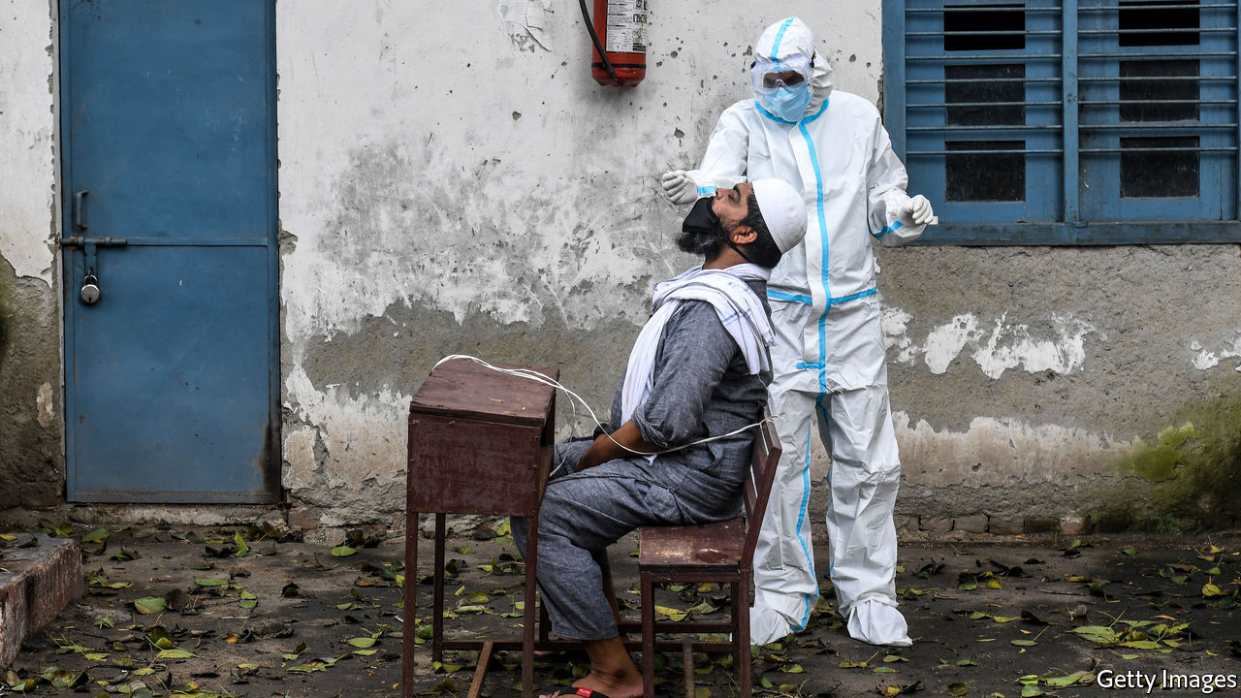

Editor’s note: Some of our covid-19 coverage is free for readers of The Economist Today, our daily [newsletter](https://my.economist.com/user#newsletter). For more stories and our pandemic tracker, see our [hub](https://www.economist.com/news/2020/03/11/the-economists-coverage-of-the-coronavirus)

AS THE AUTUMNAL equinox passed, Europe was battening down the hatches for a gruelling winter. Intensive-care wards and hospital beds were filling up in Madrid and Marseille—a city which, a few months ago, thought it had more or less eliminated covid-19. Governments were implementing new restrictions, sometimes, as in England, going back on changes made just a few months ago. The al-fresco life of summer was returning indoors. Talk of a second wave was everywhere.

Across the Atlantic the United States saw its official covid-19 death toll—higher than that of all western Europe put together—break the 200,000 barrier. India, which has seen more than half a million new cases a week for four weeks running, will soon take America’s unenviable laurels as the country with the largest official case count.

The world looks set to see its millionth officially recorded death from covid-19 before the beginning of October. That is more than the World Health Organisation (WHO) recorded as having died from malaria (620,000), suicide (794,000) or HIV/AIDS (954,000) over the whole of 2017, the most recent year for which figures are available.

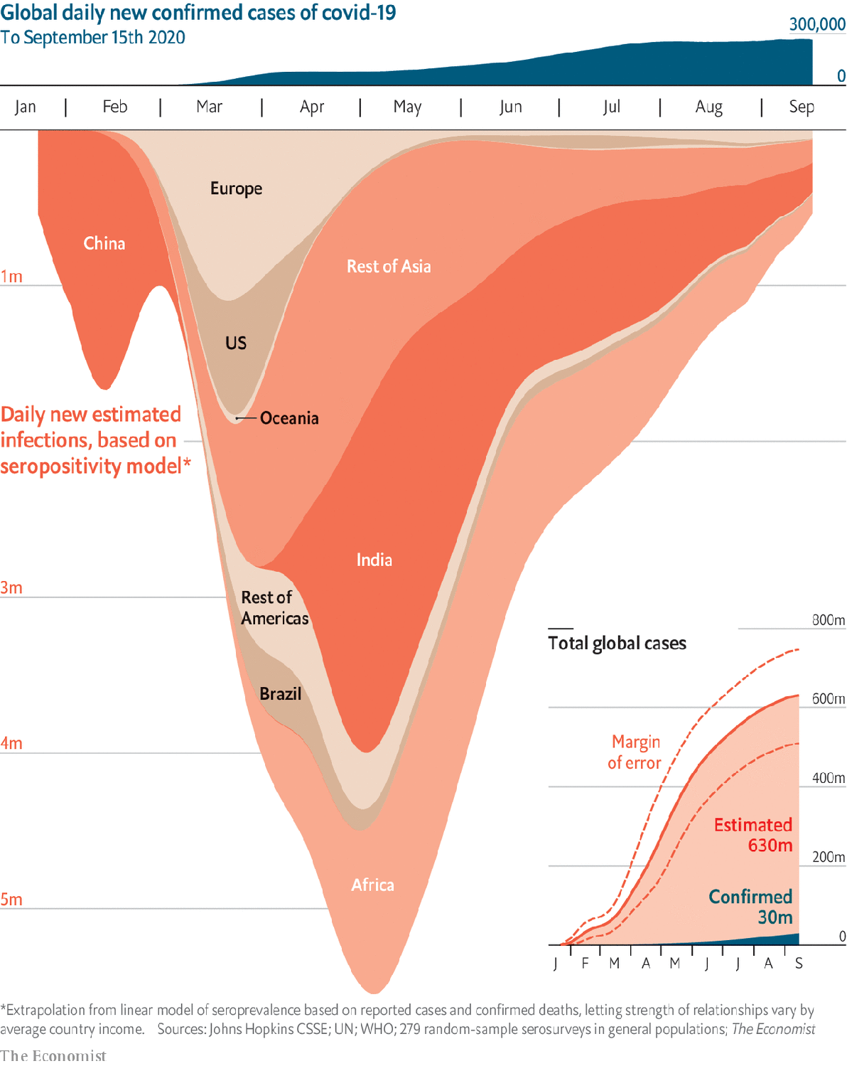

Those deaths represent just over 3% of the recorded covid-19 cases, which now number over 32m. That tally is itself an underestimate of the number who have actually been infected by SARS-CoV-2, the virus which causes covid 19. Many of the infected do not get sick. Many who do are never seen by any health system.

A better, if still imperfect, sense of how many infections have taken place since the outbreak began at the end of last year can be gleaned from “serosurveys” which scientists and public-health officials have undertaken around the world. These look for antibodies against SARS-CoV-2 in blood samples which may have been taken for other purposes. Their presence reveals past exposure to the virus.

Various things make these surveys inaccurate. They can pick up antibodies against other viruses, inflating their totals—an effect which can differ from place to place, as there are more similar-looking viruses circulating in some regions than in others. They can mislead in the other direction, too. Some tests miss low levels of antibody. Some people (often young ones) fight off the virus without ever producing antibodies and will thus not be recorded as having been infected. As a result, estimates based on serosurveys have to be taken with more than a grain of salt.

But in many countries it would take a small sea’s worth of the stuff to bring the serosurvey figures into line with the official number of cases. The fact that serosurvey data are spotty—there is very little, for example, openly available from China—means it is not possible to calculate the global infection rate directly from the data at hand. But by constructing an empirical relationship between death rates, case rates, average income—a reasonable proxy for intensity of testing—and seropositivity it is possible to impute rates for countries where data are not available and thus estimate a global total.

The graphic on this page shows such an estimate based on 279 serosurveys in 19 countries. It suggests that infections were already running at over 1m a day by the end of January—when the world at large was only just beginning to hear of the virus’s existence. In May the worldwide rate appears to have been more than 5m a day. The uncertainties in the estimate are large, and become greater as you draw close to the present, but all told it finds that somewhere between 500m and 730m people worldwide have been infected—from 6.4% to 9.3% of the world’s population. The WHO has not yet released serosurvey-based estimates of its own, though such work is under way; but it has set an upper bound at 10% of the global population.

As the upper part of the following data panel shows, serosurvey results which can be directly compared with the diagnosed totals are often a great deal bigger. In Germany, where cases have been low and testing thorough, the seropositivity rate was 4.5 times the diagnosed rate in August. In Minnesota a survey carried out in July found a multiplier of seven. A survey completed on August 23rd found a 6.02% seropositivity rate in England, implying a multiplier of 12. A national serosurvey of India conducted from the middle of May to early June found that 0.73% were infected, suggesting a national total of 10m. The number of registered cases at that time was 226,713, giving a multiplier of 44. Such results suggest that a global multiplier of 20 or so is quite possible.

If the disease is far more widespread than it appears, is it proportionately less deadly than official statistics, mainly gathered in rich countries, have made it look? Almost certainly. On the basis of British figures David Spiegelhalter, who studies the public understanding of risk at Cambridge University, has calculated that the risk of death from covid increases by about 13% for every year of age, which means a 65-year-old is 100 times more likely to die than a 25-year-old. And 65-year-olds are not evenly distributed around the world. Last year 20.5% of the EU’s population was over 65, as opposed to just 3% of sub-Saharan Africa’s.

But it is also likely that the number of deaths, like the number of cases, is being seriously undercounted, because many people will have died of the disease without having had a positive test for the virus. One way to get around this is by comparing the number of deaths this year with that which would be predicted on the basis of years past. This “excess mortality” method relies on the idea that, though official statistics may often be silent or misleading as to the cause of death, they are rarely wrong about a death actually having taken place.

## The excessive force of destiny

The Economist has gathered all-cause mortality data from countries which report them weekly or monthly, a group which includes most of western Europe, some of Latin America, and a few other large countries, including the United States, Russia and South Africa (see lower part of data panel). Between March and August these countries recorded 580,000 covid-19 deaths but 900,000 excess deaths; the true toll of their share of the pandemic appears to have been 55% greater than the official one. This analysis suggests that America’s official figures underestimate the death toll by 30% or more (America’s Centres for Disease Control and Prevention have provided a similar estimate). This means that the real number of deaths to date is probably a lot closer to 300,000 than 200,000. That is about 10% of the 2.8m Americans who die each year—or, put another way, half the number who succumb to cancer. And there is plenty of 2020 still to go.

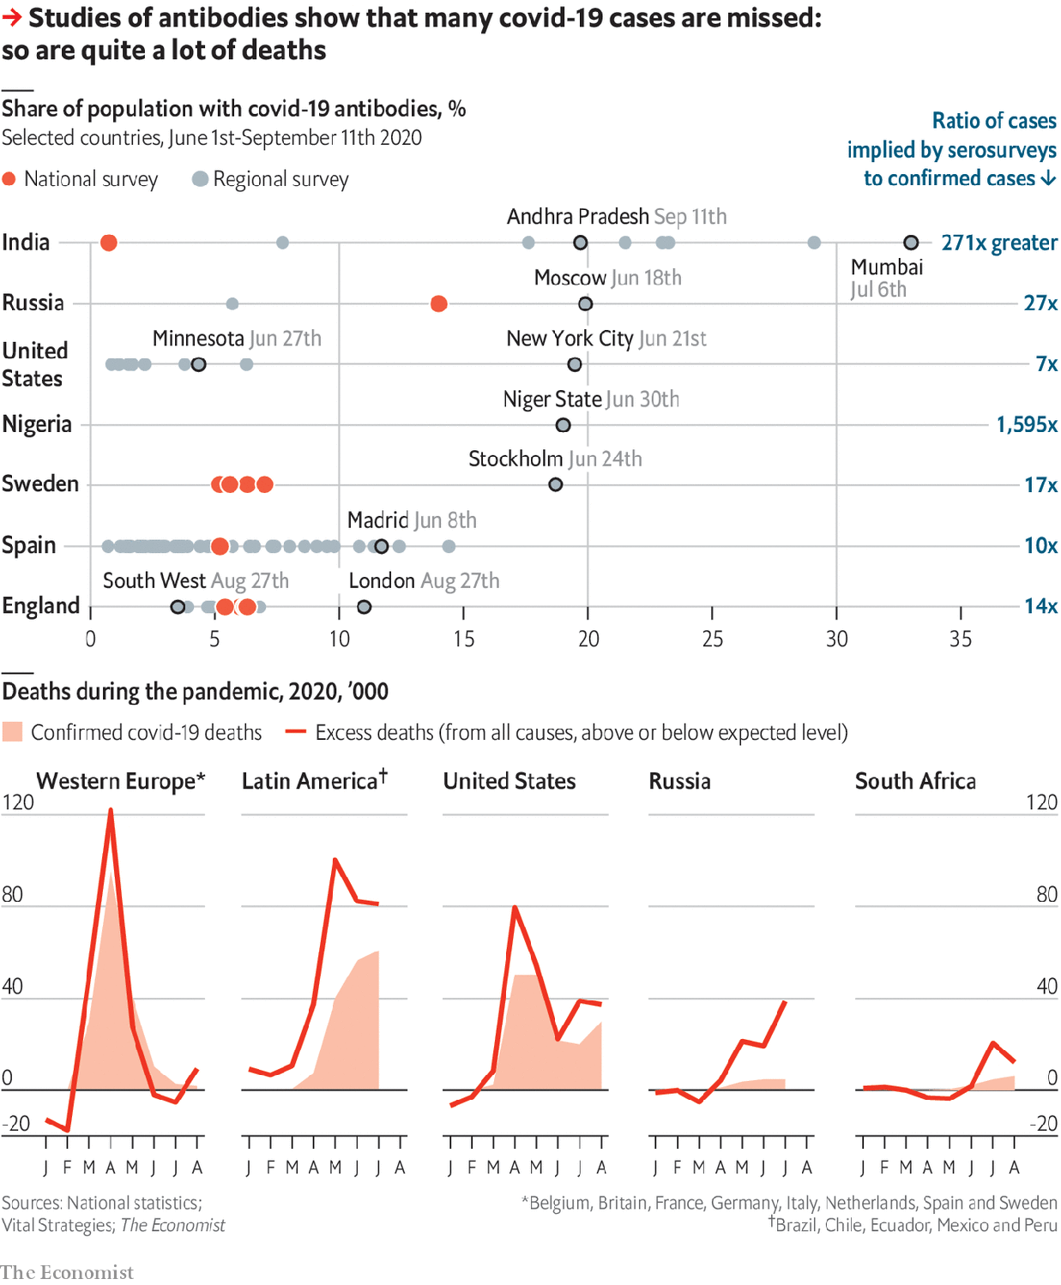

Add to all this excess mortality unreported deaths from countries where record keeping is not good enough to allow such assessments and the true death toll for the pandemic may be as high as 2m.

What can be done to slow its further rise? The response to the virus’s original vertiginous ascent was an avalanche of lockdowns; at its greatest extent, around April 10th, at least 3.5bn people were being ordered to stay at home either by national governments or regional ones. The idea was to stop the spread of the disease before health-care systems collapsed beneath its weight, and in this the lockdowns were largely successful. But in themselves they were never a solution. They severely slowed the spread of the disease while they were in place, but they could not stay in place for ever.

Stopping people interacting with each other at all, as lockdowns and limits on the size of gatherings do, is the first of three ways to lower a disease’s reproduction number, R—the number of new cases caused by each existing case. The second is reducing the likelihood that interactions lead to infection; it requires mandated levels of social distancing, hygiene measures and barriers to transmission such as face masks and visors. The third is reducing the time during which an infectious person can interact with people under any conditions. This is achieved by finding people who may recently have been infected and getting them to isolate themselves.

Ensuring that infectious people do not have time to do much infecting requires a fast and thorough test-and-trace system. Some countries, including Canada, China, Germany, Italy, Japan, Singapore and Taiwan, have successfully combined big testing programmes which provide rapid results with a well developed capacity for contact tracing and effective subsequent action. Others have foundered.

## Networks and herds

Israel provides a ready example. An early and well-enforced lockdown had the expected effect of reducing new infections. But the time thus bought for developing a test-and-trace system was not well used, and the country’s emergence from lockdown was ill-thought-through. This was in part because the small circle around prime minister Binyamin Netanyahu into which power has been concentrated includes no one with relevant expertise; the health ministry is weak and politicised.

Things have been made worse by the fact that social distancing and barrier methods are being resisted by some parts of society. Synagogues and Torah seminaries in the ultra-Orthodox community and large tribal weddings in the Arab-Israeli community have been major centres of infection. While unhappy countries, like Tolstoy’s unhappy families, all differ, the elements of Israel’s dysfunction have clear parallels elsewhere.

Getting to grips with “superspreader” events is crucial to keeping R low. Close gatherings in confined spaces allow people to be infected dozens at a time. In March almost 100 were infected at a biotech conference in Boston. Many of them spread the virus on: genetic analysis subsequently concluded that 20,000 cases could be traced to that conference.

Nipping such blooms in the bud requires lots of contact tracing. Taiwan’s system logs 15-20 contacts for each person with a positive test. Contact tracers in England register four to five close contacts per positive test; those in France and Spain get just three. It also requires that people be willing to get tested in the first place. In England only 10-30% of people with covid-like symptoms ask for a test through the National Health Service. One of the reasons is that a positive test means self-isolation. Few want to undergo such restrictions, and few are good at abiding by them. In early May a survey in England found that only a fifth of those with covid symptoms had self-isolated as fully as required. The government is now seeking to penalise such breaches with fines of up to £10,000 ($12,800). That will reduce the incentive to get tested in the first place yet further.

As much of Europe comes to terms with the fact that its initial lockdowns have not put an end to its problems, there is increased interest in the Swedish experience. Unlike most of Europe, Sweden never instigated a lockdown, preferring to rely on social distancing. This resulted in a very high death rate compared with that seen in its Nordic neighbours; 58.1 per 100,000, where the rate in Denmark is 11.1, in Finland 6.19 and in Norway 4.93. It is not clear that this high death rate bought Sweden any immediate economic advantage. Its GDP dropped in the second quarter in much the same way as GDPs did elsewhere.

It is possible that by accepting so many deaths upfront Sweden may see fewer of them in the future, for two reasons. One is the phenomenon known, in a rather macabre piece of jargon, as “harvesting”. Those most likely to succumb do so early on, reducing the number of deaths seen later. The other possibility is that Sweden will benefit from a level of herd immunity: once the number of presumably immune survivors in the population grows high enough, the spread of the disease slows down because encounters between the infected and the susceptible become rare. Avoiding lockdown may conceivably have helped with this.

On the other hand, one of the advantages of lockdowns was that they provided time not just for the development of test-and-trace systems but also for doctors to get better at curing the sick. In places with good health systems, getting covid-19 is less risky today than it was six months ago. ISARIC, which researches infectious diseases, has analysed the outcomes for 68,000 patients hospitalised with covid-19; their survival rate increased from 66% in March to 84% in August. The greatest relative gains have been made among the most elderly patients. Survival rates among British people 60 and over who needed intensive care have risen from 39% to 58%.

This is largely a matter of improved case management. Putting patients on oxygen earlier helps. So does reticence about using mechanical ventilators and a greater awareness of the disease’s effects beyond the lungs, such as its tendency to provoke clotting disorders.

## Nouvelle vague

As for treatments, two already widely available steroids, dexamethasone and hydrocortisone, increase survival by reducing inflammation. Avigan, a Japanese flu drug, has been found to hasten recovery. Remdesivir, a drug designed to fight other viruses, and convalescent plasma, which provides patients with antibodies from people who have already recovered from the disease, seem to offer marginal benefits.

Many consider antibodies tailor-made for the job by biotech companies a better bet; over the past few years they have provided a breakthrough in the treatment of Ebola. The American government has paid $450m for supplies of a promising two-antibody treatment being developed by Regeneron. That will be enough for between 70,000 and 300,000 doses, depending on what stage of the disease the patients who receive it have reached. Regeneron is now working with Roche, another drug company, to crank up production worldwide. But antibodies will remain expensive, and the need to administer them intravenously limits their utility.

It is tempting to look to better treatment for the reason why, although diagnosed cases in Europe have been climbing steeply into what is being seen as a second wave, the number of deaths has not followed: indeed it has, as yet, barely moved. The main reason, though, is simpler. During the first wave little testing was being done, and so many infections were being missed. Now lots of testing is being done, and vastly more infections are being picked up. Correct for this distortion and you see that the first wave was far larger than what is being seen today, which makes today’s lower death rate much less surprising (see data panel).

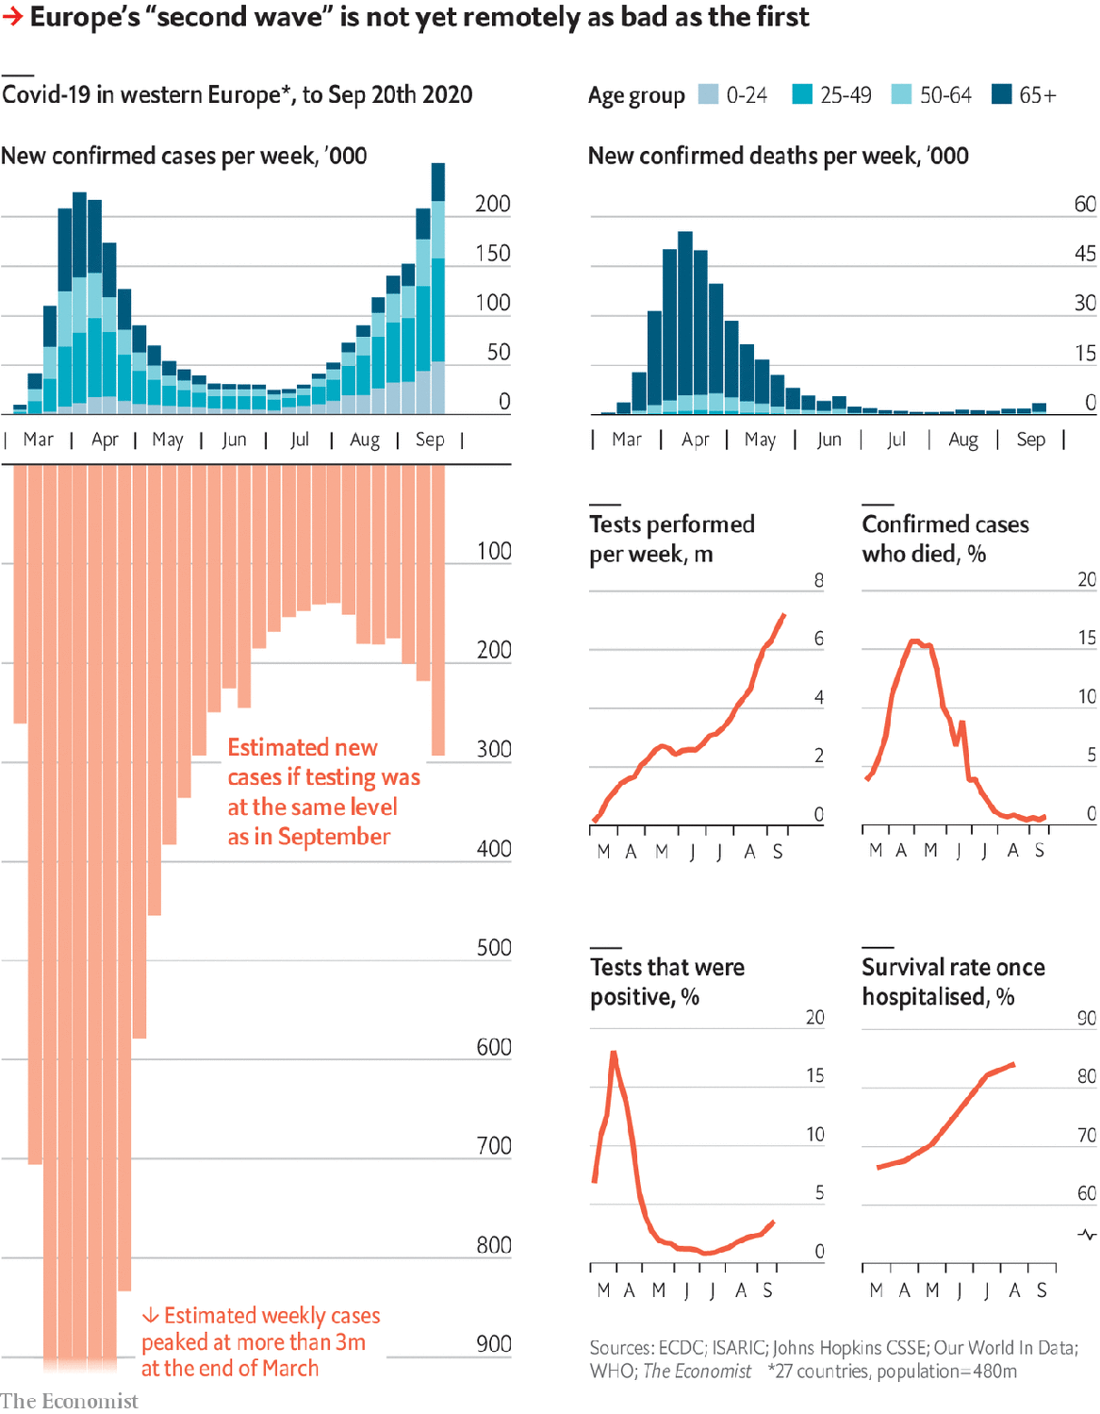

The coming winter is nevertheless worrying. Exponential growth can bring change quickly when R gets significantly above one. There is abundant evidence of what Katrine Bach Habersaat of the WHO calls “pandemic fatigue” eating away at earlier behavioural change, as well as increasing resentment of other public-health measures. YouGov, a pollster, has been tracking opinion on such matters in countries around the world. It has seen support for quarantining people who have had contact with someone infected fall a bit in Asia and rather more in the West, where it is down from 78% to 63%. In America it has fallen to 55%.

It is true that infection rates are currently climbing mostly among the young. But the young do not live in bubbles. Recent figures from Bouches-du-Rhône, the French department which includes Marseille, show clearly how a spike of cases in the young becomes, in a few weeks, an increase in cases at all ages.

As the fear of such spikes increases, though, so does the hope that they will not be recurring all that much longer. Pfizer, which has promising vaccine candidate in efficacy trials, has previously said that it will seek regulatory review of preliminary results in October, though new standards at the Food and Drug Administration may not allow it to do so in America quite that soon. Three other candidates, from AstraZeneca, Moderna and J&J, are nipping at Pfizer’s heels. The J&J vaccine is a newcomer; it entered efficacy trials only on September 23rd. But whereas the other vaccines need a booster a month after the first jab, the J&J vaccine is administered just once, which will make the trial quicker; it could have preliminary results in November.

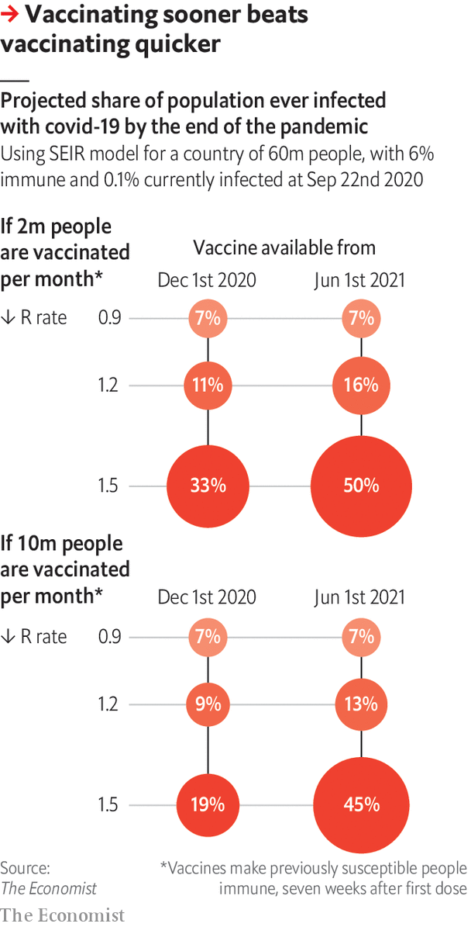

None of the companies will have all the trial data they are planning for until the first quarter of next year. But in emergencies regulators can authorise a vaccine’s use based on interim analysis if it meets a minimum standard (in this case, protection of half those who are vaccinated). Authorisation for use under such conditions would still make such a vaccine more credible than those already in use in China and Russia, neither of which was tested for efficacy at all. But there have been fears that American regulators may, in the run up to the presidential election, set the bar too low. Making an only-just-good-enough vaccine available might see social-distancing collapse and infections increase; alternatively, a perfectly decent vaccine approved in a politically toxic way might not be taken up as widely as it should be.

In either case, though, the practical availability of a vaccine will lag behind any sort of approval. In the long run, billions of doses could be needed. A global coalition of countries known as Covax wants to distribute 2bn by the end of 2021—which will only be enough for 1bn people if the vaccine in question, like Pfizer’s or AstraZeneca’s, needs to be administered twice. The world’s largest manufacturer of vaccines, the Serum Institute in India, recently warned that there will not be enough supplies for universal inoculation until 2024 at the earliest.

Even if everything goes swimmingly, it is hard to see distribution extending beyond a small number of front-line health and care workers this year. But the earlier vaccines are pushed out, the better. The data panel on this page looks at the results of vaccinating earlier versus later in a hypothetical population not that unlike Britain’s. Vaccination at a slower rate which starts earlier sees fewer eventual infections than a much more ambitious campaign started later. At the same time increases in R—which might come about if social distancing and similar measures fall away as vaccination becomes real—make all scenarios worse.

By next winter the covid situation in developed countries should be improved. What level of immunity the vaccines will provide, and for how long, remains to be seen. But few expect none of them to work at all.

Access to the safety thus promised will be unequal, both within countries and between them. Some will see loved ones who might have been vaccinated die because they were not. Minimising such losses will require getting more people vaccinated more quickly than has ever been attempted before. It is a prodigious organisational challenge—and one which, judging by this year’s experience, some governments will handle considerably better than others. ■

This article was downloaded by calibre from <https://www.economist.com/briefing/2020/09/26/the-covid-19-pandemic-is-worse-than-official-figures-show>

|  |  |  |  |
| --- | --- | --- | --- |
|  | Articles | Sections | Next |

|  |  |  |
| --- | --- | --- |
| Briefing | Sections | China |

Asia

Bureaucrats in Indonesia: Rejoice to serve

.

The monarchy in Thailand: Do you hear the people, king?

.

Agriculture in India: Yield curve

.

Malaysian politics: Anwar on the attack

.

Banyan: Twitchers without borders

.

|  |  |  |
| --- | --- | --- |
| Briefing | Sections | China |

|  |  |  |  |
| --- | --- | --- | --- |
|  | Articles | Sections | Next |

#### Rejoice to serve

# Why so many Indonesians want to be public servants

Hint: the public and service seldom have much to do with it

Sep 26th 2020 | SINGAPORE

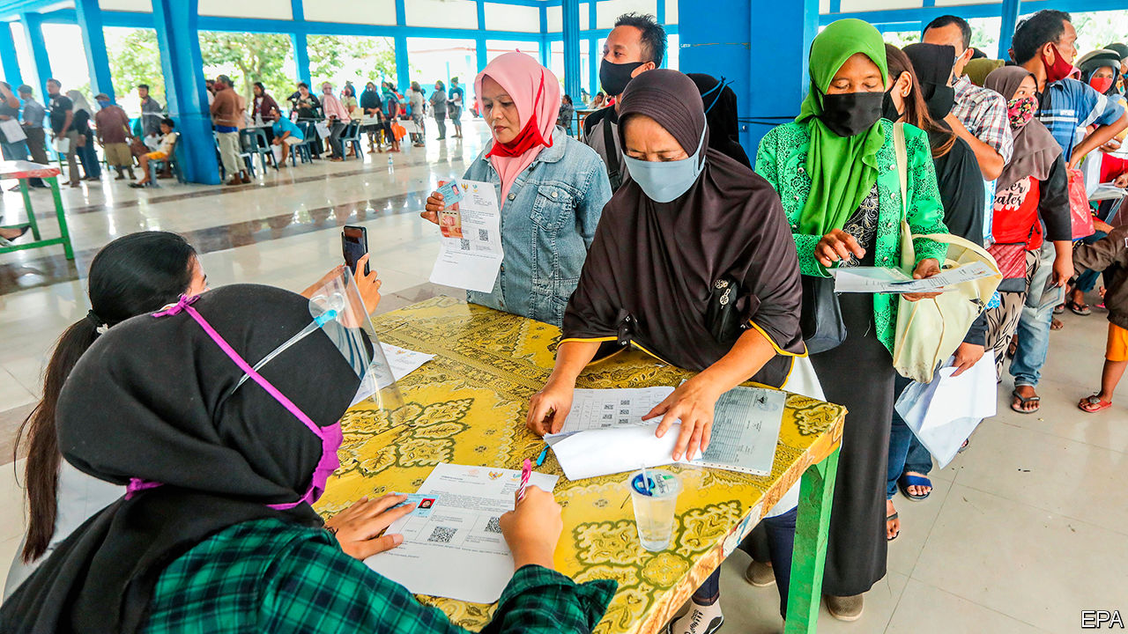

WHEN THE government rang to tell Budi (not his real name) that he had been hired as a tax collector, it was like a dream come true. When he graduated from university in 2013, the only work he could find was as a stevedore at the local port. Jobs in his hometown of Ende, a small city on the island of Flores, were scarce. Local government promised a steady income and a pension. Even more important for Budi was the status that came with the job. When he put on his civil-service uniform for the first time five years ago, “people saw me differently,” he says. “It’s one of the most respected jobs in the area.”

Budi was one of the lucky ones. Last year some 4.2m people applied for around 150,000 spots in the civil service. Many enlist to serve their country. Others are less high-minded. Jobs are hard to find for young Indonesians. In 2019 as many as 26% of those aged between 15 and 19 and 16% of those between 20 and 24 were unemployed and out of school.

In many poorer provinces, the government is one of the biggest employers: a study in the Indonesian part of New Guinea in 2014 found that, in many districts, more than one in ten people of working age were civil servants. Government salaries are often higher than those at private companies, and jobs are for life. Working-class Indonesians see the civil service as their route to the middle class, says Pande Made Kutanegara, an anthropologist at Universitas Gadjah Mada.

Moreover, there is prestige associated with being a government man. In the colonial era the Dutch stripped local aristocrats of their powers and turned them into bureaucrats. Fallen nobles lent prestige to their humble new posts, says Mr Pande. Today some senior bureaucrats, particularly in the farther reaches of the archipelago, regard the districts in which they serve as their own personal fiefs.

The reasons why so many Indonesians want to become public servants also explain why, once they have succeeded, they often fail to serve the people. Public services are patchy, particularly at the level of local government, which is responsible for health care and education, among other things. Real spending per person by local governments soared between 1994 and 2017, by 258% on average, according to the World Bank. But services remain ropy. More than half of children leave school unable to read properly, for instance.

Inefficiency is rife. At the local level, exam results, jobs, promotions and transfers are regularly sold to the highest bidders, according to a study published in 2012 by Peter Blunt and Hendrik Lindroth of the World Bank and Mark Turner of the University of Canberra. Local politicians often reward supporters with temporary posts in the civil service. Thus many bureaucrats are unqualified for their jobs. A report published in 2017 by the State Civil Service Agency found that more than 40% of the 696 directors (the highest-ranking bureaucrats) that it assessed were not fit to do their jobs.

Yet it is almost impossible to fire civil servants. In 2017 only 347 out of 4.3m were dismissed. “It means you don’t have this big motivation for your future or to develop yourself,” says Hadiono (also not his real name), who works for the Ministry of Tourism. Workers often slink away from their desks hours before they are supposed to. Municipal police in some provinces are under instructions to round up skiving bureaucrats (identifiable by their khaki uniforms) and deposit them back at the office, says Dr Pande.

Many civil servants also seek to bump up their incomes through schemes which “distract the civil servants from doing their jobs”, says Kevin O’Rourke, a political analyst. Employees of the tourism ministry, for instance, are paid a generous daily fee when they travel for work. It is standard practice to extend trips by a day or two beyond what is necessary, to claim extra cash, says Hadiono. Some officials are not content to stop there. Every year, millions of dollars are siphoned off the health system which, with its relatively large budget, is a particularly popular target for embezzlers. Indeed, graft is so widespread that some bureaucrats are frightened of taking any decisions at all, for fear that watchdogs like the Anti-Corruption Commission will assume that their motives can only have been pecuniary, explains Mr O’Rourke.

Since the arrival of democracy in 1998, there have been many attempts to reform the bureaucracy; an entire ministry is devoted to the cause. Jobs are better defined and processes have been streamlined. Comptrollers are clamping down on expenses cheats. Salaries are now boosted by allowances pegged to performance. A law that will come into effect next year will make it slightly easier to fire people.

Such reforms are working, argues Rudiarto Sumarwono of the Indonesian Civil Service Commission. Indonesia is now ranked 59 out of 100 in the World Bank’s index on government effectiveness, from a low of 24 in 1996 (the higher the ranking the more effective the government). On the corruption perceptions index of Transparency International, a watchdog, Indonesia scores 40 out of 100 (where zero is highly corrupt) against 28 in 1996. But changing the culture of entitlement will take time. “Old-school” officials in their 50s are set in their ways, says Mr Rudiarto, who has hope for younger generations. Hadiono is less sanguine; plenty of people in their 20s and 30s think “being a civil servant means I can get an easy life”. Not even President Joko Widodo, popularly known as Jokowi, seems very keen to overhaul the institution, says Mr O’Rourke.

But the pandemic has shown just how urgent reform is. By June, two months after parliament had passed its covid-stimulus package, just 1.5% of the 75trn rupiah ($5bn) budgeted for the health system had been disbursed, prompting the normally placid Jokowi to lambast his cabinet for its business-as-usual response to the crisis.

Yet the bureaucracy seems unable to shake off its lethargy. Just a third of the government’s overall budget of 695trn rupiah for the year has been disbursed so far. According to Reuters, the government actually spent a smaller percentage of its budget in the first half of 2020 than in the same period in 2019. As the bureaucrats have fiddled, the number of cases of covid-19 has soared. Along with the Philippines, Indonesia has had more far more deaths from the disease relative to its population than the other countries of South-East Asia. To treat covid-19 properly, it will need to cure its bureaucracy. ■

This article was downloaded by calibre from <https://www.economist.com/asia/2020/09/26/why-so-many-indonesians-want-to-be-public-servants>

|  |  |  |  |
| --- | --- | --- | --- |
|  | Articles | Sections | Next |

|  |  |  |  |
| --- | --- | --- | --- |
| Previous | Articles | Sections | Next |

#### Do you hear the people, king?

# Daring Thais march to the palace to demand royal reform

The king, as usual, was absent

Sep 26th 2020 |

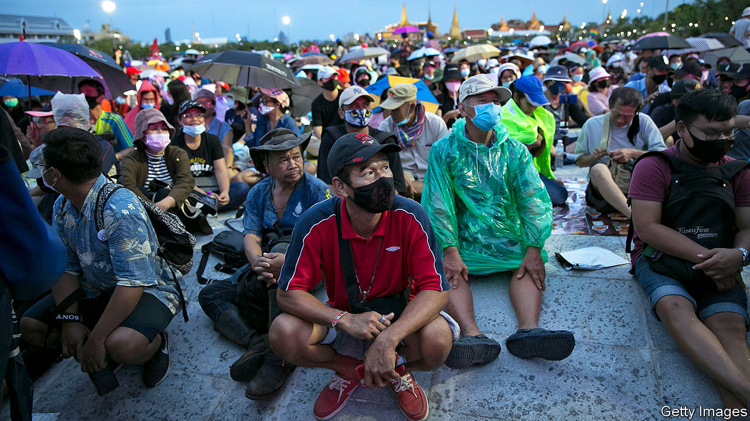

SEVERAL OF THE protesters parading through Bangkok wore tiny crop tops and tight bicycle shorts, revealing torsos covered in elaborate temporary tattoos. Others mockingly prostrated themselves before the half-clad cyclists. The performance was a reference to the man they were marching against, Maha Vajiralongkorn, Thailand’s king since 2016. King Vajiralongkorn spends most of his time in Germany, where paparazzi occasionally manage to take snaps of him and members of his harem in the sort of get-up the marchers were mimicking. Not only were the demonstrations on September 19th and 20th, in which tens of thousands took part, the largest since the present bout of protests began in July; they also revealed how opposition to the government of Prayuth Chan-ocha, a coup-leader turned prime minister, is evolving into an unprecedented attack on the monarchy.

King Vajiralongkorn lacks the popularity of his late father, Bhumibol Adulyadej, who reigned for 70 years. His personal life is as colourful as his tattoos. In addition to his current (fourth) wife, he has a concubine whom he has officially designated as “royal consort” (a title not used in Thailand for nearly a century). More troublingly, he has meddled in politics, taken control of “crown property” worth perhaps $40bn and assumed direct command of thousands of soldiers based in Bangkok.

Although Thailand is in theory a constitutional monarchy, criticism of the king has long been taboo. King Vajiralongkorn, in a show of graciousness, has instructed the government not to prosecute people under the fierce law on lèse-majesté, which carries a prison sentence of up to 15 years for insulting the king, queen, heir apparent or regent. But those who denigrate royalty often find themselves charged with sedition instead, or computer crimes if they do so online. In July one man was taken to a psychiatric hospital after wearing a T-shirt that stated: “I have lost all faith in the institution of the monarchy.”

Such incidents make the protesters’ audacity all the more striking. “This country belongs to the people, and not the king,” read a plaque installed in the pavement by some of the organisers. “Down with feudalism, long live the people!” many shouted as they marched towards the royal palace. On arrival, they handed ten demands for reform of the monarchy to a hapless policeman guarding the empty building. These included curbs on the king’s interference in politics, the disbandment of his guards, the revocation of the lèse-majesté law and the dismissal of the current government.

Officials defending the king point out that the protests were allowed to proceed and that there was no descent into violence, as has often been the case with demonstrations in Thailand in recent years. The stoutly monarchist army has kept quiet. But there are bigger tests to come. The protesters have called for a general strike next month.

This article was downloaded by calibre from <https://www.economist.com/asia/2020/09/26/daring-thais-march-to-the-palace-to-demand-royal-reform>

|  |  |  |  |
| --- | --- | --- | --- |
| Previous | Articles | Sections | Next |

|  |  |  |  |
| --- | --- | --- | --- |
| Previous | Articles | Sections | Next |

#### Yield curve

# India’s government prunes the regulations stifling farmers

But it pushed through the reforms in a needlessly confrontational way

Sep 26th 2020 |

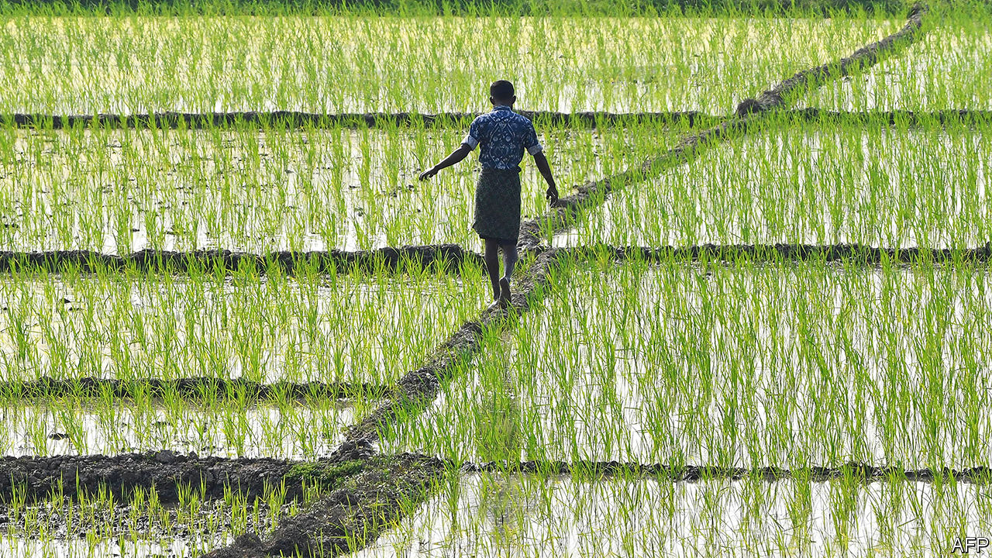

FARMERS ARE more than half of India’s workforce, but produce barely a sixth of its GDP. There are plenty of reasons for the shortfall. The tiny size of most farms is one. Some 86% of landholdings are smaller than two hectares. They are shrinking, too, as each new generation inherits ever-smaller parcels.

Yet one of the biggest underlying causes of inefficiency, ironically, is a tangle of laws that were designed to protect smallholders from grasping corporations, greedy middlemen, scheming hoarders and ruthless land speculators. In the 1950s and 1960s, paternalistic governments, hoping both to promote “food security” and to succour the poor, seeded a range of well-meaning policies that, among other things, restricted long-term contracts to supply crops to companies, obliged farmers to sell their harvest in designated wholesale markets and set minimum prices for a host of staples. Instead of protecting farmers from the depredations of capitalism, however, these policies have simply exposed them to new forms of exploitation.

The 7,000-odd wholesale markets, for instance, gradually fell under the sway of a class of middlemen—often themselves rich farmers—who fix the terms of sale, create cartels to manipulate supply and often serve as moneylenders. The concentration of business in the markets makes them an easy target for cash-strapped states’ tax-collectors. As a result, a recent study by the central bank shows, farmers tend to glean a relatively meagre proportion of the retail value of their produce.

Growers of wheat, rice and some other crops, meanwhile, have been able to earn guaranteed above-market prices from the government itself. This has ensured abundant stocks: the government’s current 70m-tonne grain mountain could feed India for a year. But it has also led to distortions. A small number of bigger farms reap the bulk of subsidies. The overabundance of certain grains has narrowed diets from a healthier range of traditional foods. The lucrative alternation of summer rice and winter wheat sucks up precious groundwater and encourages the burning of rice stubble to clear fields, adding to severe air pollution.

Narendra Modi, the prime minister, vowed during last year’s election campaign to double farmers’ incomes by 2022. The promise stoked scepticism, but his government, with a strengthened majority in its second term, seems keen to move. Since mid-September it has rushed a trio of farm bills into law. These aim to end the requirement for farmers to use state-sanctioned wholesale markets, free them to contract production for longer periods—for instance to supply restaurants or manufacturers of packaged food—and lastly to curtail the government’s power to set the prices and manipulate the stocks of crops it deems essential.

Mr Modi’s propagandists liken these changes to the ground-shaking reforms in the 1990s that unshackled India’s economy from the strictures of the previous “licence raj”. That seems a stretch. But economists do widely welcome the new laws, concurring that many past agricultural policies no longer serve their purpose. Plenty of farmers agree; one group that claims to represent southern growers described the farm bills as “visionary”.

Yet Mr Modi’s first crop of reforms has prompted complaints beyond the predictable ire of the opposition. Farm lobbies across much of north India have vowed to resist the changes, suspecting that they may be a precursor to the dismantling of support prices as well as of the subsidies farmers enjoy for electricity, fertiliser and other inputs.

Some analysts see the reforms not as needed practical measures, but as the continuation of a political strategy that has created new constituencies for Mr Modi by undermining precisely those groups that benefited from old rural power structures, such as middlemen, large landowners and landowning castes in general. The changes will probably also reward new groups that have supported Mr Modi, such as big corporations that may now find better investment opportunities in agriculture.

Even as the prime minister claimed to be liberalising farming and helping farmers, his government slapped an export ban on onions, whose rising cost apparently troubles urban voters. More undermining still, in the eyes of Mr Modi’s political opponents, was the way he pushed the farm bills through.

In the Rajya Sabha, parliament’s upper house, loud calls from the opposition for more debate were quashed. Amid a noisy fracas, two of the laws were passed on a voice vote. When protesting MPs were then suspended, the opposition walked out of both houses.

This has allowed the government to pass numerous bills in rapid succession, including big changes to labour laws. As with farming, these reforms may be long overdue, but Mr Modi’s legislative haste and disdain for consensus are generating unneeded bad will along the way. ■

This article was downloaded by calibre from <https://www.economist.com/asia/2020/09/26/indias-government-prunes-the-regulations-stifling-farmers>

|  |  |  |  |
| --- | --- | --- | --- |
| Previous | Articles | Sections | Next |

|  |  |  |  |
| --- | --- | --- | --- |
| Previous | Articles | Sections | Next |

#### Anwar on the attack

# A veteran Malaysian politician tries to topple the government

But even if Anwar Ibrahim becomes prime minister, his tenure will be troubled

Sep 26th 2020 | SINGAPORE

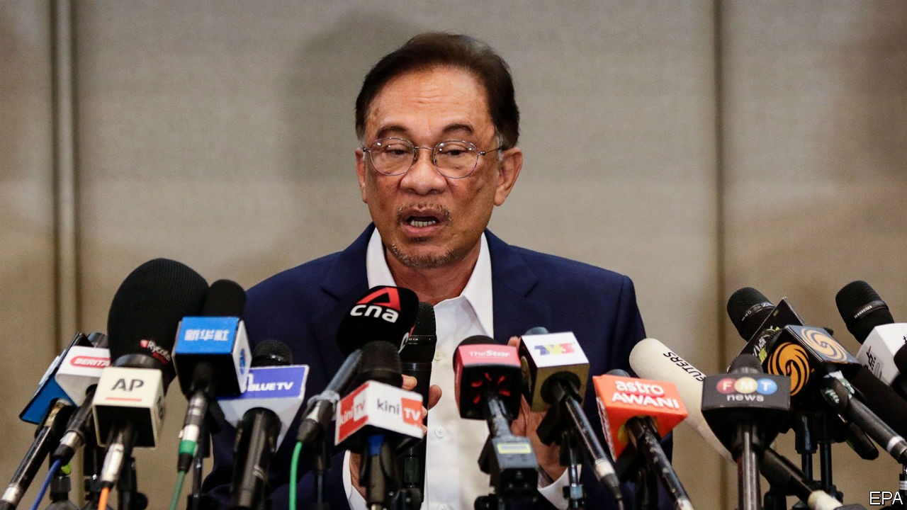

AFTER THREE stints in prison and more than two decades of waiting, Anwar Ibrahim has had enough. Long the leader of a multiracial opposition party, Parti Keadilan Rakyat (PKR), he declared on September 23rd that a “strong, formidable, convincing majority” of lawmakers wanted him to form a government. “The claim must be proven through the process and methods determined by the Federal Constitution,” retorted Muhyiddin Yassin, the incumbent prime minister. “Until proven otherwise…I am the legitimate prime minister.” The matter can only be settled by Malaysia’s king, to whom Mr Anwar promises to reveal his list of supporters. But the country remains in limbo, since the monarch says he is too unwell to receive visitors at the moment.

Mr Anwar came close to power in 2018 when a coalition of opposition parties including PKR defeated the ruling party of six decades, the United Malays National Organisation (UMNO), in a landmark election. But the job of prime minister went to Mahathir Mohamad, the leader of a smaller party in the coalition, Bersatu, on the understanding he would soon pass the baton to Mr Anwar. (The pair, who both used to belong to UMNO, had been in that situation before: when Dr Mahathir was prime minister in the 1990s, Mr Anwar had been his heir presumptive until they fell out and Mr Anwar wound up in prison.)

In the end the tension between the two men, and in particular the question of when Dr Mahathir would relinquish power, undermined the coalition. In February most of Bersatu and a faction within PKR jumped ship, siding with UMNO and an Islamic party, PAS, to form a new government with Mr Muhyiddin of Bersatu at its head. To soothe disgruntled MPs, Mr Muhyiddin was unusually generous about handing out ministerial posts and positions at government-linked firms.

That has not been enough to keep the new government’s MPs happy. For months Mr Anwar has wooed them to back yet another change at the top. UMNO’s president admitted on September 23rd that “many” of his party’s MPs had defected to Mr Anwar’s camp. But the splittists may have ulterior motives. UMNO is keen for a snap election and may not intend to keep any government formed by Mr Anwar afloat for very long. Its leaders assume that the endless bickering and scheming since PKR and Bersatu came to power will send disgusted voters flocking back to a more familiar force. Moreover, some suspect that Mr Anwar’s more racially diverse coalition will put off voters from the Malay majority, to UMNO’s benefit.

These dynamics mean that, even if Mr Anwar does manage to topple Mr Muhyiddin, the strife will continue. A man who has waited for decades to become prime minister will presumably not want to call an election right away if he will struggle to win. The timing of his bid for power—as Malaysia suffers from the painful economic impact of the coronavirus pandemic—shows his zeal for the top job. But the sickly economy will also weaken whoever ends up in charge. It took UMNO 61 years to discredit itself in the eyes of voters. Bersatu and PKR may have done so in just two. ■

This article was downloaded by calibre from <https://www.economist.com/asia/2020/09/26/a-veteran-malaysian-politician-tries-to-topple-the-government>

|  |  |  |  |
| --- | --- | --- | --- |
| Previous | Articles | Sections | Next |

|  |  |  |  |
| --- | --- | --- | --- |
| Previous | Articles | Sections | Next |

#### Banyan

# Even as countries peck at each other, their birdwatchers co-operate

When all other forms of detente fail, reach for the binoculars

Sep 26th 2020 |



FOR THOSE awed by nature on a planetary scale, this is a special time of year. During the autumn bird migration, 50m-odd individuals from 155 species of waders and other waterbirds barrel down the great avian thoroughfare known as the East Asian-Australasian Flyway.

It stretches from breeding grounds in Alaska and the extreme north-east of Russia all the way to Australia and New Zealand. In Hong Kong, where Banyan resides, wetlands and mudflats at Mai Po are of global importance—a crucial pitstop along the flyway. Fion Cheung of the WWF, which works to protect Mai Po, says it is filling up with early arrivals: Eurasian curlews, with long curved bills, and dumpy broad-billed sandpipers.

Waders reliant on rich tidal mudflats to feed need all the help they can get in this part of the world. Illegal hunters put up mist nets along China’s coast. Worse, in just 70 years China has lost more than half of its coastal wetlands to “reclamation”. In one senseless project in South Korea, 400 square kilometres of tidal estuary have been enclosed at Saemangeum. Among many species affected, the spoon-billed sandpiper now faces extinction. When two “spoonies” turned up at Mai Po this year, says Ms Cheung, birdwatchers outnumbered them many times over.

So Asia’s tiny group of bird experts was appalled earlier this month when the world’s biggest bird-conservation body, BirdLife International, a Britain-based umbrella group of NGOs from around the globe, expelled its longstanding member from Taiwan, the Chinese Wild Bird Federation (CWBF). The CWBF has led the charge to protect the habitat of the black-faced spoonbill, which breeds in the demilitarised zone between North and South Korea, winters in Taiwan and farther south, and had declined to barely 400 individuals. Numbers have climbed back to over 4,800, thanks in large part to the CWBF’s efforts.

Even more striking, the CWBF has helped bring the Chinese crested tern back from the dead. In 1937 an ornithologist shot 21 specimens, stuffing them in a museum drawer in Beijing. Never seen after that, the Chinese crested tern was presumed extinct. But in 2000 Taiwanese ornithologists rediscovered a few birds on disputed islets just off the Chinese coast. From perhaps a dozen individuals, the count is up to about 40 pairs breeding on Taiwanese and Chinese islands—still one of the world’s rarest birds.

BirdLife International denies that China, which claims Taiwan as its own and objects to anything that makes it look like an independent country, encouraged the expulsion of the CWBF. Instead BirdLife claims, implausibly, that to preserve its charitable status in Britain it had to ask for assurances that the CWBF would not take any “political” stances regarding Taiwan’s international status—which the CWBF refused to do. It may be that BirdLife took the step on its own initiative, hoping for better access to China, or perhaps even a boost to its funding. If so, there is no sign of either yet.

Allen Lyu of the CWBF insists that the organisation is apolitical, and has always bent over backwards to accommodate diplomatic niceties (it has already changed its name three times to assuage concerns). Whatever the details, the expulsion takes place in a region made more brittle by Chinese assertiveness. In recent days China has grown angry over a shopping list of American arms that Taiwan wants in order to hold back the kind of invasion China reserves the right to launch against it. In a show of strength, nearly 40 Chinese warplanes have crossed the two countries’ median line in the Taiwan Strait (right on the flyway). Even New Zealand has got it in the neck for, among other things, backing Taiwan’s involvement in the World Health Organisation, to which China vehemently objects.

In these tense times, raise a cheer for those Asians whose passion for conservation helps keep channels open. North Korea’s move to protect two wetlands under an international convention may be the only recent instance of the nuclear state sincerely embracing global institutions. The saga of the Chinese crested tern has strengthened relations between mainland and Taiwanese ornithologists, who hold an annual get-together on the tern’s status organised by the CWBF. Four years ago New Zealand and China signed a treaty to protect the habitat of the bar-tailed godwit, which, Maori tradition holds, carries the spirits of their forebears back and forth from their ancestral homeland. What better emblem could there be for cross-border co-operation?

This article was downloaded by calibre from <https://www.economist.com/asia/2020/09/26/even-as-countries-peck-at-each-other-their-birdwatchers-co-operate>

|  |  |  |  |
| --- | --- | --- | --- |
| Previous | Articles | Sections | Next |

|  |  |  |
| --- | --- | --- |
| Asia | Sections | United States |

China

Climate change: A greener horizon

.

Ren Zhiqiang: A loose cannon silenced

.

Chaguan: Tit for futile tat

.

|  |  |  |
| --- | --- | --- |
| Asia | Sections | United States |

|  |  |  |  |
| --- | --- | --- | --- |
|  | Articles | Sections | Next |

#### A greener horizon

# China aims to cut its net carbon-dioxide emissions to zero by 2060

Achieving this will not be easy

Sep 24th 2020 |

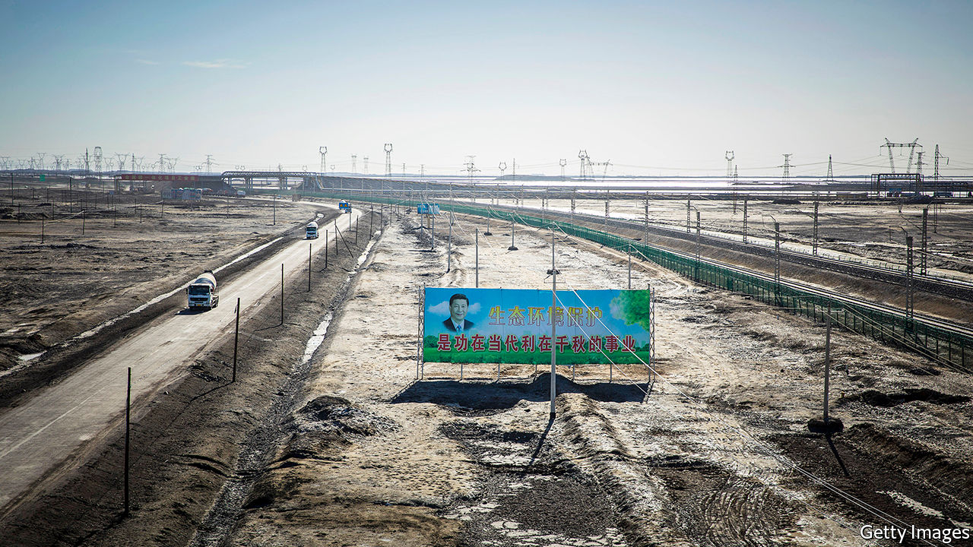

IN A RECORDED video message to the UN General Assembly on September 22nd, China’s leader, Xi Jinping, made a surprise announcement. He said that as well as aiming to halt the rise of its carbon emissions by 2030—much the same goal as five years ago—China would strive for “carbon neutrality” by 2060. In climate-change jargon, this means achieving a balance between carbon emissions and carbon reduction both technological and natural, such as planting trees. For China to succeed, it must descend from its emissions peak far more rapidly than any other major economy has either succeeded in doing, or has pledged to do. It will be a huge challenge.

Under the Paris agreement on climate change, reached in 2015, signatories were required to submit fresh plans for reducing their emissions by the end of this year. Covid-19 has put a spanner in the works. On September 2nd Patricia Espinosa, the UN’s chief climate-change official, said she expected about 80 countries to meet the deadline. Before Mr Xi’s speech, many analysts had predicted that China would not show its hand until after America’s elections in November, when American climate-change policy for the next four years will become clearer. Stung by international criticism of its early handling of the pandemic, China may have decided to reveal its hand earlier to boost its image.

But are the targets realistic? China will certainly have no problem ensuring that its emissions reach a peak before 2030. Already in 2014—a year before Mr Xi first declared such a goal (“around 2030” was the wording then)—experts had concluded that the peak could arrive as early as 2025. Indeed, some scientists believe that its emissions from fossil fuels—the biggest source of human-produced carbon—may have peaked already. The Brookings-Tsinghua Centre for Public Policy, a think-tank in Beijing, reckons they could begin declining in 2025. So Mr Xi’s reference to a target of 2030 in his speech to the UN was distinctly underwhelming.

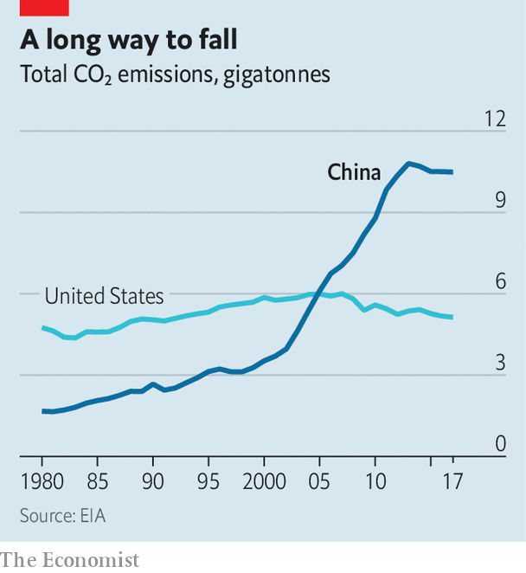

Aiming for carbon neutrality by 2060 is another matter. Mr Xi had already floated the idea that China might strive for such a goal on September 14th at a video summit with European Union leaders. Though during that call he did not commit to a deadline, his specifying of carbon neutrality as an ambition was “a political breakthrough”, says a European diplomat. Last year European leaders set a target for “climate neutrality” by 2050. America has kept silent on the topic.

In his UN speech, Mr Xi chose his words carefully. He referred to carbon neutrality by 2060, not climate neutrality. In climate-speak, this suggests the target will apply only to emissions of carbon dioxide (CO2), not other greenhouse gases such as methane, a big contributor to global warming. The EU’s goal for climate neutrality covers all emissions.

But China is the source of 27% of global emissions of CO2. Were it to commit formally to the 2060 target, previous forecasts of global warming trends by 2100 would need to be revised. Climate Action Tracker, a research group, had calculated that if all governments were to adhere to their Paris-accord pledges, the planet would warm, on average, by 2.7°C by 2100 compared with pre-industrial temperatures—still a long way off the Paris target of 1.5-2°C. Mr Xi’s announcement, they now say, could knock between 0.2°C and 0.3°C off this estimate.

That would still mean more warming than agreed in Paris, but China is not acting alone. Like China, the EU has not committed formally to its mid-century target. But doing so would have a big impact: the union’s CO2 emissions alone account for 10% of the world’s. All eyes are now on American voters. Victory for Joe Biden in the presidential election would mean the world’s top three emitters—China, America and the EU, which account for about 45% of global emissions—would all have similar time-frames for achieving net-zero goals. This would place the warming limit agreed in Paris “firmly in reach” says Bill Hare of Climate Action Tracker.

Mr Xi did not say how China would attain its 2060 goal. American CO2 emissions peaked sometime between 2005 and 2007, then dropped by about 14% in the subsequent decade. The EU’s total emissions peaked in 1990 and have since fallen by 21%. The aim is to reduce them by 45% by 2030. That would amount to a near-halving of emissions in four decades. China is implying that it will plunge from peak to near-nothing in just 30 years.

Crucially, China has not spelled out whether its new target will cover domestic emissions only, or include the emissions caused by China’s generous investments in coal outside its borders, including through the Belt and Road Initiative, a global infrastructure-building scheme. A new five-year economic plan, to be adopted next year, may provide clues to China’s plans for ending fossil-fuel dependency.

Achieving the 2060 target will require a complete decarbonisation of China’s electricity supply, more than 60% of which still comes from burning coal. Yet China is still building coal-fired power plants faster than any country. In the first six months of 2020 it built more than 60% of the world’s new installations of them. Carbon-heavy infrastructure being planned and built today could remain usable for decades. China’s efforts to revive its covid-struck economy include making it easier to secure permits to build such stuff.

But China worries about the impact of climate change—it is already plagued by floods and droughts. It can implement changes in ways that some democracies may find hard to replicate. For example, it can increase nuclear-power production without fear of public opposition—grassroots activism of any kind is suppressed. Its nuclear generating capacity more than doubled in 2014-19 to 48.7GW, according to Bloomberg NEF, an energy think-tank.

Even with a big expansion of nuclear energy, it is extremely unlikely that China could meet its target without finding ways of capturing CO2—either before it is emitted by power stations or directly from ambient air—and storing it underground. No method has yet been found for achieving this at scale. It will also be difficult to make substantial cuts in emissions from industrial processes and heavy transport without yet-to-be-invented technologies. Planting new forests would help absorb carbon, but it would need to be on a colossal scale to make the difference needed.

The lack of an obvious road-map makes Mr Xi’s commitment all the more remarkable. His ambitions will require a new approach to economic development that will need to become obvious soon. ■

This article was downloaded by calibre from <https://www.economist.com/china/2020/09/24/china-aims-to-cut-its-net-carbon-dioxide-emissions-to-zero-by-2060>

|  |  |  |  |
| --- | --- | --- | --- |
|  | Articles | Sections | Next |

|  |  |  |  |
| --- | --- | --- | --- |
| Previous | Articles | Sections | Next |

#### A loose cannon silenced

# A prominent critic of China’s leader gets 18 years in jail

Ren Zhiqiang’s sentencing shows that wayward princelings cannot expect leniency

Sep 26th 2020 | BEIJING

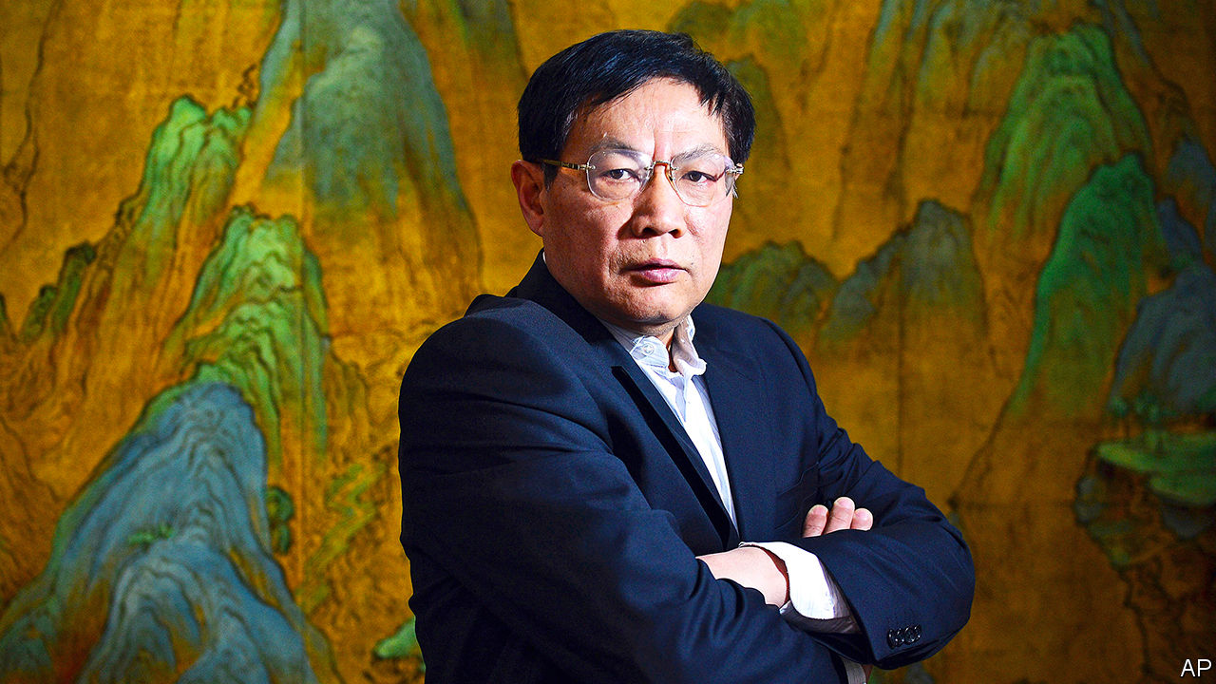

“BIG GUN REN can no longer fire,” sighed one netizen in a (swiftly censored) post on Weibo, a social-media platform. On September 22nd a court in Beijing had found Ren Zhiqiang, a retired boss of a state-owned property firm, guilty of corruption, bribery, embezzlement and abuse of power. He was sentenced to 18 years in prison.

Weibo had once been Mr Ren’s weapon of choice for lobbing fiery remarks about politics, a habit that earned him the big-gun nickname among his 37m followers. It was also a habit that infuriated the Communist Party. In 2016 his account was shut down. The party put Mr Ren, a member, on notice for one year. But many assumed that, as the son of one of Mao Zedong’s vice-ministers, and as someone with high-level friends, he enjoyed a degree of protection.

Xi Jinping, China’s leader, has now made it clear that a red pedigree cannot shield a dissenter. Mr Ren was detained by police in March after one of his essays, circulated among the party elite, criticised a self-congratulatory speech made by Mr Xi about the government’s response to covid-19 even as the nation was reeling from a disastrous early cover-up of the disease. Mr Ren denounced him as “a clown with no clothes on who is still determined to play emperor”. He wrote: “All I see are lies being used as loincloth.”

The severity of Mr Ren’s sentence—which puts him behind bars until the age of 87—sends a stark warning to other insiders. When the party expelled Mr Ren in July, investigators said he had “besmirched” it and “shown disloyalty”.

Other forthright intellectuals have recently faced harsh punishment. Xu Zhangrun, a law professor, was detained for six days in July and then dismissed from Tsinghua University after writing essays critical of Mr Xi. Cai Xia, who taught at the party’s training school for senior officials, spoke up for Mr Ren—and was stripped of her party membership and her pension. This month police detained Geng Xiaonan, the head of a publishing house, and her husband; Ms Geng had publicly defended Mr Xu.

In Mao’s day taking down a party member of Mr Ren’s status might have involved a full-fledged political campaign. The speed and “surgical precision” with which he was removed shows how much the process of purging the elite has changed, says Ling Li of the University of Vienna. In 2018 a new body, the National Supervision Commission, fused the internal-discipline apparatus of party and state—making it even easier for the party to use the courts to penalise politically wayward insiders. The big gun was no match for its powers.

This article was downloaded by calibre from <https://www.economist.com/china/2020/09/26/a-prominent-critic-of-chinas-leader-gets-18-years-in-jail>

|  |  |  |  |
| --- | --- | --- | --- |
| Previous | Articles | Sections | Next |

|  |  |  |  |
| --- | --- | --- | --- |
| Previous | Articles | Sections | Next |

#### Chaguan

# Calling for “reciprocity” is not making China or the West happier

As long as China’s view is “stay open to us, or we’ll hurt you,” talk about fairness will not solve much

Sep 24th 2020 |

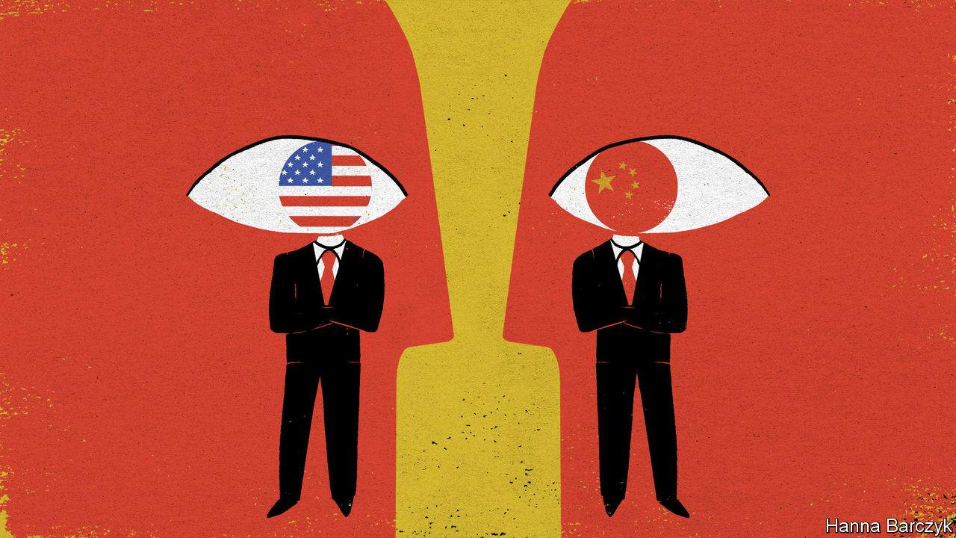

RARELY IN THE history of China’s contacts with the West have so many powerful people, in so many capitals, agreed that relations must be guided by the principle of fairness. When President Xi Jinping and his American counterpart, Donald Trump, give speeches that touch on Sino-American ties, the calls for mutual respect, shared benefits and avoiding double standards come thick and fast. The Europeans sound just as keen on fair play. In recent years the leaders of France, Germany and European Union institutions have led smaller powers in a sustained chorus, telling China that Europe is open for business, as long as it is on a basis of reciprocity. To quote France’s president, Emmanuel Macron, speaking in 2018 in the old caravan stop of Xi’an, the “new silk roads” proposed by China cannot run in only one direction.

A striking number of the ideas that fill officials’ speeches and the communiqués of summits come from the world of trade law. There is much talk of level playing-fields and non-discrimination. Yet a puzzle lurks. This focus on fairness is not making either side any happier. In the grim assessment of a veteran diplomat in Beijing, the last time that relations between China and the West were this bad was 1990, just a year after the crushing of democracy protests in Tiananmen Square.

In the face of this puzzle, Chaguan has two solutions to suggest. The first is that trade law is a flawed template for designing China policies. Trade lawyers are good at disputes between countries about mismatched import tariffs or airline landing rights. They are of less use in solving questions of high politics.

Earlier this month Mr Xi called on the Communist Party to strengthen its oversight over private companies. New party guidelines call for the creation of a vanguard of “private businesspeople who are reliable and useful at critical moments”. In such a China it is no longer a question of dry trade law whether Western businesses should seek “national treatment”, meaning the same market access conditions as Chinese ones. Should foreign firms want to be treated like Chinese ones, if that means giving party committees a management role and sharing sensitive data with the state?

These are not easy questions. At least rhetorically, Trump aides increasingly sound as if they have made up their minds. The attorney-general, William Barr, recently declared: “The ultimate ambition of China’s rulers isn’t to trade with the United States. It is to raid the United States.” Contemplating reported espionage against American universities and businesses, the secretary of state, Mike Pompeo, accused the Communist Party of exploiting America’s “free and open society”. Follow that logic, and decoupling would make America safer than remaining open to Mr Xi’s China.

European governments disagree strongly. If America’s next president is Joe Biden, he will reject decoupling, too. Still, something durable has shifted in Western views of China. For most of the past 40 years, rich-world democratic governments believed that openness to China benefited them disproportionately. It is extraordinary to read a report from 2004 about reciprocity in military-to-military ties, produced by the RAND Corporation for the United States Air Force. This noted that American officers visiting China were always taken to the same showcase bases (often near the Great Wall or other tourist sites), while Chinese military delegations to America were allowed access to lots of sensitive units. Do not worry, several defence officials told RAND’s researchers: America enjoys such a “surplus of strength” that showing off to Chinese visitors is a form of deterrence.

Breezy arguments of this kind are not heard today. China is too well-armed for that. It is also far more assertive. “Wolf warrior” Chinese diplomats have threatened Western governments that they will suffer if they refuse to buy 5G kit from Chinese firms like Huawei. Rather than attack the United States head-on, China has mounted trade and diplomatic boycotts against American allies that it sees as doing America’s bidding. Targets have ranged from South Korea to Canada and Australia.

Alas, reciprocity is no cure-all, as the Trump administration is proving. All year, China and America have expelled each other’s journalists by the score. Mr Trump’s officials picked this fight after seeing an analogy with unfair trade practices, says an insider. There were many more Chinese journalists in America than vice versa, and it was easier for them to get visas. Since polite appeals to balance out visa numbers had not worked, those officials decided there was little to lose from getting tough. Team Trump was wrong, and major American news bureaus in China have been gutted by expulsions of their reporters. Demanding reciprocity can be a good way to highlight gross asymmetries. It loses its leverage when others have different priorities and interests. China has many ways to learn about America without sending its own state-controlled media there. Its rulers also have lots to gain by expelling reporters from the New York Times, the Wall Street Journal and other outlets with unrivalled records of investigative journalism in China.

## How dare you say I’m threatening?

That American misjudgment points to the second way in which a quest for reciprocity, by itself, cannot fix relations with China. America could never win a race to the bottom on press freedoms with China, without betraying liberal values that presidents before Mr Trump, at least, have held dear. Without liberal values behind it, reciprocity means not much more than getting even. After all, “an eye for an eye” is a fair, if bleak, code of conduct. China struggles to see this distinction. Alarmed and enraged to realise how it is distrusted by Western countries, its diplomats and state media are lashing out and threatening retaliation on multiple fronts—or “legitimate countermeasures”, as China likes to put it. That version of reciprocity amounts to telling the world: “Stay open to China, or China will hurt you.” As long as that is China’s tone with the West, warm words about fairness will not solve much. ■

This article was downloaded by calibre from <https://www.economist.com/china/2020/09/24/calling-for-reciprocity-is-not-making-china-or-the-west-happier>

|  |  |  |  |
| --- | --- | --- | --- |
| Previous | Articles | Sections | Next |

|  |  |  |
| --- | --- | --- |
| China | Sections | Middle East & Africa |

United States

The battle for the Senate: The donkey’s long tail

.

Amy Coney Barrett: From RBG to ACB

.

Rural voters: Signs of the times

.

The US Navy: AI, Captain

.

Partisan warring: Courting trouble

.

Lexington: A double negative

.

|  |  |  |
| --- | --- | --- |
| China | Sections | Middle East & Africa |

|  |  |  |  |
| --- | --- | --- | --- |
|  | Articles | Sections | Next |

#### The donkey’s long tail

# Why the Democrats are our narrow favourites to win the Senate

The Economist’s new statistical model gives them a 67% chance of flipping the upper house of Congress. That would open a world of possibilities

Sep 23rd 2020 |

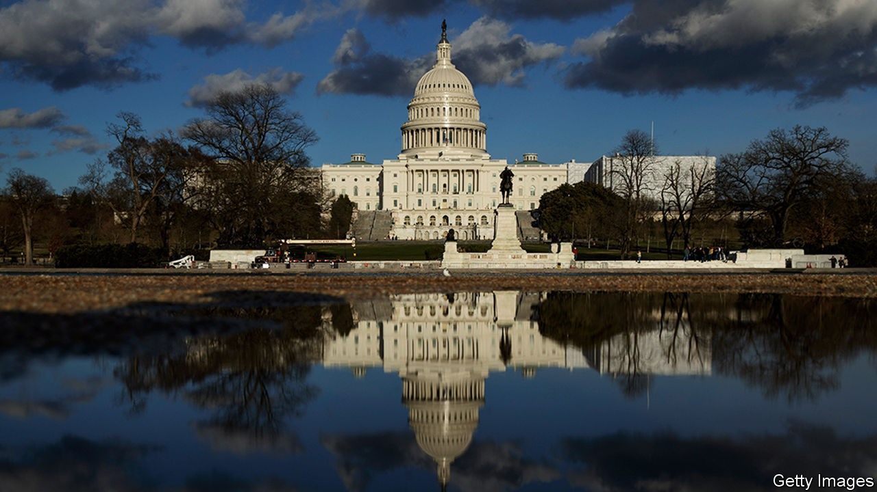

THE MOST important choice American voters face in November is whether to re-elect Donald Trump as president. The second-most important is whether to leave Republicans in control of the Senate, whose assent is required to pass federal laws and to confirm presidential nominees to federal courts and senior jobs.

If Mr Trump wins another term, Republicans will almost certainly hold the Senate as well. But if he does not, a Republican-controlled Senate would serve as a strong check on Joe Biden’s administration. If the record of Mitch McConnell, the Republican majority leader in the Senate, is any guide, a hostile upper chamber could block much of Mr Biden’s legislative agenda and prevent him filling most judicial vacancies—even if he wins the election in a landslide. Conversely, even a bare Senate majority would open up possibilities for him.

In practice, Democrats would be limited by the need to hold their caucus together. If they do win back the Senate, most of their new members will be centrists; their candidate in Kansas was a Republican until 2018. The last midterm elections, when Democrats did well, brought an infusion of moderates representing somewhat conservative places. Nonetheless, the difference in America’s political trajectory between scenarios in which the Democrats hold 49 Senate seats and those where they win 50—tie-breaking votes, if necessary, are cast by the vice-president—would be significant.

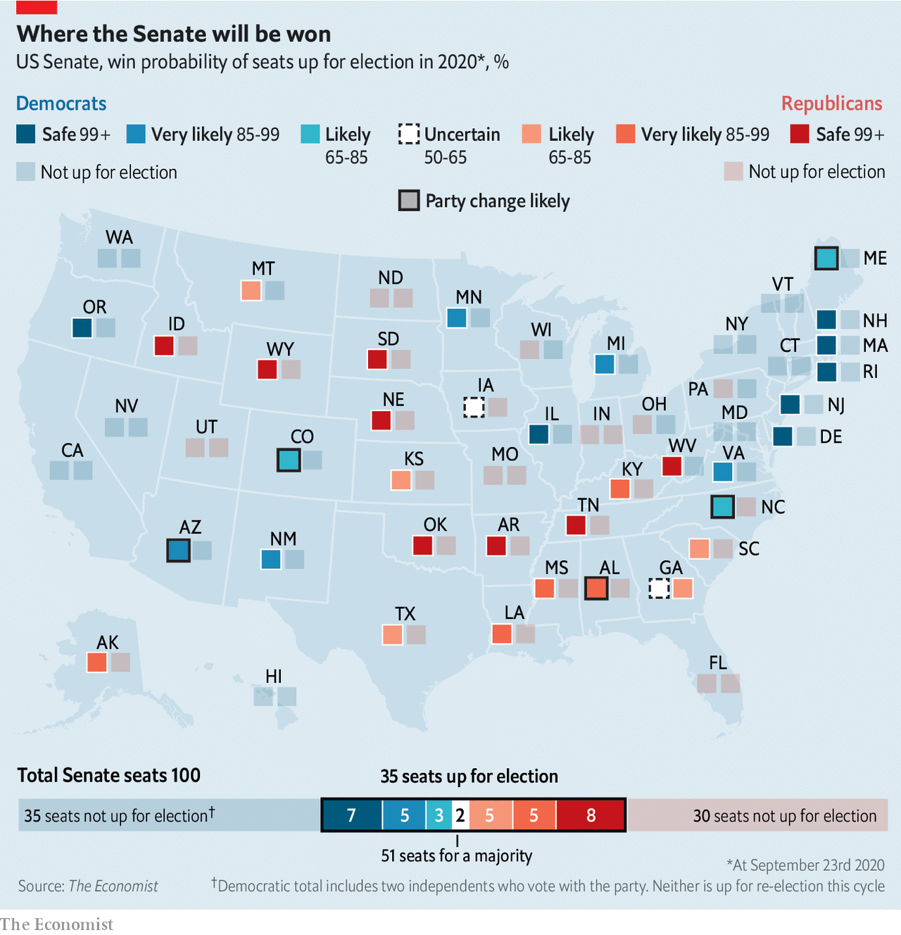

If the fight for the Senate gets less attention than it deserves, one reason may be that it is hard to analyse. There are no nationwide Senate polls. Instead there are 35 separate contests, in different states with different candidates (the other 65 seats are not up for election this year). Some races are polled often; others not at all. Even the rules can vary: Louisiana and Georgia use a two-round system with a run-off; Maine recently adopted ranked-choice voting.

To sort through these complexities, we have built a [statistical model](https://projects.economist.com/us-2020-forecast/senate) to estimate the probabilities of each party controlling the Senate (as well as the House of Representatives, which the Democrats already hold). It currently gives the Democrats a 67% chance of flipping the Senate. That probability is lower than the 86% our corresponding model gives Mr Biden of winning the presidency, but higher than conventional wisdom last year held about Senate Democrats’ odds. Our forecast will be updated on our website every day until the election as new data arrive.

## When you assume

Like all quantitative forecasts, our model is only as good as its assumptions. Above all, it relies on the expectation that the statistical relationships that have best predicted legislative election results in the past will persist more or less unchanged. Because none of the races on which the model was trained occurred during a pandemic, this foundation may prove unusually rickety in 2020. For example, the model has no idea that the share of votes cast by post is likely to soar. No one knows which side will benefit from such shifts, but they inject new, unquantifiable uncertainty into the race.

With this caveat, the rich data on Congressional races—nearly 18,000 elections have been held since 1945—permit statisticians to reach fairly sturdy conclusions about voters’ behaviour in legislative contests. Our model uses a wide range of indicators, including national, state and congressional-district polling; the voting histories of each state and district; candidates’ experience in elective office, ideological positioning, incumbency, fundraising and involvement in scandals; the president’s approval rating; the results of special elections held to fill legislative vacancies across the country; and more (see article for a step-by-step example of how this works). When applied to past races, its average forecast made on election day would have missed the correct result by two seats in the Senate, and eight in the 435-member House.

The model’s average expectation is that the Democrats will gain eight seats in the House. Two flips are virtually assured, thanks to a court-ordered redistricting in North Carolina. Others are likely to come from a list of a few dozen vulnerable seats, mostly in suburbs or with lots of college-educated white voters, in which Republicans either barely survived in 2018, face stronger challengers than they did that year, or saw a popular incumbent retire.

The Republicans have a much less promising group of targets. The overall environment this year is shaping up to be nearly as good for Democrats as the mid-terms of 2018 were, and many Democratic freshmen who toppled Republican incumbents now enjoy some benefits of incumbency themselves. The model does make Michelle Fischbach, formerly the lieutenant-governor of Minnesota and president of its state Senate, a heavy favourite to beat a Democratic incumbent in the state’s rural seventh district, which voted for Donald Trump by 31 points in 2016. Overall, however, it gives Republicans just a 1-2% chance of wresting back the House.

## The core four

The Senate, in contrast, rests on a knife- edge. With 47 seats, the Democrats need three more to secure control if Mr Biden wins the presidency, or four if he does not. Because one Democratic incumbent, Doug Jones of blood-red Alabama, is likely to lose—he won his seat in 2017 against an opponent accused of sexually assaulting teenagers—the party probably needs at least four flips, on top of a Biden victory.

Democrats are clear favourites in two seats. In Arizona, Martha McSally, who lost a close Senate race in 2018, wound up in the chamber anyway after she was appointed to fill a vacant seat. She now faces Mark Kelly, a former astronaut married to Gabby Giffords, who served in the House until she was shot in the head by a lunatic in 2011 (and miraculously survived). Mr Kelly has raised a whopping $45m, and leads in the polls by around eight percentage points. Arizona still leans slightly Republican, but autumn polling leads as robust as Mr Kelly’s rarely vanish entirely. Our model gives him a 90% chance of winning.

The Democrats’ other relatively easy flip is in Colorado, which is fast becoming a Democratic state. Their candidate, John Hickenlooper, is a centrist former governor. Colorado has been polled far less than Arizona has, and Mr Hickenlooper’s campaign has been surprisingly shaky. But he appears to lead the incumbent, Cory Gardner, by seven points. The model sees Mr Hickenlooper as an 80-20 favourite.

After these two, the Democrats’ road gets tougher. Their next-best bet appears to be in North Carolina. Mr Biden is clinging to a bare one- or two-point lead there, but the picture in the Senate is different: Cal Cunningham, a former state legislator, soldier and businessman, is polling well ahead of Mr Biden and leads Thom Tillis, a rather unloved Republican incumbent, by six points. Given how closely tied votes for the presidency and Senate have become—in 2016, for the first time since senators became elected by popular vote a century ago, every state with a Senate race voted for the same party for both branches of government—it would be surprising if Mr Tillis finishes that far behind Mr Trump. But this pattern has appeared in enough surveys from enough pollsters that our model, for the moment, makes Mr Cunningham a clear favourite. If the polls do move towards Mr Tillis, the model should boost his odds quickly.

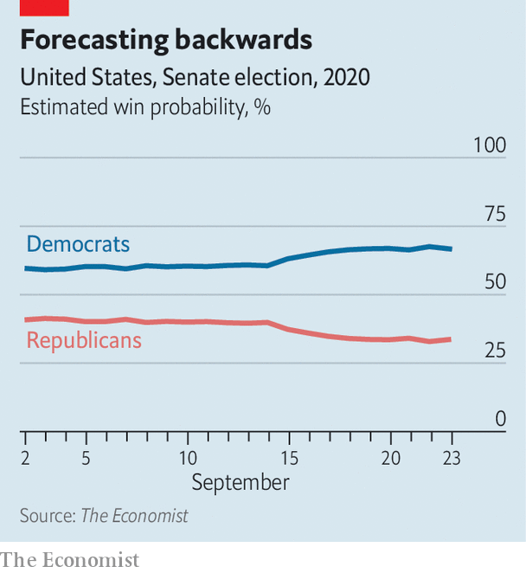

The final state where the model favours a Democratic challenger is Maine. Susan Collins, the incumbent, is the Senate’s most moderate Republican, and in 2014 voters returned her to office by a 37-point margin. However, her vote to confirm Brett Kavanaugh, a conservative judge, to the Supreme Court seems to have alerted Maine’s somewhat Democratic-leaning electorate to the fact that even a centrist Republican is still a Republican. Her challenger, Sara Gideon, is the speaker of the Maine House of Representatives and a formidable fund-raiser. A big reason that our Senate forecast has inched towards the Democrats recently is a flurry of polls giving Ms Gideon a high-single-digit lead. It now thinks her chances of winning the seat are around 70%.

If the Democrats’ path to a majority ended in Maine, they would still be far from certain to regain Senate control. However, the key to their fairly strong position is their “long tail”: an extensive list of races where they are more likely than not to lose, but have a solid chance at an upset. This list starts with Iowa, where Mr Biden and Mr Trump are running neck-and-neck. A recent survey by Ann Selzer, the state’s most prominent pollster, gave the Democrats’ Theresa Greenfield a three-point edge over Joni Ernst, the Republican incumbent.

Democrats are also nearly tied in polls in the two Georgia seats up for election, and, surprisingly, in the far redder states of South Carolina, Kansas and Montana—though their candidate in Montana is Steve Bullock, a popular sitting governor, making his strength a bit more predictable. Democrats also have an outside shot in little-watched races in Alaska and Texas—though probably not in Kentucky, where the model heavily favours Mr McConnell.

Just as in presidential elections, the results of Senate elections are correlated across states. For example, in scenarios where Republicans fend off a Democratic challenge in Montana, they are also more likely to hold on to their seats in Maine and Mississippi. However, each Senate race features a unique set of candidates, running on a distinctive set of local issues. As a result, knowing the result of one Senate election is only moderately useful in predicting the result of another. In 2018 Democratic incumbents in North Dakota, Missouri, Indiana and perennially close Florida were defeated, whereas those in Montana and West Virginia—the most Republican of the group at the presidential level—survived. Two years earlier, on the same night that rural white voters in northern states delivered the presidency to Mr Trump, Democrats managed to flip a Republican-held Senate seat in rural, white New Hampshire.

This partial independence of Senate races from national trends is the main reason why our model gives the Democrats a narrow edge. Even one upset among these eight would make up for a disappointment in Maine or North Carolina; two would all but assure them a majority. And because these states are so varied—Alaska and Montana are western frontier states with an independent streak, Iowa and Kansas are midwestern farming territory, and Georgia and South Carolina are racially polarised states in the South—Republicans would struggle to weather a defection from even one region or demographic group.

Whereas the Senate map in the mid-term elections of 2018 favoured the Republicans, this year’s battles are being fought almost entirely on their terrain. Individually, each of these races should cause the party few headaches. As a group, however, they represent a dire threat. ■

Dig deeper:  
Read the [best of our 2020 campaign coverage](https://www.economist.com/us-election-2020) and explore our [election forecasts](https://projects.economist.com/us-2020-forecast/president), then sign up for Checks and Balance, our [weekly newsletter](https://www.economist.com/checksandbalance/) and [podcast](https://play.acast.com/podcasts/2020/01/24/checks-and-balance-our-new-weekly-podcast-on-american-politics) on American politics.

This article was downloaded by calibre from <https://www.economist.com/united-states/2020/09/23/why-the-democrats-are-our-narrow-favourites-to-win-the-senate>

|  |  |  |  |
| --- | --- | --- | --- |
|  | Articles | Sections | Next |

|  |  |  |  |
| --- | --- | --- | --- |
| Previous | Articles | Sections | Next |

#### From RBG to ACB

# What does Amy Coney Barrett think?

A look at the record of the woman who is likely to be on America’s Supreme Court soon

Sep 26th 2020 | NEW YORK

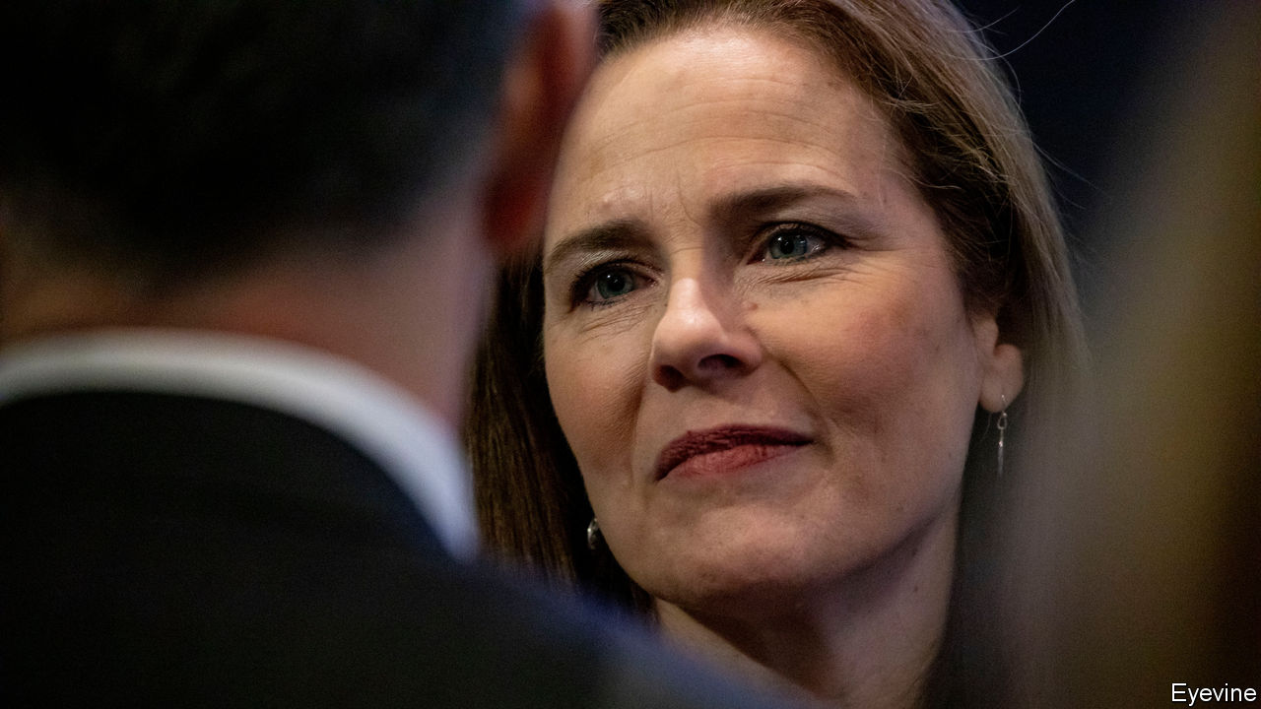

SPEAKING ON FOX NEWS, Lindsey Graham, a Republican senator from South Carolina, conveyed the state of the battle to fill the Supreme Court seat of the late Ruth Bader Ginsburg: “We’ve got the votes to confirm Justice Ginsburg’s replacement before the election,” he said. “That’s what’s coming.” Mr Graham had promised in 2016 to await election results if a Supreme Court vacancy opened in 2020, telling Democratic colleagues, “I want you to use my words against me.” He has now abandoned that pledge. Thanks to his about-face and similar changes of heart from Republican colleagues, Mr Graham’s prediction of a quick vote to confirm a third Trump appointee seems highly likely to come true.

Donald Trump has narrowed his search to five women from the 40-odd candidates on his recently bolstered roster of potential picks. He says he will announce his choice on September 26th. The front-runner—the only candidate Mr Trump has met this week—is Amy Coney Barrett, aged 48, a judge he installed on the Seventh Circuit Court of Appeals in 2017. In contrast to the president’s first two picks, Neil Gorsuch and Brett Kavanaugh, Ms Barrett does not come from an Ivy League university. She attended Rhodes College and got her law degree at Notre Dame, where she taught for 15 years before donning her robe at the appeals court based in Chicago.

Harvard or Yale may not grace her résumé, but Ms Barrett has earned a spate of academic accolades, from Phi Beta Kappa in college (an honorary society for high- achieving students) to summa cum laude honours and a law-review editorship at Notre Dame. She had two impressive judicial clerkships, one under Justice Antonin Scalia. She enjoys the support of an ideologically diverse array of former students and faculty at Notre Dame. She is telegenic—a priority for the president.

Ms Barrett also has a long paper trail, notably her writing on the balance between upholding the law and personal faith. In a typical confirmation hearing—where senators solidify their votes only after listening to the nominee—that might be a liability. But with most openly lining up in the “yea” or “nay” column before questions begin, those writings will probably represent only minor speed bumps.

In 1998 Ms Barrett co-wrote “Catholic Judges in Capital Cases”, a look into “whether judges are sometimes legally disqualified from hearing cases that their consciences would let them decide”. The question is profound. Ms Barrett is a devout Catholic with ties to the People of Praise, a charismatic community teaching that husbands have authority over their wives. Several Democratic senators worried during her 2017 hearing that this religious conviction may not mix well with service on the bench; Dianne Feinstein of California observed that “the dogma lives loudly within you”. That comment flopped, as Ms Feinstein seemed to be criticising the nominee’s deeply held beliefs.

Ms Barrett’s 1998 article contains a rejoinder, that it is “inconsistent” with the constitution’s bar on a “religious test” for office “to suggest that Catholics, simply by virtue of being Catholics, are disqualified from serving as judges”. Responsible Catholics must consider the dissonance between law and their faith “seriously”, she wrote, and should not “align” the legal system with “the Church’s moral teaching”. In their private lives, however, they should “conform their own behaviour to the Church’s standard”. Does that simply means Catholic judges should not have abortions, carry out executions or practise euthanasia themselves? This is an area Democrats will seek to clarify.

The status of abortion rights is a central concern for both American liberals and conservatives. Ms Barrett will frighten the former and delight the latter with her position that abortion is “always immoral”. She said repeatedly in her 2017 hearing that as a circuit-court judge she would be bound to “faithfully apply all Supreme Court precedent”—including Roe v Wade, the 1973 decision recognising a constitutional right to abortion. Were she to ascend to Justice Ginsburg’s old seat, however, Ms Barrett would be empowered to reconsider Roe and other long-standing precedents. Josh Hawley, a strongly pro-life Republican senator from Missouri, is satisfied that Ms Barrett will vote to overturn Roe once she has the opportunity—a requirement, he insists, if a nominee is to earn his support. Ms Barrett “clearly meets that threshold that I’ve talked about”, Mr Hawley said on September 21st. That may mobilise Mr Trump’s evangelical supporters but scare off moderate voters—particularly women.

The speed with which Mr Trump is proceeding is a sign he would like to get a nominee confirmed in time for the election. He supplied a reason for that on September 21st. “We should act quickly”, he said, “because we’re going to have probably election things involved here, because of the fake ballots they’ll be sending out, which is terrible.” The president seems to believe that if he does not score a clear victory in November, having a third justice in place will be key to the success of his plan B: litigating his way to a second term.■

Dig deeper:  
Read the [best of our 2020 campaign coverage](https://www.economist.com/us-election-2020) and explore our [election forecasts](https://projects.economist.com/us-2020-forecast/president), then sign up for Checks and Balance, our [weekly newsletter](https://www.economist.com/checksandbalance/) and [podcast](https://play.acast.com/podcasts/2020/01/24/checks-and-balance-our-new-weekly-podcast-on-american-politics) on American politics.

This article was downloaded by calibre from <https://www.economist.com/united-states/2020/09/26/what-does-amy-coney-barrett-think>

|  |  |  |  |
| --- | --- | --- | --- |
| Previous | Articles | Sections | Next |

|  |  |  |  |
| --- | --- | --- | --- |
| Previous | Articles | Sections | Next |

#### Signs of the times

# Democrats are doing less badly among rural voters

Our polling suggests a bigger swing towards Joe Biden in rural America than in the suburbs

Sep 26th 2020 | CRESCO, IOWA

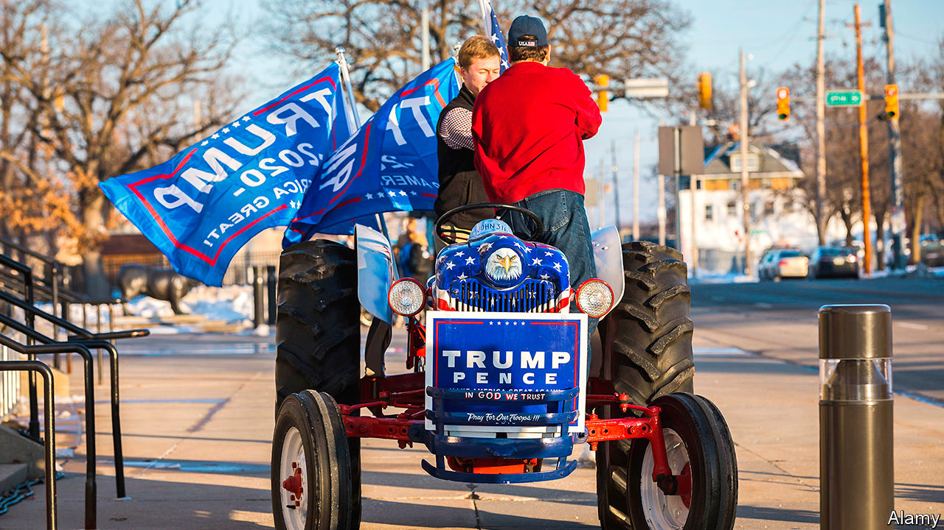

TWO MEN chuckle while hammering metal posts beside a road in Cresco, a sleepy town in northern Iowa. These will support the 70th Trump-Pence door-sized “barn sign” they have put up in Howard County in past weeks. Already they have erected ten times more signs and flags than four years ago, says Neil Shaffer, Republican county chairman, as he twists a plastic tag. He was tickled recently by one that derided the Democratic candidate, Joe Biden. Its slogan was “Vote No on Creepy Joe”. He laughed so much, he recalls, he had to pull off the road.

Mirth is needed, he says, because “the way politics are, it’s so mean-spirited now”. As a Republican activist since 1986, he sees the current “violent…nastiness” as worse than ever. Some signs have been defaced with orange paint. Many voters, he believes, are scared to admit—including to pollsters—that they back Donald Trump. They fear “bullies from the left, who are very closed-minded”. His friend, John Gehling, sees “voter hatred; they hate Trump so much”. Someone recently fed his dog rat poison, he says. He reckons the attack was to do with the election.

A short drive away, in a house in Riceville, a dozen face-masked Democratic activists swap strikingly similar tales. Laura Hubka, the Democratic county chair, has been in the area for 25 years. Never before was it this “nerve-racking, horrible”, she says, even when somebody shot at her own dog. A passing driver recently screamed that she was a “fucking idiot” as she distributed Biden signs. Those, too, have been stolen and defaced. Last week she told police about an abusive, racist message from a local man who, disliking her politics, wrote of the future rape of a family member. “Even in 2016 it wasn’t this nasty. It has definitely turned into a hateful place.”

Jane Podgorniak, a local candidate for the Iowa House, speaking as a dachshund in the garage nips her ankles, says her husband called the sheriff this month when someone drove to their rural house and shot at a cluster of Democratic signs outside it. “We’ve had people flip us off and scream at us. Never, ever would you have seen that behaviour before,” she says.

Whatever happened to midwestern nice? Many locals blame nastiness online for infecting once cordial real-world relations. Democrats finger Mr Trump’s divisive style. A shop owner says “Trump-or-die” supporters post vile and anti-science messages online, or race about in noisy pickup trucks while blaring support for the president. Karry, a Trump supporter sipping coffee in Sue-Z-Q’s diner in Cresco, says “Division is fuelled by the left; it’s always about ‘racism’.” Republicans say Democrats are somehow imposing “coastal culture” on the heartland.

The stakes feel high in Howard County, which is populated by older, white, religious, non-college-educated and often disaffected voters, including many independents. This is the sort of place where diversity means people are descended from both Norwegians and Germans. It voted overwhelmingly for Barack Obama in 2008 and 2012, before a huge swing of over 41 points to Mr Trump last time. Mr Shaffer expects another big victory “over 60%”. Ms Hubka more modestly hopes to contain her side’s loss. If Democrats limit rural pain but stir enthusiasm in cities, notably Des Moines, Mr Biden might eke out a statewide victory, as Mr Obama twice did. The Senate race is even more promising for them: polls suggest it is tied.

Democrats can take heart from polling that shows rural voters everywhere have cooled a bit on Mr Trump. He still has a 14-point lead in rural places, but that is well short of his 22-point advantage four years ago. Commentators seem not to have noticed that Mr Biden has so far gained a bigger swing in rural places than he has in the suburbs. Polling by YouGov for The Economist also shows he is doing better than Hillary Clinton managed among the elderly. And among non-college-educated whites Mr Biden has managed a ten-point gain over Mrs Clinton. Even if barn signs in Howard County don’t all point the Democrat’s way, those are decent numbers.■

Dig deeper:  
Read the [best of our 2020 campaign coverage](https://www.economist.com/us-election-2020) and explore our [election forecasts](https://projects.economist.com/us-2020-forecast/president), then sign up for Checks and Balance, our [weekly newsletter](https://www.economist.com/checksandbalance/) and [podcast](https://play.acast.com/podcasts/2020/01/24/checks-and-balance-our-new-weekly-podcast-on-american-politics) on American politics.

This article was downloaded by calibre from <https://www.economist.com/united-states/2020/09/26/democrats-are-doing-less-badly-among-rural-voters>

|  |  |  |  |
| --- | --- | --- | --- |
| Previous | Articles | Sections | Next |

|  |  |  |  |
| --- | --- | --- | --- |
| Previous | Articles | Sections | Next |

#### AI, captain

# China now has the world’s largest fleet, alarming its Pacific rival

America’s navy secretary announces a high-tech plan to secure parity

Sep 26th 2020 |



A SLEEK GREY trimaran that cuts through the water at 27 knots, the Sea Hunter is capable of sailing from San Diego to Tokyo, and back again, on a single tank of diesel—all by itself. The ship is an “autonomous unmanned surface vehicle”—a fancy name for a sailing drone—operated by America’s navy. The air conditioning on board is for the benefit of computers, rather than humans. The design pays little heed to human comfort. “I’m on a ship that looks like a Klingon bird of prey,” remarked an official when visiting the ship in 2016. Earlier this month the Sea Hunter spent time with the USS Russell, a more traditional destroyer, practising “manned-unmanned teaming”. The idea is that such double acts are the future of naval warfare.

In a report published this month, the Pentagon acknowledged a grim milestone: China’s navy, having churned out warships like sausages, has become the world’s largest. America had held that crown since the second world war. Though America’s warships tend to be heftier than their Chinese counterparts, the total tonnage of warships launched by the PLA navy between 2015 and 2019 exceeded that of America over the same period by almost half, estimates Thomas Shugart, a former submarine officer (see chart). Mr Shugart notes that the last such dramatic and rapid naval build-up was Ronald Reagan’s drive for a 600-ship navy in the 1980s.

In a speech on September 16th, Mark Esper, America’s defence secretary, explained how he intended to solve the problem. The starting point was more ships, if not quite as many as Reagan envisaged. America now has 296. Mr Esper promised to expand the fleet to more than 355 (a figure mandated by Congress, and five more than China’s current tally). As a statement of intent, he pointed to the fact that in April the navy granted a $795m contract for the first in a new class of frigate (“It’s like a yacht with missiles on it,” was Donald Trump’s assessment), with the option to buy nine more for a total of $5.6bn. That was its first major new shipbuilding programme in more than a decade.

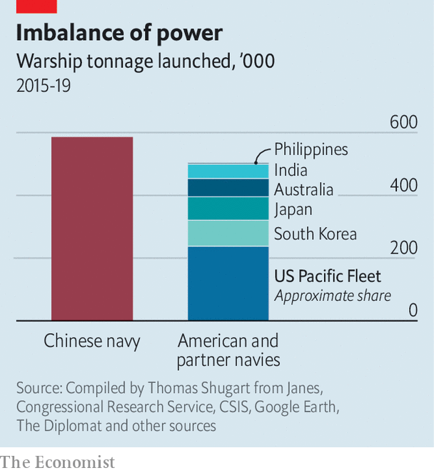

But fleet size is not everything. Though there would be more ships, said Mr Esper, they would have to be smaller and nimbler. The fleet would have to grow more “distributed”, in other words capable of spreading out more widely to survive China’s plenteous missiles, and attacking from a greater variety of positions. And the very nature of the ships would have to change. In the past, America’s shipbuilding targets have featured only traditional warships—complete with sailors. Mr Esper’s goal includes unmanned vessels like the Sea Hunter.

Sailor-less ships have the advantage of being smaller (and so harder to spot on radar), and cheaper to build and operate. They are also what military types call “attritable”, which means that in a war they could be sunk in large numbers without the backlash that would follow heavy human casualties. In its most recent budget request to Congress, America’s navy asked for around $580m for developing several varieties of unmanned (and “optionally manned”) ships.

Mr Esper said that unmanned ships would “perform a variety of warfighting functions”, including supplying other ships and laying mines, but also “delivering lethal fires”. That is controversial. An armed unmanned ship must be either remote-controlled, and therefore vulnerable to having its communications jammed, or entrusted with the authority to make life-and-death decisions on its own.

Some question whether this goes far enough. Mark Montgomery, a retired rear-admiral, points out that for all the talk of autonomous platforms, the navy’s next carrier-based fighter jet, the F/A-XX, which the navy will not start building until the 2030s, will continue to have a pilot. That bulks up its design and shortens its range (or reduces its payload). At present, less than 2% of navy aircraft are unmanned.

The other problem is money. In his prepared remarks, Mr Esper said that the shipbuilding budget would have to grow from 11% of the navy’s spending to 13%, “the same levels…committed during the Reagan era”. Perhaps in a fit of fiscal sobriety, those numbers were struck from the final speech because, the Pentagon explained, a decision had not yet been reached. Once built, just running a 355-ship navy would cost tens of billions of dollars more per year.

Congress is reluctant to provide fresh funds until the navy proves the utility of unmanned platforms. The new plans would therefore require raiding other bits of the navy’s budget, at a time when crewing ships is already hard. “If this administration survives,” tweets Bryan McGrath, a naval expert, “there will be no money to operate this fantasy fleet.”■

This article was downloaded by calibre from <https://www.economist.com/united-states/2020/09/26/china-now-has-the-worlds-largest-fleet-alarming-its-pacific-rival>

|  |  |  |  |
| --- | --- | --- | --- |
| Previous | Articles | Sections | Next |

|  |  |  |  |
| --- | --- | --- | --- |
| Previous | Articles | Sections | Next |

#### Courting trouble

# The knife fight over Ruth Bader Ginsburg’s replacement

Republicans may come to miss the norms they are breaking in the Senate

Sep 26th 2020 |

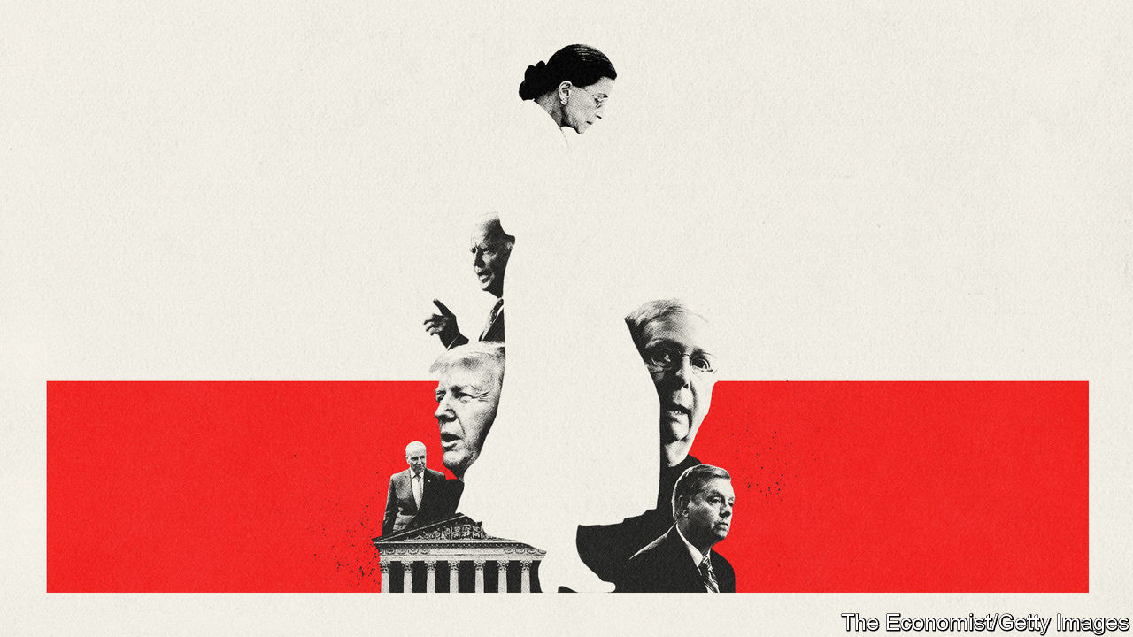

THE PARTIES to a civil war almost never agree on why it began—and the parties to America’s decades-old fight for control of the Supreme Court are no different.

For Republicans, the cause of the conflict is a Democratic Party that has tried to block conservative justices, starting with Robert Bork’s failed nomination in 1987, by underhand means. In attacking Bork’s opposition to civil-rights legislation, Ted Kennedy abandoned a bipartisan tradition of assessing judicial nominees on their qualifications, not their values; in airing allegations of sexual abuse against Clarence Thomas in 1991, Democrats allegedly took that a step further; ditto in the sorry case of Brett Kavanaugh in 2018.

Democrats consider this self-serving nonsense. They note that they supported Ronald Reagan’s alternative to Bork, Anthony Kennedy; and that their efforts to block Justices Thomas and Kavanaugh were unsuccessful. The median justice on the court has grown more conservative in recent decades—suggesting that if the Democrats are trying to sabotage its conservative drift, they are failing. They believe Republicans’ grievances are fuelled by undimmed rage at the court’s consequential liberal lean in the 1960s, and a related ambition to turn back the clock.

These positions have long been entrenched. Yet the conflict has been managed through a combination of improved geriatric medicine and partisan micromanagement of Supreme Court retirements. With only one justice dying in office between 1955 and 2016 (the conservative William Rehnquist, in 2005), the parties have generally replaced outgoing judges with like-minded successors. The death of Ruth Bader Ginsberg on September 18th, following that of Justice Antonin Scalia in 2016, has abruptly ended this phoney war.

Given his party’s fixation with the court, Mitch McConnell’s decision to push through a conservative replacement for the liberal heroine was never in doubt. Even so, the contempt for Senate norms it has necessitated on his and his Republican colleagues’ part is one for the history books. In 2016 Mr McConnell refused to hold hearings for Barack Obama’s nominee to replace Scalia, Merrick Garland, on a made-up pretext that new justices were not confirmed in an election year. This was so demonstrably untrue that even some Republicans seemed discomforted by it.

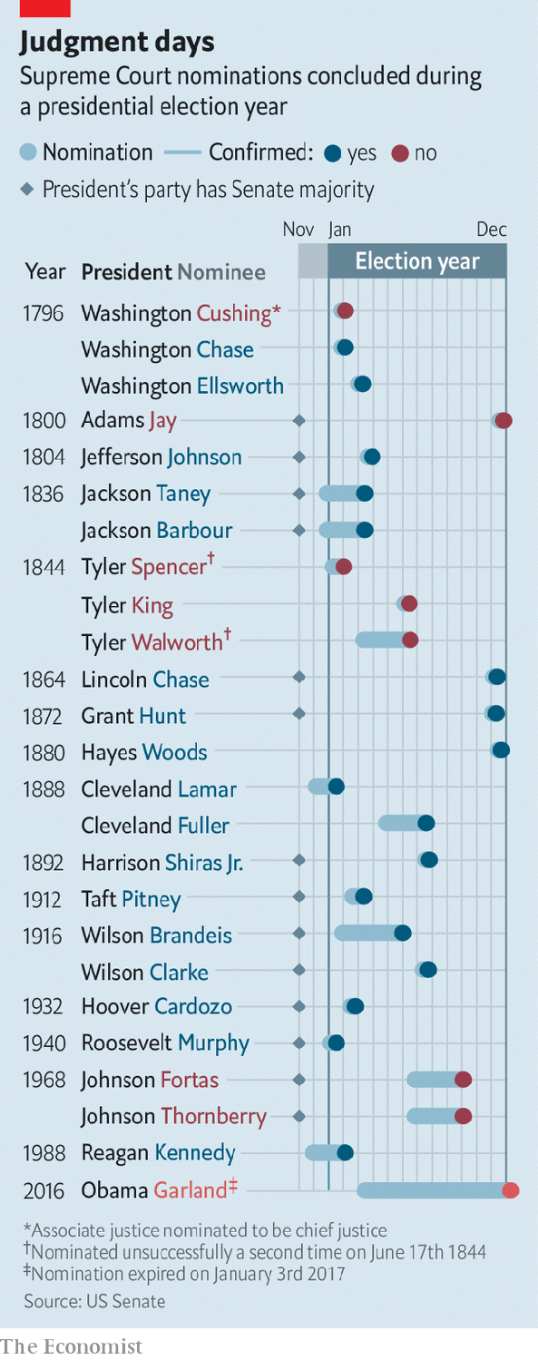

Lindsey Graham of South Carolina, a sometime bipartisan moderate, felt compelled to insist that Republicans would honour the same precedent in the unlikely event that a justice died in the last year of Mr Trump’s term. Chuck Grassley of Iowa said the same. Mr McConnell’s latest breach of fair play has therefore occasioned a rippling cascade of bad faith. For his part, Mr McConnell claims to have identified a bogus exception to his bogus precedent. When the Senate and presidency are held by the same party, he says his 2016 rule does not apply. (The most recent election-year confirmation, of a conservative judge by a Democratic Senate, points to the nonsense of that.)

Mr Graham, chairman of the Senate Judiciary Committee, meanwhile claims the Democrats invalidated his pledge by being beastly to Justice Kavanaugh. Mr McConnell needs the votes of 50 of the 53 Republican senators to confirm Mr Trump’s nominee to replace Justice Ginsberg, and at the time of writing only Susan Collins of Maine seemed certain to deny him hers. Lisa Murkowski of Alaska vowed to do likewise, then appeared to back down. A gathering of Republican senators over lunch this week appeared to leave only the fine-print of Mr McConnell’s strategy to be worked out.

Most Republican senators are keen to push ahead with the confirmation before the November election—including, as a sign of how reliant the Republican Party has become on base-rallying, those such as Thom Tillis of North Carolina facing stiff re-election fights. A handful of others believe there may be electoral advantage in waiting until after the poll. Yet even if the Republicans lose control of the Senate and White House in that scenario, they still plan to confirm Mr Trump’s third Supreme Court justice. So the court will almost certainly soon have a 6:3 conservative majority. And given that Justice Ginsberg was one of its most liberal members and her expected successor, Amy Coney Barrett, would be one of its most conservative, it will probably be jolted to the right.

Democrats appear stunned. A few days ago they were looking forward to a possible sweep of the White House and Congress, and thereby an opportunity to reverse the damage done by Mr Trump to Mr Obama’s legacy and to the country’s governing institutions. Now they are contemplating the possibility of Obamacare being eviscerated by hostile conservative judges (Ms Barrett is not a fan of Mr Obama’s health-care reform) when it appears before the Supreme Court after the election.

Any future Democratic rule or law could also fall victim to such a court. And even if the justices refrain from activism, the court is in danger of losing the vestige of bipartisan public trust it has hitherto retained. The Senate, which has already lost its vestige, is meanwhile likely to be rendered even more dysfunctional by the bad blood Mr McConnell is generating. “The potential damage to the Senate, the damage to how the parties see each other, to the institution of the court is real,” said Senator Chris Coons, an influential Democrat on Mr Graham’s committee.

While moderate Democrats such as Mr Coons still dread that possible scenario, their Republican counterparts seem to have concluded that the time for norm-respecting niceties has passed. Mr McConnell’s strategy permits no other conclusion. So does the fact that his supporters invariably present his abandonment of Senate tradition as a defence against the even worse abuses they claim the Democrats are plotting. No matter what Mr McConnell does, they suggest the Democrats are about to pack the Supreme Court with liberal judges; if that is right, his theft of the odd Supreme Court seat might seem defensive and proportionate. Like William Howard Taft, another divisive Republican, Republican senators have convinced themselves that the malice of their opponents leaves them no alternative but to “do anything I find myself able to do”.

In reality the alleged Democratic perfidy is not obvious. Left-wing activists and their few elected champions—including Congresswoman Alexandria Ocasio-Cortez—do advocate the structural changes Republicans fear, such as expanding the Senate and Supreme Court bench in a bid to stop conservatives accruing immense power with a minority of votes. But they are relative fringe players in the party. Joe Biden is the Democratic presidential nominee. And he and most of his rivals in the primaries (including Senator Bernie Sanders) ruled out court-packing.

Even after Mr McConnell’s latest judicial heist—and despite media speculation to the contrary—it is hard to imagine 51 Democratic senators backing such a proposal anytime soon. There is especially little appetite for it among the moderate Democrats whose influence increases as the party’s congressional numbers rise. But in the longer term, if Republicans continue down this path, Democratic forbearance will end. Emboldened by their belief that the culture and a majority of Americans are with them, Democrats will also discover their breaking-point. And the Republicans may rue what comes next.■

Dig deeper:  
Read the [best of our 2020 campaign coverage](https://www.economist.com/us-election-2020) and explore our [election forecasts](https://projects.economist.com/us-2020-forecast/president), then sign up for Checks and Balance, our [weekly newsletter](https://www.economist.com/checksandbalance/) and [podcast](https://play.acast.com/podcasts/2020/01/24/checks-and-balance-our-new-weekly-podcast-on-american-politics) on American politics.

This article was downloaded by calibre from <https://www.economist.com/united-states/2020/09/26/the-knife-fight-over-ruth-bader-ginsburgs-replacement>

|  |  |  |  |
| --- | --- | --- | --- |
| Previous | Articles | Sections | Next |

|  |  |  |  |
| --- | --- | --- | --- |
| Previous | Articles | Sections | Next |

#### Lexington

# Hope turned out black voters for Barack Obama

Will fear bring them out against his successor?

Sep 26th 2020 |

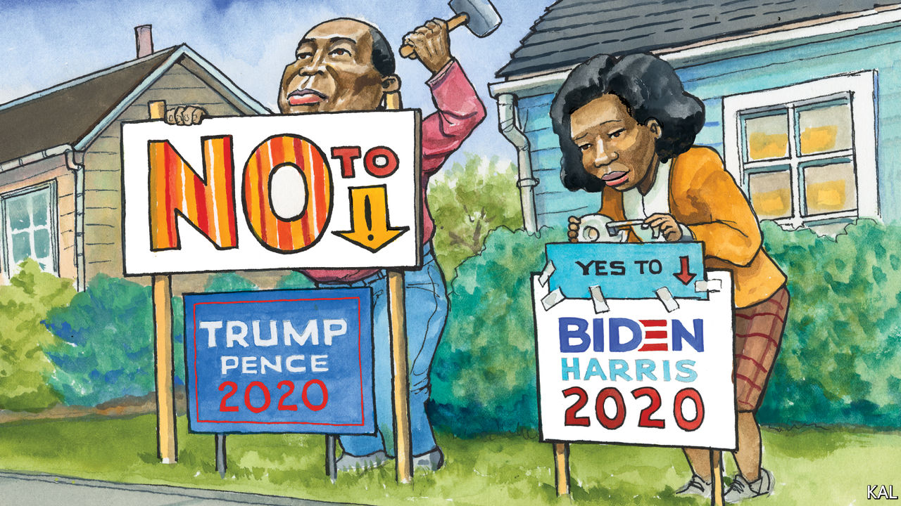

IT WAS INTERESTING to recall, while Lexington was observing some canvassing of black North Carolinians last week, that only three months previously America had been convulsed by the biggest racial-justice protests since the 1960s. On the doorsteps of poor black neighbourhoods in Greenville and the countryside east of the city, nobody raised them.

Nor did the couple of dozen voters your columnist met—at the side of masked and PPE-clad Democratic activists—mention another milestone, Joe Biden’s decision to put a black woman on the ticket. Asked for their view of Kamala Harris, most of the targeted voters, who were all black and mostly women, merely nodded politely. One praised her “professionalism”; another the fact that she seemed “strong enough to back up Joe”. Beyond such bland statements, few of the voters even mentioned Mr Biden. But all said they were especially determined to vote for the Democratic candidate this year, because of Donald Trump.

“Gotta get 45 out, that’s the only thing that matters,” said Mary Ellis, at her house in Greenville Heights, one of a row of single-storey dwellings thumping with music. “Everything I hear from him isn’t right,” said her neighbour, Magdalene Knight. “It scares me to think we’ve got a generation of young people watching his immorality,” said Ruby Perkins, a retired teacher, with a large “Thank you Jesus” sign outside her door. “That man lied to the nation about a pandemic. You’ve got to be demented to think he’s the answer.”

This should be music to Democratic ears. A huge majority of African-Americas will vote for Mr Biden, and they will do so for the main reason Democratic strategists have been inviting them to. They want the election to be a referendum on an unpopular president, not a choice between two old white men, and most of them made that determination long ago. “You could put up a flowerpot against Trump and we’d vote for the flowerpot,” said Betsy Wallace in rural Williamston, 30 miles to the north-east. Yet notwithstanding black voters’ overriding support for Mr Biden, they have recently emerged as one of his campaign’s biggest worries.

Polls point to a marginal softness in their support for Mr Biden relative to that enjoyed by Hillary Clinton. Where she won 88% of African-Americans, YouGov polling suggests 83% are committed to voting for Mr Biden. He will probably bridge the gap. Only 8% of black voters say they will vote for Mr Trump; many of the rest are undecided and most likely to plump for Mr Biden. Yet his advisers had been counting on Mr Biden to do better with black voters than Mrs Clinton. To win back the midwestern states she lost, let alone North Carolina, a state where a quarter of voters are black, he may need to do much better. And the polls are not the only things fuelling Democratic anxiety on this score.

Another is the flipside of Mr Trump’s negative appeal. The president’s offensiveness to black voters, combined with Mr Biden’s own limitations as a campaigner, have made it hard for the challenger to make a positive case for himself. “He’s got a good heart, he’s one of us,” was the most the voters in and around Greenville said for Mr Biden. This might suggest his support among African- Americans is wider than it is deep. Which in turn could suggest it will not take much to stop them turning out in the numbers he needs. And covid-19 is a lot. Alongside their loathing for the president, almost all the North Carolinians appeared terrified of the virus, which has hit black America disproportionately hard. Most spoke to the canvassers from behind a screen or a front door held slightly ajar. “I’m sorry, baby,” said Ms Ellis, of Greenville Heights, to explain why she would not step outside. “We’re scared.”

These are valid concerns, which will not be fully allayed until the returns are in. (Representative G.K. Butterfield, whose congressional district includes Greenville, said his biggest fear was of a covid-19 surge a week before the election.) Yet Lexington’s day on the trail suggested the Democrats may be worrying a bit too much.

Voting for the least bad option is not a novelty to black voters. The exuberance of their support for Barack Obama (“The most beautiful thing I’ve ever seen,” recalled Ms Perkins) was an anomaly. They generally take a starkly pragmatic view of politics. For many black voters, elections represent more a source of protection than a promise of future perfection. Their dogged support for the often-disappointing Democrats illustrates that. Republicans tend to ascribe it to leftist identity politics; it is more a defensive measure against a majority-white party that has often sought to repress their voting rights. Mr Trump, who this week randomly accused his opponents of wanting to build “projects” in the leafy suburbs, has hardened that suspicion, and thereby drawn a predictable African-American response. Asked what would get her neighbours to the polls in numbers, Ms Perkins replied: “Fear. Fear of covid. Fear of losing your job and house. Fear of being shot while watching TV in your house.” As an indicator of likely black turnout, enthusiasm for the candidate may be overrated.

## The audacity of fear

Without underestimating the covid-related uncertainties, there are also indicators that the virus could have less of a dampening effect than nervous Democrats fear. Projections from the latest survey data suggest black turnout is on course to be nine points higher than it was in 2016. All the voters canvassed insisted they would not allow the virus to stop them voting. Most said it had made them more determined to vote, and that they had already made plans to protect themselves, by voting early by mail or in person. Polls suggested black voters are 25% more likely to vote early than they were in 2016. That could make it harder to suppress their votes. “I’m voting,” said Ethel Peele, on her doorstep in Williamston. “Even if I have to get me a cab, I’m voting.”

African-American voters are facing even more formidable obstacles than usual this year. Yet they are formidable voters. Most of the evidence suggests Mr Biden can count on them. ■

Dig deeper:  
Read the [best of our 2020 campaign coverage](https://www.economist.com/us-election-2020) and explore our [election forecasts](https://projects.economist.com/us-2020-forecast/president), then sign up for Checks and Balance, our [weekly newsletter](https://www.economist.com/checksandbalance/) and [podcast](https://play.acast.com/podcasts/2020/01/24/checks-and-balance-our-new-weekly-podcast-on-american-politics) on American politics.

This article was downloaded by calibre from <https://www.economist.com/united-states/2020/09/26/hope-turned-out-black-voters-for-barack-obama>

|  |  |  |  |
| --- | --- | --- | --- |
| Previous | Articles | Sections | Next |

|  |  |  |
| --- | --- | --- |
| United States | Sections | The Americas |

Middle East & Africa

Syria: Despot of deprivation

.

Lebanon: After the blast, the bulldozers

.

Social media and war crimes: Accidental cover-up

.

Gold in Ghana: What’s the rush?

.

|  |  |  |
| --- | --- | --- |
| United States | Sections | The Americas |

|  |  |  |  |
| --- | --- | --- | --- |
|  | Articles | Sections | Next |

#### Despot of deprivation

# Victory for Bashar al-Assad has meant more suffering for his people

People are growing ever more desperate in the areas under his control

Sep 26th 2020 |

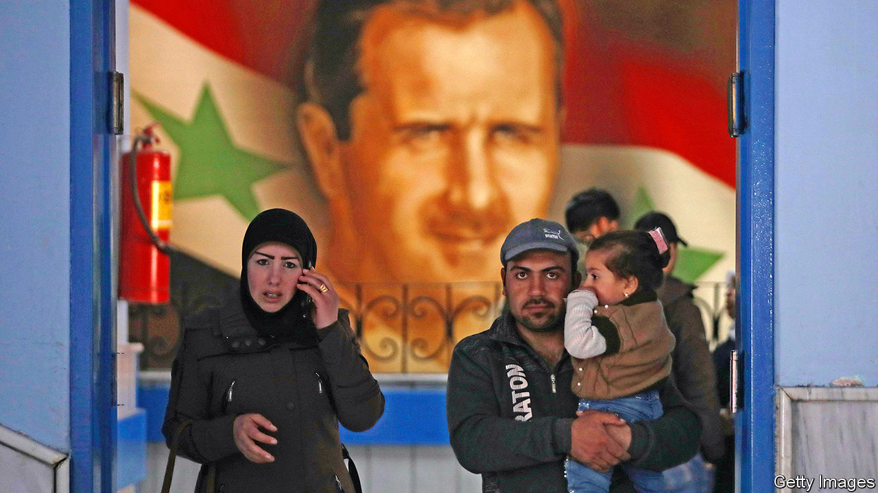

THE PRICE of food in Syria has risen so high that women boil weeds to eat. At bakeries in Damascus, the capital, men clamber over each other to get their hands on what little subsidised bread is available. Across the country, queues for petrol snake for miles. Large parts of some cities are rubble. The currency is worth so little that locals use it as cigarette paper.

This was meant to have been a year of recovery for Bashar al-Assad. After nearly a decade of civil war, Syria’s dictator has all but defeated the rebels who tried to unseat him. He hoped one last push would seal his victory and that foreign powers, seeing no alternative, would re-establish diplomatic ties and begin to pay for reconstruction.

So far, it has not worked out like that. Rebels, backed by Turkey, repelled Mr Assad’s spring offensive on their last big stronghold in Idlib province (see map). Despite President Donald Trump’s promise to withdraw, American troops remain in Syria’s oil-rich north-east, helping the Kurds consolidate their rule over the territory. American sanctions have hurt the Syrian economy; a financial crisis in neighbouring Lebanon adds to the pain. Then there is covid-19, which is hitting Syria hard. Humanitarian conditions in regime-held territory are worse now than at the height of the war, says the UN.

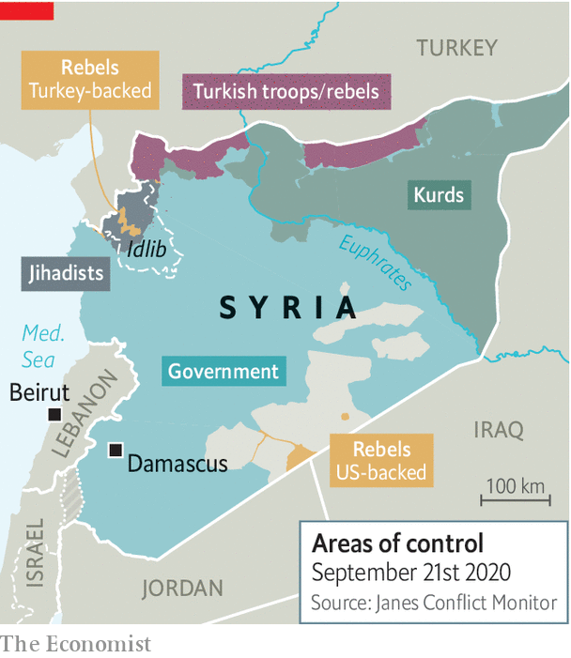

The war had already hollowed out the economy. Syria now produces 60,000 barrels of oil a day, a sixth of its pre-war output. Last year’s wheat crop was half as big as the pre-war average. Syrians have long parked their money in Lebanese banks, but last year those banks limited withdrawals, leaving everyone short of hard currency. Partly as a result, the Syrian pound has lost over 70% of its value against the dollar this year alone. Prices of staple goods have soared. Meanwhile, the regime has cut handouts and subsidies. To protect its own banks, Syria’s government has frozen loans and banned dollar transactions as well as limiting withdrawals.

Covid-19 is exacerbating the economic pain. Some 60% of Syrian businesses have temporarily or permanently closed because of the pandemic, says the UN. The regime locked down the country in March, but the restrictions were quickly ignored by desperate citizens. Now the cost, in terms of health, is becoming clearer.

The regime has tried to hide the scale of the outbreak. Its goons order doctors to blame pneumonia, not covid-19, for deaths. Officially fewer than 200 Syrians have died from the disease. But the number is surely much higher. “We do know that community transmission is widespread, as almost 90% of newly confirmed cases cannot be traced to a known source,” says Mark Lowcock, the UN’s emergency-relief co-ordinator. The death toll in Damascus could be 80 times the official tally, according to a study led by scientists at Imperial College London. Nearly 40% of people there may already have caught the virus. Only the well-connected get hospital beds. Doctors go around with oxygen canisters offering the sick relief.

Countries that in the past came to Syria’s aid can’t, or won’t. Iran, which backs Mr Assad, is under sanctions itself and cannot afford to offer much economic help. The dictator’s other big ally, Russia, is also under sanctions. It could do more, say Syrians, but President Vladimir Putin seems to relish the leverage that Syria’s desperation gives him. Earlier this month his foreign minister, Sergei Lavrov, visited Damascus, seeking new energy and construction contracts. “Our saviours have become vultures,” says a Syrian businessman loyal to the regime. America and Europe send money for things like food and medicine, but they refuse to fund reconstruction—at least until a political settlement is reached.

Mr Trump has piled sanctions on Syria, hoping to push Mr Assad towards a settlement that might, eventually, end his time in power. Restrictions imposed in June targeted foreign-currency transactions, including the remittances on which many Syrians depend. They also ended the regime’s hope of moving its banking operations from Beirut to Dubai. European states have applied their own sanctions on Mr Assad’s family and henchmen. Some are also trying to hold the regime accountable for its atrocities. German judges are hearing evidence in the trial of two Syrian officials accused of torture. The Netherlands has threatened to launch a case against the regime for war crimes at the International Court of Justice in The Hague.

Yet the regime is growing more predatory. It has already fleeced those who opposed it. Now it is preying on the businessmen and farmers who supported it. Customs officers and militiamen reportedly impound trucks and confiscate goods, then demand hefty bribes for their return. To collect taxes the state uses generals and warlords, who take a cut. Frontmen for the regime are buying real estate and businesses at a discount from an impoverished middle class. “Assad is seizing ever more of the economy for himself,” says an analyst who often visits Damascus.

Loyalists wonder about the future. “I’m no longer sure he’ll survive,” says a Syrian businessman of Mr Assad. Others dream of far-fetched schemes that might lift Syria out of the vortex. If Mr Assad could bury the hatchet with Turkey’s president, Recep Tayyip Erdogan, Turkish construction firms could come back and rebuild Syria, says a regime insider. Another dreams of wooing America by engaging with Israel, which has conducted hundreds of air strikes on Iranian targets in Syria.

Mr Assad, though, seems uninterested in diplomacy. “His position has not changed from day one,” says a family friend. After two decades in power, his regime has proven remarkably resilient. Loyalists and civil servants have nowhere else to go for a pay cheque. The secret police snuffs out the odd protest, while the army keeps up the pressure on Idlib. Mr Assad’s seven-year term ends next summer, when he is planning another sham election. He and his wife, Asma, are said to be grooming their 18-year-old son, Hafez, to take over one day. For the Assads, remaining in power is victory enough. ■

This article was downloaded by calibre from <https://www.economist.com/middle-east-and-africa/2020/09/26/victory-for-bashar-al-assad-has-meant-more-suffering-for-his-people>

|  |  |  |  |
| --- | --- | --- | --- |
|  | Articles | Sections | Next |

|  |  |  |  |
| --- | --- | --- | --- |
| Previous | Articles | Sections | Next |

#### After the blast, the bulldozers

# Will the architectural heritage of Beirut survive the explosion?

Residents fear history is repeating itself

Sep 26th 2020 | BEIRUT

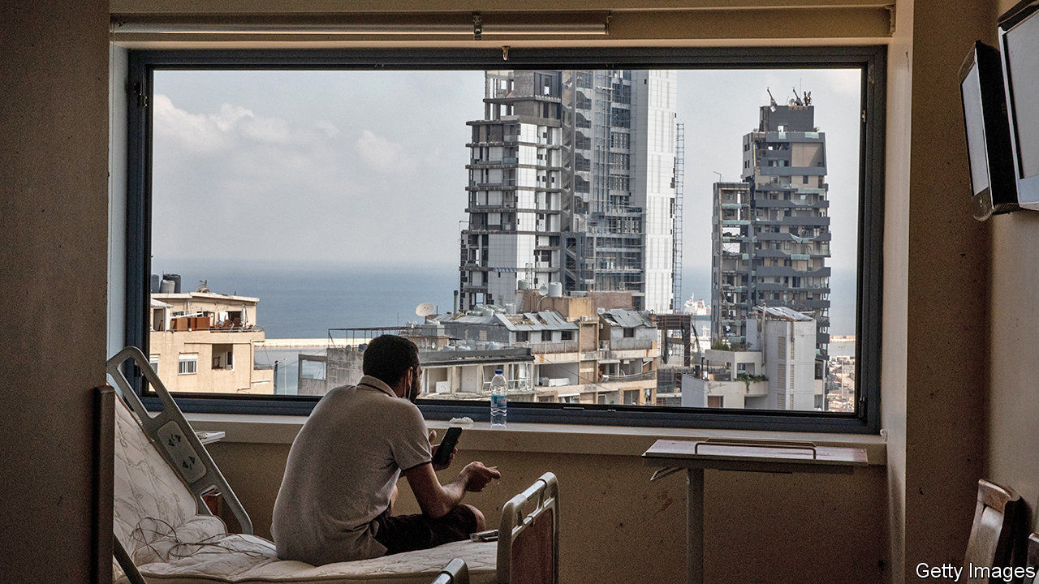

THE RUBBLE had not even been cleared when the speculators started to descend. They visited the Ghoulam family twice, offering to buy a shattered home on one of Beirut’s most famous streets. They called one man for days before he finally stopped answering. When the direct approach failed, some tried subterfuge: unnamed visitors whispered to owners that their homes were structurally unsound and should be demolished.

Two months have passed since the massive explosion at Beirut’s port on August 4th, which killed almost 200 people. Much of the city centre is still a wreck, with buildings blown open to the elements and debris heaped on balconies. The army has surveyed more than 85,000 homes and businesses ruined by the blast. The damage to housing alone could cost $2.8bn-$3.4bn, estimates the World Bank.

As the city rebuilds, many Lebanese worry about what will emerge from the rubble. Decades of runaway development have spoiled Beirut’s natural and architectural beauty. The Mediterranean coast was gobbled up by developers, leaving residents without access to public beaches. Stately old homes were bulldozed to make room for unsightly apartment blocks.

Still, the city’s old charm endured in a few neighbourhoods. In Gemmayzeh and Mar Mikhael, Ottoman-era homes with their iconic triple-arched façades were renovated into hipster bars and art galleries. In Karantina, a neglected district by the port, some became shops and churches. Then came the explosion. It damaged 640 historic buildings, says UNESCO, the cultural arm of the United Nations. As developers circle, many Beirutis fear those buildings will be lost for good.

Such fears are rooted in a similar experience decades earlier. Downtown Beirut was heavily damaged during the country’s long civil war, when it became a front line. After the war the prime minister, Rafik Hariri, set up a company called Solidere to oversee reconstruction (his family was one of its largest shareholders). The government used eminent domain (compulsory purchase) to control the city centre. Developers razed hundreds of historic buildings. In their place rose luxury apartments and high-end boutiques priced beyond the reach of most Lebanese. Many sat empty.

Most residents affected by the latest blast hope to stay and rebuild, but some are struggling even to replace their windows. The army recorded 550,000 square metres of broken glass across the city. Last year a square metre cost around $15 or its equivalent in Lebanese pounds, long pegged at 1,500 to the dollar. But a banking crisis that began in October has pushed the pound’s black-market value 80% below the official rate. Annual inflation hit 120% in August. (The central bank is subsidising the import of some construction materials at an intermediate rate.)

With demand high, supplies scarce and the exchange rate a matter of interpretation, vendors charge whatever they wish. Even the scrupulous ones have doubled or tripled their prices. Wood or aluminium frames add to the costs. The state told contractors not to charge more than 750,000 pounds per square metre for glass and aluminium frames—but that is still more than the monthly minimum wage. A new front door costs about two months’ pay.

So the speculators keep hovering, some offering hundreds of thousands of dollars for ruined homes. Property has seemed a relatively safe haven amidst the banking crisis; prices have soared. In the first five months of 2020 the value of real-estate transactions was up 53% compared with the previous year, estimates Bank Audi. A single historic building could be replaced by a tower of pricey flats. Many residents insist their homes are not for sale. But as the economy crashes and the cold, rainy winter sets in, their resolve may falter. ■

This article was downloaded by calibre from <https://www.economist.com/middle-east-and-africa/2020/09/26/will-the-architectural-heritage-of-beirut-survive-the-explosion>

|  |  |  |  |
| --- | --- | --- | --- |
| Previous | Articles | Sections | Next |

|  |  |  |  |
| --- | --- | --- | --- |
| Previous | Articles | Sections | Next |

#### Accidental cover-up

# Social-media platforms are destroying evidence of war crimes

Algorithms designed to scrub terrorist propaganda are making it harder to convict terrorists

Sep 26th 2020 |

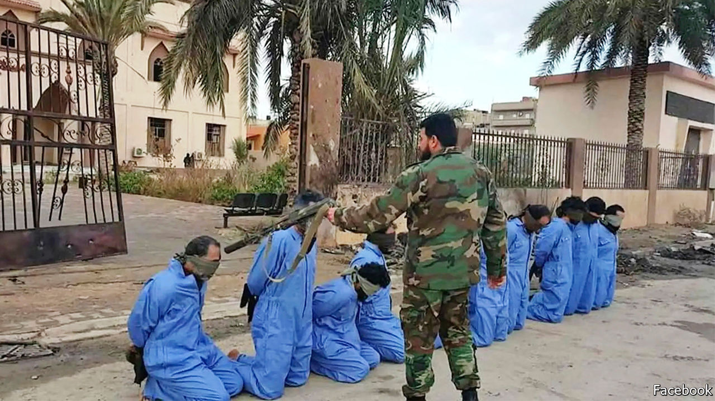

“PUT YOUR hands up! Put your hands up!” shouts a gunman at his hooded captive, who already has two hands in the air and shuffles about, seemingly unsure what more to do. The gunman then shoots his victim to the ground before firing more bullets into the body and saying: “You have been misled by Satan.”

Until fairly recently, brutal acts such as this might never have come to light. But a video showing this murder was posted on Facebook in 2016. A year later the International Criminal Court (ICC) issued its first-ever warrant that relied, in large part, on videos posted on social media by the perpetrators of war crimes themselves. It called for the arrest of Mahmoud al-Werfalli, a Libyan warlord (pictured). It accused him of being the gunman in the killing described above and of being responsible for murdering 33 people in seven incidents captured in videos on Facebook.

Although Mr Werfalli has yet to appear before the ICC in The Hague, the warrant for his arrest marked a turning-point. For the first time videos and photos posted on social media would not only be used to bring the world’s attention to war crimes, but could also offer hope of bringing the perpetrators to justice. “This is a mine of potential evidence,” wrote Emma Irving, a human-rights expert at Leiden University, in a blog post at the time. Yet for all its promise, the use of social-media evidence also raises real problems.

For a start, evidence posted on social media is far from perfect. People recording atrocities often lack expertise or may be partisan and thus film selectively. Prosecutors and judges may worry that footage has been staged, manipulated or misattributed. These worries will further increase, as it becomes easier to get computers with artificial intelligence to make “deep fakes” or highly plausible audio and video forgeries.

Yet because it is difficult and dangerous to gather evidence in war zones, such footage may be all that prosecutors have to go on. At the very least it can provide new leads, or help to corroborate eyewitness reports and other evidence.

Fighters bragging about their exploits on Facebook may inadvertently give away their location. They may also provide prosecutors with evidence of intent. Such information can help war-crimes prosecutors assemble the gold standard of evidence: a combination of the physical, documentary and testimonial varieties.

In 2018 the BBC looked into a video circulating on social media showing soldiers blindfolding and then shooting two women and children in Cameroon. Although Cameroon’s government initially claimed the video was faked or from elsewhere, the BBC and freelance investigators matched mountains in the background of the footage to maps and satellite images. By analysing shadows on the ground they were able to work out that the killings happened in 2015. To identify the soldiers involved they matched the weapons in the video to those used by specific units in the Cameroonian army. Shamed into action, the government investigated and prosecuted seven soldiers. This week four of them were sentenced to ten years in jail.

## Justice deleted

Yet even as prosecutors and the courts are discovering the uses of such evidence, much of it is disappearing. Human Rights Watch, a pressure group, recently revisited the social-media evidence it had cited in its public reports between 2007 and 2020 (though most were published in the past five years). It found that 11% of it had vanished. Others have run into similar problems. The Syrian Archive, a non-profit group that records and analyses evidence of atrocities in Syria, estimates that 21% of the nearly 1.75m YouTube videos it had catalogued up to June 2020 are no longer available. Almost 12% of the 1m or so tweets it logged have also disappeared.

Some of this content will have been deleted by users themselves, but much has been removed by internet companies such as Facebook and Twitter. Sometimes they scrub horrific content for good reasons. They want to protect users from snuff videos and extremist propaganda. Under pressure from activists and governments, many have adopted stringent content-moderation policies. But because there is little, if any, regulation over what happens to content that is removed by social-media firms, there is no certainty that it will be preserved if it is later needed as evidence.

Algorithmic moderation makes the problem worse. In 2017 a new YouTube algorithm proved unable to differentiate between material posted by Islamic State glorifying its killings and that from human-rights activists who were documenting them. YouTube removed hundreds of thousands of videos of abuses in Syria. Many of these were restored after a public outcry, but newer algorithms now take down content before it ever reaches the public. Of the content that Facebook removed for violating its guidelines between January and March, 93% was flagged by automatic systems, not by human moderators. Of those items, half were removed before any viewer saw them.

Human-rights groups argue that internet platforms should be obliged to preserve deleted content, or pass it on to independent archives. In Syria, for instance, had the Syrian Archive not collected copies of videos and tweets showing abuses, much of this evidence would have been lost, and with it any hope of justice for many of those who risked their lives to bear witness, by pressing “record”. ■

This article was downloaded by calibre from <https://www.economist.com/middle-east-and-africa/2020/09/26/social-media-platforms-are-destroying-evidence-of-war-crimes>

|  |  |  |  |
| --- | --- | --- | --- |
| Previous | Articles | Sections | Next |

|  |  |  |  |
| --- | --- | --- | --- |
| Previous | Articles | Sections | Next |

#### What’s the rush?

# Ghana is planning to sell most of its future gold royalties

The deal is causing a furore

Sep 26th 2020 |

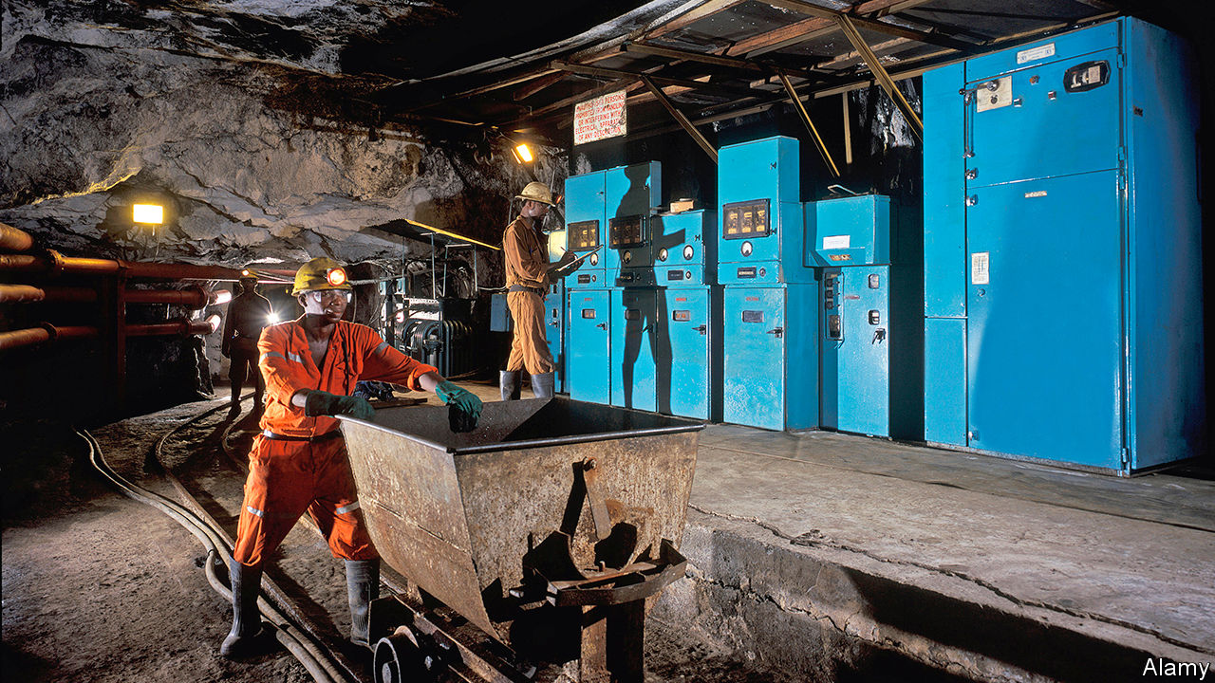

WHEN PORTUGUESE mariners first dropped anchor in the mouth of the river Pra in what is now Ghana, they heard of goldfields so rich that for the following five centuries the entire region became known as the Gold Coast. The promise of wealth sparked a rush to grab land, build forts, trade slaves and secure bullion, which poured into treasuries in Europe.

A somewhat more genteel rush is now under way to sell the rights to most of the government’s bullion royalties in Africa’s biggest gold producer. The deal, which some see as a model for other resource-rich developing countries, is aimed at providing cash now against income from royalties in the future. The appeal to Ghana’s government is obvious. It is struggling to cope with the economic hit of covid-19 and to sustain public spending under the crushing weight of debt that is expected to equal almost 70% of GDP this year. Yet it is also causing controversy, with critics raising questions over the rushed and opaque process, as well as its terms.

At stake is the roughly 4% in royalties that Ghana’s government earns on every ounce of commercially mined gold. The ounces add up. In 2018 Ghana shipped almost $6bn of the shiny stuff, its single biggest export. Now the government wants to bundle up the rights to 75% of the royalties from 16 big mines (including four under development) in a Jersey-incorporated company called Agyapa. It then plans to sell as much as 49%, with shares being floated on the London and Ghana stock exchanges, for about $500m.

The government says the deal has the advantage of delivering cash without adding to public debt. But critics argue that this is sophistry. “The government is basically selling off its ability to repay its existing normal loan portfolio,” says David Mihalyi of the Natural Resources Governance Institute (NRGI), an international think-tank.

Moreover, Ghana has already received and spent much of the money it hopes to get in future from pumping oil, mining bauxite or selling electricity. Not all has been spent wisely. The treasury’s purse strings typically open in election years (voters go to the polls in December) and money is often squandered on big pay increases for civil servants.

Critics also question the terms of the deal, which is not for a set amount of gold nor a clearly fixed time period. That makes it far more open-ended than is typical in resource-backed deals studied by NRGI, says Mr Mihalyi. Agyapa will continue to get its cut of the revenues if there are any renewals or extensions to mining leases in the 16 areas covered by the agreement. This would give investors any upside from extensions or renewals, but no corresponding obligation to pay the government for them, let alone invest anything itself in exploring for gold or doing the tedious, risky and grubby work of mining it.

Because it is particularly difficult for either the government or investors to value such an open-ended deal, there is a real risk that Ghana will be short-changed. Documents leaked to The Economist suggest the government has put a valuation of $1bn on Agyapa. But calculations by Yakubu Abdul-Salam, a resource economist at Aberdeen University, suggest it is worth at least $2.5bn (and perhaps far more) even given uncertainties over how much gold will be mined and its price.

A spokesperson for the ruling party says the $1bn valuation was just to “spice up” the deal and attract investors and that the real valuation will come from the market when the shares are floated. But, says Bright Simons of Imani, a think-tank in Ghana, the government has been talking with investors for two years, so the $1bn figure probably reflects the value it would expect ahead of the initial public offering (IPO).

One reason for the big difference between the two figures may be investors’ perception of the risk Ghana poses. But no one knows because the government has not been transparent about the assumptions or discount rates used in its valuation (unlike Mr Abdul-Salam, who has published his sums).

Charles Adu Boahen, Ghana’s deputy minister of finance, insists that there will be “total transparency” and the London flotation will help ensure that the company is valued properly by the market. Yet one may reasonably ask why the government registered Agyapa in Jersey, a tax haven that does not have a public register of company owners, rather than, say, London, which does.

The government pooh-poohs these concerns, saying Jersey was chosen for tax efficiency. It says it will exercise control of the company through its majority shareholding and will receive a meaningful annual dividend. But documents obtained by The Economist “raise questions as to how much influence Ghana will have over what Agyapa does with the royalties” that it receives, says Nicola Woodroffe, a lawyer with NRGI.

More questions surround the process of setting up the deal. Although it has been in the works for years, parliament was given just four hours to scrutinise its many complex documents before they were waved through by the ruling party. The opposition walked out in protest. Critics point to the lack of transparency over the recruitment of Agyapa’s boss, who happens to be the son of the senior minister in cabinet and a schoolboy chum of the deputy finance minister. Imani, the Ghanaian think-tank, says it can find no evidence of a public advertisement for the role. Also involved in the deal is an investment bank founded by the finance minister (at which his wife is still a non-executive director). He says the bank was chosen on merit. On September 10th Ghana’s special prosecutor wrote to parliament asking for information and saying it was looking into whether any elements of the deal were corrupt.

The agreement has also caused divisions within government. A leaked memo shows that on July 22nd the attorney-general wrote to the minister of finance saying the deal was “unconscionable”. On August 12th she nonetheless gave the go-ahead to take it to parliament. Since then she has not said publicly whether she changed her mind or whether the deal was changed.

The Ghanaian government is now promising to consult further with NGOs. But the agreements to sign over the royalties have been passed in parliament and the government seems intent on holding the IPO before the end of the year. That leaves little time for change. ■

This article was downloaded by calibre from <https://www.economist.com/middle-east-and-africa/2020/09/26/ghana-is-planning-to-sell-most-of-its-future-gold-royalties>

|  |  |  |  |
| --- | --- | --- | --- |
| Previous | Articles | Sections | Next |

|  |  |  |
| --- | --- | --- |
| Middle East & Africa | Sections | Europe |

The Americas

Peru: Limping in Lima

.

Argentina and Uruguay: A mini-war across the River Plate

.

Bello: Darkness in Mexico

.

|  |  |  |
| --- | --- | --- |
| Middle East & Africa | Sections | Europe |

|  |  |  |  |
| --- | --- | --- | --- |
|  | Articles | Sections | Next |

#### Limping in Lima

# Martín Vizcarra survives an impeachment vote

But Peru’s politics will remain chaotic

Sep 24th 2020 | LIMA

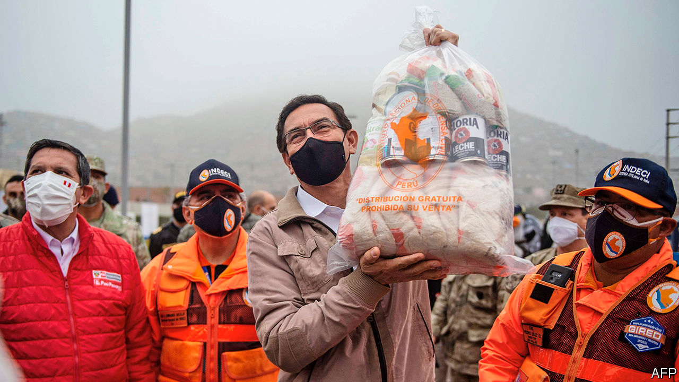

AT FIRST SIGHT, the impeachment vote on September 18th looked like a big victory for Peru’s president, Martín Vizcarra. Just 32 of 130 congressmen voted to remove him on suspicion that he had obstructed a corruption investigation. But the president owes his survival to the incompetence of his foes rather than to the strength or enthusiasm of his supporters. One congressman, Daniel Urresti, described him as the “living dead” before abstaining.

Peru needs a vigorous president more than usual. The country has the world’s highest number of recorded deaths from covid-19 as a share of its population. The government expects the economy to shrink by 12% this year, which would be the most severe contraction in Latin America. But Peruvians will have to wait months for a fully functioning government and may not get one even then. The country is due to hold a general election in April, and to inaugurate a new president in July. The impeachment saga suggests that the political system may well fail to produce stability.

Until recently, the country has prospered despite its chaotic politics. Annual GDP growth averaged 4.5% in the decade from 2009, among the fastest in the region. The Central Bank has kept inflation low and the finance ministry has kept budget deficits in check. The official poverty rate dropped from 42% in 2007 to 20% last year.

But the pandemic is showing that politics matters. One reason for the high caseload is that many Peruvians have low-paying informal jobs; if they don’t work, they don’t eat. Many also live tightly packed together. Many distrust the politicians who tell them to lock down, and so ignore the rules. Alonso Segura, a former economy minister, doubts the government’s prediction that the economy will grow by 10% next year, recovering much of its losses. “Not only are conditions for pro-growth reforms absent, but the political system has become a source of disruptions and counter-reforms,” says Mr Segura.

Mr Vizcarra’s unexpected elevation to the presidency in March 2018 was a consequence of a crisis that began 30 years ago, with the rise to power of Alberto Fujimori. He was an effective leader, but a despotic and corrupt one. He is serving a prison sentence for human-rights abuses and graft. Two of his successors are under house arrest. Another is soon to go on trial. A fourth, Alan García, committed suicide last year to avoid arrest. Mr Vizcarra took over from Pedro Pablo Kuczynski, one of the housebound ex-presidents, who resigned to avoid impeachment for allegations of corruption, perjury and congressional vote-buying.

Mr Vizcarra promised to clean up corruption, for example by eliminating legislators’ immunity from prosecution. But his tenure has been more notable for grandstanding than for reform. Early on he clashed with Congress, which was dominated by the Popular Force party, led by Mr Fujimori’s daughter, Keiko. It tried to remove Mr Vizcarra. He struck back by proposing to hold a general election a year early, in April 2020, in which he would not stand. When Congress rejected that he shut it down and called a new election for the legislature alone, which was held in January this year.

The pandemic struck not long after the new Congress took office. At first, Mr Vizcarra won praise and popularity by imposing a swift and strict lockdown and providing support to people’s incomes worth 12% of GDP. But the government had trouble delivering cash to people who needed it (in part because it lacks information about them) and hurt the economy by shutting down mines. Mr Vizcarra’s approval ratings remain high. But he clashed with the new Congress, even though pesky Popular Force is a much diminished presence.

Now he is embroiled in scandal. In May news emerged that the culture ministry had since 2018 paid $51,000 to a flamboyant folk singer who calls himself Richard Swing to give motivational talks to government workers. Mr Swing had campaigned for Mr Vizcarra when he was a candidate for vice-president in 2016. Mr Vizcarra’s congressional foes suggested that the president or his top aides had initiated the payments to Mr Swing as a belated reward. On September 10th this year the congressman leading the investigation said that he had a recording of Mr Vizcarra strategising with his aides about how to handle it. Congress then scheduled an impeachment vote.

Mr Vizcarra admitted that the recording, made secretly by a secretary, was genuine and apologised but said he had committed no crime. Bumbling by Congress’s leaders helped him. The speaker, Manuel Merino, called the armed forces’ top generals about the impeachment—to “reassure” them, he said. The administration claimed he was plotting a coup. On September 12th the prime minister appeared, flanked by the generals, to denounce Mr Merino. Many legislators decided that dumping the president at a time of crisis would do the country more harm than good.

There is little reason to expect the quality of government to improve after next year’s presidential and congressional elections. None of the 24 registered parties has chosen a presidential candidate. (Candidates must join one by the end of September.) The only candidate with double-digit support so far is George Forsyth, a former football goalkeeper who is now the mayor of La Victoria, a gritty district of Lima. His nearest competitor is “none of the above”. He is flirting with National Restoration, an evangelical party that has never governed.

In Peru that is no bar to winning high office. García is the only president since 1990 who won as the candidate of a party that had governed before. Without the backing of strong parties, presidents lack support in Congress and talented deputies to run their administrations. The election in January did little to strengthen the party system. It produced a fragmented Congress, with nine parties, despite a threshold to enter of 5% of the vote. Although Popular Action, a centre-right party, is the largest in Congress, just 6% of Peruvians back it, according to a poll by Ipsos. More than 60% of voters call themselves independents. National Restoration was not among the 11 parties the pollster asked about.

Peru’s next president will have scant resources to cope with an economy still wounded by the pandemic and a rise in poverty. Foreign-exchange reserves have been depleted by the cost of measures to limit the economy’s decline. Public debt will jump from 27% of GDP last year to 35% in 2020, according to the finance ministry. Peru needs economic reforms, such as clearer rules to encourage investment in public works and such vital industries as mining. Mr Vizcarra is unlikely to make much progress in the short time that remains to him. The worry is that his successor may not accomplish much more. ■

This article was downloaded by calibre from <https://www.economist.com/the-americas/2020/09/24/martin-vizcarra-survives-an-impeachment-vote>

|  |  |  |  |
| --- | --- | --- | --- |
|  | Articles | Sections | Next |

|  |  |  |  |
| --- | --- | --- | --- |
| Previous | Articles | Sections | Next |

#### A mini-war across the River Plate

# Why Argentines are flocking to Uruguay

A small country lures migrants with tax breaks and a low infection rate

Sep 24th 2020 | PUNTA DEL ESTE

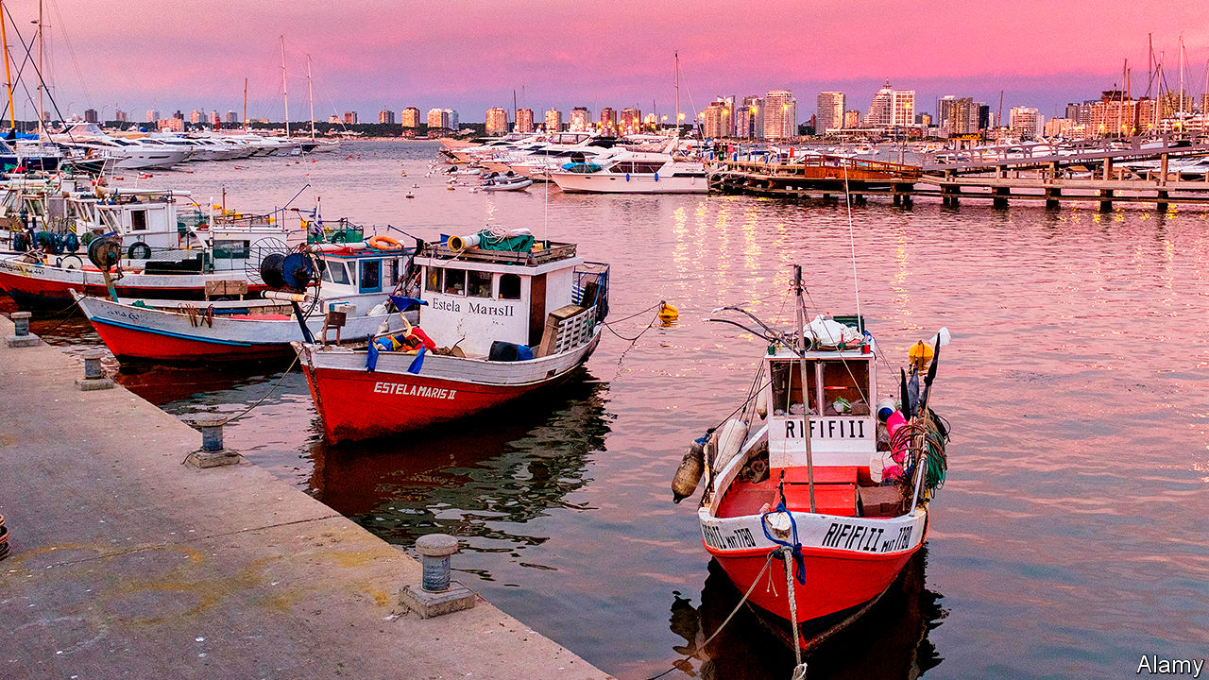

FRANCISCO, AN ACCOUNTANT, sips coffee in a café as he explains why he would move to Punta del Este, Uruguay’s most famous beach resort, from his native Argentina. “I can’t sit back and watch my government drain my pension pot empty over the next few years with crazy taxes.” Arturo, a business owner from the province of Buenos Aires, joins the conversation. “I’ve moved already, and my family will follow when the school year ends.” The Peronists, who won back power in Argentina last year, had started “class warfare”.

The exchange on Calle Gorlero, Punta del Este’s main shopping street, suggests that the drive to attract new residents to Uruguay, launched by the country’s conservative president, Luis Lacalle Pou, is beginning to work. On June 11th, three months after taking office, he issued a decree making it easier for foreigners to settle in the country. It reduces the value of property a person must buy to qualify for residency from $1.7m to $380,000. For business owners, the minimum investment has been cut from $5.5m to $1.7m. A five-year tax holiday for both sorts of newcomer has been extended to ten. Foreigners need no longer spend six months every year in Uruguay to qualify for residency. From July 1st the minimum stay is 60 days. The legislature endorsed the changes in August.

As enticing as those tax breaks are, Uruguay’s competent management of covid-19 may have become an even bigger draw. It has the highest testing rate and lowest death rate in Latin America. In Argentina, recorded cases and deaths are soaring. “I worry about taxes, sure,” said a technology mogul on the ferry from Buenos Aires to Montevideo, Uruguay’s capital. “But fear is making me move. I fear for my health, and that of my family.”

The pandemic has caused a “stampede”, says an estate agent in Punta del Este. Inquiries from Argentines have risen sixfold since last year, he says. “This has the makings of a mini-war across the River Plate.”

With 3.5m people on a territory roughly the size of England, Uruguay “needs more people”, says Mr Lacalle Pou. Its fertility rate of less than two children per woman is among the lowest in Latin America. The proportion of people older than 60 is among the highest. Migrants who buy property might give a boost to the economy by encouraging construction. In the long run they will help pay for the welfare state, one of the most generous in the region.

Mr Lacalle Pou says he wants people “from all parts of the world” but his main recruiting ground is Argentina, whose population is 13 times larger than Uruguay’s. His advisers say they hope 100,000 Argentines will relocate. To reconcile immigration with public health, Uruguay requires new arrivals to quarantine. In July Mr Lacalle Pou gave a series of newspaper and television interviews in Argentina touting his country’s charms.

Argentina’s new government is making life harder for the rich. In December 2019 it imposed an annual tax of up to 2.25% on worldwide assets of citizens and residents. Congress is contemplating an additional tax on fortunes of more than $3m. Such nest eggs will be safe across the border. Uruguay is no tax haven, Mr Lacalle Pou insists: it does not let residents hide their income. But it does not tax income earned or wealth held outside the country.

Argentina’s president, Alberto Fernández, is trying to slow the exodus. He responded to Mr Lacalle Pou’s decree with one of his own. It says that Argentines who relocate for tax purposes must live in their new residences for at least six months of the year. They will be allowed to spend only 90 days a year in Argentina.

Despite those restrictions, some 20,000 Argentines have applied to move across the River Plate this year. Enrique Antia, a former mayor of the region of Maldonado, which includes Punta del Este, predicts that the resort’s population will double from 15,000. Uruguay may be small, but in a mini-war that is no disadvantage.■

This article was downloaded by calibre from <https://www.economist.com/the-americas/2020/09/24/why-argentines-are-flocking-to-uruguay>

|  |  |  |  |
| --- | --- | --- | --- |
| Previous | Articles | Sections | Next |

|  |  |  |  |
| --- | --- | --- | --- |
| Previous | Articles | Sections | Next |

#### Bello

# AMLO’s war against the intelligentsia

Why does Mexico’s president fear a couple of small-circulation journals?

Sep 24th 2020 |



ON SEPTEMBER 21st President Andrés Manuel López Obrador (known as AMLO) began his televised early-morning press conference by asking a functionary to read out an interminable list of petrol prices at service stations around the country. Then there were video updates on AMLO’s pet infrastructure projects: an $8bn oil refinery, a new airport in Mexico City and three new railway lines. After an hour or so, he got to the meat of his agenda: attacking two small monthly magazines, Nexos and Letras Libres, and singling out by name their editors, Héctor Aguilar Camín and Enrique Krauze.

They “were the chiefs of the intelligentsia throughout the neoliberal period”, AMLO complained. He insinuated that they acted as hired propagandists for the governments of his predecessors. “They belong to the conservative grouping which would like to maintain the same regime of corruption, injustices and privilege,” he said earlier this month. These attacks, which apply, too, to Reforma, an independent newspaper, have intensified in the past few weeks. They look like an attempt to silence critical voices in the Mexican media by a populist president who has already hobbled previously independent institutions such as the Supreme Court and regulatory agencies. Many media businesses practise self-censorship.

Last month the government fined Nexos 1m pesos ($45,000) and banned all state bodies from dealings with it or its small book publisher. An official claimed that in 2018, when the magazine won an advertising contract from the Social Security Institute, it had failed to pay full labour taxes for its staff. This is false, says Mr Aguilar, who has appealed to a court. This month Paco Ignacio Taibo, a leftist historian appointed by AMLO to be the director of a big state-owned publisher and bookseller, warned Messrs Aguilar and Krauze: “stay in your little corner or change countries. It’s not a threat.” It obviously was, and AMLO has not required Mr Taibo to withdraw it.

This “public lynching” is dangerous, says Mr Krauze, a historian. “The presidential word is very powerful in Mexico. You don’t know how people will interpret it if he is continually pointing to someone as an enemy.” Some critics of past presidents have been murdered (as have journalists who fell foul of crime gangs).

Government support for the media through advertising is an unhealthy Mexican tradition, going back to the 1920s. AMLO is continuing it with partisan gusto. During his first year in office, the two main television companies, which provide adulatory coverage, received a total of 700m pesos in advertising. La Jornada, a small leftist daily, got 252m pesos.

The president’s insinuations that Nexos and Letras Libres lived purely from state largesse during earlier administrations are false. Mr Krauze says that income from the state, which included advertising, subscriptions by public libraries and contracts for historical documentaries, amounted to only 15% of the total revenues of his cultural businesses, Letras Libres and Clío, a film company. In Nexos’s case government advertising was around 25% of the total.

Both Nexos and Letras Libres are niche publications whose combined circulation is fewer than 30,000 copies (though both have popular websites). So why is AMLO scared of them? There are two apparent reasons. One is that he is temperamentally allergic to criticism. The other is that he is pursuing a populist strategy of dividing his country into “the people” and “the reactionaries”. No matter that both Mr Krauze and Mr Aguilar have been champions of democracy for decades, and were fiercely critical of previous governments.

Although opinion polls give AMLO an approval rating of around 55%, the going is getting tougher for him ahead of a vital mid-term election next July. His government has mismanaged the pandemic. Mexico’s economy is set to contract by 10% this year, more than the regional average. A president who claims to champion the poor has done little to prevent their numbers multiplying.

This month 650 of Mexico’s most prominent academics and intellectuals published an open letter stating that “freedom of expression is under siege in Mexico, and with that democracy is threatened.” That mirrors the fears of intellectuals in Brazil regarding their populist president, Jair Bolsonaro. Mr Bolsonaro is of the right, and AMLO claims to be of the left. But it increasingly looks as if the main difference between them is merely that the Mexican speaks more softly and has nicer manners.

This article was downloaded by calibre from <https://www.economist.com/the-americas/2020/09/24/amlos-war-against-the-intelligentsia>

|  |  |  |  |
| --- | --- | --- | --- |
| Previous | Articles | Sections | Next |

|  |  |  |
| --- | --- | --- |
| The Americas | Sections | Britain |

Europe

French diplomacy: Trying to square a circle

.

Corruption in Ukraine: Lock up the small fry—for a start

.

Italy: Counter-strike

.

Switzerland and the European Union: Is it in Europe?

.

Charlemagne: The right to sell passports

.

|  |  |  |
| --- | --- | --- |
| The Americas | Sections | Britain |

|  |  |  |  |
| --- | --- | --- | --- |
|  | Articles | Sections | Next |

#### Trying to square a circle

# France, as ever, wants to be both European and French

It is proving awkward

Sep 26th 2020 | PARIS

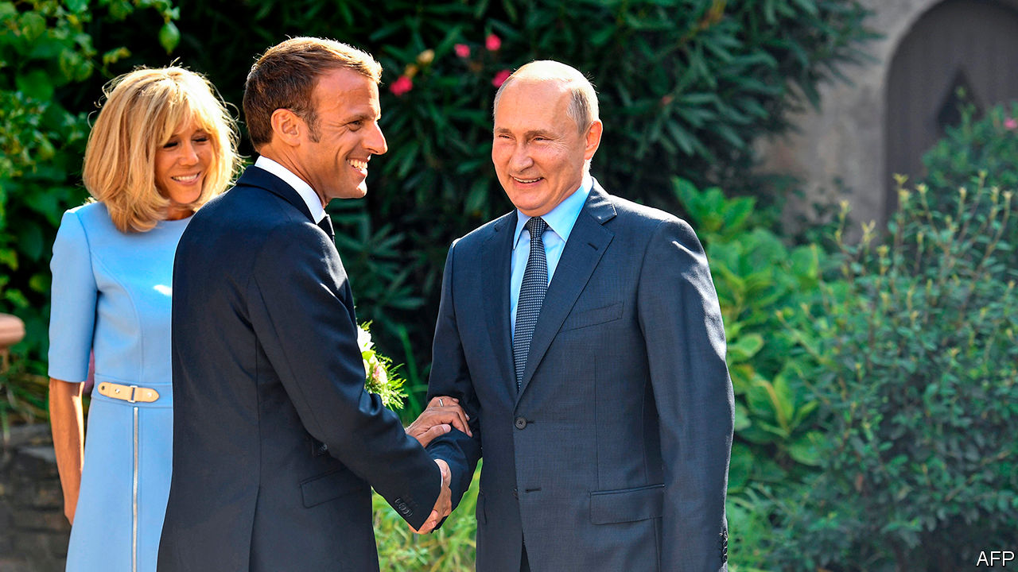

THE PANDEMIC has grounded most European leaders. But not Emmanuel Macron. In recent weeks, the French president has been in hyperactive diplomatic mode. He has jetted off twice to Lebanon, once dropping in on Iraq on the way back. He has dispatched a frigate and two fighter jets to help Greece and Cyprus defend their waters from Turkish incursions, and held a sea-front summit of Mediterranean leaders in Corsica to try to rally others to make a tougher stand against Turkey. On September 28th-30th the French president is off again, this time to Latvia and Lithuania, where he will visit French soldiers serving in a NATO battlegroup.

What is Mr Macron up to? Three years ago this month, in the amphitheatre of the Sorbonne, he outlined an ambitious plan to reinvigorate the European Union. This stood on two principles: more “solidarity” among member countries, and more assertion of European “sovereignty” in the face of big-power rivalry. In July, when all 27 EU members agreed to issue mutualised debt for a massive recovery fund, Mr Macron made progress on his first point. On the second, however, France is still trying to work out how to reconcile its version of the collective European interest, notably in response to regional troublemakers in Turkey, Russia, Libya and elsewhere, with how others see it.

In some respects the debate has shifted France’s way. “Mentalities are changing,” says Clément Beaune, Mr Macron’s Europe minister: “We inoculated Europe against hard power, because 70 years ago we built the project on reconciliation and said that hard power isn’t for us. Now we are learning to speak the language of power.” The phrase “European sovereignty”, which might once have been dismissed as a French abstraction, is now uttered even by the German foreign minister, Heiko Maas. Ursula von der Leyen, head of the European Commission, has said that she wants the commission to be “geopolitical”.

As France is discovering, though, such concepts do not mean the same to everyone. Take the French stance towards Turkey. Mr Macron’s muscular backing for the Greek and Cypriot navies, offered in August after a phone call to Kyriakos Mitsotakis, the Greek prime minister, was seen in France as clear-cut: support for a threatened fellow European country, in defence of international law and sovereign borders. Yet it was not universally welcomed. Norbert Röttgen, the Christian Democratic chairman of the Bundestag’s foreign-affairs committee, argued that the EU “shouldn’t pick a side” as “this will only lead to escalation”. Others said it undermined parallel German mediation efforts.

As it turns out, Turkey has now agreed to resume talks with Greece, a decision that Mr Macron applauded in a call to Turkey’s president. The French argue that it was the division of labour—with Mr Macron as warrior and Angela Merkel as mediator—that clinched it. Asserting European sovereignty means doing both, they say, and Europe should get used to that.

Misgivings about French activities on Europe’s periphery, though, remain. The most pressing concern Mr Macron’s efforts to create a “strategic dialogue” with Russia. With great fanfare he invited Vladimir Putin to the official presidential retreat on the Mediterranean in August last year (pictured), arguing that the best way to keep Russia out of China’s arms was to offer it a place on Europe’s eastern fringe under a new security architecture. At the time, such suggestions enraged Poland and the Baltic states, which eye Russia nervously on their eastern flank, and consider NATO—which Mr Macron went on to criticise—to be their guarantor of security.

The poisoning of Alexei Navalny, Mr Putin’s leading opponent, along with Russia’s propping-up of Alexander Lukashenko’s dictatorship in Belarus, has made Mr Macron’s approach increasingly untenable. Earlier this month the French called off a planned “2+2” meeting in Paris of French and Russian foreign and defence ministers. Le Monde described a “dialogue of the deaf” between Mr Macron and Mr Putin, in which the Russian president suggested in a phone call on September 14th that Mr Navalny may have poisoned himself.

“Ours is a strategy that has to adapt to circumstances,” Mr Beaune told The Economist on September 22nd. “We never said it was an unconditional or irreversible dialogue. The Navalny affair makes it more difficult in the short run. It’s never been a question of U-turns but adaptations.” Mr Macron had already expressed his “reservations” about Germany’s Nord Stream 2 pipeline, which will bring Russian gas to Europe. The tone in Paris is hardening.

“Macron is slowly coming to terms with the fact that he’s going nowhere with Putin,” says Bruno Tertrais of the Foundation for Strategic Research in Paris. This does not mean that France has abandoned its longer-run hopes of a meaningful dialogue with Russia. But the French president is under pressure to distance himself right now from Russia’s leader. France has backed the EU’s plan to impose sanctions on selected Belarusian leaders. Mr Beaune has urged Cyprus not to block them. There is talk that Mr Macron may meet Svetlana Tikhanovskaya, the exiled Belarusian opposition leader, when he is in Lithuania.

Mr Macron’s setback over Russia is by no means his only headache. Covid-19 cases at home are rising steeply again. His poll ratings remain low. On September 21st Pierre Person, the deputy leader of his party, La République en Marche, resigned from his post, saying that the party was “at risk of disappearing” and didn’t “produce any new ideas”. (The outfit has appointed Mr Beaune, among others, to come up with some.) Amid all of this, the president’s chief consolation is that a growing majority of the French give him credit for defending the country’s interests abroad, even if outsiders are not always so impressed. ■

This article was downloaded by calibre from <https://www.economist.com/europe/2020/09/26/france-as-ever-wants-to-be-both-european-and-french>

|  |  |  |  |
| --- | --- | --- | --- |
|  | Articles | Sections | Next |

|  |  |  |  |
| --- | --- | --- | --- |
| Previous | Articles | Sections | Next |

#### Lock up the small fry—for a start

# Ukraine’s anti-corruption court bares its teeth

In its first year it has racked up some real if modest achievements

Sep 26th 2020 | KYIV

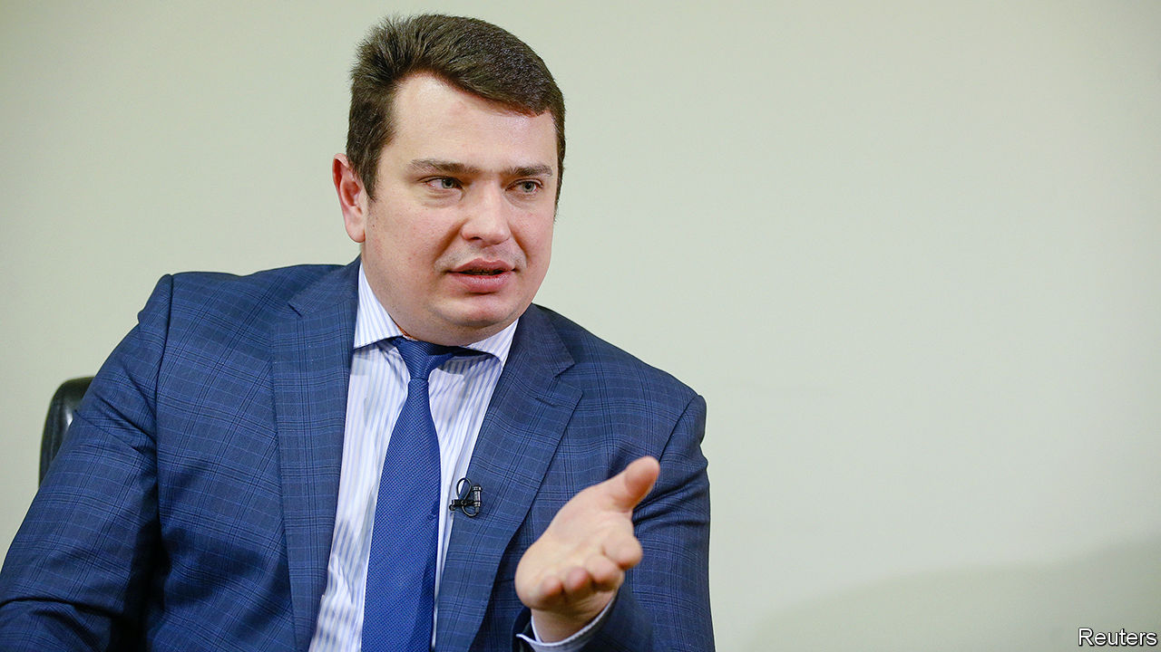

THE OFFICIALS who ran Ukraine before its revolution in 2014 are believed to have stolen billions of dollars. One crony gave Viktor Yanukovych, when he was president, a solid gold loaf of bread. So nabbing a regional forestry official for a $10,000 bribe may seem like small potatoes. But the sentencing on August 28th of Oleksandr Levkivsky, who stands to serve four years in prison for taking a kickback to let out public land, is a big deal. Mr Levkivsky is among the first officials convicted by Ukraine’s High Anti-Corruption Court (HACC), which began work a year ago.

The court was set up at the behest of the IMF, which demanded an independent anti-corruption mechanism, among other things, in exchange for the billions of dollars in credit Ukraine needs to keep its economy afloat. The HACC has handed down 17 verdicts so far (almost all of them guilty), and is hearing scores more cases. But after years of being robbed, many Ukrainians are not satisfied with small fry. They want bigger fish hooked.

The HACC’s 38 judges were selected in a multi-round competition, with help from international experts. Some of the cases they hear are brought by an anti-corruption prosecutor supervised by the prosecutor general, but others come from the National Anti-corruption Bureau of Ukraine (NABU), an independent agency. The judges have proved willing to push back against investigators: in Mr Levkivsky’s case, they dismissed evidence that was gathered illegally. “There is no question about the professionalism of this court,” says Andrii Borovyk of Transparency International Ukraine, an anti-corruption watchdog.

But efforts to beat graft are under constant attack. In August the Constitutional Court ruled that since the constitution does not give the president the power to select NABU’s head, Artem Sytnyk, the respected prosecutor picked to run the agency in 2015, had been illegally appointed. Mr Sytnyk refuses to step down, saying the ruling is retaliation for NABU’s investigations into judicial corruption, but the court has now ruled that NABU itself was established on dubious legal grounds.

It is no coincidence that pressure is increasing just as the new court hits its stride, says Vadym Valko, a legal expert who closely follows NABU. The judges are hearing a number of high-profile cases, including ones involving the mayor of Odessa and a former tax chief. But collecting smaller victories, rather than focusing on big fish in order to satisfy public pressure, may be a better strategy. “Make sure that due process works,” says Matthew Murray, a former official in Barack Obama’s administration who helped push for the HACC. The court’s chief justice, Olena Tanasevych, wrote recently that sometimes “it seems as though absolutely everyone is dissatisfied.” That may mean her team is on the right track.

This article was downloaded by calibre from <https://www.economist.com/europe/2020/09/26/ukraines-anti-corruption-court-bares-its-teeth>

|  |  |  |  |
| --- | --- | --- | --- |
| Previous | Articles | Sections | Next |

|  |  |  |  |
| --- | --- | --- | --- |
| Previous | Articles | Sections | Next |

#### Circus minimised

# Italians vote for fewer, better politicians

After a referendum, parliament is to be cut down to size

Sep 26th 2020 | ROME

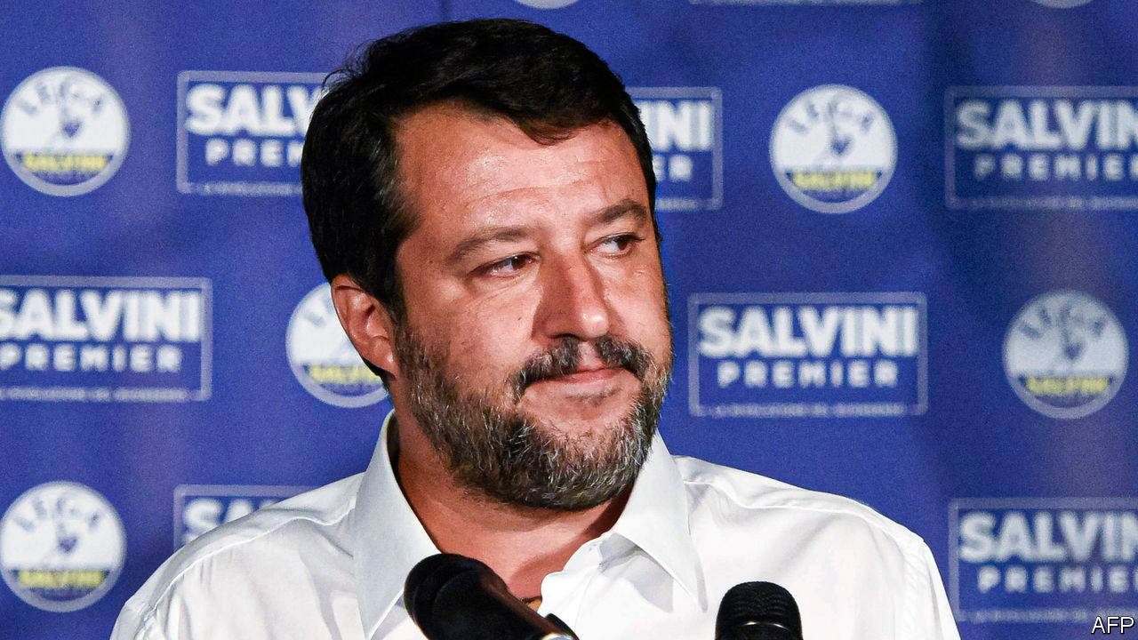

IT IS NOT often that voters get a chance to cut politicians down to size. But on September 20th-21st, Italy’s did—and they seized the opportunity with both hands. By a whopping majority of 70% to 30%, they opted in a referendum to slash the number of lawmakers by more than a third. The lower house (the Chamber of Deputies) will have 400 members, down from 630, while the upper one will have 200 elected senators rather than 315. The reform also capped at five the number of presidentially nominated senators-for-life.

The new law will take effect after the next general election, which does not have to be until 2023 though it may come earlier. It will not affect the generous salaries and perks of Italy’s parliamentarians. Nor does it tackle a more fundamental problem: that the two houses have identical functions. Still, it brings the ratio of voters to lawmakers to around the same level as in Germany and represents a triumph for anti-politics, the distrust of a governing elite whose members are seen by many Italians as pampered, corruptible and virtually impossible to dislodge. Anti-politics was an important reason for the rise of the maverick Five Star Movement (M5S), which sponsored the reform.

So another populist advance? Regional elections held at the same time suggested otherwise. First, they showed Italians cared enough about old-school parliamentary democracy to defy the risks posed by covid-19 to vote in sizeable numbers. Nowhere was turnout below 50% and in Valle d’Aosta, by the border with France, it was more than 70%, impressive by any standards for a regional election. Second, faced with a Europe-wide resurgence of the virus and the daunting responsibility of investing wisely the vast funds that the EU has earmarked for Italy’s economic recovery, voters opted for continuity.

The centre-left Democratic Party (PD), which governs in a coalition including the Five Stars, had feared a disaster. Seven of Italy’s 20 regions were at stake, four of them governed by the PD. Polls suggested the party could lose three, including Tuscany, a left-wing heartland since the days of the now defunct Italian Communist Party. In the event, the PD’s candidate for governor in Tuscany convincingly defeated a challenger put up by Matteo Salvini’s hard-right Northern League. The only defeat for the PD and its genial but uncharismatic leader, Nicola Zingaretti, was in the neighbouring Marche region, once considered part of Italy’s central “red belt”. There, victory went to the Brothers of Italy (FdI), which has roots in neo-fascism (and which, despite its name, is led by a woman.)

It was the latest of many signs the FdI may now be poised to overhaul the shriller, more populist League to take command of the Italian right. It was little comfort for Mr Salvini that the League came first in the Valle d’Aosta, with almost 24% of the vote. And he will have been even less cheered by the outcome in Veneto, which has been a bastion of the League since its earliest days. The incumbent governor, Luca Zaia, romped home with 77% of the vote. But his triumph, like that of the Democrats’ Vincenzo De Luca, in Campania, the region around Naples, was largely attributable to his adroit handling of the pandemic rather than any obvious sympathy for the League’s harsh messages on immigration and Europe. Mr De Luca, whose authoritarian ways earned him the nickname “Pol Pot”, managed the seemingly impossible task of getting Neapolitans to respect the lockdown by, among other things, threatening to deploy police armed with flame-throwers. Mr Zaia won plaudits globally for containing the virus with blanket testing. The bad news for Mr Salvini is that as a result Mr Zaia is now being talked of as a potential and imminent successor to him.

Despite their referendum win, the Five Stars’ performance also showed that Italians have become picky about populism. In only one region did they scrape into double figures. Even worse was their result in Liguria, in the north-west. Here, the M5S allied with the Democrats to back a shared candidate, the idea being that this could deliver the extra votes to oust a centre-right incumbent. Instead, the allies’ contender slumped to a 17-point defeat. As Italy enters a crucial phase, which could decide whether it recovers its economic dynamism or sinks further into debt-laden lethargy, the PD will be firmly in the driving seat. ■

This article was downloaded by calibre from <https://www.economist.com/europe/2020/09/26/italians-vote-for-fewer-better-politicians>

|  |  |  |  |
| --- | --- | --- | --- |
| Previous | Articles | Sections | Next |

|  |  |  |  |
| --- | --- | --- | --- |
| Previous | Articles | Sections | Next |

#### Is Switzerland in Europe?

# Upcoming referendums will show how the Swiss may relate to the EU

A proposal to end freedom of movement with the EU will probably fail

Sep 26th 2020 | ZURICH

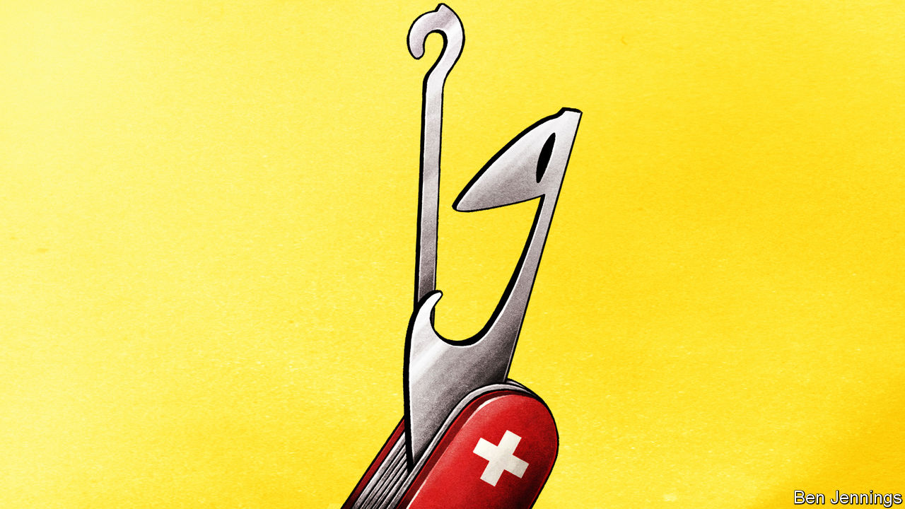

OPERATION LIBERO is planning something, but it won’t say what. The Swiss liberal activist group is known for its creative campaigns against referendums launched by the right-wing populist Swiss People’s Party (SVP). On September 27th the latest such initiative, to end freedom of movement with the EU, comes to a vote, and Operation Libero plans to stage an unspecified media stunt. The aim is to tease the country’s politicians, not for doing too much to integrate into the EU, but for doing too little. “They think Swiss people don’t want [more integration] with the EU, but that’s not true,” says Laura Zimmermann, the group’s co-head. “Times have changed.”

If so, Operation Libero deserves some credit. For decades the tone of Swiss politics has been set by the anti-immigrant SVP, the country’s biggest party. In 2014 an SVP initiative to renegotiate the treaty that lets EU citizens live and work freely in Switzerland (and vice versa) unexpectedly won 50.3% of the vote. That prompted a circle of young liberals headed by Flavia Kleiner, then 24, to launch Operation Libero. Their volunteers ran outreach campaigns under a bright-pink logo. Rather than argue on the populists’ terms, the group recast the debate. When the SVP proposed expelling foreigners who commit even minor crimes, Operation Libero framed it as an assault on Switzerland’s precious rule of law.

Since then, all of the SVP’s big initiatives have lost. Polls show the current one will probably fail too, with about 60% of Swiss opposed. Many voters have learned from the 2014 initiative: the EU refused to negotiate and the Swiss gave in. The SVP’s new, tougher proposal would force the government to scrap the treaty if it has not reached a new one within a year. But seven crucial treaties with the EU are covered by a “guillotine clause” that suspends all of them if only one is abrogated. Few Swiss imagine they have much leverage in Brussels.

The next fight will come after the vote. The EU wants the Swiss to sign an “institutional framework agreement” that requires them automatically to adopt shifts in EU rules unless they specifically object. (Currently there is no obligation, but they generally follow anyway for fear of losing market access.) The two sides reached an agreement last year, but the Swiss have held off putting it to parliament until after the referendum. Thomas Aeschi, the SVP’s parliamentary leader, warns that under the framework agreement EU rules could restrict the cherished autonomy of the Swiss cantons and stop them granting tax breaks.

“I think that would be a good thing,” laughs Balthasar Glättli, the head of the Swiss Green Party. But the Greens worry that the framework agreement might undercut minimum-wage guarantees. The justice minister, Karin Keller-Sutter of the centre-right Liberals, backs the deal, as do drug firms and banks. But there is no majority for it in the seven-member Federal Council that rules the country.

Swiss attitudes are mixed. Sotomo, a pollster, finds that most of them want a framework agreement with the EU rather than the current patchwork of treaties, but other polls show less support. Still, the SVP has lost momentum; the Green and Liberal parties were the big winners in elections last year. Ms Kleiner, who recently stepped down from Operation Libero (“I turned 30,” she explains), thinks this a good moment to try out new political narratives. Switzerland is a conservative country, but it may also be ready for a change. ■

This article was downloaded by calibre from <https://www.economist.com/europe/2020/09/26/upcoming-referendums-will-show-how-the-swiss-may-relate-to-the-eu>

|  |  |  |  |
| --- | --- | --- | --- |
| Previous | Articles | Sections | Next |

|  |  |  |  |
| --- | --- | --- | --- |
| Previous | Articles | Sections | Next |

#### Charlemagne

# The problem of the EU’s “golden passports”

A crackdown raises questions about citizenship the EU would rather not answer

Sep 26th 2020 |

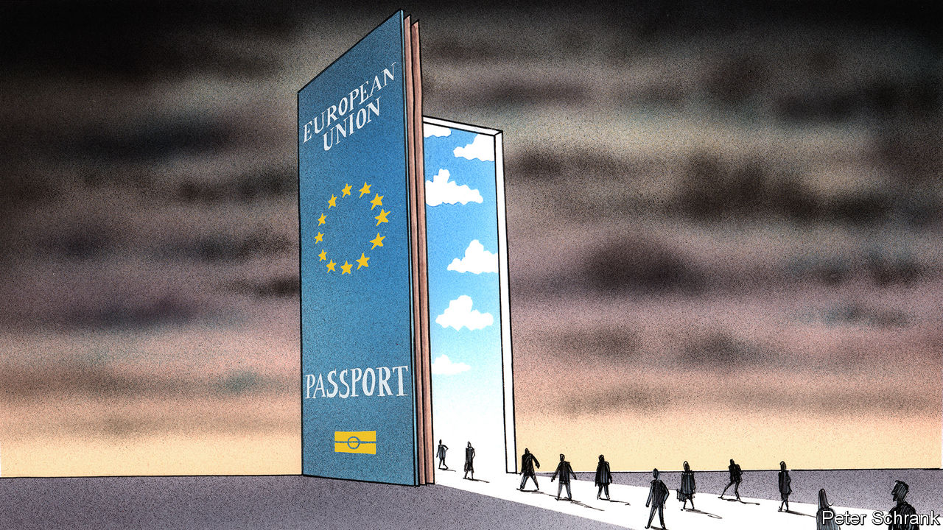

AN EU PASSPORT is one of the most desirable documents on the planet. Its bearer can live and work in 27 different countries, all of them prosperous and peaceful. Many have excellent food, too. In the birthright lottery of citizenship, those with a burgundy ticket marked “European Union” are among the lucky winners. Putting a pricetag on this is hard, but Cyprus has managed it. Invest €2.2m ($2.6m) in the island and a Cypriot passport with all the benefits of EU citizenship can be yours. Malta runs a similar (and, at just over €1m, rather cheaper) scheme for anyone tired of travelling with papers that open fewer doors.

Not everyone thinks this is a good idea. In a recent speech Ursula von der Leyen, the European Commission’s president, mentioned such “golden passports” as one of a list of threats to the rule of law in Europe, alongside judge-nobbling. Her annoyance is understandable. Since anyone with an EU passport can move anywhere in the bloc, a quick buck for the Cypriot government can create problems for the rest of the EU. Cyprus has made €7bn from the scheme since its launch in 2013, which amounts to a quarter of the island’s annual GDP. It has sold passports to plenty of rich but disagreeable folk, who are now free to settle in Germany or France.

Banning such sales would be popular. But it is no simple matter. Deciding who is and is not a citizen is a jealously guarded right of EU member states. All EU countries issue passports for reasons beyond the bog-standard naturalisation of those who marry a local or live in the country in question long enough to qualify. Some countries hand them out to curry favour with diasporas, atone for historic wrongs or create new voters. Being an EU citizen may come with common rights. But there is stark disagreement among the member states as to who should be allowed to be one.

Some EU countries, particularly those with large diasporas, dish out the burgundy like a wine wholesaler at Christmas. Ireland allows anyone with an Irish grandparent to claim Irish citizenship. Given Irish enthusiasm for emigration, this leaves an uncountable number of potential Irish abroad. In Britain alone, an estimated 6m people would qualify for an Irish passport. That is about 20% more than live in Ireland, and thanks to Brexit, many have good cause to apply for one. Italy is even more generous to its diaspora. Anyone with a male Italian ancestor has a shot at an Italian passport. Along the patrilineal line, there is no upper limit, so the right goes back to 1861 and the creation of Italy. (The rights of descendents of women only start in 1948.) Between 1998 and 2010, 1m people obtained an Italian passport in this way. According to one estimate, 60m potential Italian citizens lurk around the globe. (However, many have settled in even richer places, such as America, and are unlikely to return.)

Passports can be given out for political purposes. Hungary’s prime minister, Viktor Orban, has been the most cunning in this regard. After the first world war redrew eastern Europe’s borders, ethnic Hungarians were left scattered across neighbouring countries, such as Serbia and Romania. Mr Orban’s government has eased citizenship rules in an attempt to naturalise and enfranchise 1m of them. Between 2011 and 2016, 180,000 new Hungarians were created every year—more than the number of naturalisations in France and Germany, according to Yossi Harpaz in “Citizenship 2.0”, a book on dual nationality. Anyone who can trace lineage back to the right part of the Austro-Hungarian empire and is willing to learn Hungarian—a notoriously difficult language—can claim a passport. (Predictably, Hungarian language schools have popped up across Serbia.) The strategy has worked: when these new Hungarian citizens vote, they overwhelmingly support Mr Orban.

Offering citizenship as a form of atonement is common. Austria, which normally restricts dual nationality, now allows descendants of Jews who were expelled, or fled, during the 1930s and 1940s to claim a passport. A similar right can be found in Germany, where it is embedded in the country’s constitution. Spain goes back even further, allowing descendants of Sephardic Jews kicked out in the 15th century to reclaim Spanish citizenship. (Descendants of Muslims kicked out in the same period have no such luck.)

A few countries take the opposite path and hoard their passports. Along with Austria, the Netherlands and Germany both have strict rules on dual-nationals from outside the EU. In the days when citizens were regularly conscripted to butcher their neighbours, restrictions on dual citizenship made sense. Now they seem outdated, serving only to leave immigrants—who may not want to give up their other nationality—as perpetual outsiders.

## Who are EU then?

If passports can be seen either as a commodity or political tool, on the one hand, or a life-long civic commitment on the other, devising common rules for handing them out is close to impossible. Although member states are happy to slam Malta and Cyprus, they do not appreciate criticism of how they themselves distribute citizenship. Some may balk at the idea of limiting dual nationality. Others may be uncomfortable with the unknown size of the Irish and Italian diasporas who could turn up as EU citizens. How countries seek to atone for the Holocaust is a deeply inappropriate question for an EU ruling. A clear definition of who qualifies for an EU passport is the obvious next step for any passport-selling ban; it is also a nightmare.

An Al Capone approach may be enough for the EU to crack down on the current schemes operated by Malta and Cyprus. Rather than stop them from selling passports outright, Brussels could pursue them via money-laundering legislation and make life difficult for the dodgier newcomers. But a determined state—and some canny lawyers—could keep the golden passport trade going. Granting citizenship is a huge power and member states are unlikely to give it up. That means they will probably have to tolerate their neighbours selling passports to plutocrats. ■

This article was downloaded by calibre from <https://www.economist.com/europe/2020/09/26/the-problem-of-the-eus-golden-passports>

|  |  |  |  |
| --- | --- | --- | --- |
| Previous | Articles | Sections | Next |

|  |  |  |
| --- | --- | --- |
| Europe | Sections | International |

Britain

The Labour Party: Reflections on conservatism

.

Trans rights: Who’s a woman?

.

Covid-19: Winter has come

.

Public transport: The little engine that couldn’t

.

Conservative protest: Leave.BBC

.

Income distribution: Importing inequality

.

Commercial property: A pain in the portfolio

.

Bagehot: The king in the north

.

|  |  |  |
| --- | --- | --- |
| Europe | Sections | International |

|  |  |  |  |
| --- | --- | --- | --- |
|  | Articles | Sections | Next |

#### Patriot games

# Keir Starmer’s rather conservative message to Britain

The Labour leader stresses family, security and love of country in an appeal to former voters

Sep 26th 2020 |

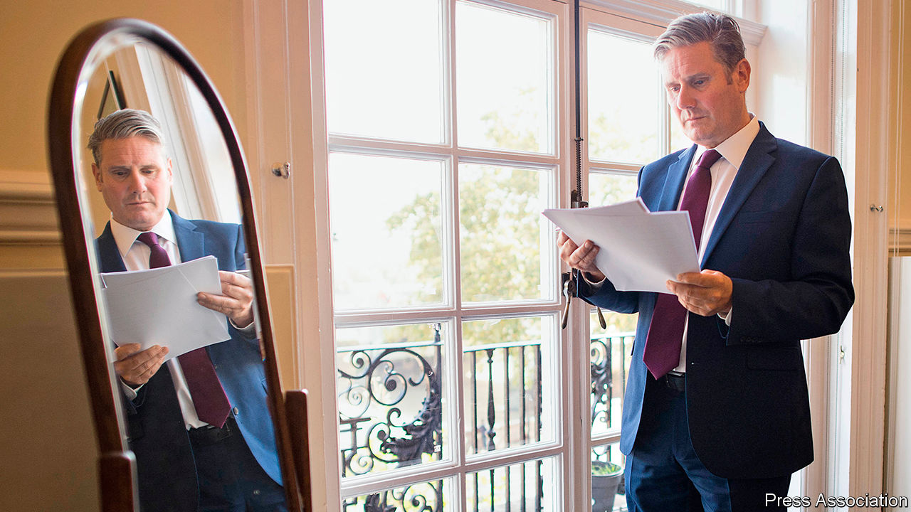

CONSERVATIVE PARTY literature makes plentiful reference to Sir Keir Starmer’s knighthood. Tories hope it will signal to voters that the Labour Party’s leader, a former human-rights lawyer who lives in a fashionable part of north London and defended immigrants and suspected extremists, is part of the metropolitan elite.

If Sir Keir, who calls himself a socialist and was named after his party’s first leader, saw his title in the same light, he might be expected to downplay it. But in his first speech to Labour’s annual conference as leader, on September 22nd, he told his party that his investiture at Buckingham Palace was one of the proudest days of his parents’ lives. His title is, he said, a symbol of what he owes Britain’s education system. It was granted in recognition of his term as the head of Britain’s public prosecution service, which he says he spent chasing terrorists and bent politicians. The subtext is that unlike his predecessor Jeremy Corbyn, he is proud of the monarchy and the British state, and qualified for the nation’s greatest office.

In vaunting his title, Sir Keir reveals his strategy. Both he and Boris Johnson are pitched at the same group of voters: socially conservative working classes in the so-called “red wall” of small towns in northern England, the Midlands and Wales which flipped dramatically from Labour to the Tories in 2019. While the Conservative Party is consumed by revolutionary fervour, Sir Keir is playing to an older, more deferential strand of conservatism, which defends the nation’s ruling institutions instead of attacking them.

Sir Keir’s address covered the traditional fare of a Labour leader: promises to improve Britain’s schools and hospitals, tackle racial inequality, and improve the lot of workers. Yet it was cast in strikingly conservative terms. Under his watch, Sir Keir said, Britain will be a “country in which we put family first”. Labour will defend Britain’s national security and territorial integrity, and champion decency and neighbourliness. Above all, it will be patriotic. “We love this country as you do.”

One of the speech’s authors was Claire Ainsley, an aide to Sir Keir and author of “The New Working Class: How to Win Hearts, Minds and Votes”, a book which argues that Labour’s policies need to be built on “moral foundations”—ideas such as fairness, hard work and family. Values trump soundbites. Mr Corbyn, who spent a career denouncing British militarism and sympathising with Irish Republicanism, left the party with a reputation for ambivalence or hostility to British interests. Sir Keir’s speech hit the right notes, says Deborah Mattinson, a pollster who advised the party under Tony Blair and author of “Beyond the Red Wall”, a study of the seats Mr Corbyn lost. “I cannot stress it enough: if you don’t love your country, the ‘red wall’ will never love you.” But it must be sincere, she says. “All voters, and ‘red wall’ voters perhaps more than most, can sniff out inauthenticity in a nanosecond.”

The appeal to patriotism is not new. Mr Corbyn and his predecessor, Ed Miliband, both declared their love for Britain in their first big speeches as leader. Yet Sir Keir’s pitch is more credible for two reasons.

One is that he can plausibly position himself as a better steward of Britain’s institutions than Mr Johnson. The government plans to unleash creative destruction on the civil service, curtail the judiciary’s power and break the Brexit withdrawal treaty—a breach of international law which Sir Keir characterises as a tantrum by an unqualified prime minister. “For a party called the Conservative Party, they don’t seem to conserve very much,” he said of the neglect of public services that covid-19 exposed. In his promise to make Britain “once again admired and respected” overseas, some supporters see parallels with Joe Biden’s pitch to restore dignity to the White House. “We don’t have to burn the institutions down to create a great country. We have to improve them,” says an ally. Anneliese Dodds, the shadow chancellor, has promised to be more careful with public money than the Tories.

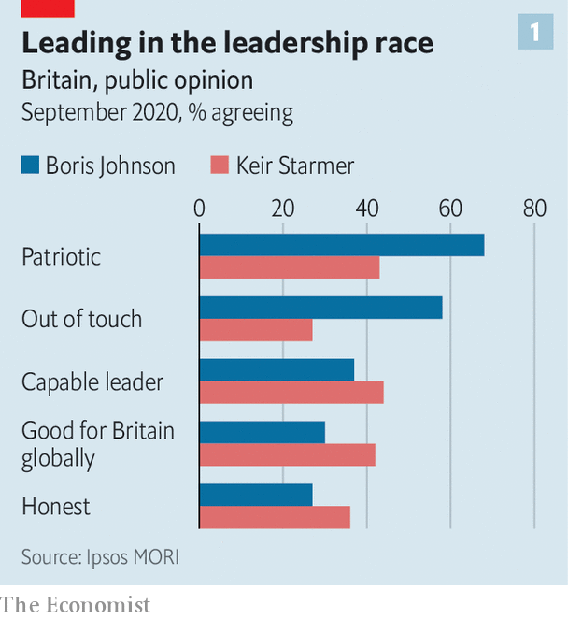

The second is that Sir Keir is a more credible messenger than his predecessors. The Labour Party’s polling has undergone a rapid recovery under his watch. A poll by Ipsos MORI in September found that voters regard Sir Keir as more capable, as a better representative for Britain abroad, and as having better judgment than the prime minister. Voters regard Mr Johnson as more patriotic, and having more of a personality. Mr Johnson’s party is miserable after a string of U-turns and unforced errors. His satisfaction ratings after 14 months in office are similar to those of Theresa May and David Cameron at that point in their premiership: not a disastrous result, but not a good one considering he secured an electoral landslide in December 2019.

Sir Keir’s personality is more conservative too. He contrasts his diligent career at the Bar to Mr Johnson’s as a fabulist newspaper columnist. He is a family man, and neatly attired; the prime minister has a more bohemian lifestyle.

The Conservatives paint Sir Keir’s transformation as opportunistic and the party as unreformed. The Tories will remind voters of Sir Keir’s support for a second referendum on Brexit, and how he loyally served in Mr Corbyn’s team.

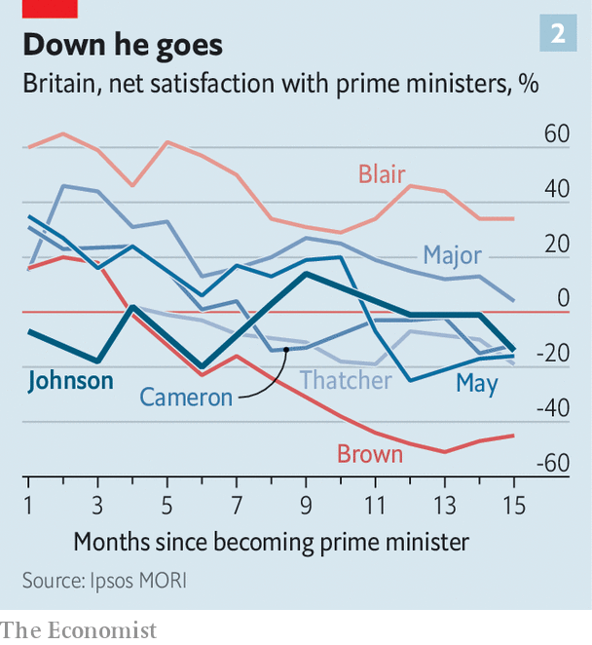

They risk fighting the last war. Mr Corbyn is out in the cold. Sir Keir declined to mention him in his address, unlike former winners Tony Blair, Harold Wilson and Clement Attlee, and told the party it must swallow the fact that voters had rejected his project. Brexit has united Mr Johnson’s electoral coalition and split Sir Keir’s. But voters are weary of the question and, like Sir Keir, want a deal struck and the issue put to bed. Sir Keir has elegantly brushed aside arguments which could fuel a culture war, such as whether patriotic songs should be sung at the Proms.

Still, it is four years till the next election, and Sir Keir has a mountain to climb, in the shape of Mr Johnson’s 87-seat majority. Despite his personal lead over Mr Johnson, the Tories are (just) leading in the polls. Some Labour MPs and many of its activists fear Mr Corbyn’s radical economic programme is being abandoned and dislike the leadership’s new turn. “They’re trying to wrap themselves in a bigger flag than the Tories,” says Joe Guinan, a left-wing thinker. When it comes to patriotism, he believes, the Tories will “always outbid us”.■

This article was downloaded by calibre from <https://www.economist.com/britain/2020/09/26/keir-starmers-rather-conservative-message-to-britain>

|  |  |  |  |
| --- | --- | --- | --- |
|  | Articles | Sections | Next |

|  |  |  |  |
| --- | --- | --- | --- |
| Previous | Articles | Sections | Next |

#### Trans rights

# Britain’s Gender Recognition Act won’t change

The government goes back on a plan to allow self-ID

Sep 26th 2020 |



IN THE BATTLE over trans rights, no prisoners are taken. On September 15th J.K.Rowling (pictured), the author of the “Harry Potter” books and a critic of gender ideology, published a new book (under a pseudonym) in which a character occasionally dresses as a woman to stalk his victims. Accusations of transphobia and an online punch-up ensued.

On this issue Ms Rowling, who is also known for her left-of-centre political views, finds herself, along with many other lefty British women, on the same side as the Conservative prime minister, Boris Johnson. This week it was the winning side. On September 22nd the government announced it would not go ahead with a change to the Gender Recognition Act that had been proposed by Mr Johnson’s predecessor, Theresa May.

The act says that anyone can change the gender on their birth certificate, but they must have two medical opinions, including a diagnosis of gender dysphoria. Trans rights groups want to remove the medical gatekeepers and allow people to change their legal gender simply by declaration (known as “self-ID”), and Mrs May had proposed to do that. “Gender critical” women’s groups warn that such a move would allow any man to enter any women-only space whenever he wants. They have welcomed the government’s backtracking. Nancy Kelley, head of Stonewall, a gay and trans lobby group, retorted that the British government had “missed a key opportunity to progress LGBT equality”, calling it a “shocking failure in leadership”.

James Johnson, a pollster with JL Partners, believes the government has concluded there is little political advantage to be gained by perpetuating a culture war. Gender issues “are right at the bottom of the agenda for most voters,” he says. “We’re not America.”

When ordinary people are asked for their views, they turn out to be rather cautious and conservative. A survey in June by YouGov found that 63% of the public believe a doctor’s approval should be required to change their legal gender. Some 46% say that trans women should not use women’s changing rooms if they have not undergone gender reassignment surgery, against 26% who believe they ought to be allowed.

Yet the government’s decision to abandon gender self-ID is unlikely to shut down the debate nor bring Ms Rowling respite from online attacks. That is because another piece of legislation, the Equality Act, already allows trans women into women’s spaces in some circumstances. “Self-ID won’t now happen in legislation, but it is already effectively public policy throughout British society,” says Stephanie Davies-Arai of Transgender Trend, a group campaigning against the medical transitioning of children.

As well as protecting people on the basis of race and other characteristics, the Equality Act protects “gender reassignment”, a vague term. The law is “too open to interpretation”, says Rosa Freedman, a professor of law at Reading University. Under the act, trans women may enter some women’s spaces, although they can be excluded if the bar can be proved to be “a proportionate means to achieving a legitimate aim”. The lack of clarity leaves space for groups on both sides to lobby public bodies for their preferred interpretation. Ms Davies-Arai calls it “self-ID by the back door”.

“We need a legal definition of four things: woman, female, sex and gender identity,” says Professor Freedman. Ms Rowling has some ideas on definition: “‘Woman’ is not a costume, ‘woman’ is not an idea in a man’s head, ‘woman’ is not a pink brain,” she wrote recently. Until the government decides whether it agrees or not, the rows are bound to continue.■

This article was downloaded by calibre from <https://www.economist.com/britain/2020/09/26/britains-gender-recognition-act-wont-change>

|  |  |  |  |
| --- | --- | --- | --- |
| Previous | Articles | Sections | Next |

|  |  |  |  |
| --- | --- | --- | --- |
| Previous | Articles | Sections | Next |

#### Pandemic

# The British government tightens covid-19 restrictions

As cases rise, it attempts to avoid the worst of the last lockdown

Sep 26th 2020 |

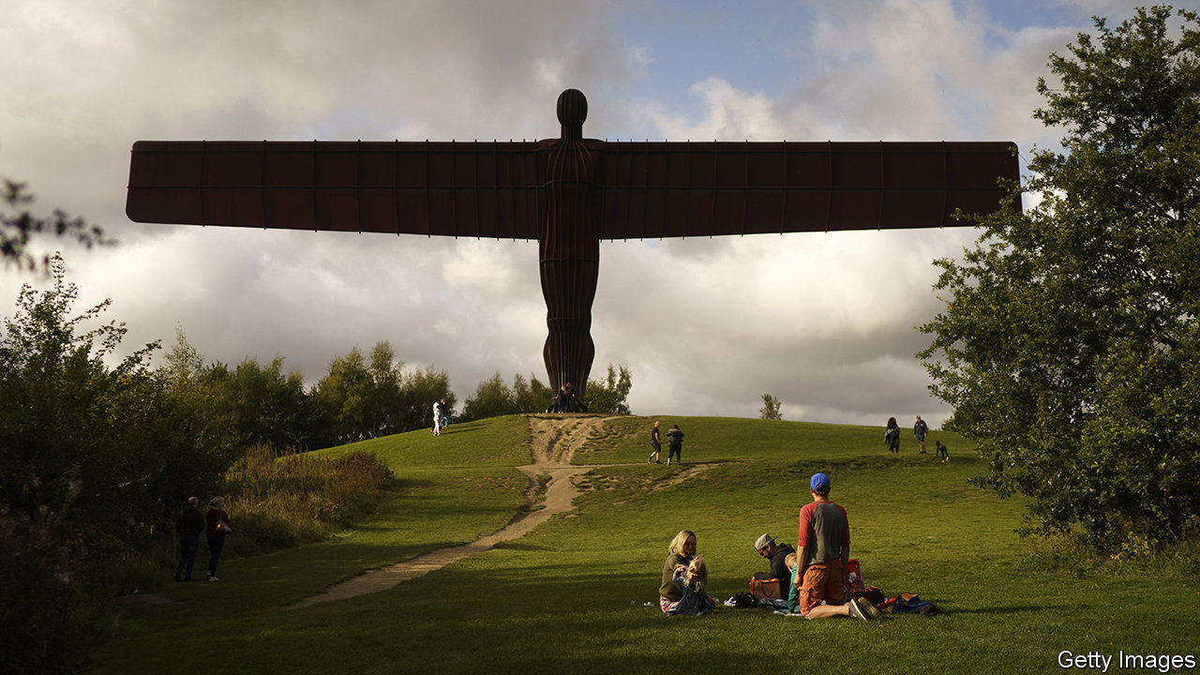

THE CHURCHILLIAN rhetoric is back. “Never in our history has our collective destiny and our collective health depended so completely on our individual behaviour,” Boris Johnson, the prime minister, warns. So are new nationwide restrictions. From September 24th, bars and restaurants will have to close at 10pm. More people will be required to wear masks; working from home will be encouraged. All rules will be strictly enforced. Barring a vaccine or testing breakthrough, Mr Johnson said, these new restrictions will last for six months. Merry Christmas indeed.

Over the summer the government has tried to suppress covid-19 with local restrictions. It now believes a change of approach is necessary. Britain is counting more than 4,500 cases a day, up from just over 1,500 at the start of September, and case counts are rising across the country. Hospitalisations are also growing—most worryingly in the north. Though deaths are still very low, they too seem to be heading in the wrong direction. The government hopes to avoid the worst elements of the first wave of the virus, both by responding earlier to rising case counts and by not clamping down as hard.

The new measures have received enthusiastic public support. According to a poll by YouGov, 78% of people think the government was right to introduce them; a plurality believes it should go further still. Yet ministers are keen to wait to see the impact of earlier restrictions—including the decision on September 14th to ban social gatherings involving more than six people—before adding extra ones. All told, things are less urgent than in the spring. Cases are rising more slowly, treatment has improved and, though problems remain, the test-and-trace system at least exists.

Restrictions on commerce are thus less severe. During the first lockdown, non-essential retail, bars and restaurants were closed. Businesses nevertheless greeted the new measures with dismay. A return to working from home will hit transport and hospitality especially hard. Retailers fear that footfall will suffer. A ban on socialising involving multiple households, which both Northern Ireland and Scotland have plumped for, will be particularly damaging to pubs and restaurants.

The government is also keen to minimise the cost of this wave to the exchequer. Since the early days of the pandemic, the two core elements of the government’s economic response have been the Jobs Retention Scheme, under which it pays 80% of the wages of furloughed employees, and a range of cheap loans to tide firms over. Both are due to wind down in the next few weeks, with the main loans facility closing to new applicants on September 30th and the furlough programme ending in October. At the start of September 3m employees were estimated still to be on the scheme. Whitbread, which runs hotels and pubs, and has made heavy use of the furlough scheme, announced on September 22nd that it would be making up to 6,000 redundancies in the coming weeks.

An announcement extending the application period for the various lending packages had been expected on September 23rd, but those involved in the talks say it has been pushed back, as the government wants to announce extra support for jobs at the same time. As The Economist went to press, the Treasury looked set to announce a German-style short-time working scheme, under which the government would top up the incomes of employees who had their hours cut. Whereas the furlough scheme cost the Treasury almost £40bn between April and mid-September, the bill for such a programme would run to just hundreds of millions of pounds a month.

Plans for an autumn budget have been scrapped. Restrictions on behaviour, and with them the economy’s needs, change so swiftly these days that long-term planning looks like something from another age.■

Editor’s note: Some of our covid-19 coverage is free for readers of The Economist Today, our daily [newsletter](https://my.economist.com/user#newsletter). For more stories and our pandemic tracker, see our [hub](https://www.economist.com/news/2020/03/11/the-economists-coverage-of-the-coronavirus)

This article was downloaded by calibre from <https://www.economist.com/britain/2020/09/26/the-british-government-tightens-covid-19-restrictions>

|  |  |  |  |
| --- | --- | --- | --- |
| Previous | Articles | Sections | Next |

|  |  |  |  |
| --- | --- | --- | --- |
| Previous | Articles | Sections | Next |

#### Railways

# Britain’s experiment in radical rail privatisation is over

A new franchising system could follow

Sep 26th 2020 |

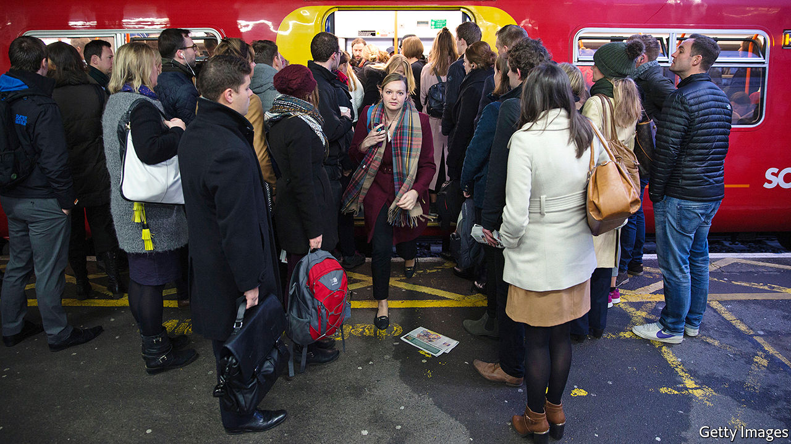

IN 2013 THE then transport secretary, Patrick McLoughlin, gave a speech to mark the 20th anniversary of railway privatisation. It had been a brilliant success, he said. Britain had turned a clapped-out railway network into the safest, most improved system in Europe. Naturally, there had been “a few wobbles along the way”, but these had been sorted out. Anybody who believed that railways ought to be controlled by the state was “completely missing the point”.

Now look at it. On September 21st the transport secretary, Grant Shapps, declared that the model of railway privatisation that Britain has followed for the past two and a half decades had stopped working, and would end forthwith. He did not even pin all the blame on covid-19, which has cut train travel by about three-fifths. So was railway privatisation a brilliant success that went wrong, or was it flawed from the beginning?

Although many rich countries privatised their railways in the 1980s and 1990s, few were as bold as Britain. Whereas Germany and Sweden allowed the incumbent to keep running trains, British Rail was abolished. Private companies were invited to bid for franchises and take on almost all the financial risk of running services. Because the government continued to set many rail fares, their goal was straightforward. If they lured lots of new customers, they would thrive; if not, they would fail.

For a long time, they did thrive. The annual number of railway journeys jumped from 740m to 1.7bn between 1993-94 and 2019-20. That is exceptionally rapid growth, although Sweden and Switzerland (which resisted privatisation) are not far behind. The train-operating companies hustled hard, offering cheap tickets and advertising their shiny new carriages on television. One academic study suggested that 69% of the growth in passengers up to 2009 could be attributed to privatisation.

In another way, though, the revolution failed. In continental Europe, opening the railways to competition reduced costs—something that also happened when Britain’s buses were deregulated. British railways, by contrast, not only stayed expensive but became more so. Net government support for the railways in 2018-19 amounted to £7.1bn—more than twice as much, in real terms, as the average level in the decade before privatisation.

Some of that is because of HS2, an inordinately expensive new railway line. But not all of it. Labour costs are stubbornly high; over the five years to 2018-19 franchisees’ staff costs rose by 19% while passenger miles grew by 12%. Andrew Smith, a transport economist at the University of Leeds, says that the brevity of franchises (often seven years in the early days, though they have lengthened) mean that train operators strive to avoid industrial disputes. They also tend to compete for experienced drivers rather than training their own.

The privatised railway network lacks a guiding hand—a strategist who can think about how the system should evolve and see through big changes. For years that seemed like an abstract weakness. But in 2018 a big change to timetables was botched, leading to mass cancellations. It was unclear who exactly was responsible. The then transport secretary, Chris Grayling, certainly didn’t think it was him.

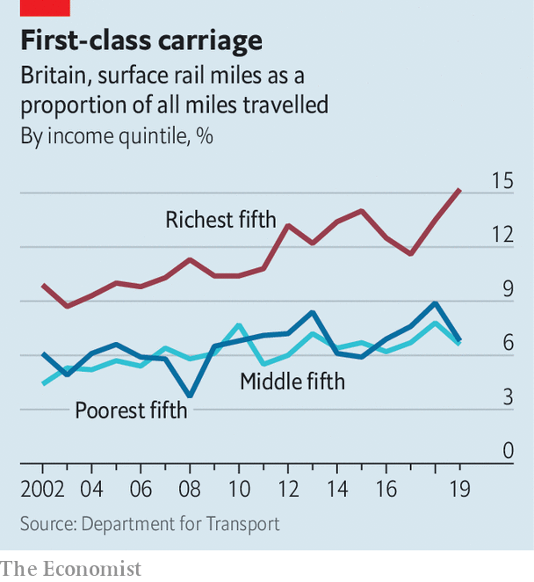

If passenger numbers had kept surging, the high costs and strategic weakness might have been forgiven. But even before covid-19 struck, that seemed improbable. Rail is overwhelmingly a middle-class mode of transport, and becoming more so (see chart). In 2019 adults in the top earnings quintile travelled 1,400 miles each by train, on average, five times more than adults in the bottom quintile. Professionals like trains because they can work on them. But a person who can work on a train can work from home. Around 2018 train operators noticed that commuters were buying fewer season tickets. If you only travel to the office three or four days a week, they aren’t worth it. And even before the pandemic struck, the number of people working from home had started to rise.

For the moment, the state is bailing out the train operators. When the covid crisis ends, Britain will probably move to a new franchising system, in which private companies bid to operate lines but take less financial risk. Rather than try to lure more customers, they will try to hit government targets for punctuality and the like. To the unions’ disappointment, this is not renationalisation; it is closer to the mild continental form of privatisation. The railways’ revolutionary phase is over. ■

This article was downloaded by calibre from <https://www.economist.com/britain/2020/09/26/britains-experiment-in-radical-rail-privatisation-is-over>

|  |  |  |  |
| --- | --- | --- | --- |
| Previous | Articles | Sections | Next |

|  |  |  |  |
| --- | --- | --- | --- |
| Previous | Articles | Sections | Next |

#### Conservative protest

# Defund the BBC, home for idling Brexiteers

A new battleground for the right

Sep 26th 2020 |

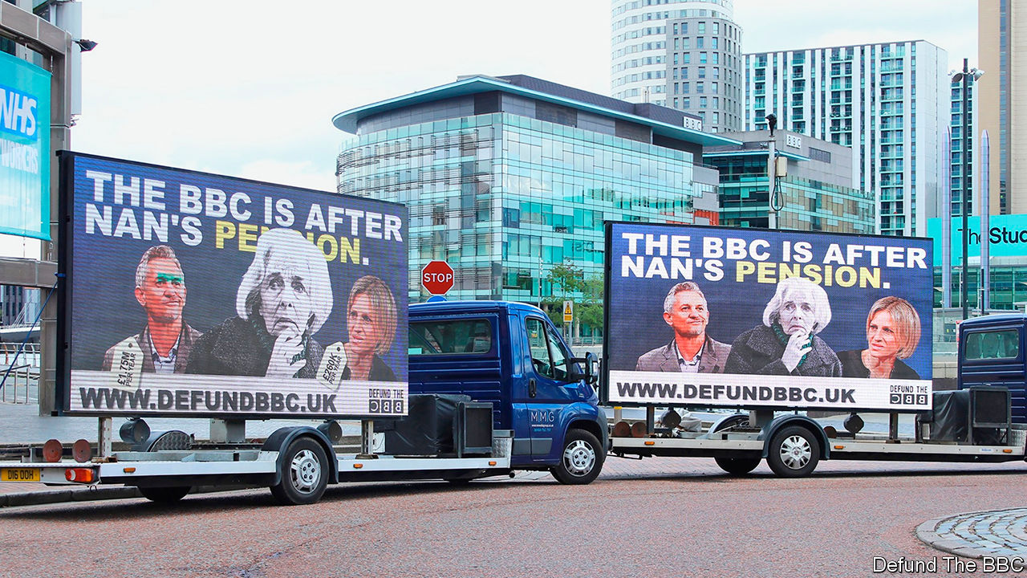

ROGER SCRUTON, the late conservative philosopher, reflected last year that right-wingers are not good protesters. “If you think what a slogan would be on the conservative side, it would be something like: ‘Hesitate’,” he told an audience at an event organised by the Spectator magazine. That, he concluded, “doesn’t work”. Growing numbers of right-wingers are nevertheless giving it a go. In recent months, a new breed of revolutionary conservative has taken to the streets, armed with slogans that include “Masks are muzzles” and “Facts not fear”. Many got their first taste for protest during the Brexit wars.

Among them is Defund the BBC, a campaign group set up in June as Black Lives Matter (BLM) protests swept Britain. Its founder, James Yucel, a student at the University of Glasgow, was offended by what he saw as the BBC’s lack of impartiality. The group’s name takes a jab at BLM’s aim of defunding the police. That punchiness attracted Rebecca Ryan, a veteran of the pro-Brexit campaign, whose stewardship has sent advertising vans blazoned with the group’s slogans across northern England.

Defund the BBC’s first aim is to decriminalise non-payment of the licence fee, a £158 charge all television viewers must pay. But its long-term ambition is to reduce the scope of the BBC Charter, which sets governance rules, at the corporation’s mid-term review in 2022. Ms Ryan says that, rather than defund it outright, the group wants to force the BBC to evolve.

The government, too, doubts that the BBC is impartial, and takes a dim view of the licence fee. Is there any point, then, in a dedicated protest group? It helps “in finding a focus and building consensus”, reckons Andrea Jenkyns, a Tory MP and deputy chair of the right-wing European Research Group. It also provides a cause for idling Brexiteers. Ms Ryan ran StandUp4Brexit, a grassroots outfit whose work ended with a failed bid to get Big Ben to “Bong for Brexit” on January 31st. Darren Grimes, a member of the Brexit commentariat who ran the youth-focused BeLeave during the referendum, is on board. So is Calvin Robinson, a former Tory and Brexit Party candidate.

The Labour Party is used to radical fringe groups, including Stop the War and Abolish Eton. The Tories are less so. But the Brexit years have created a generation of radicals experienced in taking on liberal bogeymen, and winning. Over that period, Defund the BBC maintains, the corporation’s left-wing bias became more entrenched. It started pushing, Ms Ryan says, “an extremely metro-centric view”. Ms Jenkyns concurs. In her view, the corporation is “trying to re-educate the population to adhere to a certain view of the world”.

This might be going a little far. Polling by the Reuters Institute at the University of Oxford finds that the BBC reaches an audience from across the political spectrum. Meanwhile, Defund the BBC has not taken the nation by storm. It has raised only £60,000 ($76,000) out of the modest £100,000 it is aiming for, and it has its own struggles with metro-centricity. Ms Ryan runs a digital-marketing agency and lives in Kent. The northern ad-van campaign happened only after the group’s first billboard, in the capital, made them “keen to make sure that we are not London-centric”, says Ms Ryan. But, pointing to the Tories’ success in winning over disaffected Labour voters in the north, she claims that the BBC has disenfranchised people all over the land. “Kent is the red wall, too.”■

This article was downloaded by calibre from <https://www.economist.com/britain/2020/09/26/defund-the-bbc-home-for-idling-brexiteers>

|  |  |  |  |
| --- | --- | --- | --- |
| Previous | Articles | Sections | Next |

|  |  |  |  |
| --- | --- | --- | --- |
| Previous | Articles | Sections | Next |

#### Income distribution

# Does immigration import inequality?

A new paper suggests that immigration has had a central role in the rise of the very rich

Sep 26th 2020 |

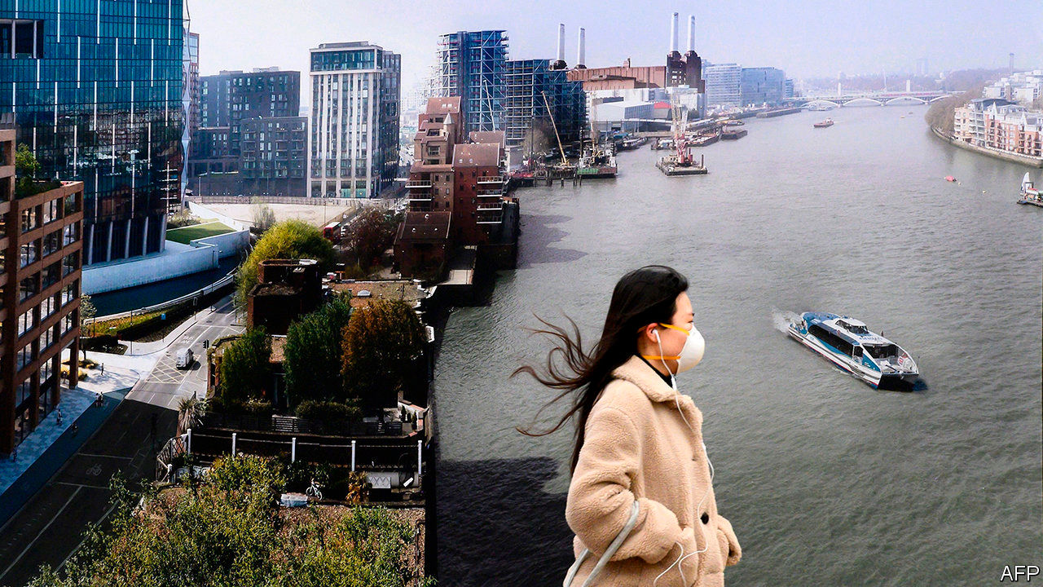

THAT INCOME inequality has risen more sharply in Anglo-Saxon countries than in continental Europe and Asia is not much debated. The reasons for it are. Tax policy, looser regulation of financial services, performance pay for chief executives and culture are among the usual suspects. In a new paper, a group of economists at the University of Warwick, employing an unusual data set, have provided evidence to implicate another culprit: immigration.

The researchers looked at the National Insurance (NI) numbers of British taxpayers. The data are anonymised, but Britons are assigned NI numbers when they are 16, so those whose numbers were assigned later are bound to be immigrants.

People tend to think of immigrants as poor, but the research shows that they make up a much larger proportion of the top of the income range than of the bottom (see chart). Their share of the top of the distribution has grown rapidly since the late 1990s. They made up less than a fifth of the top 1% in 1997 but more than quarter 20 years later; 85% of the total growth in the income share of the top 1% since the late 1990s can be attributed to immigrants. Stripping them out leaves the income share of Britain’s top 1% similar to those in Italy, France and Sweden.

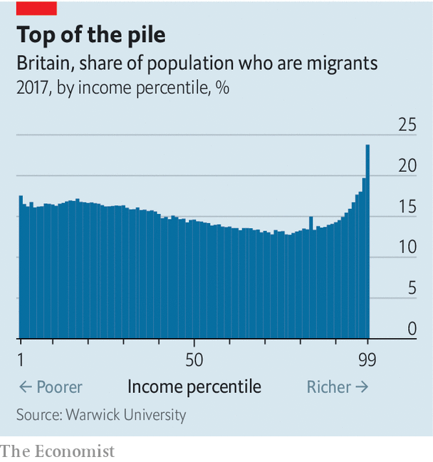

That is not to say that immigration caused the rise in inequality in Britain. If the country had not had a big financial services sector and lowish personal taxes, rich foreigners would not have come in such large numbers; had they not, there would still have been locals on six- and seven-figure salaries. But the research implies that immigrants are responsible for a big chunk of the rise in top pay: immigrant top-one-percenters are paid 8% more than locals, and a third arrived within the previous five years, suggesting they were headhunted for their specialist skills. Whatever the factors behind the growth, it has shaped British politics and society this century.

This article was downloaded by calibre from <https://www.economist.com/britain/2020/09/26/does-immigration-import-inequality>

|  |  |  |  |
| --- | --- | --- | --- |
| Previous | Articles | Sections | Next |

|  |  |  |  |
| --- | --- | --- | --- |
| Previous | Articles | Sections | Next |

#### Property investment

# Britain’s coming commercial property slump

It will hit pensioners, foreigners and the queen

Sep 24th 2020 |

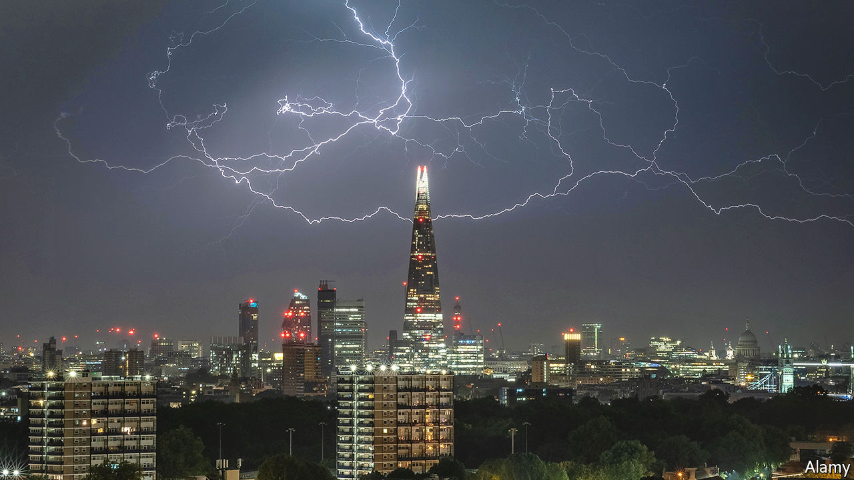

AMONG THE assets that adorn the queen’s property portfolio are 17 provincial shopping and leisure centres. On September 18th Crown Estates, which manages the monarch’s portfolio, wrote down their value by 17%, cutting Her Majesty’s net worth by £552.5m ($700m). Set against the £13.4bn valuation of her entire property portfolio, which includes swanky London addresses such as Regent Street and St James’s, that is fairly small beer. But the outlook even for the top end of the market has darkened: the Crown Estates expect “profit and property valuations to be significantly down” over the coming year.

Covid-19 has accelerated the growth of online retailing, hamstrung the hospitality sector and thrown the future of the office into question. None of this is good news for commercial-property owners. The consensus forecast of a recent survey of 24 large property investors and consultants by the Investment Property Forum (IPF), a trade body, was that capital values would drop by 12% in 2020.

The headline numbers hide a lot of variability. Industrial units are expected to perform reasonably well while retail, and especially shopping centres, will take the largest hit. The IPF survey suggests a 28% fall in shopping centre valuations and 20% drop in other types of retail premises. Shopping centres are struggling with the loss of the large department stores that once acted as anchor tenants and widespread closures of chain restaurants that used to draw in customers. A big landlord talks of a rise of “mission-based shopping” and expects people will be less keen to hang around in indoor retail parks in future. Another property investor expects 300 of Britain’s 650-or-so shopping centres to close.

The greatest uncertainty, says Andrew Burrell, head of property at Capital Economics, a consultancy, is over offices, for their future depends on how the pandemic plays out. Estimates for capital values in 2020 for City offices range from a fall of over 20% to modest positive growth.

Nobody quite knows what commercial property in Britain is worth. If, as some trade bodies suggest, it is £1.6trn, then small percentage declines would mean huge declines in value. The IPF put the size of the invested stock (the part of commercial property held for investment purposes) at £512bn in 2018; which, on the basis of guesses about what is happening this year, would mean a decline in value of over £50bn.

Commercial-property busts in the mid-1970s, the early 1990s and 2007 all triggered losses at banks that led to a wider tightening of credit availability with ramifications across the rest of the economy. But this time financial regulators are more relaxed. Banks are better capitalised and less exposed to commercial property than in 2007. Pension funds’ holdings of commercial property have increased in the past decade because of low returns from bonds, but typical allocations are only around 5% of their total assets and even a large fall in capital values would be offset by higher returns this year in other assets such as global equities.

Ownership is more diversified, too. Foreigners own 30% of invested stock, up from 17% in 2007. The Qatari sovereign-wealth fund, with landmarks such as Canary Wharf, the Shard and Chelsea Barracks, is now the biggest owner of commercial property in London by square footage. The Kuwaitis have also been on a buying spree, snapping up City Hall, the mayor’s office, in 2013.

But there will be ripple effects in Britain. More than two-thirds of small-to-medium-sized businesses use commercial property as collateral; corporate investment tends to move in sync with commercial-property prices. A 10% drop in valuations, according to a study, would cut firms’ investment by 1%. A decline in property values would also hit business rates (worth some 1.4% of GDP) and thus public-sector revenues. But though some landlords may fail, and some pension funds and insurance companies take a hit, it is unlikely to be on the scale of 2007-09. ■

This article was downloaded by calibre from <https://www.economist.com/britain/2020/09/24/britains-coming-commercial-property-slump>

|  |  |  |  |
| --- | --- | --- | --- |
| Previous | Articles | Sections | Next |

|  |  |  |  |
| --- | --- | --- | --- |
| Previous | Articles | Sections | Next |

#### Bagehot

# Andy Burnham strengthens the case for devolution in Britain

The mayor of Manchester has influenced the government’s covid policies

Sep 26th 2020 |

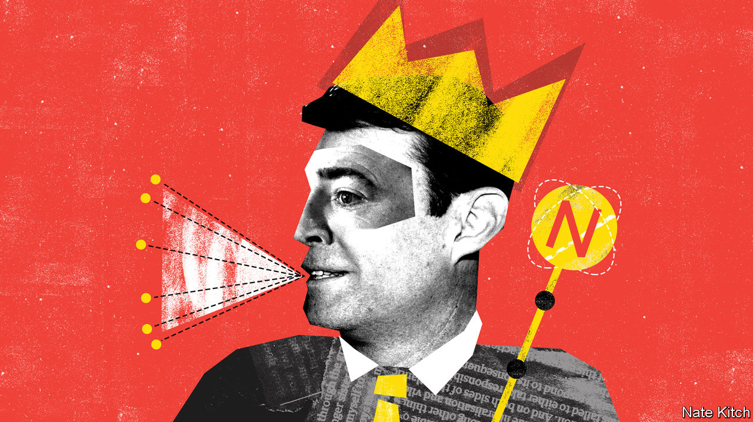

THE LIST of British politicians who have had a “good pandemic” is as short as the list of those who have had a bad one is long. But it must surely include the mayor of Greater Manchester. The pandemic has been good for Andy Burnham’s national political profile. He has had a bigger impact on the government’s covid policy than any other Labour politician, including Sir Keir Starmer. More important, it has been good for the great cause he has championed for the past decade—devolving power to the provinces.

As the voice of northern common sense and the scourge of southern muddle, Mr Burnham has excelled at getting himself heard in the capital. He has repeatedly raised the alarm early about the government’s failure to work with local authorities: for example, neglecting to provide local officials and experts with timely data about local infection rates. His success is partly a testament to his network and skills. As a former secretary of state for health (who, incidentally, presided over Labour’s response to the swine flu outbreak), he has good connections in the national press, and as a canny northerner he knows how to exploit the regions’ resentments of the Great Wen. It is also testament to the inherent virtues of regionalism: who better to tell you where the shoe pinches than the person who is wearing it? And who better to shape policy for a place than those who know it best?

Whitehall, argues Mr Burnham, operates in departmental silos: a regional mayor can integrate them and forge policies that suit the city-region’s particular needs. Manchester’s work in co-ordinating health and social care is a prime example of this approach. Mayors can also be innovators, designing local policies that can later go national. Mr Burnham took a radical (and successful) approach to getting homeless people housed, and was also one of the first to spot that the pandemic couldn’t be controlled if the homeless were left on the streets. And smaller units of government can often be nimbler than large ones. Manchester, for instance, managed to acquire millions of pieces of personal protective equipment for health workers in May, when Whitehall was still struggling to source the stuff.

Yet, measured by the proportion of revenue raised centrally and locally, Britain is far and away the most centralised country in the G7. This model of government doesn’t give Mr Burnham much scope for doing things differently. His powers are limited compared with, say, those of American mayors: some Mancunians have dubbed him “the bus conductor”, because he has more power over local transport than over schools and the police.

Covid-19 has reinforced the case for changing this model by exploding the most powerful argument against devolution: that central government is much more competent than the local sort. It has repeatedly demonstrated that even a weak mayor can come up with good ideas and tie together disparate policies. Germany has been much more successful at controlling the pandemic, in part because of its highly devolved public-health system.

The pandemic effect comes at a time when the arguments in favour of devolution are gaining traction. “Levelling up” areas outside the south-east of England is Boris Johnson’s mantra, and place-based policymaking is essential to achieving it. Regional inequality is an ancient and complex problem, but one-size-fits-all policies are part of its cause, not the solution to it. This week a group of leading economists, assembled by Mr Burnham, has published a report that both provides rich details about Manchester’s mix of strengths (clusters of excellence in medical innovation and manufacturing) and weaknesses (entrenched and growing poverty), and makes it clear that the only way forward is to involve local people with local knowledge not just in implementing new policies, but also in designing them.

Yet the centre rarely chooses to give up power. Dominic Cummings, Mr Johnson’s chief adviser, who cut his teeth in politics campaigning against a north-east assembly, is as hostile to local politicians as he is to national ones. His solution to regional inequality is to move bits of government to the provinces without shifting the locus of power. That would put lipstick on the pig of centralisation while doing nothing to capture the benefits of local knowledge. But the imminence of a white paper on devolution suggests that others are prepared to take the arguments for it more seriously. The “City Hall” faction in Downing Street (people who worked with Mr Johnson when he was mayor of London) is instinctively in favour of mayoral power, and Michael Gove, the Cabinet Office minister, has spoken enthusiastically about the need for devolution.

The government will not be able to ignore Mr Burnham, for the main battleground of British politics is now the northern constituencies (including Mr Burnham’s old seat of Leigh) that fell to the Conservatives in the election. This is a double blessing for the mayor. The Tories can’t hold on to power without offering something substantial to these red-wall voters; so he is in a good position to demand both money and freedom from central control. Labour can’t return to power without reversing its losses in the north, as Sir Keir admitted by giving his party-conference speech in Doncaster this week; so this gives Mr Burnham a fine chance to influence its policies. Labour needs to put a northern face on a party that has been run by two Londoners in a row. It also needs to tap people with executive experience, given that only one member of the current front bench has held ministerial office.

Britain was not always the highly centralised country it is now, and British politics was not always the monopoly of Westminster cliques. Victorian England was a land of mighty cities and powerful local economies that celebrated their success in magnificent civic buildings. Some of Britain’s most powerful politicians, such as Joseph Chamberlain on the Liberal side and Herbert Morrison on the Labour side, made their names as mayors. The ground has been prepared for a return to a better balance. ■

This article was downloaded by calibre from <https://www.economist.com/britain/2020/09/26/andy-burnham-strengthens-the-case-for-devolution-in-britain>

|  |  |  |  |
| --- | --- | --- | --- |
| Previous | Articles | Sections | Next |

|  |  |  |
| --- | --- | --- |
| Britain | Sections | Business |

International

Covid-19 and poor countries: From plague to penury

.

|  |  |  |
| --- | --- | --- |
| Britain | Sections | Business |

|  |  |  |  |
| --- | --- | --- | --- |
|  | Articles | Sections | Next |

#### From plague to penury

# The pandemic is plunging millions back into extreme poverty

It could take years for them to escape again

Sep 26th 2020 | CÁRDENAS, KAMPALA AND MUMBAI

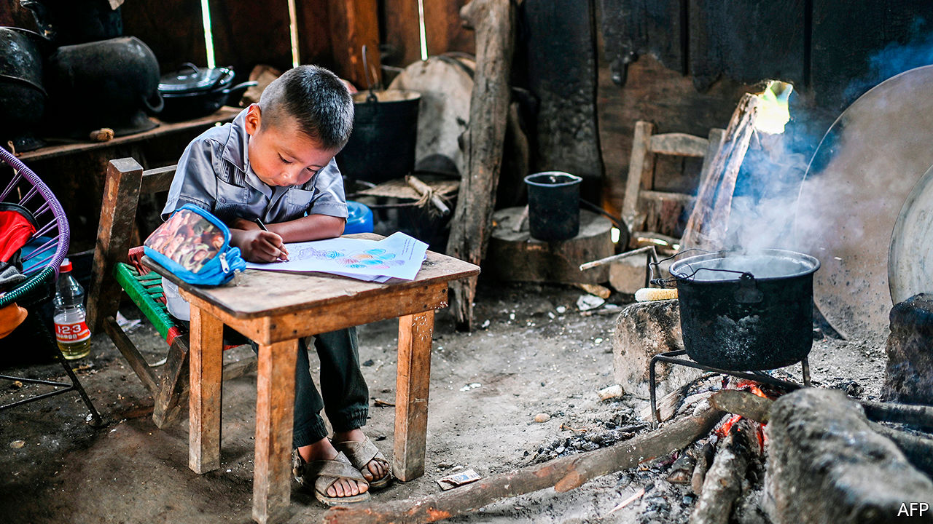

Editor’s note: Some of our covid-19 coverage is free for readers of The Economist Today, our daily [newsletter](https://my.economist.com/user#newsletter). For more stories and our pandemic tracker, see our [hub](https://www.economist.com/news/2020/03/11/the-economists-coverage-of-the-coronavirus)

FOR MORE than a decade Suresh Aryal has flogged momos, steamed dumplings from Nepal, on the streets of New Delhi. On a good day the 32-year-old could take home as much as 6,000 rupees ($82). Then in March, as covid-19 spread, India shut down. Mr Aryal waited for things to improve for three months. When they did not, he returned to his home village in Nepal.

India has since eased its lockdown. But Mr Aryal has no plans to return to the Indian capital. While people are still strapped for cash and reluctant to eat on crowded kerbsides, there is little point. Years spent surviving in a big city and sending money home to his family have left him with no savings. He has been getting by on loans from neighbours, but such generosity has its limits. Jobs are scarce in the village and Mr Aryal does not qualify for government support. “I don’t have a plan,” he says. “I’m going to have to hustle to feed my family.”

Mr Aryal is not alone. According to estimates in June by the World Bank, national lockdowns and the ensuing economic catastrophe will push between 71m and 100m people into extreme poverty this year, defined as subsisting on less than $1.90 a day (at 2011 prices). Its predictions have worsened since the pandemic began, and suggest that three years of progress will be wiped out. Some countries could be even worse hit, depending on the scale of the recession (see chart). From 1990 until last year the number of extremely poor people fell from 2bn, or 36% of the world’s population, to 630m, or just 8%. Most of those left in poverty were in sub-Saharan Africa (see map) and in countries riven by conflict. By contrast, almost half the newly destitute will be in South Asia.

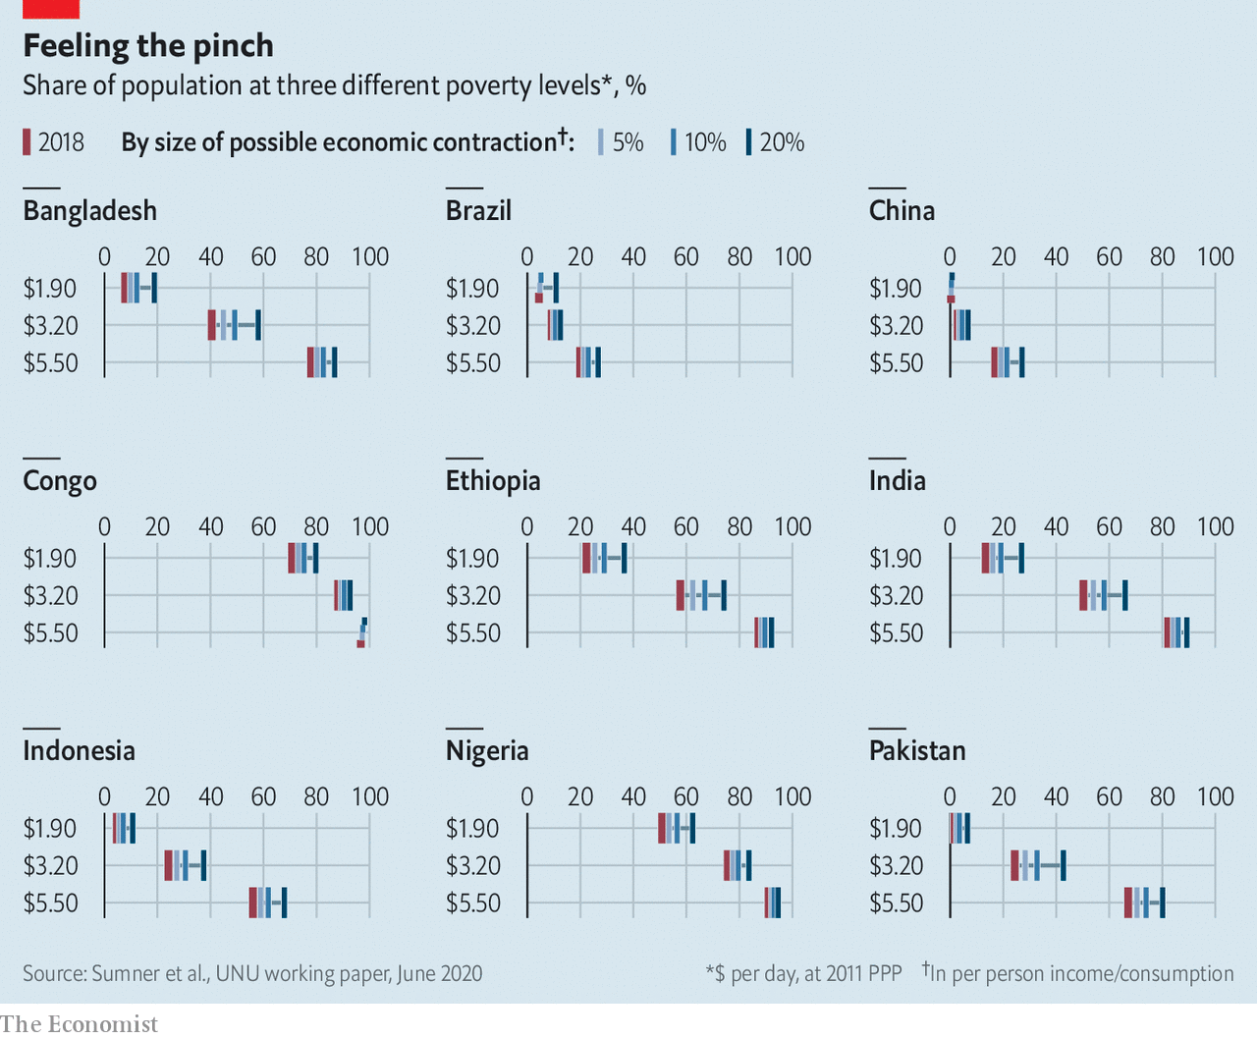

The United Nations is even gloomier. It defines people as poor if they do not have access to things like clean water, electricity, sufficient food and schools for their children. Working with researchers from Oxford University, it reckons the pandemic could cast 490m in 70 countries into poverty, reversing almost a decade of gains.

The economic crisis caused by the pandemic has exacerbated inequalities more sharply than previous recessions. The pandemic has left them with few fallback options. Those who lost formal jobs were unable to make a quick buck in the informal sector driving rickshaws, shining shoes or sorting rubbish, because the world had shut up shop. Lockdowns have frozen entire economies—black, white and grey. Since the disease has struck everywhere, relatives in richer countries may not be able to send extra cash home; remittances may drop by about a fifth this year, the biggest decline in recent history, according to the latest figures from the World Bank.

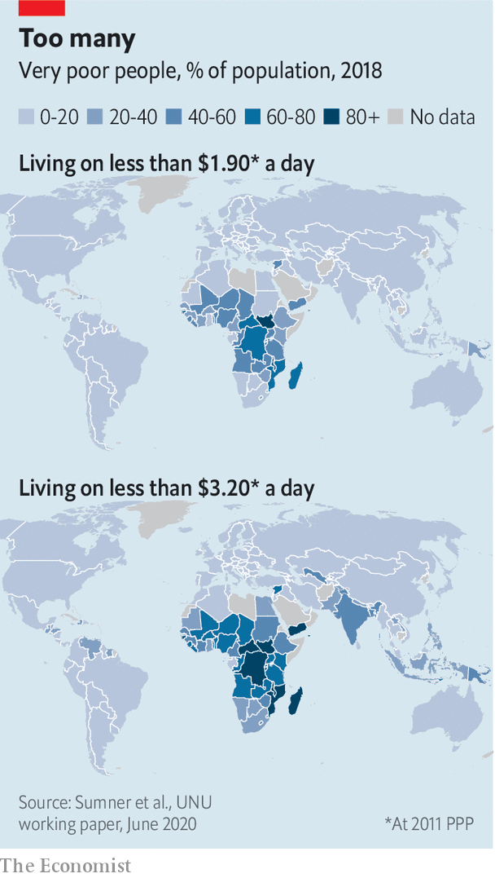

Worst affected have been the millions who escaped poverty by moving to bustling cities with running water, electricity and schools. Many have lost work and fled to more rural areas, where there are few jobs but at least living costs are cheaper. Official data in India suggest 10m people have relocated, but others reckon the total is five times more. In Kampala, Uganda’s capital, SafeBoda, a motorbike ride-hailing app, reckons that 40% of its drivers went back to the countryside under the lockdown. Returning to big cities holds little appeal until it is clear that economic activity is picking up and that further lockdowns are unlikely. With places such as Jakarta, Indonesia’s capital, announcing new restrictions in response to rising infections, it is not clear when that will be.

The economic crisis is already turning into a food crisis. Peter Lutalo ran a thriving bar in Kiboga, in central Uganda. His family used to eat meat at the weekend and drink milky tea every day. But since the government ordered bars to close they can afford meat only once in three weeks and take their tea black. He is far from alone. The number of people unable to afford enough to eat could double as a result of the pandemic, says the UN’s World Food Programme. That would mean an additional 130m people this year suffering from the sort of debilitating hunger that harms adult health in the long term and can stunt children’s development.

Nor have international organisations plugged the gap. Anna Obba is a teacher in the Bidibidi refugee camp in Uganda. When schools shut down, her income disappeared and her children’s education was disrupted. The World Food Programme cut food rations for refugees by 30% in April, citing a financial crunch. Since then the family has been living on one meal a day.

The disruption to education will have awful long-term consequences. Children whose families have fled cities will probably get a worse education in rural areas, if they get one at all. A survey by the UN’s World Health Organisation found that in August schools were fully open in only six of 39 African countries; only 12 more expect classrooms to reopen this month. Kenya has closed schools until 2021. As every year of education is reckoned to increase annual earnings by roughly 10%, the consequences for poor children are alarming.

The harm to health-care systems will be long-lasting, too. Clinics have been short of staff as medics have been unable to travel to work safely. People have been nervous about visiting them, too. The Bill & Melinda Gates Foundation says vaccination rates among children are dropping to levels last seen in the 1990s. Some of those jabs can be done once doctors are able to work properly again. But for infectious illnesses like measles, even a temporary pause may be lethal. Just 67% of the world’s children may get a crucial third dose of the diphtheria-tetanus-pertussis vaccine (which is usually administered around the age of six months) this year. Last year 84% did.

Some hope that, as lockdowns lift, economies will start to grow again fast, as they often do after disasters. Large parts of Vietnam were destroyed during the war there, but the country bounced back rapidly thanks to economic reforms: between 1990 and 2015 real GDP per person tripled, according to IMF estimates. The portion of the population living on less than $1.90 a day has fallen from over 60% in the 1980s to less than 5% just before covid-19 struck.

Poor countries are unlikely to see similar growth in the short term. For the first time in 25 years sub-Saharan Africa will fall into recession this year. The IMF is forecasting a contraction of 3.2% in the region in 2020, and an underwhelming rebound to 3.4% growth next year. Among the G20 economies India’s shrank most in the spring; its GDP is set to fall by about 4.5% in 2020. It may take some time to catch up. “Historically certainly, growth and poverty reduction have gone hand in hand,” says Carmen Reinhart, chief economist at the World Bank. “But there are enormous question-marks about how much growth we’re going to get.”

There are some signs of improvement. According to recent phone surveys by the World Bank in Ethiopia, 87% of respondents said they had had at least an hour’s work in the week before the interview, though that is still below pre-pandemic levels. Employment levels in Nigeria are almost back to their pre-pandemic level.

But it seems likely that a return to growth will be fitful and uneven. People in poor countries are plainly desperate to return to work. Most are young, and so less vulnerable to covid-19. The World Economic Forum estimates that just 3% of Africans are over 65 years old, whereas over 40% are under 15. Hunger could kill them before the virus does.

## Hungry for work

If these economies were getting going again, those who stayed in cities should be able to find plenty of work, given the exodus to the countryside. Poor workers still have the same skills they had six months ago; most are keen to use them. But demand for labour remains low. Vishwanath Kamble used to earn around 350 rupees a day as a cobbler in Mumbai. With offices shut and few passers-by, he more often gets only ten rupees nowadays. When he says his daily prayers, he pleads for things to go back to how they were before. That is still far off. Data from Google Maps show that even in mid-September visits to Mumbai’s restaurants, cinemas and shopping centres were down by over 70% compared with January and early February.

Widespread fears about the spread of the virus are still hampering any recovery. “I’m scared too, but what can I do? I have to go to work,” says Munni Mehra, a maid looking for a job in Mumbai. Her husband is working as a cook, earning 10,000 rupees a month. But if Ms Mehra stays at home much longer they will have to go back to their village in Uttarakhand, in India’s far north. Domestic workers see the irony in how middle-class employers think they are the ones at risk if they rehire house servants, says Martha Chen of Harvard, who has been interviewing informal workers around the world throughout the crisis.

Cleaners, with their meagre salaries, are not the ones visiting shopping malls, spas and cinemas where covid-19 thrives. Raju, a flower-seller in the same city, can no longer deliver flowers to people’s homes because security guards will not let him into posh blocks of flats. With no trains running, he has been unable to get to the wholesale market, so has had to use pricier local suppliers. As a result his costs have soared. Since covid-19 took hold in India, his earnings have almost halved, from 13,000 a month to 7,000 rupees.

Nor can poor countries rely on foreign spending. The sharp fall in oil prices earlier this year was enough to slash revenues in countries like Nigeria and Angola that rely on oil exports. In two-thirds of poor countries, commodities make up more than 60% of total merchandise exports, according to the UN’s latest estimates, rising to 88% in Zambia and 100% in Angola. Foreign tourists are not booking safaris in east Africa or beach breaks in Bali. Demand for exports such as Kenyan flowers and Bangladeshi garments has slumped, too. These industries can expect to recover when the pandemic subsides and borders reopen. But the poor cannot wait.

For the time being they must rely on help from their own governments. The World Bank reckons that in the past six months 212 countries and territories have rolled out—or made plans to roll out—1,179 social-protection measures that will reach 2bn people. As well as the usual efforts to hand out food and waive utility bills, poor countries are trying out new ideas. Kenya’s government has started a programme to give temporary jobs to more than 26,000 young Kenyans. Montenegro’s is offering subsidies to the tune of 70% of the minimum wage to encourage employers to create new jobs.

Cash handouts, heralded by policymakers for years as a cheap and effective form of support, are proving most popular. Technology is helping. A new national ID system in the Philippines and a unified digital payment system in Tunisia have been speeded up, so that governments can get cash to the poor faster. The Democratic Republic of Congo wants to use mobile-phone data to locate the poor and then send money directly to their e-wallets. In July the central bank also said it would set up special accounts—either through banks or online—to hand out emergency cash.

But such schemes are useful only if governments can afford to hand out serious lumps of cash. Poor countries on average have spent just $4 a head on programmes to help the poor during the covid-19 crisis, compared with an average of $695 per head of the population in rich countries such as Britain, France and America, according to World Bank estimates. The Congolese government plans to hand out $50m to just two million people in Kinshasa and other badly affected provinces, amounting to $25 for each recipient.

And in other countries governments are doing far from enough. A World Bank survey in Ethiopia in June found that 2% of households had received government help in the previous three weeks. A poll of people in Indian cities by the London School of Economics at around the same time found that only a fifth of those responding had received any money from the government. The transfers on average made up less than a quarter of their monthly salary.

Other governments are barely doing anything at all. Residents of Cañales, a poor suburb of Cárdenas, a smallish city in the Mexico, say the only help they have received was a single round of food packages from the state government in May. Marco Antonio González Cruz has been jobless since the pandemic struck. But he isn’t holding out for help from politicians. “They only come when they want the vote,” he says. President Andrés Manuel López Obrador, a left-wing populist, created a slew of welfare programmes after taking office in 2018, including an expanded pensions system, an apprenticeship scheme for the young and a tree-planting programme in a number of Mexico’s states. But he has provided close to nothing in response to the worst recession the country has seen in a century.

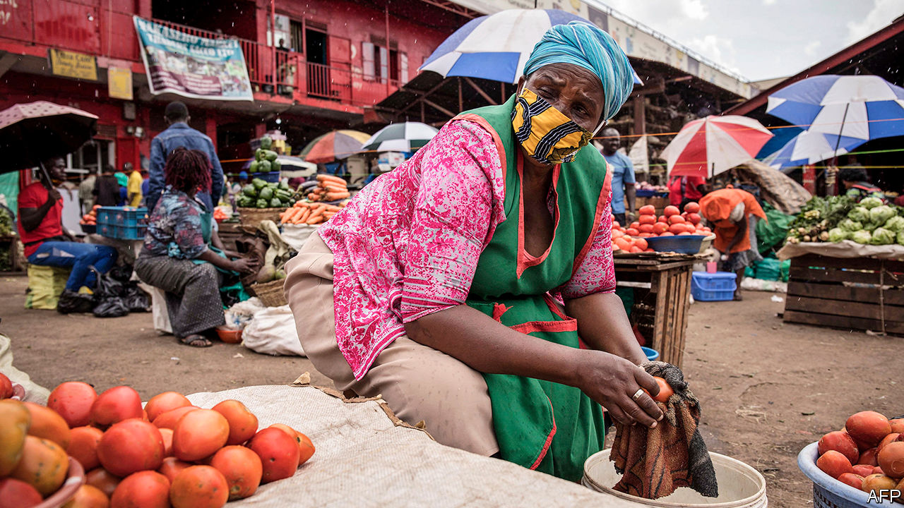

Because the urban poor have been harder hit than those in rural areas, governments need to spend any money they do have more cleverly. The Indian government should expand its rural employment guarantee scheme to urban areas, suggests Abhijit Banerjee, an economist at the Massachusetts Institute of Technology. The programme, which provides 100 days of guaranteed work every year, could deploy low-skilled workers as assistants in primary schools or care workers for the elderly. “If the cities recover, then there is hope,” argues Mr Banerjee, who won the Nobel prize for economics last year.

Governments will struggle to continue funding such efforts as revenues fall. Emerging-market governments issued $124bn in hard-currency debt in the first six months of the year. But there are limits to how much more they can borrow. The recent wave of sovereign downgrades has been startling, even compared with previous crises.

## Too little help from their friends

The response from richer governments and international institutions has been patchy. The IMF has disbursed over $30bn in emergency financing to 76 countries since March. It has acted fast, but the sum is far from enough. Earlier this year African finance ministers got together and calculated that African countries alone will suffer a short-term funding gap of $100bn in 2020, rising to $200bn next year.

The G20 has agreed to suspend payments between May and December on bilateral debt from 73 of the world’s poorest countries, if they want such help. That is a fraction of the $31.5bn in external debt servicing they face in that period. So far just 42 countries have requested support, which would free up $5.3bn for them to spend on things like health care and welfare programmes. The scheme doesn’t touch commercial lending from banks or bondholders. Nor does it include Asian countries such as India and the Philippines, where many of the newly destitute reside.

Politicians in poor countries, shackled by debt, will struggle to provide meaningful support. The pandemic has shown how flimsy recent progress has been, says Andrew Sumner of King’s College London. He reckons that the proportion of people in poor countries living on less than $1.90 a day had fallen last year to 17%. But a third were still living on less than $3.20 a day. Covid-19 has exposed the vulnerability of that group—the poor but not destitute—in the face of a big economic shock. Policymakers must now help people climb back above the poverty line—and devise ways to make them more resilient to future shocks. ■

This article was downloaded by calibre from <https://www.economist.com/international/2020/09/26/the-pandemic-is-plunging-millions-back-into-extreme-poverty>

|  |  |  |  |
| --- | --- | --- | --- |
|  | Articles | Sections | Next |

|  |  |  |
| --- | --- | --- |
| International | Sections | Finance & economics |

Business

Oracle: Larry’s last stand

.

TikTok: The principals’ uncertainty

.

Cola wars: Fire-starter

.

BP v utilities: The new majors

.

Bartleby: The toughest business school

.

Rocket Internet: Coming down to earth

.

Microblogging: Weibo woes

.

Schumpeter: Lighting up Japan Inc

.

|  |  |  |
| --- | --- | --- |
| International | Sections | Finance & economics |

|  |  |  |  |
| --- | --- | --- | --- |
|  | Articles | Sections | Next |

#### Larry Ellison’s last stand

# Can TikTok help Oracle stay relevant in the cloud-computing age?

The corporate-software giant has a few things going for it. But it faces stiff competition

Sep 23rd 2020 | SAN FRANCISCO

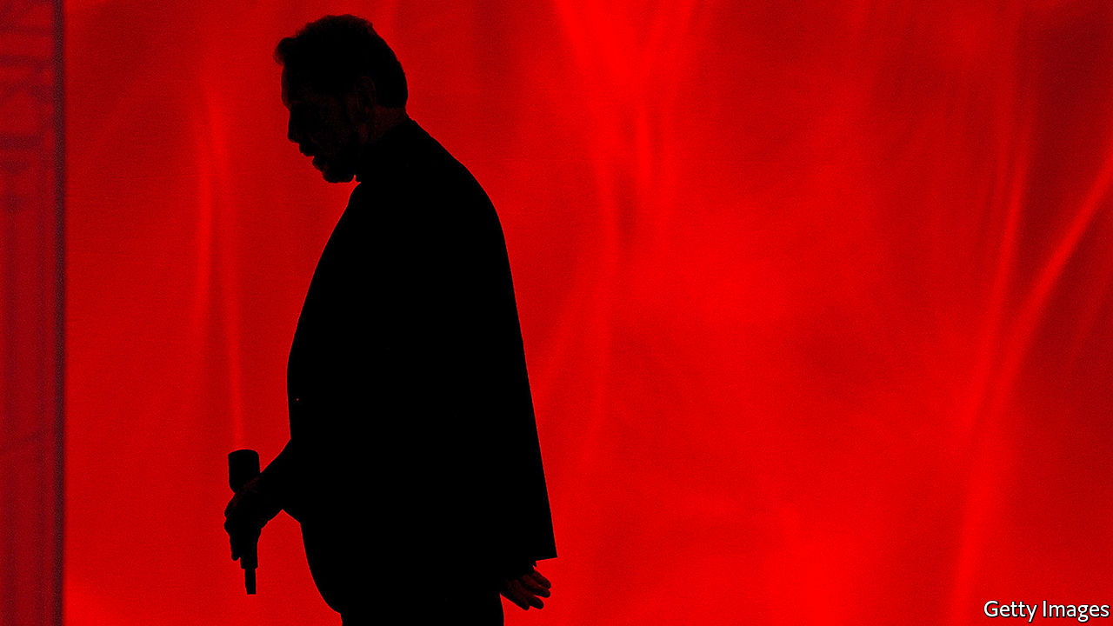

LARRY WHO? A few weeks ago asking a young tech worker in Silicon Valley about Larry Ellison, co-founder, former boss and now chief technology officer of Oracle, might have elicited blank stares. More surprising, given that his company is still the world’s second-largest software-maker, a follow-up question might have been: “Remind me what Oracle sells?”

Being treated like a has-been must have irked the 76-year-old Mr Ellison. In Oracle’s heyday 20 years ago he was Silicon Valley’s best-known rogue billionaire—yesteryear’s Elon Musk. “The Difference Between God and Larry Ellison”, one of the many books written about the firm and its colourful founder, was subtitled “God Doesn’t Think He Is Larry Ellison”.

Now he and his firm are back in the headlines, thanks to something that, in software terms, is about as far from Oracle’s bread and butter of corporate databases as jelly beans are from white toast. Its deal to team up with TikTok has made its brand recognisable even to many teenagers—the main clientele of the Chinese-owned video-sharing platform. Whether the notoriety lasts more than 15 seconds, the length of a typical TikTok video, is another matter.

Attempts at reinvention are nothing new in Silicon Valley. It can be made harder by lucrative legacy businesses; just ask IBM, another once-great information-technology (IT) giant that has been sliding into irrelevance. Oracle would rather emulate Microsoft, which has ridden the cloud revolution to a market capitalisation of $1.6trn and stellar returns (see chart). The TikTok arrangement, which would see Oracle host the app’s data in its cloud, confirms that is Mr Ellison’s plan. Like the transaction—which could yet be blocked by President Donald Trump (see next article)—Oracle’s metamorphosis is not, however, a done deal just yet.

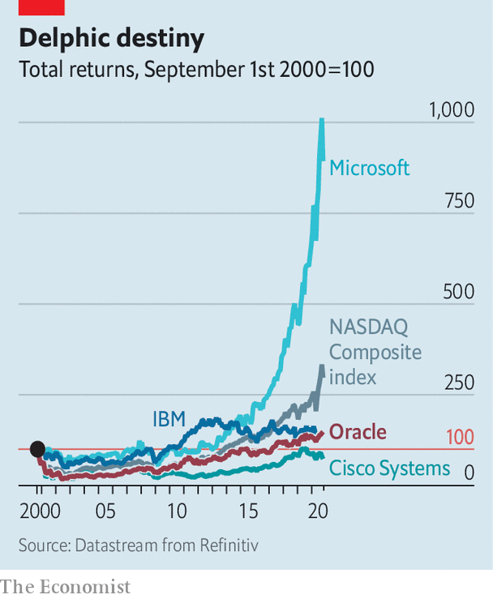

Since its founding in 1977 Oracle has been the odd one out in Silicon Valley—less focused on inventing the next new thing and more on signing the next big contract. By the mid-1990s it dominated the market for “relational” databases, which underlie corporate applications from book-keeping to supply-chain management. After the dotcom crash in the early 2000s it used its pile of cash and high share price to consolidate swathes of the IT industry. Within a few years it acquired several software rivals, including BEA Systems and PeopleSoft, as well as Sun Microsystems, a maker of powerful computers. It is still hard to find a sizeable firm that does not send a cheque to Oracle’s snazzy headquarters in Redwood City. With customers locked in by the sheer tedium of switching databases, Oracle could extract huge profits. In its last financial year the company earned a net income of more than $10bn on revenue of nearly $40bn.

Success in old IT was a big reason why Oracle was late to the new sort: cloud computing. Mr Ellison long dismissed it as a faddish label for existing technology. By the time he realised it was an epochal shift in IT, Oracle had fallen behind. Oracle Cloud Infrastructure (OCI), as it calls its offering, is said to have sales of less than $2bn annually, compared with more than $40bn for Amazon Web Services (AWS). The e-commerce titan’s market-leading cloud unit is valued at several times Oracle’s market capitalisation of $178bn. Cloud-based rivals of the sort that Mr Ellison once dismissed, such as Adobe and Salesforce, are worth around a quarter more than his firm.

Even in databases, Oracle’s core business, the world has moved on. For many new applications, such as customer-facing websites, its tools are too expensive and inflexible. Recent years have seen the rise of more specialised digital repositories, many of them in the cloud and based on malleable “open source” software. According to Gartner, a research firm, Oracle’s share of the database market fell from nearly 44% in 2013 to 28% last year. And it has yet to shake off a reputation for antagonising clients with things like audits to verify their use of software by workers—and hefty charges for firms that exceed licence limits. Brent Thill of Jefferies, a bank, echoes other Oracle bears when he says that the company has been stuck for years even as “we are living in the data age, the biggest tech-boom ever.”

## Seers of a brighter future

Oracle optimists counter that the firm has a few things going for it. One is management. The death last October of a co-CEO, Mark Hurd, left Safra Catz as the woman in charge. She is widely considered an effective operator. Mr Ellison, who stepped down as chief executive in 2014, has in recent years taken a more active role in product development—considered his forte—without treading on Ms Catz’s toes. The upshot, says Ted Friedman of Gartner, is better technology such as the “autonomous database”, which uses artificial intelligence to automate work once reserved for human IT administrators. For example, it allows software updates to be installed without shutting systems down, a dreaded procedure which can go badly wrong.

OCI enjoys the latecomer advantage in the cloud, says Clay Magouyrk, one of its leaders. “We did not have to take the circuitous path others had to take to get it right,” he says. Mr Magouyrk points to Oracle’s next-generation cloud platform, which will, among other things, offer hundreds of local sub-clouds that let customers keep their data close to home, as privacy regulations may require them to. In April Zoom, a videoconferencing service, opted for OCI to help it manage pandemic-fuelled growth (mostly because Oracle charges less for the use of its networks). Landing the TikTok contract would be another boost: the video app spends an estimated $1bn annually on cloud-computing services.

A bigger opportunity for Oracle lies in cloud-based applications. It has begun converting some of its existing customers to these programs, which are more sophisticated than the basic computing and storage offered by AWS and OCI, observes Mark Moerdler of Bernstein, a broker. The company’s bundle of cloud-based services already accounts for 8% of its software revenue; sales have been growing by more than 30% a year.

The wild card is Oracle’s political bets. The firm has positioned itself close to Mr Trump. In 2016 Ms Catz served on the president’s transition team and this year Mr Ellison hosted a fund-raiser for him. This did not help them win a lucrative cloud contract with the Department of Defence; OCI was not technically up to snuff. But being in the White House’s good graces may have helped Oracle beat Microsoft (which won the Pentagon contract) to the TikTok deal. If the deal succeeds—a big “if”—Oracle’s cloud may emerge as a digital haven for companies seeking to reassure Washington that their data are safe from prying Communist eyes in Beijing amid the Sino-American tech cold war.

It is, then, too early to write Oracle off. When a group of youngish cloud-services CEOs recently met reporters on a Zoom call, they were unanimous in their assessment. Jennifer Tejada of PagerDuty, which helps firms manage IT incidents, summed it up: “You have to respect Oracle for finding ways to keep itself relevant.” Relevance is not the same as fast growth, which may prove elusive given competition from AWS and others. But it is better than the digital dustbin of obscurity.■

This article was downloaded by calibre from <https://www.economist.com/business/2020/09/23/can-tiktok-help-oracle-stay-relevant-in-the-cloud-computing-age>

|  |  |  |  |
| --- | --- | --- | --- |
|  | Articles | Sections | Next |

|  |  |  |  |
| --- | --- | --- | --- |
| Previous | Articles | Sections | Next |

#### The principals’ uncertainty

# Why the TikTok deal is like Schrodinger’s cat

To understand the video-app saga, think of quantum mechanics

Sep 26th 2020 | SAN FRANCISCO

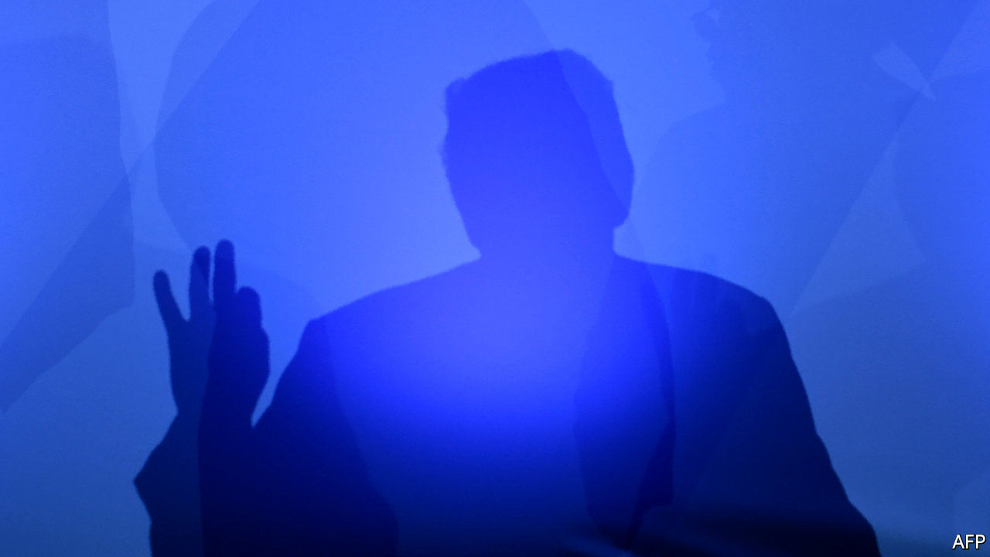

IF YOU WANT to understand the agreement between TikTok, a Chinese-owned video-sharing service, and Oracle, which sells corporate software (see article), it is useful to think of Schrödinger’s cat. Like the hypothetical feline of quantum mechanics, simultaneously alive and dead, the deal seems to be in two states at once—one hunky-dory to Beijing but fatally flawed to Washington, the other vice versa.

Take the question of who owns TikTok Global, the new company to be spun out of ByteDance, TikTok’s Chinese owner, to give the data of American users a secure home in America. ByteDance insists that it will hold 80% of the new entity. The Americans say they will control a majority stake. Oracle and Walmart, a supermarket titan which has joined in, will own only 20% of TikTik Global between them. But American venture-capitalists already own 41% of ByteDance. Apply the right maths and both the Chinese parent and the Americans own more than 50% of TikTok Global, which the deal values at $60bn and which is supposed to go public within a year.

What about TikTok’s technology? Beijing says that ByteDance’s eerily accurate recommendation engine is not for export. Security hawks in America want to ensure no data are diverted and the algorithm is not used to spread misinformation. So the source code will stay in China but Oracle will have access to it. How this will work in practice is about as clear as Schrödinger’s equation is to non-physicists.

In normal times everyone would resolve the ambiguities at the negotiating table. But times aren’t normal, especially in America. Ahead of November’s election, President Donald Trump prizes ambiguity. He wants to bash China but not irk America’s 100m users of TikTok, which he has threatened to ban (along with WeChat, a messaging app owned by another Chinese tech giant). A federal body that examines foreign investments in America looks ready to approve the Oracle deal, obviating a Department of Commerce edict banning Americans from doing business with TikTok from September 27th (a federal judge this week blocked the WeChat ban on free-speech grounds). Predictably, mostly positive noises from Washington have provoked angry ones in China, where state media have denounced the deal. Observe Schrödinger’s cat close enough and it ends up either dead or alive, after all. ■

This article was downloaded by calibre from <https://www.economist.com/business/2020/09/26/why-the-tiktok-deal-is-like-schrodingers-cat>

|  |  |  |  |
| --- | --- | --- | --- |
| Previous | Articles | Sections | Next |

|  |  |  |  |
| --- | --- | --- | --- |
| Previous | Articles | Sections | Next |

#### Fire-starter

# How Donald Kendall, as PepsiCo’s boss, sparked the cola wars

The legacy of the legendary salesman lives on

Sep 26th 2020 | NEW YORK

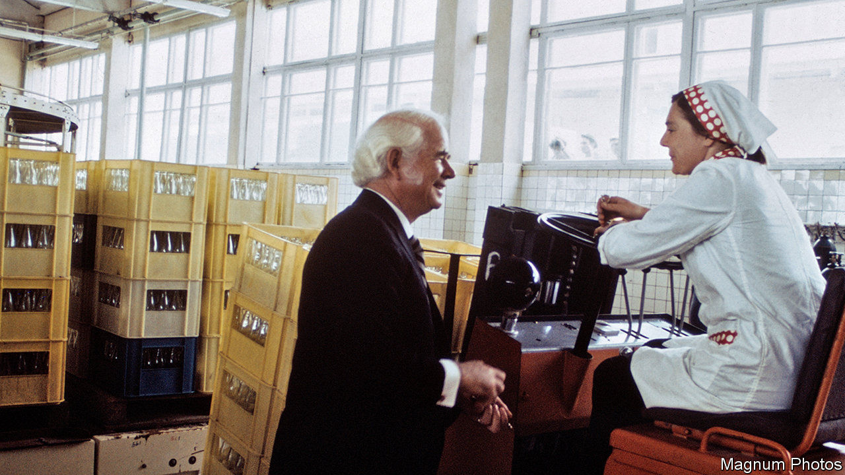

“ROCK AND roller cola wars, I can’t take it any more!” cried Billy Joel in his chart-topping song from 1989, “We didn’t start the fire”. He had had enough of the intense marketing battle between America’s fizzy-drinks behemoths. As the underdog, PepsiCo had stunned its bigger rival, Coca-Cola, by signing Michael Jackson, the era’s biggest musical star, to promote its brand in a record-setting $5m deal.

The cola wars became a cultural phenomenon. Credit for that goes to Donald Kendall, PepsiCo’s legendary former boss, who died on September 19th aged 99. A gifted salesman, he rose quickly through the ranks from his start on the bottling line to become the firm’s top sales and marketing executive at the tender age of 35. Seven years later he was named CEO. In 1974 he injected a dose of fizzy capitalism into the Soviet Union, which allowed Pepsi to become the first Western product to be legally sold behind the iron curtain. By the time he stepped down as boss in 1986, PepsiCo’s sales had shot up nearly 40-fold, to $7.6bn. His legacy continues to shape the industry.

Mr Kendall offered a mix of strategic vision, principled leadership and marketing flair. Two years after taking charge he acquired Frito-Lay, a leading purveyor of snacks, giving PepsiCo an advantage from diversification that persists to this day. PepsiCo’s revenues last year of $67bn dwarfed Coca-Cola’s $37bn in sales. Decades before Black Lives Matter he named African-Americans to top jobs, making PepsiCo the first big American firm to do so—staring down racists including the Ku Klux Klan, which organised a boycott.

But his masterstroke was the all-out marketing blitz against Coca-Cola, long the global market leader in non-alcoholic beverages. The two firms had competed for decades, but they mostly fought low-grade battles. Mr Kendall changed that, by forcing both companies into an advertising arms race. In 1975 Coca-Cola spent around $25m on advertising and PepsiCo some $18m. By 1985 those figures had shot up to $72m and $57m, respectively. In 1995 Pepsi outspent Coke by $112m to $82m.

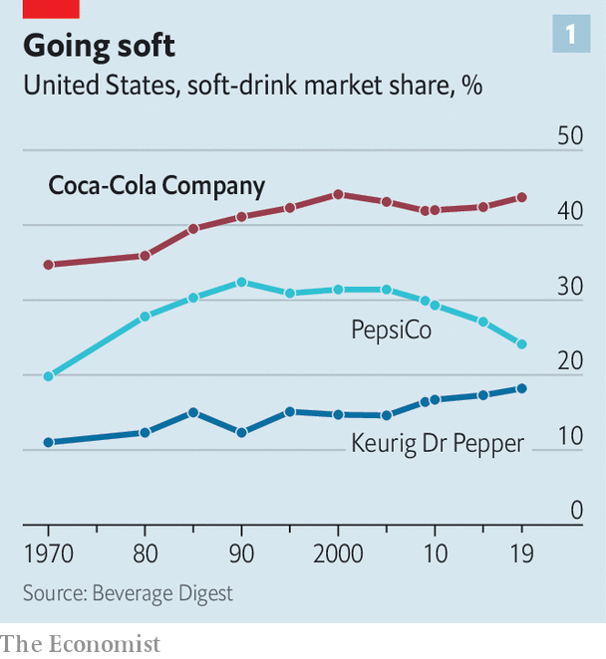

This was a risky gambit for both cola rivals. But it paid off in two ways. First, it helped fizzy drinks win a greater “share of throat” (a term coined by Roberto Goizueta, a former boss of Coca-Cola, who died in 1997). They went from 12.4% of American beverage consumption in 1970 to 22.4% in 1985. And though Coca-Cola maintained its lead in that period, with over a third of the market, PepsiCo’s share shot up from 20% to a peak of over 30% in the 1990s. Last year carbonated-drinks sales totalled $77bn in America, and over $312bn globally. Coca-Cola and PepsiCo remain dominant.

The second way that the cola wars benefited both companies was by turning them into “the world’s best marketers”, observes Kaumil Gajrawala of Credit Suisse, a bank. Today a decades-long obsession with cut-price volume growth has been replaced by a focus on revenues and profits.

PepsiCo in particular has relinquished some of the soft-drinks market, where its share has fallen back down to a quarter (see chart 1). But its marketing magic continues to sparkle, even if it is deployed to sell less sugary alternatives such as bottled water, coffee and energy drinks to health-conscious consumers. And over the past 40 years PepsiCo has returned nearly a third more to shareholders than Coca-Cola has (see chart 2).

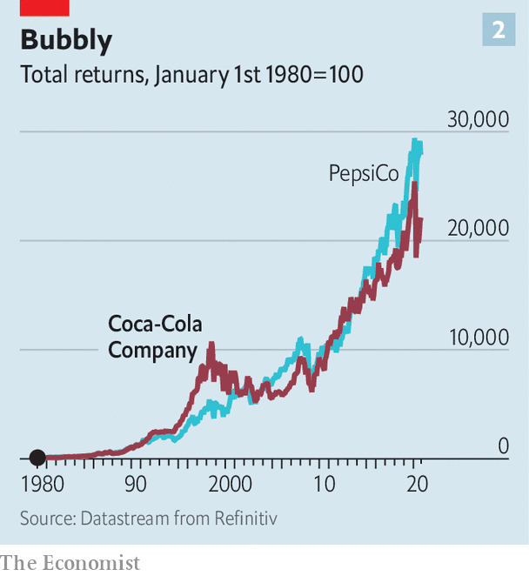

In many industries a cosy duopoly retards innovation and harms consumers. The happy outcome of the cola wars has been the exact opposite. As Mr Kendall himself observed, “If there wasn’t a Coca-Cola, we would have had to invent one, and they would have had to invent Pepsi.” ■

This article was downloaded by calibre from <https://www.economist.com/business/2020/09/26/how-donald-kendall-as-pepsicos-boss-sparked-the-cola-wars>

|  |  |  |  |
| --- | --- | --- | --- |
| Previous | Articles | Sections | Next |

|  |  |  |  |
| --- | --- | --- | --- |
| Previous | Articles | Sections | Next |

#### The new majors

# BP and other oil majors v utilities

Electric utilities are becoming power players in the energy industry

Sep 26th 2020 |

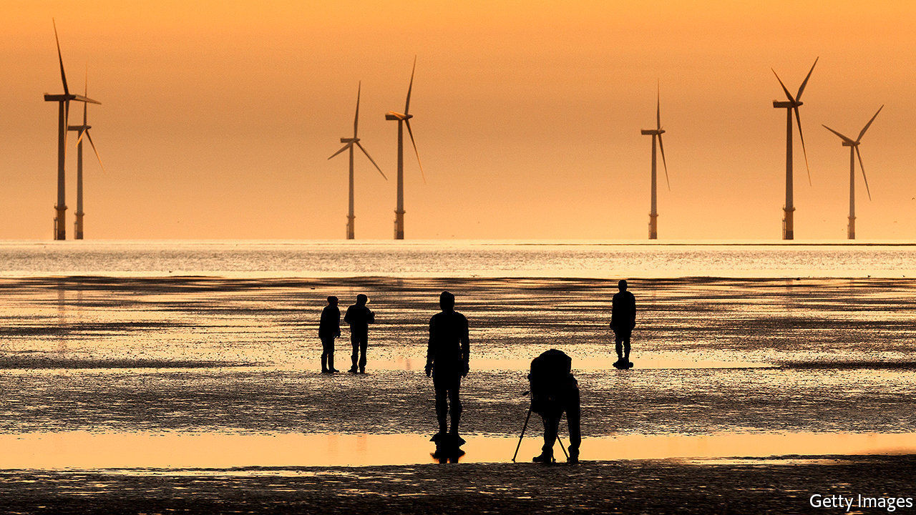

INVESTOR WEBINARS are not generally mass entertainment. But some 25,000 people tuned in this month when BP outlined plans to transform its business. Top on the British oil-and-gas giant’s to-do list is raising its wind, solar and biopower capacity from 2.5 gigawatts (GW) last year to 20GW by 2025 and 50GW by 2030, when annual investment in low-carbon energy will reach $5bn or so. BP hopes to become a new kind of energy major. It is not alone.

European electric utilities have lately emerged as the world’s top developers of wind and solar projects outside China (see chart). These offer growth and, in an era of ultra-low interest rates, stable returns thanks to long-term contracts. Concern about climate change means that big, risky drilling projects must offer higher returns to lure investors. Michele Della Vigna of Goldman Sachs, a bank, estimates that the divergent cost of capital for oil and renewables investments implies a price of up to $80 a tonne of carbon dioxide, well above the global average of around $3. As share prices of oil giants such as ExxonMobil have tanked amid the pandemic slump in demand for crude, those of electricity majors, such as Spain’s Iberdrola, Germany’s RWE or Portugal’s EDP, are up this year. That of Orsted, a Danish wind-energy champion, has risen by a third. BP wants in.

A decade ago excess capacity, the financial meltdown and competition from renewables firms imperilled Europe’s traditional power companies. Faced with the falling value of their coal and gas assets, many took the shift to cleaner energy seriously, says Deepa Venkateswaran of Bernstein, a research firm. Orsted has turned itself from an ailing state enterprise into the world’s largest developer of offshore wind. This year RWE and E.ON, another German firm, swapped assets, with E.ON concentrating on grids and RWE on generating clean power. Iberdrola, EDP and Italy’s Enel have invested in wind and solar projects in Europe and beyond.

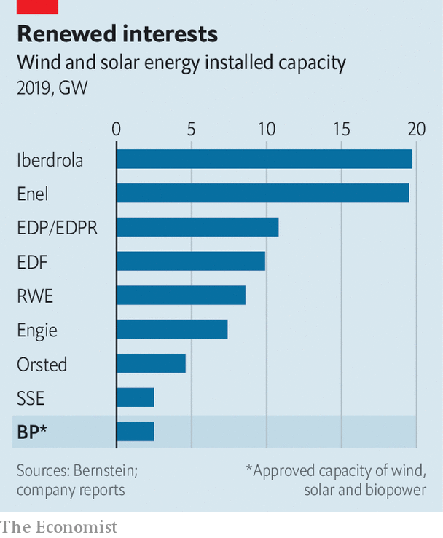

Now the falling cost of renewables is coinciding with rising ambition to deploy them. Dev Sanyal, who leads BP’s renewables business, sees “very vibrant demand” from America, where states and companies are keener on green than the carbon-cuddling federal government. In Europe, which wants carbon-neutral electricity by 2040, national energy plans require total investment of €825bn ($960bn) over the next decade, Goldman Sachs reckons.

Mr Sanyal says that BP’s trading capabilities and project management will give it an edge in such projects, which offer a rate of return of 8-10% on equity capital invested. But BP’s planned wind and solar capacity in 2025 would be less than half what Enel or Iberdrola will have by then, estimates Bernstein. Henrik Poulsen, Orsted’s outgoing boss, argues that building an offshore wind turbine is not the same as building an oil platform. “We have much more experience and we have stronger procurement,” he contends.

Those with green ambitions can take comfort. Plentiful future demand for renewables ought to leave room for everyone. George Papadimitriou, who runs Enel’s green business in North America, welcomes new, well-capitalised rivals. Having oil and gas companies join in, he says, “confirms that we’re on the right path”. ■

For more coverage of climate change, register for The Climate Issue, our fortnightly [newsletter](https://www.economist.com/theclimateissue/), or visit our [climate-change hub](https://www.economist.com/news/2020/04/24/the-economists-coverage-of-climate-change)

This article was downloaded by calibre from <https://www.economist.com/business/2020/09/26/bp-and-other-oil-majors-v-utilities>

|  |  |  |  |
| --- | --- | --- | --- |
| Previous | Articles | Sections | Next |

|  |  |  |  |
| --- | --- | --- | --- |
| Previous | Articles | Sections | Next |

#### Bartleby

# The world’s toughest business school

The challenges of being an entrepreneur in a refugee camp

Sep 24th 2020 |



IN 1996 CIVIL war erupted in what was then Zaire and is now the conflict-ravaged Democratic Republic of Congo (DRC). Karasira Mboniga managed to escape, eventually settling in the Kiziba refugee camp in Rwanda, and working as a secondary-school teacher. But he says that his life changed for ever when he started his own business in 2008, selling food and performing money transfers.

That business came under threat when the pandemic hit earlier this year. But Mr Mboniga was one of many refugees to be helped by the African Entrepreneur Collective (AEC), a charity which started to disburse grants from a special covid-19 relief fund in June.

AEC, which started in Rwanda in 2012, has had a focus on job creation from the start. Eventually it realised that helping refugees would serve that aim, as jobs would also be created in the host community. Until the pandemic, it focused on making loans, rather than grants, to small businesses.

Its new covid-19 fund was established with help from the MasterCard Foundation, the payment processor’s charitable arm. It has already helped almost 4,000 entrepreneurs; 91% of the businesses that were closed have since reopened. On average, the ventures have managed to increase their staff by a third within a month of receiving a grant.

Sara Leedom of the AEC says the charity has put few restrictions on how the refugees can spend the money. Some have used it to settle debts; some to pay their employees; some to restock the business; some on covid-related issues, such as sanitation; and some have invested in new technology. Many operate small shops, kiosks or cafés; several work in agriculture; and a few in tourism and hospitality. “We were blown away with what was possible,” she says.

All the residents in the camps tend to rely on grants from the UN refugee agency for their monthly income. When people do buy goods, they often have to purchase them on credit. As a consequence, the camp’s entrepreneurs can get easily into debt as they wait to be repaid by their customers. That, in turn, helps explain why loans and grants from charities can be necessary to tide them over.

As well as a grant, however, Mr Mboniga has received business training from the AEC and says he would advise other refugees to join the programme. In the long run, he hopes that “my business will help me to support my family, to be self-reliant”. But he also wants to “create jobs for other refugees who don’t have other sources of income”.

Another person to make it out of the DRC was Muzaliwa Rushama, who reached the Nyabiheke Camp in the Gatsibo district of Rwanda in 2008. For many years, he had part-time work delivering goods. Starting a business was difficult, he says, because he did not have enough capital and it was also hard to find somewhere to conduct his trade and to acquire business knowledge. From his part-time income, he would save around 20,000 Rwandan francs ($20) a month until eventually he was able to accumulate 300,000 francs. That allowed him to start his business, selling food, such as flour and rice, in 2017.

Mr Rushama started working with the AEC in 2018 and has benefited from training, particularly in book-keeping, which he found immensely useful. “I know how to count money in and out, my expenses and stock,” he says. He was able to borrow $100 in 2018 and is currently servicing a $300 loan; he estimates that the value of his business has risen more than threefold since it began. His dream is to diversify into selling other products, for example shoes and clothes.

The challenges of operating a business in the middle of a refugee camp are enormous, to put it mildly. Almost everyone there relies on aid. Access to traditional sources of finance, like banks, is extremely limited and expensive. Many goods need to be brought in from outside but the Kiziba camp has only a dangerous road linking it with the nearest town. On the plus side, the Rwandan government at least does not tax the enterprises run within the camps.

Creating a business gives refugee entrepreneurs two things: a degree of control over their own lives and hope for the future. For those who have languished in such places for years or decades both are invaluable.

AEC is expanding its operations. A year ago it began helping refugees in a Kenyan camp called Kakuma. Its entrepreneurial wards may never become the next Apple or Facebook. But turnover is not the only measure of business achievement. Small can be beautiful.

This article was downloaded by calibre from <https://www.economist.com/business/2020/09/24/the-worlds-toughest-business-school>

|  |  |  |  |
| --- | --- | --- | --- |
| Previous | Articles | Sections | Next |

|  |  |  |  |
| --- | --- | --- | --- |
| Previous | Articles | Sections | Next |

#### Rocket Internet

# Why Rocket Internet has come down to earth

Europe’s erstwhile online darling wants to delist

Sep 24th 2020 | BERLIN

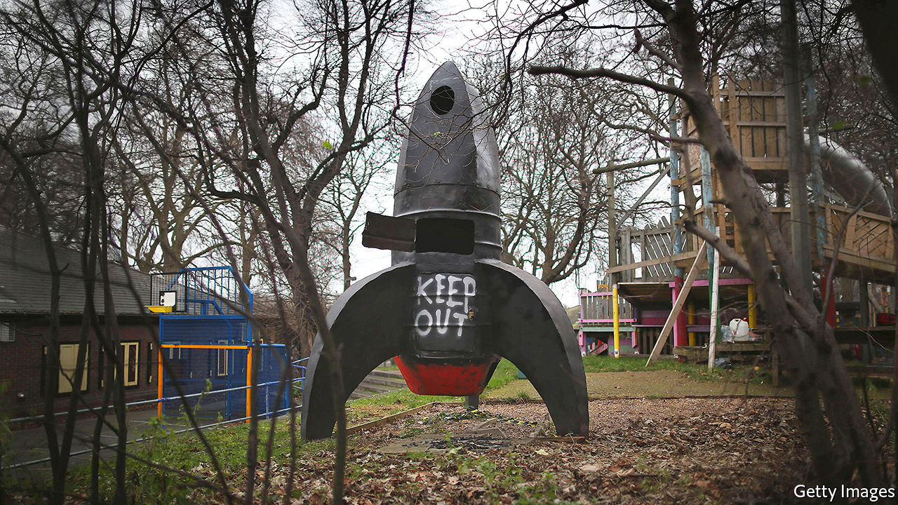

“I AM NOT Scrooge McDuck,” said Oliver Samwer in 2017 when he denied the request of shareholders of Rocket Internet, the startup incubator he co-founded with his two brothers, to use the company’s cash to boost its ailing share price through share buy-backs. Now the way he has handled a planned delisting of Rocket from stock exchanges in Frankfurt and Luxembourg reminds those same shareholders of Walt Disney’s money-hoarding cartoon character. Those who put money into Rocket’s initial public offering (IPO) in 2014 may end up with a hefty loss.

“It is totally legal and totally immoral,” says Michael Kunert of SDK, an association which defends investors’ rights, about the planned delisting of Rocket, expected to be rubber-stamped at the firm’s extraordinary general meeting on September 24th, after The Economist went to press. Rather than using external capital to buy investors out at a premium, the usual way to take a firm private, Mr Samwer has used company cash to buy back €223m ($260m) of its own shares. This pushed his clan’s stake to over 50%. He plans to use another €1bn of Rocket’s cash to buy out minority shareholders at €18.57 a share, the volume-weighted average price in the past six months but down from the IPO price of €42.50.

Mr Kunert reports that Rocket’s minority shareholders complain Mr Samwer is using the coronavirus crisis, which has hit nearly all the firm’s 200-odd startups and brought its market value below that of its cash and liquid assets, to push them out. They say that the price offered by Mr Samwer’s does not take into account Rocket’s €1bn-worth of stakes in unlisted startups such as Traveloka, an Indonesian online-travel firm. Investors are under no obligation to sell their shares, of course. But those who stay put will have little power to affect the course of the firm now that the Samwer brothers control the board with their majority stake. Rocket has stated it will be “better positioned” for long-term development if not listed on a stock exchange.

Why did Rocket not take off? Analysts say the air got thinner as soon as others in Europe got better at aping American e-commerce successes at home and in emerging markets—a business model that Rocket pioneered. Rocket’s successful IPOs, like that of Delivery Hero, an online food-delivery business which recently joined Germany’s DAX 30 blue-chip index, have in recent years given way to smaller technology investments and a handful of real-estate bets. Following last month’s spectacular crash of Wirecard, an online-payments processor accused of huge fraud, Rocket’s bruising re-entry from public markets leaves Germany even more bereft of digital darlings than it already was. ■

This article was downloaded by calibre from <https://www.economist.com/business/2020/09/24/why-rocket-internet-has-come-down-to-earth>

|  |  |  |  |
| --- | --- | --- | --- |
| Previous | Articles | Sections | Next |

|  |  |  |  |
| --- | --- | --- | --- |
| Previous | Articles | Sections | Next |

#### Weibo woes

# Can Weibo do better than Twitter?

China’s microblogging giant faces ever stiffer competition for advertising revenue

Sep 24th 2020 | BEIJING

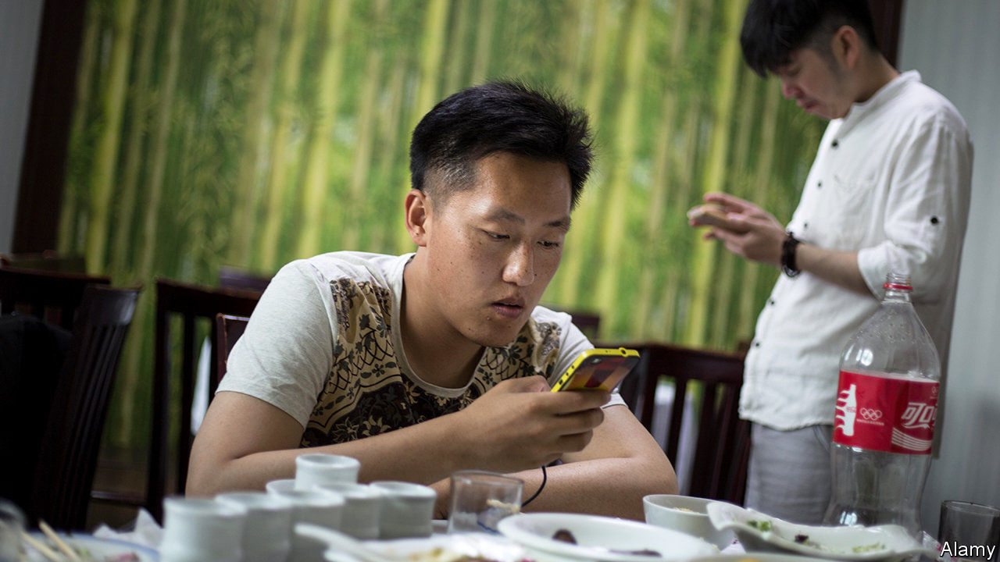

THREE YEARS after Twitter launched in 2006, Chinese techies created a similar microblogging service in China. Weibo (literally “microblog” in Chinese) boasted an average of 241m daily active users in March, more than Twitter. Like its American cousin, Weibo allows users to follow other users, tweet, retweet and browse a real-time list of trending topics (though it steers clear of politics, out of bounds in its communist homeland). And like Twitter, it relies heavily on advertising revenue.

So as coronavirus-induced uncertainty led advertisers to slash budgets, Weibo saw advertising revenue, which accounts for nearly 90% of sales, plunge. In the first quarter it fell by a fifth year on year, to $275m. Operating profit plummeted by more than half, to $58m. Delayed second-quarter results, due on September 28th, may be less terrible. China was the first to be hit by covid-19 but began to recover just as the West went into lockdown.

But Weibo also confronts a longer-term challenge. Yujun Shao of Westwin, a Shanghai-based digital-marketing firm, notes that for much of the past decade two firms—Weibo and Tencent (which owns WeChat, a messaging service)—sucked in the vast majority of advertising spending on Chinese social media. Today the “big two” are competing for ad yuan with another behemoth, ByteDance, which operates Douyin, an addictive short-video app (as well as TikTok, its global version). Other rising internet stars, such as Pinduoduo, which offers bargain shopping, are also muscling in on the advertising market.

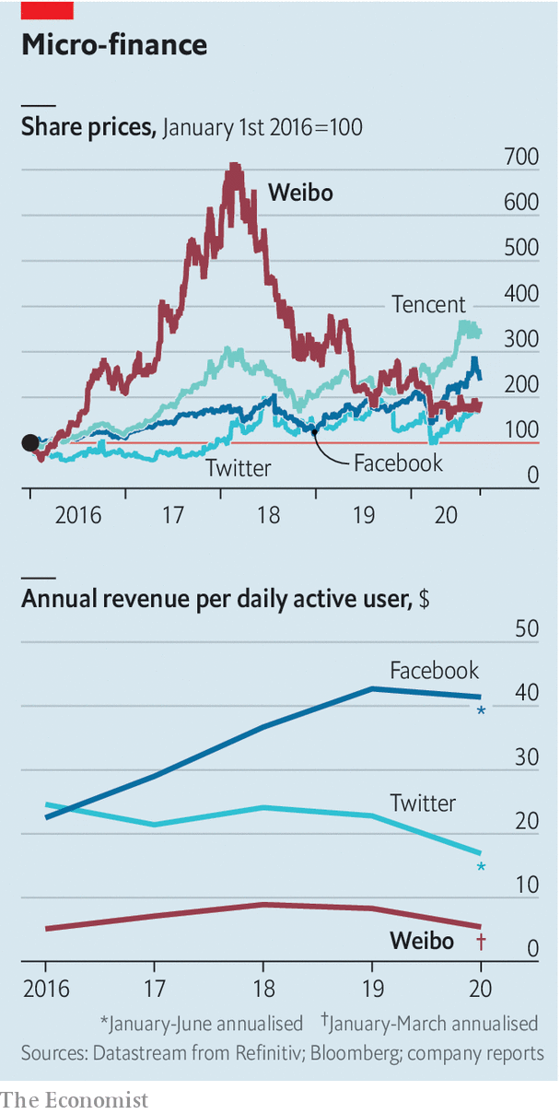

Weibo already boasts more than half a billion registered users in China. But user growth has slowed. To keep advertisers on board, Weibo must therefore boost user engagement. The company understands this. It already sports a richer array of functions than Twitter, for example a popular question-and-answer service in the mould of Quora. It is constantly adding new ones. In 2018 it acquired Yizhibo, in which people live-stream stand-up comedy, moonwalks and other acts for tips. Last year it launched a photo-sharing service akin to Instagram called Oasis. Still, Weibo’s revenues per user have been declining since 2018, and its share price with them (see chart). That is one more feature it has in common with Twitter—but is the opposite of what you would expect from a platform with strong network effects, such as Facebook.■

This article was downloaded by calibre from <https://www.economist.com/business/2020/09/24/can-weibo-do-better-than-twitter>

|  |  |  |  |
| --- | --- | --- | --- |
| Previous | Articles | Sections | Next |

|  |  |  |  |
| --- | --- | --- | --- |
| Previous | Articles | Sections | Next |

#### Schumpeter

# What Warren Buffett sees in Japan Inc

The trading houses reflect a growing pro-shareholder culture

Sep 26th 2020 |

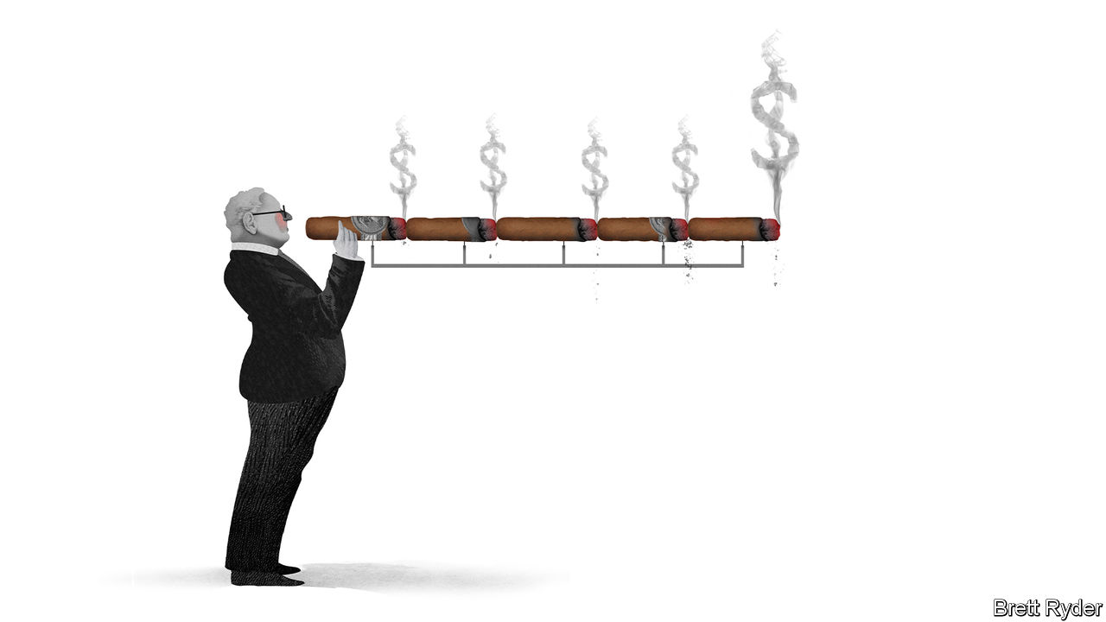

TO UNDERSTAND WHY it was a shock last month when Berkshire Hathaway invested $6.5bn in five Japanese trading houses that have been around for far longer even than its 90-year-old chairman, go back to a talk Warren Buffett gave to business students in Florida in 1998. As a sprightly sexagenarian with his sleeves rolled up, the Sage of Omaha was at his witty—and wicked—best.

The first question he fielded was about investing in Japan. He replied that the country’s 1% interest rates made it look attractive. Nonetheless, he considered Japanese firms poor bets because of their lousy returns. Low-profit businesses could be worth buying based on what he called the “cigar-butt” approach. “You walk down the street and you look around for a cigar butt someplace. Finally you see one and it is soggy and kind of repulsive, but there is one puff left in it. So you pick it up and the puff is free.” But not even this theory would draw him to Japan Inc, the pride of the country’s post-war revival, he explained. It is hard to think of an analogy more distasteful in a spick-and-span country like Japan.

Some 22 years of rock-bottom interest rates later, Mr Buffett has finally overcome his stogy-phobia. Berkshire’s investment in 5% each of Itochu, Marubeni, Mitsubishi, Mitsui and Sumitomo, though small relative to his investment firm’s $140bn mound of cash, was its biggest outside America. It said its stakes could increase to as much as 9.9% over time. But the acquisitions were a head-scratcher. What, if anything, had changed over the past few decades to make the trading houses appealing all of a sudden? Or had Mr Buffett simply succumbed to the temptation of a few cheap puffs because money was burning a hole in his pocket?

At first glance, the acquisitions make it look like he has lost the plot. The trading houses, or sogo shosha, make a mockery of many of the investment principles he has stuck to all his life. He says he likes easy-to-understand businesses like Coca-Cola and Apple. He argues that companies should not just be cheap but have reliable returns—and, ideally, “moats” to keep competitors at a safe distance. On each count the trading houses fail dismally.

Start with simplicity. In Western eyes no Japanese company is a model of Anglo-American shareholder capitalism. But few seem as far-removed from it as the trading houses. They are shaped by history, which dates back to the 19th-century zaibatsu and post-war keiretsu system of corporate loyalties and cross-shareholdings. In the modern era their business models have twisted and turned. From the 1950s to the 1980s they acted as go-betweens, scouring the world for energy, metals and minerals, helping to underpin Japan’s economic miracle. Then they invested in mines and hydrocarbons to feed the China-led commodities boom before shifting “downstream”, buying everything from convenience stores to cable companies. In the process they accumulated assets faster than they sold them. The results are unwieldy. Mitsubishi peddles everything from coking coal to Kentucky Fried Chicken. Itochu, the most profitable, calls its consumer division the 8th Company, implying it has run out of names after seven other units.

What about returns and value? Undoubtedly, the trading companies are cheap. Of the five, only Itochu trades at a market price higher than the book value of the net assets on its balance-sheet. That is not to say they are a bargain, though. Kikkawa Tatsuya of JPMorgan Chase, a bank, says their low-return legacy assets, which sometimes suffer big write-downs, increase investors’ perception of risk. Their complexity raises their cost of equity, which is higher than for more focused commodities producers, such as ExxonMobil or Rio Tinto.

And then there is the traders’ competitive position. Perhaps Mr Buffett is betting that as a venerated corporate species in Japan, the sogo shosha’s survival is safe. But as individual companies, their returns suggest they have nothing like the moats of other Berkshire stalwarts. If anything, they are each other’s bitterest rivals.

Look below the surface, though, and there may be a method in Mr Buffett’s madness. As he admitted in 1998, his view on Japan could change if managers became “more shareholder responsive”. In recent years they have, even in the trading houses, which once viewed corporate governance with disdain. Zuhair Khan of Union Bancaire Privée, a Swiss bank, says views started to change as a result of shareholder-friendly reforms promoted from about 2014 by Abe Shinzo, who stepped down as prime minister earlier this month. In some trading houses, executives bought large quantities of shares to align their interests with those of other shareholders. Pay became more performance-based. The focus moved from investing to generating cash and beefing up dividends. The pandemic is expected to slow but not derail the trend. Suga Yoshihide, Mr Abe’s successor, looks keen on further measures to empower shareholders, Mr Khan says.

Mr Buffett may see other attractions. He likes energy firms, and all the trading houses, particularly Mitsui and Mitsubishi, have big energy businesses. They stand to benefit from a post-pandemic economic rebound that boosts demand for power. The companies are also wellsprings of talent. Jeremy White of Baker McKenzie, a law firm, says they maintain a tradition of recruiting from the best Japanese universities, and rival investment banks and tech firms as the most prestigious companies to work for. And if anyone can find their way around bewildering corporate organigrams and balance-sheets, it must be the people behind Berkshire Hathaway, America’s biggest financial conglomerate.

## Stogy? Or just stodgy?

It is no sure bet. History is littered with fortunes lost to the belief that Japanese firms can become more Anglo-Saxon. If that is the case, Berkshire’s shareholders will rue Mr Buffett’s nonagenarian adventure. If, by contrast, his investments reinforce a view taking root in Japan that shareholders, domestic and foreign, are a constituency worth fighting for, he will deserve a fat Cohiba. ■

This article was downloaded by calibre from <https://www.economist.com/business/2020/09/26/what-warren-buffett-sees-in-japan-inc>

|  |  |  |  |
| --- | --- | --- | --- |
| Previous | Articles | Sections | Next |

|  |  |  |
| --- | --- | --- |
| Business | Sections | Science & ... |

Finance & economics

Ailing companies: The corporate undead

.

Companies in Japan: The return of the living dead?

.

America’s economy: Snapback

.

Buttonwood: The bright side

.

The Vatican’s finances: A holy mess

.

Free exchange: The mop that never stops

.

|  |  |  |
| --- | --- | --- |
| Business | Sections | Science & ... |

|  |  |  |  |
| --- | --- | --- | --- |
|  | Articles | Sections | Next |

#### The corporate undead

# Why covid-19 will make killing zombie firms off harder

Easier access to credit and government support means they will stumble on

Sep 26th 2020 |

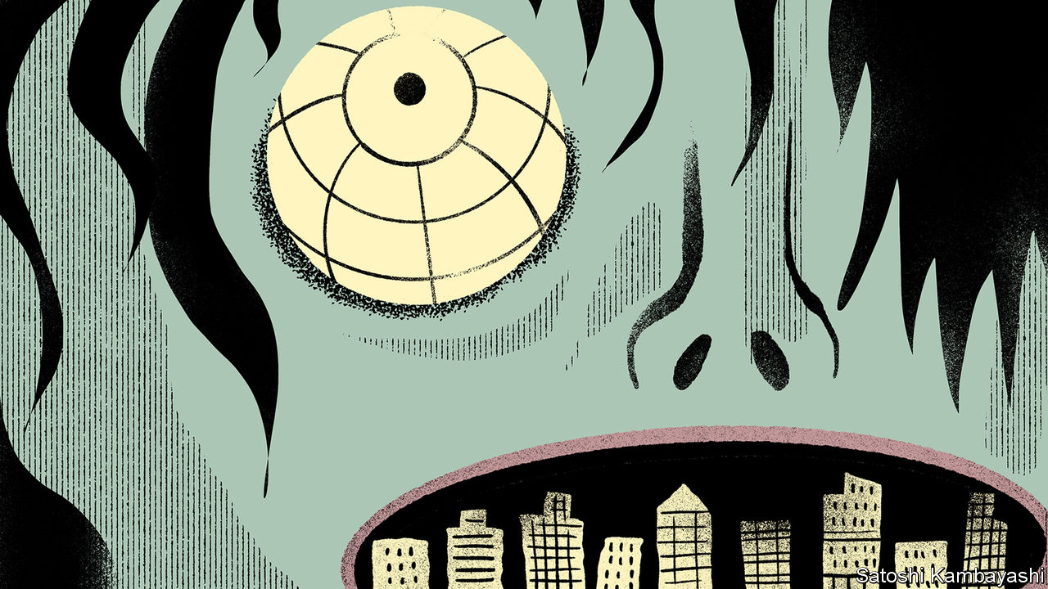

COMPETITION BETWEEN businesses can deliver vast rewards to the winners, as rich lists dotted with spacefaring billionaires attest. The fate of the losers, on the other hand, is a gruesome demise. At least, that used to be the case. A horde of companies has of late emerged that is neither profitable nor condemned to liquidation or takeover. Such corporate “zombies” stalk the business landscape. They are bad news for the economy. And many more firms are in danger of being zombified during the covid-19 downturn.

Zombie businesses are not a new phenomenon. Marginally profitable firms featured prominently in Japan’s “lost decade” in the 1990s (see [article](https://www.economist.com/node/21792097)). They have since gained ground in the rest of the world. According to the Bank for International Settlements (BIS), a club of central banks, nearly one in six listed firms in rich countries could be classified as a zombie in the run-up to the pandemic, up from around one in 20 in the 1980s (see chart 1). These are defined as firms that fail to generate enough revenue to make their interest payments on borrowings for three years running, and have low valuations that suggest moribund prospects.

There is some disagreement over where these undead firms are concentrated. The BIS, which focuses on listed companies, finds most in places like America and Britain, estimating that as much as a fifth of firms there are zombies. But that seems to be because these places have lots of smaller listed firms, and smaller firms are generally more likely to be zombies. The OECD, a rich-country policy outfit, fingers others, such as the less dynamic duo of Greece and Italy. All sides agree, though, that the numbers have crept up in recent decades.

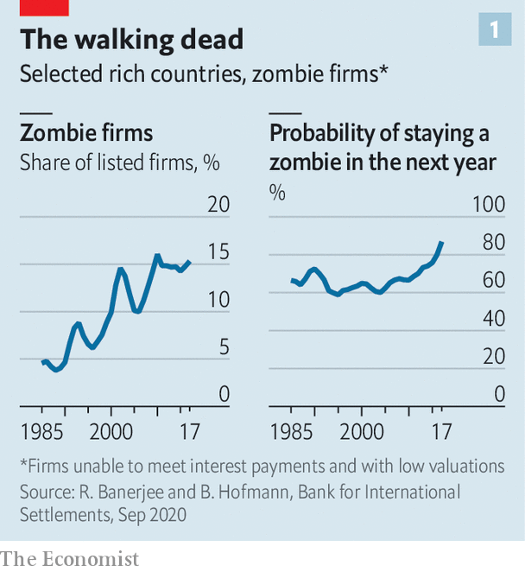

What conditions have helped zombies thrive? Rather like the living dead of horror films, unproductive businesses have found ways to stumble on despite lacking the usual vital signs. Banks would once have nudged their bad credits into bankruptcy, perhaps hoping to recoup some of their outstanding loans through restructuring, sale or liquidation. Far from playing their zombie-slaying role, banks have enabled them, letting ailing firms repay old loans with fresh borrowing.

That may be, indirectly, the result of loose monetary policy: lending money to a poor prospect is less painful if the bank pays little in funding costs. Banks with weak balance-sheets—often the result of low profitability itself linked to low interest rates—are more prone to backing zombies. Extending new loans and pretending they will be repaid avoids recognising losses, at the risk of compounding them.

“Evergreening” dud loans, in banking parlance, is particularly appealing if pushing a firm into bankruptcy results in a long, painful process of recovery. Some countries, like America, have efficient ways of restructuring failing firms, balancing the interests of creditors, employees and existing owners. But too often the prospect of years of judicial squabbles—resulting in little of value being left over—means that sitting still and hoping that the company in question somehow recovers is the least bad option. This is particularly the case for smaller firms, which are thus much more likely to be zombies.

Keeping ailing firms chugging along may seem unproblematic: a company need not make profits to keep paying its workers. But the rise in zombies coincides with broader signs of sapped economic vitality. As fewer firms have exited markets, fewer firms have also been created. Younger companies are hiring fewer workers. Employees are moving less, despite technology making it easier for them to find new jobs. Studies suggest that zombification hurts economic dynamism in several ways.

Zombified businesses are found to invest and innovate less than non-zombies. Worse, in some instances zombie firms seem to crowd out healthy ones. Economists at the OECD have found that productive firms in industries laden with zombies find it harder to attract capital. Margins at non-zombies are undercut by firms content to make no return on their investments. Healthy firms invest less as a result. A one percentage-point rise in the zombie share translates into a one percentage-point decline in capital spending by non-zombies, according to the BIS. In turn, productivity growth declines by 0.3%.

Zombification could also have consequences for market competition. Several studies have shown a widening range of productivity performance across firms in the same sector. The dispersion is not solely driven by superstar firms shining more brightly. Studies suggest that the laggards have also stagnated as they have been unable or unwilling to adopt best practices. Markets are less contested, and, in time, deliver lousier service to customers.

All this means that a further rise in zombie firms could be a nightmarish prospect. Covid-19 will swell their ranks. Firms will see profits decline because of the global recession, but two factors make conditions look ideal for zombification: companies’ easier access to credit; and governments’ attempts to freeze the economy in place during the pandemic.

Take credit first. A lending frenzy in recent years meant more loans were issued without covenants—clauses which, if breached, allow creditors to have a say in how a business is run. Almost all euro-denominated leveraged loans, for instance, were “covenant-lite” at the start of 2020; in 2013, fewer than a tenth were. Even if banks and other creditors wanted to push unprofitable firms to restructure or liquidate, they lack the power to do so.

In addition, the amount raised by high-yield bonds, issued by companies with ropy repayment prospects, has risen sharply in recent years. This has offered companies cheap ways to keep funding themselves while hoping for better times. Fears that the credit market would dry up as economic conditions turned have so far not materialised, perhaps thanks to the Federal Reserve’s emergency backstop for these dodgier “junk” bonds. High-yield issuance shot up in the first half of the year (see chart 2). The $292bn raised in America in the first eight months of 2020 exceeds the amount issued in all of 2019.

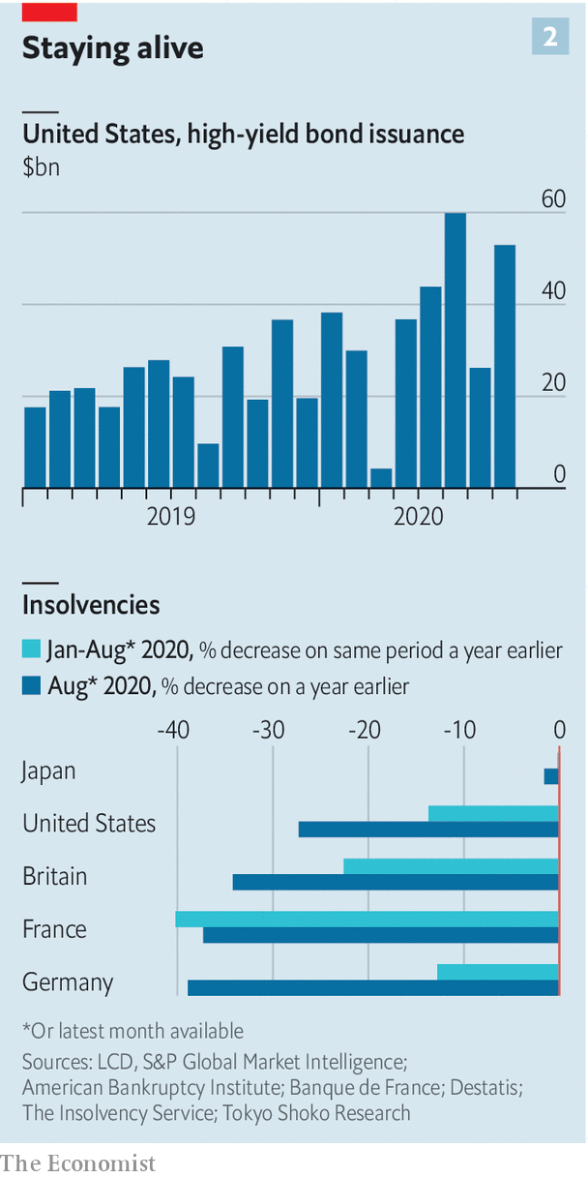

Government measures to protect the economy from the worst of the pandemic may also contribute to a rise in the number of zombie firms. Furlough schemes that cover wage bills and state-backed loans that provide liquidity enable unprofitable firms to keep going. Some politicians have leant on banks not to foreclose on companies. Many countries have thrown more sand in the gears of creative destruction. In March Germany allowed companies upended by covid-19 to put off filing for insolvency. Australia made pushing firms into bankruptcy harder. In India the central bank has allowed lenders to put off recognising bad loans even as they pile up, reducing the pressure for bankers to take on failing borrowers.

The concern now is that the covid-era zombies will pile up on top of older ones. There may already be evidence of such accumulation. Bankruptcies in 2020, given dire GDP figures, ought to be up by 20-40%, according to the BIS. But in many countries they are in fact lower than before the pandemic (see chart 2, right-hand panel). Credit markets suggest no uptick is expected.

As economic conditions improve, some zombies will no doubt emerge from their stupor. History suggests, though, that this is not easy. The probability of remaining a zombie from one year to the next has been steadily rising. Even revived zombies are problematic. Many relapse. Firms that used to be zombies in 1995 had a 5% chance of slipping back into an undead state, reckon BIS researchers, roughly the same as other firms. Now the probability is 17%. Even those that do not relapse stay weak, with lower growth in profits, productivity, investment and employment compared with non-zombies.

## Zombie apocalypse

How then to tackle the potential hordes of the corporate undead? In Japan a clean-up of the banking sector in the 2000s led to a rapid decline in unproductive firms. The good news is that the zombie share fell partly because firms made more profits, rather than go out of business.

Today’s global recession makes an immediate profit recovery unlikely. So instead you might think that the downturn ought to clear out unproductive firms. But that presumes lenders can cope with credit losses, and will not try to dodge write-offs. Fragile banks during the financial crisis of 2007-09 did little to kill off zombies. This time, emergency support measures, if not tapered, will delay the needed clear-out.

One threat to zombies would be a change in investors’ willingness to put up with mediocre returns. Thus far bankers and markets have been accommodating. But a rise in interest rates, though not on the cards any time soon in the rich world, would be much more painful in a zombified economy. In horror films, finishing off a zombie is a gory affair. The same is likely to be true in business. ■

Editor’s note: Some of our covid-19 coverage is free for readers of The Economist Today, our daily [newsletter](https://my.economist.com/user#newsletter). For more stories and our pandemic tracker, see our [hub](https://www.economist.com/news/2020/03/11/the-economists-coverage-of-the-coronavirus)

This article was downloaded by calibre from <https://www.economist.com/finance-and-economics/2020/09/26/why-covid-19-will-make-killing-zombie-firms-off-harder>

|  |  |  |  |
| --- | --- | --- | --- |
|  | Articles | Sections | Next |

|  |  |  |  |
| --- | --- | --- | --- |
| Previous | Articles | Sections | Next |

#### The return of the living dead?

# Will Japan see a new generation of zombie firms?

Lessons from the birthplace of the corporate zombie

Sep 24th 2020 | TOKYO

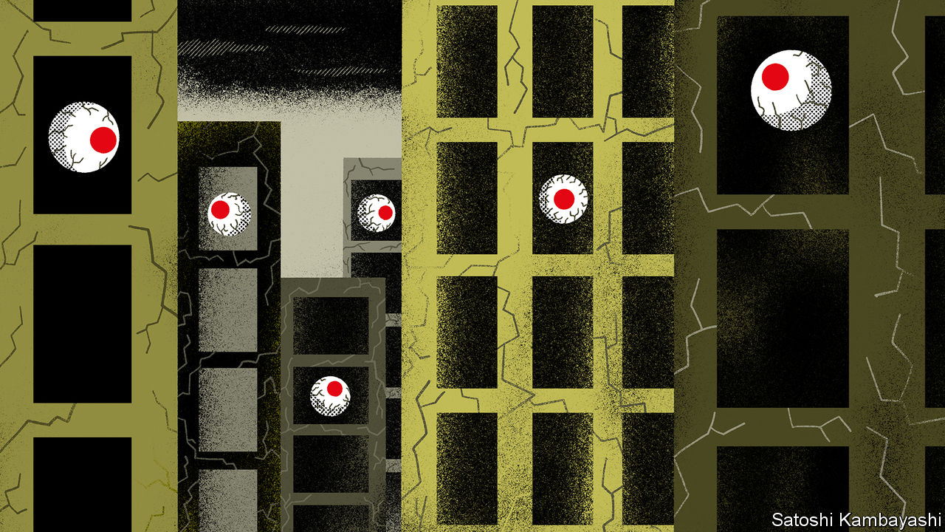

ECONOMISTS USING the term “zombie” used to have Japanese companies in mind. Firms that are dead competitively but continue to haunt their living peers proliferated in the decade or so following Japan’s financial crisis of 1990, as banks tided unprofitable borrowers over, at times with the government’s encouragement. By 2001 zombies made up more than 15% of listed firms, according to calculations in 2012 by Nakamura Jun-ichi, then of Hitotsubashi University, and Fukuda Shin-ichi of the University of Tokyo. It took drastic reforms of accounting rules and bank-supervision policies in the early 2000s to begin clearing out and reviving the corporate undead.

Zombification has long since spread beyond Japan, and covid-19 has led to fears that the ranks of the undead are swelling further (see [article](https://www.economist.com/node/21792063)). As in other rich countries, Japan has offered companies generous support during the covid-19 pandemic. The Bank of Japan (BoJ) has announced a slew of monetary-stimulus measures, including making ¥110trn ($1trn, or 20.5% of GDP in 2019) available to support corporate financing. The government has provided credit guarantees, and banks are lending more than they did last year.

The moves were a wise response to the crisis, helping to prevent a surge in bankruptcies and huge rises in unemployment. But some are starting to worry that continued largesse could lead to a new generation of zombie firms. “The foundation of the Japanese economy will be shaken, even if zombie companies are helped,” Nakanishi Hiroaki, head of Japan’s powerful business federation, Keidanren, warned this month. Kuroda Haruhiko, the BoJ’s governor, has played down such worries, promising to taper support as demand picks up.

Japan knows the disastrous consequences of failing to clear out zombies all too well. A landmark paper on Japanese zombie firms by Ricardo Caballero of the Massachusetts Institute of Technology, Hoshi Takeo of the University of California, San Diego, and Anil Kashyap of the University of Chicago in 2008 showed that the presence of zombies in the 1990s depressed profits, productivity and investment. Investment was between 4% and 36% lower in the 1990s than if the share of zombie firms had remained at historical averages. Job turnover in industries with more zombie firms was lower than in others.

As elsewhere, avoiding mass zombification will mean figuring out when the corporate lifeline starts to become counterproductive. Letting zombies go also means lost jobs and more pessimistic consumers—creating deflationary pressures that Japan can ill afford.

Mr Hoshi, now of the University of Tokyo and a pioneer of research into zombie firms, suggests adopting measures that protect workers without shielding inefficient companies. That could range from making it easier for employees to move between firms and industries, to introducing limited universal basic income, a negative income tax or expanded unemployment insurance. In short, policy should help the living, not the living dead. ■

This article was downloaded by calibre from <https://www.economist.com/finance-and-economics/2020/09/24/will-japan-see-a-new-generation-of-zombie-firms>

|  |  |  |  |
| --- | --- | --- | --- |
| Previous | Articles | Sections | Next |

|  |  |  |  |
| --- | --- | --- | --- |
| Previous | Articles | Sections | Next |

#### Snapback

# Why is America’s economy beating forecasts?

A retreat of the virus, a big stimulus and a flexible labour market is causing faster growth

Sep 24th 2020 |

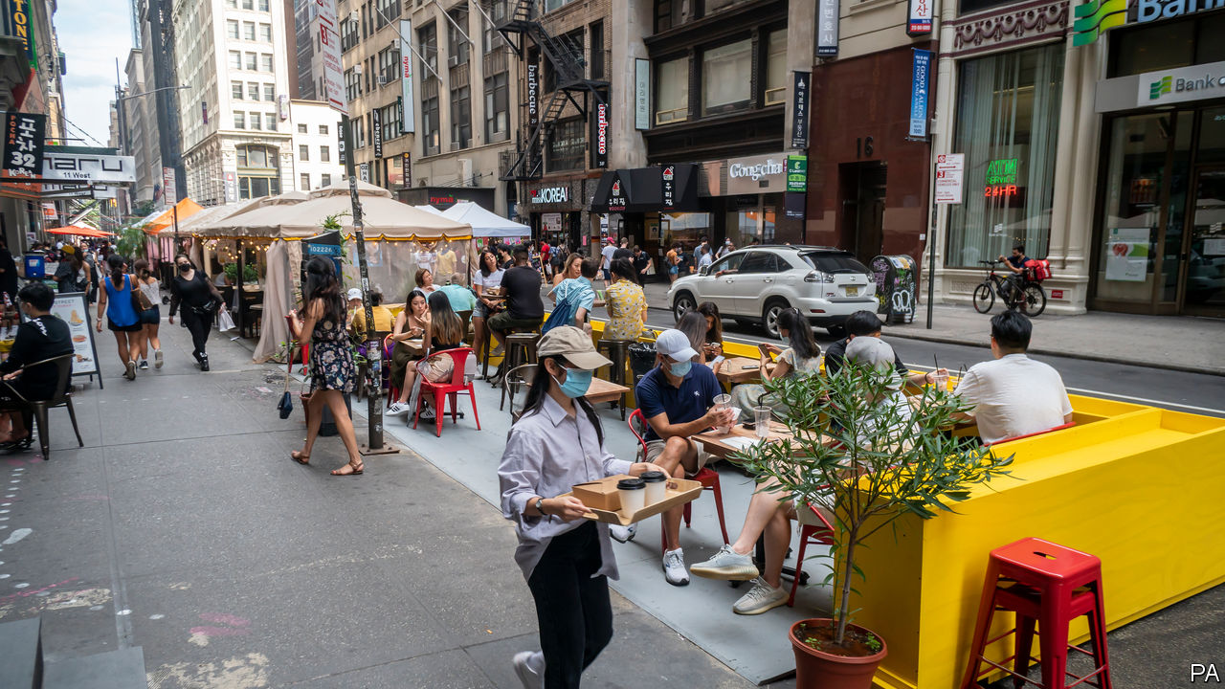

“WHEN AMERICANS vote in November, unemployment will be below 6%,” declared Lars Christensen, a maverick economist, in May. Given that lockdowns had sent the unemployment rate soaring to 14.7% only the month before, it was a bold prediction. In June at least 14 of the Federal Reserve’s 17 interest-rate-setters forecast that quarterly unemployment at the end of the year would still be above 9%. Most other prognosticators were equally gloomy. They expected American GDP to collapse in 2020 and recover relatively slowly. Mr Christensen insisted that natural disasters, unlike financial crashes and recessions brought on by economic policy mistakes, are typically followed by rapid recoveries.

He may be proven right. Over the summer the unemployment rate fell fast, to 8.4% in August. And economists have scrambled to upgrade their growth forecasts (see chart). On September 16th the OECD, a rich-country think-tank, predicted that the American economy would shrink by 3.8% this year, rather than the 7.3% expected in June. The outlook was upgraded across the rich world, but nowhere by as much. America still faces a recession about half as deep again as the one it endured after the financial crisis. But expectations are not as apocalyptic as they were—and look better than they do in most of Europe.

The upgrades in America can be attributed to three factors. First, the spread of the coronavirus in the southern “sunbelt states”, which rode a wave of the epidemic in the summer, has slowed. Second, America’s economic stimulus, the world’s largest both in absolute terms and as a proportion of GDP, has been potent. Thanks to one-time stimulus cheques worth up to $1,200 per person and an extra $600 a week in unemployment-insurance (UI) payments, households’ disposable income has risen since the pandemic began. Americans did not spend the money all at once, meaning that it continues to support consumption today, even though most of the emergency support has expired. In early September UI recipients were still spending more than they did before the pandemic hit.

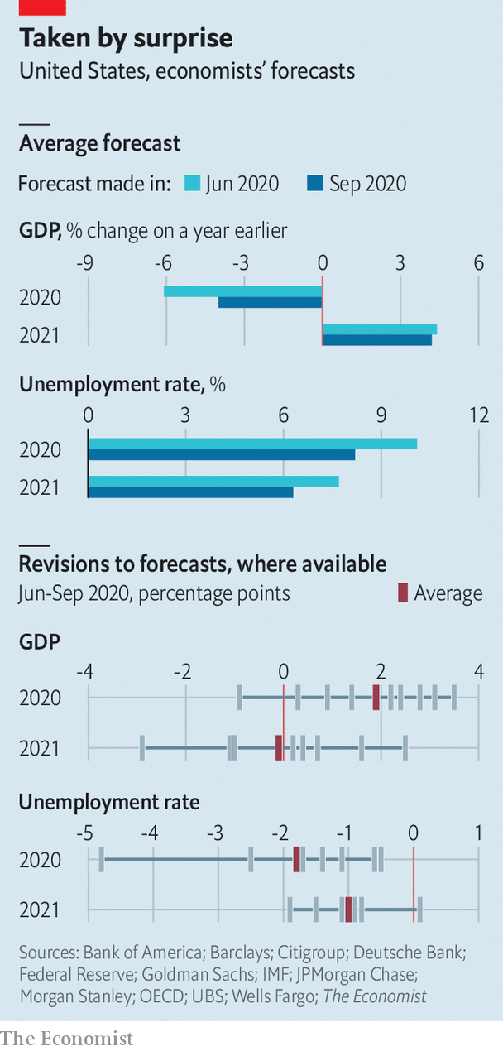

The final reason behind the forecast revisions is probably America’s flexible labour market. The fall in unemployment in recent months seems to reflect more new jobs, rather than discouraged workers exiting the workforce. In Europe governments have tended to assume much of the payroll cost for furloughed workers. Such schemes are handy in a tight spot. But if prolonged, they could keep workers in jobs that are never coming back. America, by contrast, has mainly protected people’s incomes with unemployment benefits (although it has absorbed the payroll costs of many small businesses via loans that may eventually be forgiven). As a result the reallocation of labour from dying industries to up-and-coming ones is happening at speed. For example, the number of travel agents has fallen by 10% since April, even as overall employment has risen. Employment in general-merchandise shops is 6% higher than before the pandemic.

Much could still go wrong. The virus could surge again, as it has in Europe. Many forecasters continue to assume, optimistically, that Congress will pass another stimulus package this year. Americans cannot run down their savings forever. And social-distancing requirements remain in place in much of the country. As a result some labour-market indicators still look dire. In August, even as the overall unemployment rate fell, roughly 3.4m jobs were permanently culled, more than in October 2008, soon after Lehman Brothers collapsed. The rapid rebound this time could yet hit a hard ceiling. But Mr Christensen’s optimism no longer looks so exceptional. ■

Editor’s note: Some of our covid-19 coverage is free for readers of The Economist Today, our daily [newsletter](https://my.economist.com/user#newsletter). For more stories and our pandemic tracker, see our [hub](https://www.economist.com/news/2020/03/11/the-economists-coverage-of-the-coronavirus)

This article was downloaded by calibre from <https://www.economist.com/finance-and-economics/2020/09/24/why-is-americas-economy-beating-forecasts>

|  |  |  |  |
| --- | --- | --- | --- |
| Previous | Articles | Sections | Next |

|  |  |  |  |
| --- | --- | --- | --- |
| Previous | Articles | Sections | Next |

#### Buttonwood

# Does economic growth boost stock prices?

There is sense to the current combination of pessimism and high stock prices

Sep 24th 2020 |

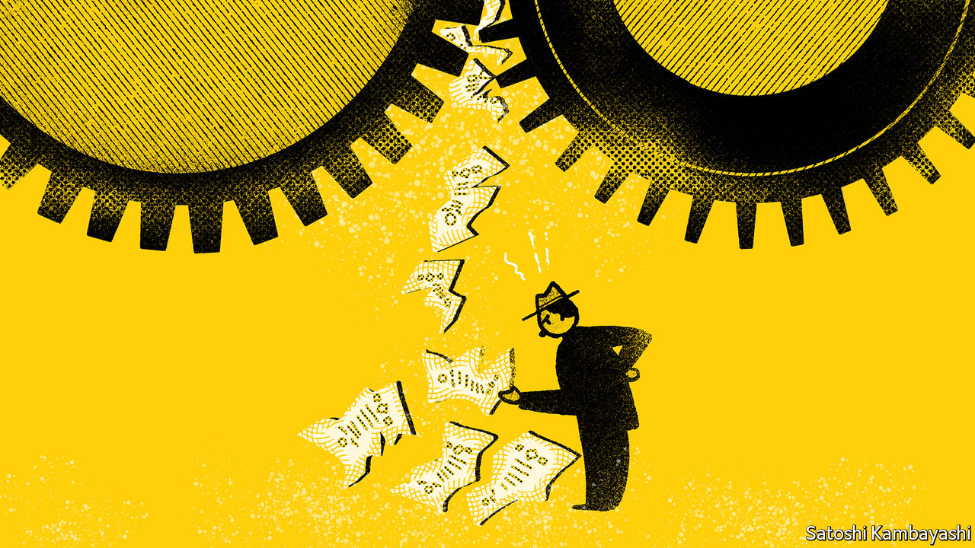

THE LATE 1990s is dismissed as a silly era. People left well-paying jobs to join a gold rush in Silicon Valley. Good money was thrown at sketchy business ideas. It was, though, a time of hope. Talk of new-era economics was a little feverish, but there was a genuine surge in productivity in America.

Today is quite a contrast. Optimism is thin on the ground. This is not just a matter of the uncertainties stemming from covid-19. Real long-term interest rates—rough shorthand for GDP-growth prospects—have rarely if ever been lower. Productivity growth has been dismal.

There is a commonality between then and now: steep share prices. The cyclically adjusted price-to-earnings (CAPE) ratio, compiled by Robert Shiller of Yale University, stands a shade above 30. That is a little higher than its level before the 1929 crash, although lower than the peak of 2000. In the 1990s optimism about growth was part of the justification for pricey shares. Now we have pessimism and high prices. Paradoxically, there is more sense to the current combination.

A paper in 2013 by William Bernstein points out that periods of technological change have not been terribly good for stockholders.* The booms of the 1920s and 1990s ended badly. The second quarter of the 19th century—the era of the steam engine, the railways and the telegraph—was no better. The fragmentary evidence Mr Bernstein cites suggests that returns on securities were less than spectacular. Historians of Britain’s “railway mania” of the 1840s find that the social and economic benefits of railways were huge, but investors did not do well.

The value of a share is in discounted cashflows. If you focus on the “cashflows” part of this equation, the 1990s narrative had some logic. Productivity picked up. The speed limit of America’s economy was raised. More growth means more profits. But as Mr Bernstein points out, faster growth does not reliably translate into better returns. In periods of rapid growth, shares are issued at an even faster rate than the growth in earnings and dividends. Each share has a diminished claim on the larger economy. Such dilution is attributable to technological obsolescence. The existing stock of plant and machinery has to be junked more frequently in a fast-growing economy—and fresh assets have to be financed by issuing new capital.

The “discounted” part of the valuation equation must also be reckoned with. As many a buzz-kill noted in the late 1990s, stronger GDP growth often comes with higher real interest rates. At one point real long-term rates were 4% in America. That diminished the value of future cashflows.

Consider a particular blend of these influences—GDP growth, dilution and discount rates—and today’s asset prices start to make more sense. The dilution effect has been largely absent. Until covid-19, American companies had been buying back shares, not issuing more. Discount rates were low, and fell further when the virus struck. People seem as worried about tomorrow’s consumption as about today’s. They are paying handsome prices for vehicles—tech stocks, government bonds, and so on—to carry their spending power into the future.

Over the broad sweep of history, returns have tended to fall as societies become wealthier. A recent Bank of England paper concludes that real interest rates worldwide have fallen over the past five centuries.** Mr Bernstein explains this with a thought experiment. In subsistence societies, almost all the harvest is needed to stay alive. Setting aside capital for seed or housing is desirable. But the surplus is scarce so the rewards for doing without today for the sake of tomorrow—the cost of capital—are high. As economies grow richer, they generate more surplus capital. People are less impatient. If you are well-fed, you can afford to wait. A cheeseburger tomorrow is almost as good as one today. Your discount rate is lower.

There is noise around these trends. At times people suddenly worry a lot more about today’s cheeseburger: the start of recessions, for instance. Personal discount rates go up. Risky assets become cheaper—as they did, briefly, earlier this year. There will no doubt be other opportunities to buy stocks more cheaply again. But as Mr Bernstein’s study suggests, such episodes are likely to be more fleeting than in the past.

*“The Paradox of Wealth”, by William J Bernstein, Financial Analysts Journal (2013).

** “Eight centuries of global real interest rates, R-G, and the ‘supra-secular’ decline, 1311–2018”, by Paul Schmelzing, Bank of England Working Paper No 845 (2020).

This article was downloaded by calibre from <https://www.economist.com/finance-and-economics/2020/09/24/does-economic-growth-boost-stock-prices>

|  |  |  |  |
| --- | --- | --- | --- |
| Previous | Articles | Sections | Next |

|  |  |  |  |
| --- | --- | --- | --- |
| Previous | Articles | Sections | Next |

#### A holy mess

# Has the Vatican cleaned up its finances?

International inspectors will arrive to find two controversies swirling

Sep 26th 2020 | VATICAN CITY

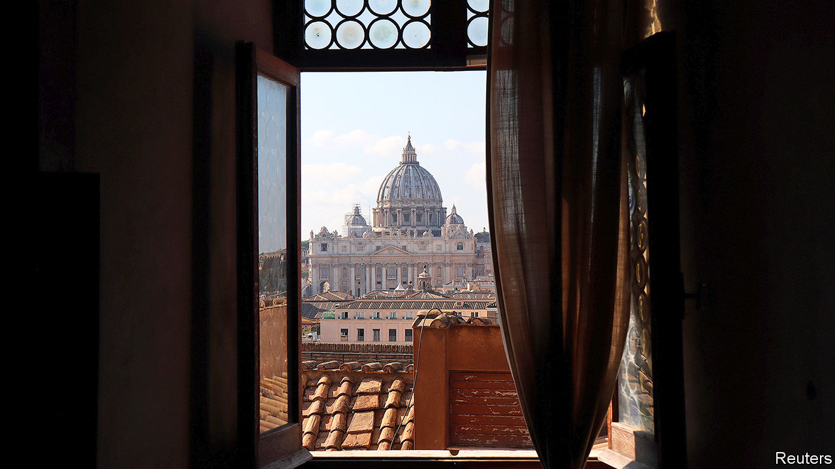

SMALL EUROPEAN enclaves have given financial regulators big headaches in the past. Two of them, San Marino and the Vatican, will be visited by inspectors from Moneyval, the organisation set up to fight money-laundering and terrorist funding in Europe, in the final days of September. They will arrive at a delicate moment. Starting next spring, the European Union (EU) plans to pour about €209bn ($245bn) into Italy in order to help it recover from the covid-19 pandemic. Even allowing for inflation and economic growth, that is more than was invested in the country through the post-war Marshall Plan.

Much of the EU cash will be directed towards the poorer south of Italy. But that is where Italy’s mafias can most easily steer funds and contracts their way. Having two inadequately regulated mini-states on their doorstep would offer them an easy way to launder their gains. On a recent visit to Rome Catherine De Bolle, the executive director of Europol, warned that her organisation had detected a rise in organised crime’s penetration of the European economy and asked EU states to be particularly vigilant with regard to the recovery funds.

As Moneyval made clear in its last report in 2015, San Marino has made significant progress towards installing a robust anti-money-laundering system. But the Holy See looks more problematic, despite Pope Francis’s avowed intention of overhauling its tangled finances. Two controversies are swirling. The first has to do with the Vatican Bank, properly known as the Institute for the Works of Religion (IOR), a lender located within the city state. The second concerns a judicial investigation into dealings by the Roman Curia, the central administration of the Catholic church, the effects of which have rippled abroad.

Inspectors had hoped that the Vatican Bank was no longer a problem. In a report on the Holy See in 2017, Moneyval concluded that its anti-money-laundering procedures were “firmly established”. Yet the IOR is now ensnared in litigation, which ironically arises from the clean-up.

In March a Maltese court authorised three companies involved in a dispute with the bank to seize assets worth €29.5m— equivalent to more than three-quarters of the IOR’s profits in 2019. The two Malta-based investment companies and a Luxembourg-based subsidiary claim that, following a change of management, the IOR reneged on a commitment to invest €33m in the purchase and development of the building that once housed the Budapest Stock Exchange. (The IOR contends that the deal was altered in a way that prejudiced its interests and claims to have incurred losses and lost profits of up to €25.2m.)

Another controversy relates to the Curia. Several Vatican officials, clerical and lay, are being investigated by the city state’s prosecutors in connection with the purchase of a building in London that was partly financed using donations from the faithful. Prosecutors are reportedly considering bringing charges that could include extortion. In October 2019 Vatican gendarmes raided the offices of the department that bought the property: the Secretariat of State, the pre-eminent branch of the Vatican bureaucracy, which combines the roles of prime minister’s office and foreign ministry.

Most damagingly for the Vatican’s international credibility, the Holy See’s own regulatory authority was also raided in connection with the case and its director, Tommaso Di Ruzza, put under investigation. Why remains unclear; no charges have since been brought against any of the suspects. Now known as the Supervisory and Financial Information Authority, the Vatican’s regulator combines the roles of banking watchdog and financial-intelligence unit (FIU). Documents and data seized by the police included confidential information that foreign FIUs had sent to the Vatican. The Egmont Group, a network of most of the world’s FIUs, promptly excluded the Vatican regulator from its information-sharing mechanism and only reinstated it after the authority had brokered a deal with the prosecutors aimed at preventing similar episodes in future.

The raid appeared to breach an established norm: that FIUs should have the freedom to decide which cases of suspected financial jiggery-pokery should go to court. Whether coincidentally or not, on July 14th Germany’s FIU in Cologne was searched on the orders of prosecutors who suspected its employees of having failed to refer for prosecution the suspected laundering of some €1.7m.

## Clerical accounting

Whether laws were broken in the complex transactions surrounding the London property deal is yet to be proven. But the affair highlights a key problem. The Curia has a sovereign-wealth fund, the Administration of the Patrimony of the Apostolic See, through which the Vatican’s investments might be expected to be channelled. Yet it is dotted with departments jealously guarding substantial pots of cash that are either undeclared or unquantified.

Cardinal George Pell, the first head of the Vatican’s “finance ministry”, the Secretariat for the Economy, revealed in 2014 that he had found “hundreds of millions of euros…tucked away”, in accounts off the Vatican’s balance-sheet. The cardinal, who was later charged with sexual assault in his native Australia, tried, convicted and acquitted on appeal, said that “it was impossible for anyone to know accurately what was going on overall”. Moneyval’s inspectors will need to work out how much, if at all, the situation has changed since then—an almighty task. ■

This article was downloaded by calibre from <https://www.economist.com/finance-and-economics/2020/09/26/has-the-vatican-cleaned-up-its-finances>

|  |  |  |  |
| --- | --- | --- | --- |
| Previous | Articles | Sections | Next |

|  |  |  |  |
| --- | --- | --- | --- |
| Previous | Articles | Sections | Next |

#### Free exchange

# Can China’s economic miracle continue?

In a new book, Thomas Orlik argues China is “the bubble that never pops”

Sep 26th 2020 |

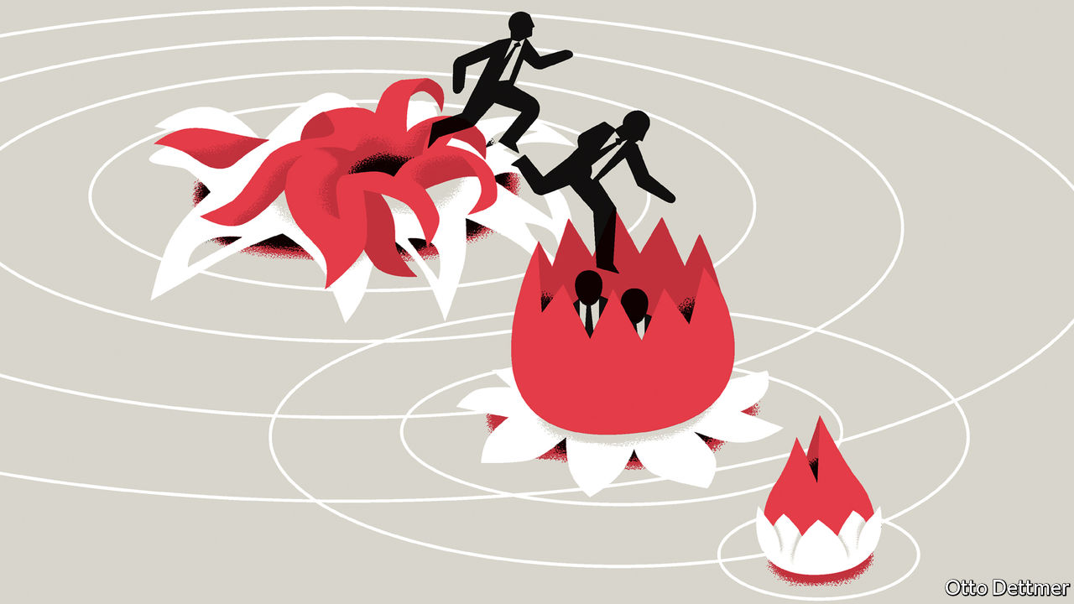

FORECASTS CAN haunt their authors, especially when they appear in headlines or book titles. Most pundits play it safe, giving “a number or a date, but not both”, as an old sage once advised. Thomas Orlik of Bloomberg is more courageous. His latest book, “China: The Bubble That Never Pops”, provides an unusually even-handed account of China’s economic resilience that is both closely observed and analytically interesting. But its title offers up quite a hostage to fortune. “Never”, after all, spans a lot of dates.

Fortunately for Mr Orlik, his definition of China’s bubble leaves him some wiggle room. He is not referring to any particular market or mania (such as the frenzy for tech stocks this year, bike-sharing in 2017 or caterpillar fungus in 2012). The title refers instead to China’s crisis-proof economic momentum, which has survived countless predictions of collapse. Even now, this unpoppable force is bouncing back with impressive speed from the covid-19 pandemic (which arrived after this book was written). Will Mr Orlik ever wish he’d never said never?

Although Mr Orlik does not draw heavily on economic theory to justify his confidence, he can take some comfort from it. A bubble that never pops sounds like the sort of thing that the laws of economics should rule out, like a free lunch or an unpocketed dollar bill. In fact, theorists have long entertained the possibility of sustainable bubbles, inspired by the work of two Nobel prizewinners, Paul Samuelson in 1958 and Jean Tirole in 1985.

They showed that bubbles can persist when an economy’s growth rate consistently exceeds its interest rate. In these circumstances, a bubble can remain both attractive and affordable, enticing the buyers it needs to sustain itself without dwarfing the economy. Suppose, for example, that workers in every generation plough a portion of their income into an intrinsically useless asset, such as an empty flat, which they plan to sell when they retire. Because every cohort has the same plan, each will find buyers among their descendants for the asset they bought from their forefathers. Since another generation is “always coming along”, as Samuelson put it, this chain need never break.

If the economy is growing, each generation will have more income to spend on the asset than the one preceding it. That will allow the seller to earn a positive return. And if the economy’s growth rate exceeds the interest rate, this return will be higher than what other saving vehicles, such as bank deposits, can offer. This condition, known as “dynamic inefficiency”, was once thought to be rare. But in an era of near-zero interest rates, it has come to seem almost familiar. China’s dynamic inefficiency was documented in 2006 by economists at the Hong Kong Monetary Authority and has been confirmed by subsequent studies.

It may be that China’s interest rate understates the true return on capital in the country, thanks to lingering financial repression. But even so, a long-lasting bubble could arise, according to a 2014 paper by Kaiji Chen of Emory University and Yi Wen of the Federal Reserve Bank of St Louis. In their model, private capital earns impressive returns for as long as it can profit from cheap labour migrating from fields to factories and from state-owned enterprises to private firms. That gives entrepreneurs the financial means to venture large sums in the property market. At the same time, they know that the profitability of their businesses will eventually decline as labour becomes scarce. That gives them the motive to diversify their wealth into other stores of value, such as property.

In this scenario, property prices will keep pace with the rate of return to entrepreneurial capital, which is even higher than the growth rate of the economy as a whole. Then, as workers become harder to find, the returns to capital and to property steadily diminish in tandem. The later chapters of Mr Orlik’s book explain how China managed this slowdown. It entered 2016 in a shaky state. Real-estate developers held daunting inventories of unsold flats and owed similarly daunting sums to shadow lenders. China also suffered from overcapacity in allied industries, such as steel, which threatened to plunge the economy into deflation.

How did China cope? The answer is what you might call the five r’s: reflating and remixing the economy, as well as refinancing, rotating and writing off assets and liabilities. China remixed the composition of activity without reducing its pace, spending less on new mines and steel plants, and more on infrastructure. Projects financed with short-term high-interest bank loans were refinanced with low-yielding bonds issued by provincial governments. Some debt rotated from overstretched developers onto the cleaner balance-sheets of households who were given easier access to mortgages.

## Clean-up operation

China also wrote off bad loans (including shadow loans) and many physical assets. Old mines were closed. Slums were cleared. Displaced households were given money to help buy newer flats. These efforts were often financed by targeted loans from the central bank. The clearances, closures and write-offs reduced the economy’s stock of wealth, but did not interrupt the flow of fresh activity. Indeed, the combination of new money injected into the economy and old capacity removed from it lifted prices and quickened the growth of nominal GDP. That restored the gap between growth and interest rates, making debt levels easier to sustain.

This clean-up took advantage of some of China’s unusual strengths, including the reach of its regulators and the flexibility of its labour force. When the mix of activity changed, workers followed suit. But it also conformed to some economic principles that could apply anywhere. The deflationary pressure China faced in this dangerous period showed that there was room to stimulate the economy. And because interest rates were lower than growth rates, it could afford to roll over any liabilities it dared not write off.

Will China never pop? Safer to say there is little it cannot mop.■

This article was downloaded by calibre from <https://www.economist.com/finance-and-economics/2020/09/26/can-chinas-economic-miracle-continue>

|  |  |  |  |
| --- | --- | --- | --- |
| Previous | Articles | Sections | Next |

|  |  |  |
| --- | --- | --- |
| Finance & economics | Sections | Books & arts |

Science & technology

The business of quantum computers: Uncertainty principals

.

Evolution: Accidental killer

.

A fossorial fossil: A burrowing dinosaur

.

|  |  |  |
| --- | --- | --- |
| Finance & economics | Sections | Books & arts |

|  |  |  |  |
| --- | --- | --- | --- |
|  | Articles | Sections | Next |

#### Uncertainty principals

# Commercialising quantum computers

Today’s small, limited and finicky machines may yet have business uses

Sep 26th 2020 |

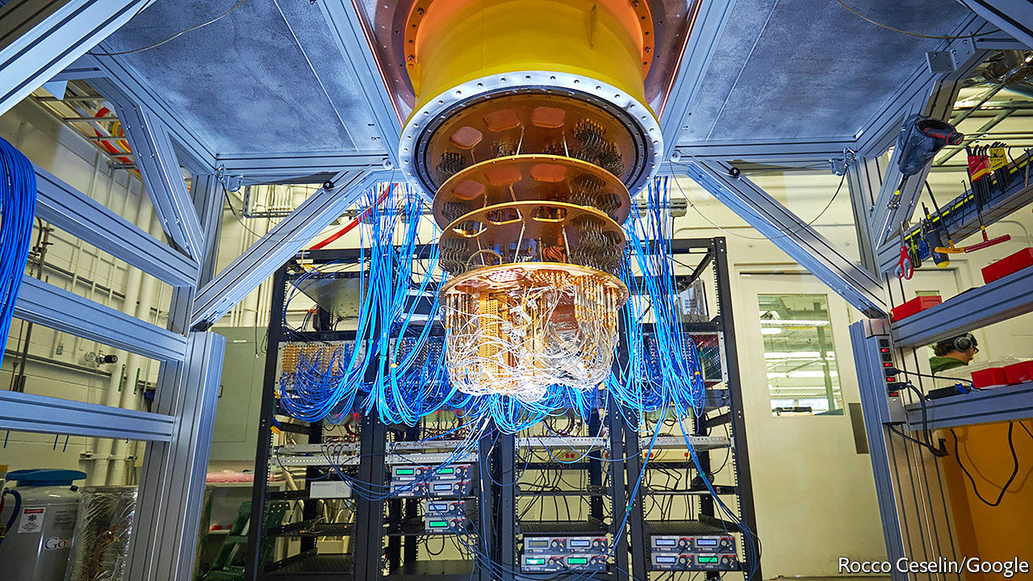

BIG, STABLE quantum computers would be useful devices. By exploiting the counterintuitive properties of quantum mechanics they could perform some calculations (though only some) faster than any conceivable non-quantum machine.

For one thing, they would probably be much more rapid than any classical computer at searching a database—an elemental operation with a thousand uses. They would be quicker at more specific tasks, too. Precisely simulating all but the simplest chemical reactions is mathematically intractable for any non-quantum computer, no matter how huge. A quantum computer could do this, aiding the development of drugs, catalysts and batteries. Quantum computers would also speed up the analysis of optimisation problems, which try to find the best way to juggle many variables in order to maximise a particular outcome. That would be a boon to the transport industry (by finding efficient routes) and to finance (by maximising profits given a set of constraints). Boston Consulting Group (BCG), a management consultancy, foresees quantum computers improving the operating income of their users by between $450bn and $850bn a year by 2050.

Unfortunately, big, stable quantum computers do not yet exist. But small, ornery, unstable ones do. John Preskill, a quantum-computing researcher at the California Institute of Technology, dubs such machines NISQs—Noisy, Intermediate-Scale Quantum computers. Some see NISQs as mere stepping stones towards size and stability, and that is certainly the goal of those working on them. A growing number of companies and investors, however, are hopeful that NISQs themselves will be able to do useful work in the meantime. These firms are hunting for “quantum advantage”—a way in which even today’s limited machines might have an impact on their bottom lines, or those of their customers.

## Let a hundred flowers bloom

For most of the field’s history, quantum-computing research has been backed by governments or big information-technology firms. Increasingly, though, the venture-capital (VC) industry is showing an interest. PitchBook, a research firm based in Seattle, has tracked $495m of VC money that has been invested in quantum computing so far this year—almost double last year’s total (see chart). Dozens of startups are competing with the incumbent tech giants. And established companies, such as Daimler, a carmaker, and Goldman Sachs, a bank, are beginning to experiment with the nascent industry’s products, hoping that, if they can master them, they will bestow an advantage over their competitors.

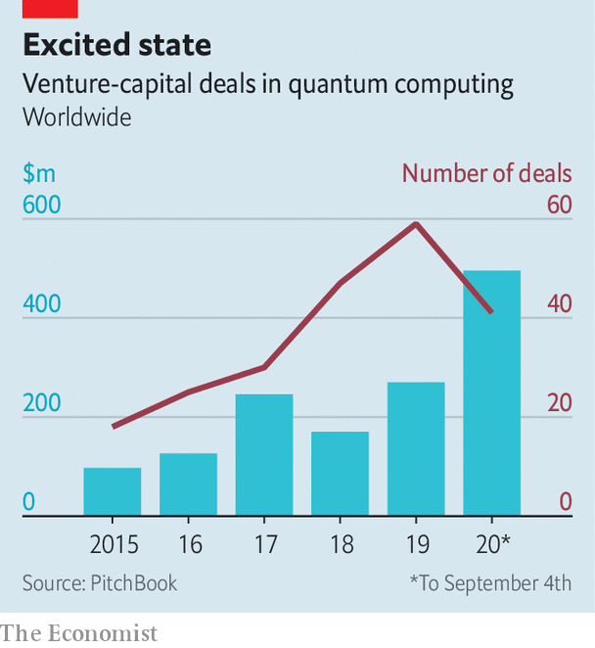

Much of the money is going towards building hardware. Doug Finke, a computer engineer who runs the Quantum Computing Report, which focuses on the nascent industry, is aware of 87 organisations, big and small, trying to construct quantum computers. Unlike classical computing, which had settled by the 1970s on silicon transistors as the units of computation, there is, as yet, no consensus on the best way to build a quantum computer. IonQ, a firm in Maryland that has raised $84m, uses trapped ytterbium ions, manipulated by lasers, to perform its calculations. Rigetti Computing, a Californian company which announced earlier this month that it would be building a quantum computer for the British government, employs microwaves to control pairs of electrons flowing through superconducting circuits. Microsoft, although very much not a startup, is working on a “topological” quantum computer that relies on the interactions of super-cold electrons.

One particularly well-financed new firm is PsiQuantum, which does its computing with photons that run along waveguides etched onto ordinary silicon chips. It hopes to leapfrog the NISQ era entirely and produce a fully fledged quantum computer within about five years—though that is far sooner than most experts think feasible. PsiQuantum was founded in 2015 by researchers from Imperial College and the University of Bristol, both in Britain. It has raised $215m from backers including BlackRock, a giant investment firm, and the Founders Fund, an American VC company that was an early investor in SpaceX and Facebook. Jeremy O’Brien, one of the firm’s founders, says that, in partnership with GlobalFoundries, a big contract chipmaker, PsiQuantum is already producing wafers full of quantum-computing chips.

## Custom and practice

Other firms are concentrating on making quantum computers easier to work with. Q-CTRL is an Australian startup that has raised “tens of millions” from investors including Sequoia Capital and In-Q-Tel (which invests on behalf of America’s intelligence agencies). “We build ‘quantum firmware’,” says Michael Biercuk, one of the company’s founders. This is the lowest level of software, responsible for controlling a computer’s hardware directly.

One reason NISQs are so hard to work with is that the delicate quantum states they rely on break down in fractions of a second, so calculations must be completed in those slivers of time. On top of this, imperfect manufacturing means that some parts of a quantum chip suffer noticeably more errors than others—a pattern which varies unpredictably between individual chips. Careful control of a machine’s hardware, says Dr Biercuk, can help minimise these difficulties. To this end Q-CTRL’s engineers have used machine learning to improve hardware-control routines written initially by human beings. Dr Biercuk reckons this can cut error rates by 90% and reduce the variability across an individual chip by a similar amount.

After building a machine and tuning it to work as well as possible, the next step is to get it into the hands of potential customers. The easiest way to do this is to connect interested parties to the internet and invite them to experiment. IBM’s “Q Network”, established in 2017, is a cloud-computing service that lets clients use the firm’s own quantum computers. IBM now has partnerships with dozens of established firms, including Daimler, Samsung and Goldman Sachs, which are intended thus to explore the technology.

Smaller hardware-makers, lacking IBM’s reach, have joined up with other cloud-computing firms. Microsoft (whose own topological machines are still at an early stage of development) offers access via Azure, its cloud-computing service, to machines from IonQ, Honeywell and a company called Quantum Circuits. Amazon hosts machines from Rigetti, IonQ and D-Wave, a Canadian company that builds specialised, fixed-purpose computers called quantum annealers.

Rather than have hardware-makers come up with useful algorithms, the hope is that existing businesses, by being given access to the machines in this way, will invent such algorithms for themselves. With that in mind, says Krysta Svore, who leads Microsoft’s quantum-computing research, one task is to make those machines as easy as possible to use. The firm has developed tools intended to help customers wrap their brains around the counterintuitive properties of quantum computers. It has also developed software intended to smooth over differences between machines from different makers, so that programmers do not have to worry about whether they are marshalling ions or electrons. She compares this to the early days of classical computing, when the development of compilers and early programming languages freed human beings from the need to think in the ones and zeros of raw machine code.

The big question is what all this is leading up to. Despite the excitement, the industry’s commercial pioneers have their work cut out for them. There is plenty of promise, but, as yet, no certainty. Finding algorithms that are both commercially useful and simple enough to work within a NISQ machine’s limitations is not easy. A report published last year by America’s National Academy of Sciences reminded readers that no commercial applications are currently known to exist.

The first step, then, is to go looking. The industry has been cheered by Google’s demonstration last year of “quantum supremacy”, in which it used a NISQ machine to perform, with minutes of computing time, a calculation that would have taken thousands of years on classical hardware. Google’s calculation was highly contrived and of little use in the real world. But it proved a point. In August the firm followed up with a paper in Science, describing the simulation of a chemical reaction involving hydrogen and nitrogen atoms. That reaction was simple enough to be within the reach of classical machines.

Optimists like Mr Finke think that, with a bit of luck and progress, the first commercially relevant applications of quantum computers will appear within the next two or three years. In particular, he reckons it is worth keeping an eye on the finance industry, where quantum computers could boost trading algorithms and portfolio management. “To develop a new battery or a new drug you have to test the product,” he points out. This can take years. A slick new financial algorithm could be deployed in days. And given the scale of the markets, even a tiny advantage could be worth a great deal of cash. Amit Kumar, a partner at BCG, agrees—though he points out that, keen to preserve its advantage, a firm which had found a way to benefit from quantum acceleration might try to keep the fact under its hat.

## NISQy bets

This influx of money has, though, led some researchers to worry that hype may be overtaking reality, and storing up disappointment for the future. Some of the cash, says Dr Biercuk, comes from VC firms taking calculated risks by investing in what has come to be called “deep tech”—cutting-edge, highly technical projects like quantum computing, which advance the state of the art—as opposed to consumer-focused apps or gizmos with a shorter and more certain path to market. But he cautions that there is no shortage of hype-struck “dumb money” sloshing around, too.

Whether those bets pay off will have implications beyond the venture-capital industry’s next bonus round. One reason classical computers developed so quickly was that even early, feeble machines were useful for everything from wartime code-breaking to automating the payrolls of big firms. Those applications generated enough cash to design the next generation of less-feeble machines, which brought in yet more money. The resulting virtuous spiral is still turning, decades later.

Those now moving into quantum computing hope to encourage a similarly virtuous feedback loop. If they succeed, the promise of quantum computing could be realised faster than the decade or more likely to pass before big, stable machines are ready. If they fail, the field’s reputation may take a knock. That knock is unlikely to be fatal. But it will delay the arrival of a usable machine.■

Correction (September 24th 2020): An earlier version of this article described Mr Finke as a physicist, and gave him the title "Dr". He is in fact a computer engineer, and goes by "Mr". Apologies for the mistake.

This article was downloaded by calibre from <https://www.economist.com/science-and-technology/2020/09/26/commercialising-quantum-computers>

|  |  |  |  |
| --- | --- | --- | --- |
|  | Articles | Sections | Next |

|  |  |  |  |
| --- | --- | --- | --- |
| Previous | Articles | Sections | Next |

#### Evolution

# Why funnel-web spiders are so dangerous to people

They have not had the chance to evolve not to be

Sep 26th 2020 |



FUNNEL-WEB spiders have a fearsome reputation. People bitten by these Australian arachnids suffer extreme pain, breathing problems, confusion, convulsions and dangerously high blood pressure. Left untreated, the venom can kill within hours. For years, researchers assumed this lethal effect was an evolutionary accident. The venom, they presumed, evolved to help the spiders kill their prey—normally insects. Killing mammals was either just collateral damage or a form of protection against possible predators.

Except that the venom does not, in general, kill mammals. Dogs, cats, mice, rabbits and guinea pigs all shake it off. It is only human beings and other primates that succumb. And there is another odd thing about it. Funnel-web-spider venom has thousands of components, but delta-hexatoxins, the specific molecules within it that kill people, are produced in particularly large quantities by sexually mature males during the breeding season—a time when they are barely feeding at all.

Putting these various facts together has led Bryan Fry of the University of Queensland to suggest, in a paper published in the Proceedings of the National Academy of Sciences, that the role of delta-hexatoxins in funnel-web venom is not to kill prey but rather as a sophisticated form of defence—and that, paradoxically, its deadliness to humans is because neither they nor their primate ancestors were, until recently, a threat to the spiders.

Prey animals routinely attacked by venomous predators are under powerful pressure from natural selection. Any mutation which confers resistance to the venom will spread. This puts evolutionary pressure back onto the predator, encouraging the emergence of more potent venoms, which encourages further resistance and provokes further potency. And so on. Toxins directed against prey thus evolve rapidly.

That, though, is not true for defensive venoms. Taking a single type of spider off its menu diminishes a predator’s potential to survive and reproduce only slightly. From this predator’s point of view the requirement to evolve resistance to a venom, particularly one that is not lethal, is therefore low. The spider’s interests, too, may be served by the evolution of non-lethal venom. A live predator that has learnt not to attack may be better than a dead one, which might then be replaced by a conspecific which has not learned that lesson. This is particularly true when the venom is directed towards animals that teach their young, as many mammals do, about what is and is not dangerous in the world. Get stung by a bee and you will surely advise your children to give bees a wide berth, even though bees are not predators.

To pursue this idea, Dr Fry and his colleagues looked at the genetic sequences describing 22 types of delta-hexatoxin, extracted from ten species of funnel-webs. This let them analyse the peptides’ evolutionary histories. Funnel-web spiders are an ancient group, believed to have emerged about 150m years ago, near the end of the Jurassic period. Dr Fry’s analysis suggested that, around that time, delta-hexatoxin peptides were evolving rapidly, but have subsequently barely changed. This is consistent with the idea that they were evolving into something which would discourage, but not kill, vertebrate predators such as mammals—a group that also appeared in the late Jurassic. Which is all well and good, but does not explain why funnel-web delta-hexatoxins are so deadly to people.

The answer to this, Dr Fry suspects, is that until the arrival in Australia 65,000 years ago of human beings, funnel-web spiders had never encountered primates (of which that continent has no wild representatives) and so had had no chance to co-evolve with them. In one sense, then, the fact funnel-web delta-hexatoxins are lethal to humans is indeed an unlucky accident caused by some quirk of primate biochemistry not shared with other groups of mammals. But if such co-evolution had taken place, it would have been in the interests of both sides for this lethality, too, to have been whittled away. ■

This article was downloaded by calibre from <https://www.economist.com/science-and-technology/2020/09/26/why-funnel-web-spiders-are-so-dangerous-to-people>

|  |  |  |  |
| --- | --- | --- | --- |
| Previous | Articles | Sections | Next |

|  |  |  |  |
| --- | --- | --- | --- |
| Previous | Articles | Sections | Next |

#### Palaeontology

# A burrowing dinosaur

Chinese researchers have found a fossorial fossil

Sep 26th 2020 |



THIS DINOSAUR, a newly described species called Changmiania liaoningensis, was extracted from 123m-year-old rocks in Liaoning province, China. It has a snout shaped like a shovel and a short, robust neck and forearms, and was almost certainly a burrowing animal, like a modern rabbit—though, at 1.2 metres in length, it was somewhat larger. The rocks in question came from a volcanic eruption that entombed local animals by the million. This specimen was reported this week in PeerJ, by Yang Yuqing of Northeastern University, in Shenyang, and his colleagues, together with a second, similarly well preserved. Since the original finds were made by farmers, and their precise locations are unknown, it is impossible to tell whether the animals were buried in their burrows. But their excellent state of preservation makes that likely.

This article was downloaded by calibre from <https://www.economist.com/science-and-technology/2020/09/26/a-burrowing-dinosaur>

|  |  |  |  |
| --- | --- | --- | --- |
| Previous | Articles | Sections | Next |

|  |  |  |
| --- | --- | --- |
| Science & ... | Sections | Economic & ... |

Books & arts

Gangs and governments: The monster and the boys

.

American statesmen: All the presidents’ man

.

Cradles of civilisation: Pivot of the world

.

A writer’s life: Cool to be kind

.

Hercule Poirot: The case of the 100-year-old detective

.

|  |  |  |
| --- | --- | --- |
| Science & ... | Sections | Economic & ... |

|  |  |  |  |
| --- | --- | --- | --- |
|  | Articles | Sections | Next |

#### The monster and the boys

# Born in Los Angeles, MS-13 came to terrorise El Salvador

Two books unpick the factors that led to the gang’s rise

Sep 26th 2020 |

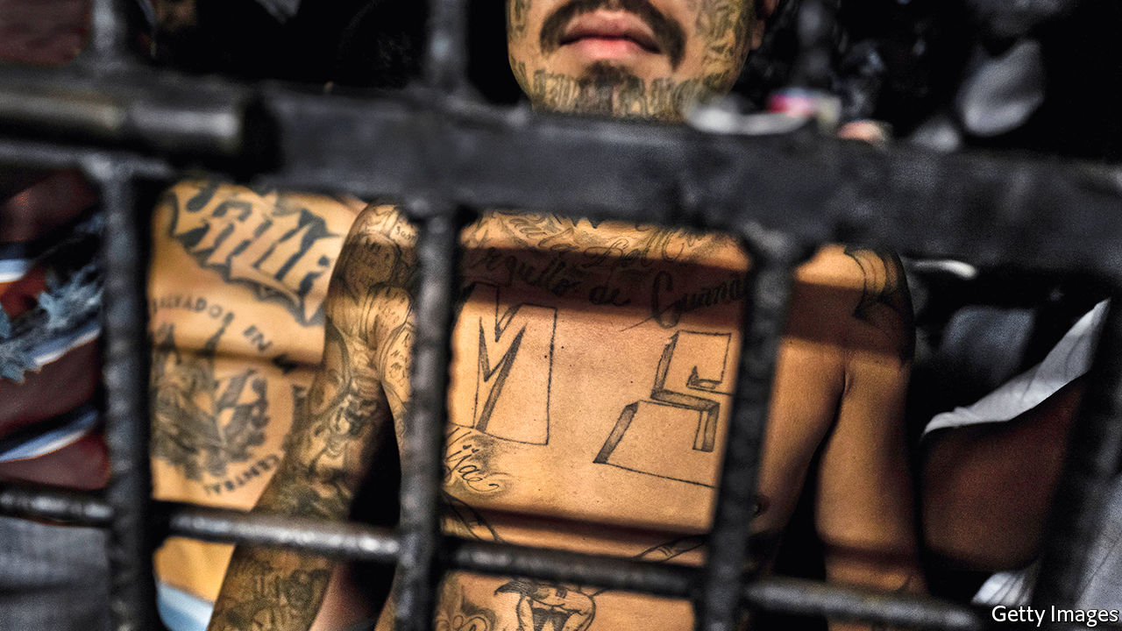

MS-13. By Steven Dudley.Hanover Square Press; 352 pages; $28.99. To be published in Britain by Bonnier Books in July 2021; £8.99.

The Hollywood Kid. By Óscar Martínez and Juan José Martínez. Translated by John Washington and Daniela Maria Ugaz.Verso; 320 pages; $26.95 and £16.99.

THE PRESIDENT of El Salvador, Nayib Bukele, has been “very tough” on the street gang MS-13—or so said Donald Trump last year. Murders have indeed fallen 80% since 2015, when El Salvador was the most violent country in the world (apart from conflict zones such as Syria). Mr Bukele attributes the improvement to a crackdown on MS-13 and its rival, Barrio 18. But prison logs and intelligence reports published on September 3rd by El Faro, a Salvadorean news site, suggest another explanation: that for 15 months Mr Bukele’s government has secretly negotiated with MS-13’s imprisoned leaders, granting perks in exchange for keeping murders down.

Mr Bukele denies the reports. If true, they make painfully clear something Salvadoreans already know: the streets belong to the gangs, not the government. Practically every city block in El Salvador (and much of Guatemala and Honduras) is extorted by one or both of the gangs. La renta is squeezed out of tortilla carts and telecoms firms alike, then split among tens of thousands of members. It doesn’t make them rich. Rather, their rivalry is itself their raison d’être. Deal or no deal with Mr Bukele, tread on enemy turf and you get killed.

How a group of metalheads in Los Angeles in the 1980s evolved into a gang that terrorises three countries is the subject of “MS-13” by Steven Dudley, founder of Insight Crime, a site that covers organised crime in Latin America. The story begins with El Salvador’s civil war, which between 1980 and 1992 left 75,000 people dead and over 1m displaced. Like the guns Ronald Reagan’s administration sent down for use against leftist guerrillas, the gang is an American export. Mara Salvatrucha (“Salva” for El Salvador, “trucha” for “savvy”) first referred to a group of refugees in Los Angeles with tastes for crack and heavy metal. When they took to wielding machetes, America started deporting them.

Back in El Salvador, MS-13 thrived on the same ingredients that drove the previous generation to take up arms (minus the ideology): poverty, impunity, a culture of violence, lots of young men and too few opportunities. Salvadoreans living under gang control call their teenage overlords los muchachos (“the boys”), a euphemism once used for the guerrillas. Acknowledging the parallel, Mr Dudley suggests that the term “insurgency” properly captures the gangs’ weaponry and political capital.

As with rebels of earlier decades, El Salvador’s response hardened the hoodlums. Consecutive presidents packed the prisons, but with virtually no rehabilitation they became gang training grounds. Then, in 2012, an ex-guerrilla forged a short-lived truce between gangs and the government that halved the murder rate but horrified elites and the American embassy (the mediator is now in jail). Still, it set a precedent. Deals continued in secret: support from MS-13 probably swayed the tight presidential election of 2014. Yet official policy reverted to all-out war against the gangs, fuelling a new exodus of migrants to the Mexican-American border, including numerous children. Mr Trump claimed, falsely, that many were gang members.

The best reporting on MS-13 is by local journalists, including El Faro, which has churned out cinematic dispatches from gang-torn barrios for more than a decade. A recent string of murders on Long Island led to a spate of stories in America, including a Pulitzer-winning series by ProPublica, a non-profit news outfit, which showed how Mr Trump’s immigration policies have inflamed gang tensions. But Mr Dudley’s book is uniquely comprehensive. Years of research have yielded a shrewd analysis of the structural forces that created the gang, which Mr Dudley calls “the bastard child that no one wants to acknowledge from an affair that most choose to ignore”.

## Biting the bullet

His sources include police reports from murder trials, testimony from asylum cases and scores of interviews with current and former MS-13 members. Many, he observes, were just children when they evolved from “victims of circumstance, caught in a system that marginalises, vilifies and destroys them” into victimisers who destroy the lives of others. Scarcely a year separates the day one wins $35 in a breakdancing contest and the day he gets into a knife fight with Barrio 18 members.

Mr Dudley does not shy away from the violence—a brutal passage describes how gang members rape and murder women perceived to have slighted them—but nor does he sensationalise it. “MS-13 members were, to put it simply, not good criminals”, he writes. Their facial tattoos and lack of discipline made them easy targets for ambushes and wiretaps.

His book shares its subject’s transnational sprawl, jumping between countries and characters, sometimes confusingly. “The Hollywood Kid”, published in English last year, solves this problem by telling the gang’s story through a single anti-hero: an MS-13 hitman. Quickly readers learn of his 50-plus kills. “The Kid has euphemisms for everything,” write brothers Óscar Martínez and Juan José Martínez (a reporter for El Faro and an anthropologist, respectively). “If he kills someone and dumps him in a well, he’s sent him to get a drink. If he buries someone, dead or alive, in some field, he’s sent him to count stars.”

But they also see the childhood traumas that drove the Kid into the gang—such as the dark room into which his father’s boss at a coffee plantation disappeared with his 15-year-old sister—and the disillusion that made him try to leave it. His choice to become a government witness confined him to a precarious safe house, where the Martínez brothers interviewed him repeatedly. Behind-the-scenes details—the Kid’s tenderness toward his infant daughter, his openness, the permanent cloud of marijuana smoke—help humanise him. His life unspools through flashbacks and vivid prose that succeeds where Mr Dudley’s writing occasionally falls short. “Why do you want to tell my story?” the sicario asks. “Because we believe that your story, unfortunately, is more important than your life,” the authors answer sheepishly. When, predictably, the Kid was murdered by his own gang, they started writing.

“The Hollywood Kid” shows why thousands of adolescents who have never heard of AC/DC or set foot in America have had their lives shaped by MS-13, in turn shaping the trajectories of their countries. Mr Dudley takes on a trickier question: what to do about it? Programmes to peel away gang members and reintegrate them into society are “woefully underfunded and politically unpalatable”, he laments. There is little appetite in either America or El Salvador to dismantle the elements of “the monster” behind the carnage: hardline policing, mass incarceration and deportation, inadequate social services, economic inequality and political populism.

His subtitle is “The Making of America’s Most Notorious Gang”. Double-dealing by Salvadorean politicians is a reminder that Central America suffers most. ■

This article was downloaded by calibre from <https://www.economist.com/books-and-arts/2020/09/26/born-in-los-angeles-ms-13-came-to-terrorise-el-salvador>

|  |  |  |  |
| --- | --- | --- | --- |
|  | Articles | Sections | Next |

|  |  |  |  |
| --- | --- | --- | --- |
| Previous | Articles | Sections | Next |

#### All the presidents’ man

# James Baker and the art of power

“The Man Who Ran Washington” describes a distinguished statesman’s career and guile

Sep 26th 2020 |

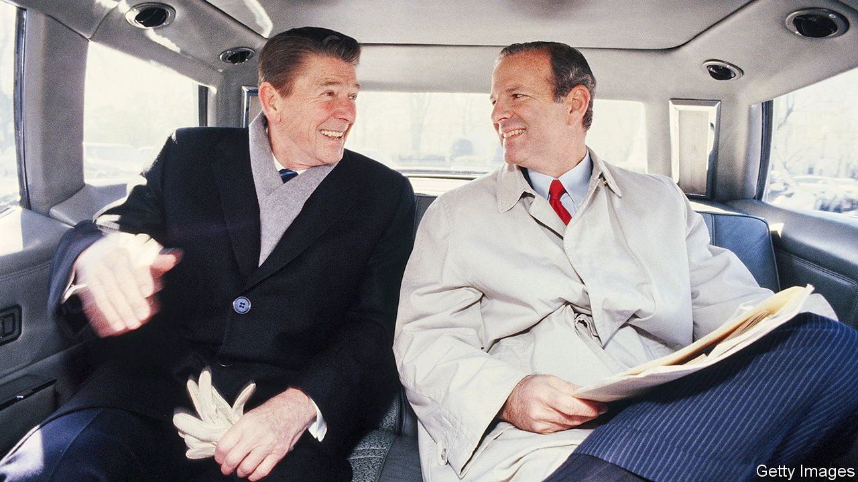

The Man Who Ran Washington: The Life and Times of James A. Baker III. By Peter Baker and Susan Glasser.Doubleday; 720 pages; $35.

DURING THE confusion that followed the attempt on Ronald Reagan’s life in 1981, Alexander Haig, the secretary of state, proclaimed at the White House podium: “I am in control.” Breathless and sweating, Haig reassured no one. While he floundered, someone else took command. James Baker, the chief of staff, monitored Reagan’s condition, kept the government running and crisply briefed colleagues. Throughout the tense day Mr Baker proved unflappable, say Susan Glasser and Peter Baker (no relation to their subject) in a new biography.

Widely regarded as the most effective chief of staff ever, Mr Baker ran the White House for both Reagan and George H.W. Bush. He was also Reagan’s treasury secretary and Bush’s secretary of state, and led five presidential campaigns. Pragmatism and competence were his hallmarks. “There was little idealism involved and a fair degree of opportunism,” write the authors of “The Man Who Ran Washington”. By their account, Mr Baker “was not above political hardball to advance his team’s chances at the ballot box. He never lost sight of what was good for Jim Baker.” But he got things done.

Ms Glasser (of the New Yorker) and her co-author and husband (of the New York Times) are well-placed to chronicle Mr Baker’s life. They interviewed 170 people, including three former presidents and Mr Baker himself. Now 90, and a careful steward of his own reputation, he may have mixed feelings about the result. Yet it is a masterclass in political biography. The authors portray the man in full, managing to be both brisk and comprehensive.

They lay out his flaws, including his temper, cynicism, tendency to blame underlings and allegations of skulduggery. They decry his lack of vision in the last years of the cold war: he and Bush merely reacted to the Soviet Union’s demise, they argue, rather than devising a bold approach of their own. Yet the book also depicts a manager capable of handling almost any situation, from the Gulf war to the presidential recount in 2000, which Mr Baker confidently oversaw for the Republicans. He closed deals by focusing on the signature line rather than the fine print.

He was Jim to presidents and cabinet secretaries but “Mr Baker” to everyone else. Despite his patrician manner he could swear like a Texas roughneck; “ratfuck” was a favourite term for Washington backstabbing. He grew up among the Houston aristocracy, where the oilfield meets the tennis club. Bush, a fellow blue-blood, became his doubles partner, and the book explores their lifelong friendship. When Mr Baker learned from a doctor that his first wife’s cancer was terminal, he told Bush but not the patient herself. One key to his success, the authors write, is that he was adept at leveraging their connection. “Everyone knew that he was Bush’s good friend and that when Baker spoke, he was speaking with the authority of the president.”

His own name appeared on just one ballot: in the race to be attorney-general of Texas in 1978. He lost. Over the years he harboured presidential ambitions and, in 1996, came close to running. If he stayed out he could be remembered as the most important secretary of state since Henry Kissinger, a diplomat tested by great events and equal to them. If he ran and failed, he would be one more might-have-been. He weighed the options and made his choice. As so often, he was probably right. ■

This article was downloaded by calibre from <https://www.economist.com/books-and-arts/2020/09/26/james-baker-and-the-art-of-power>

|  |  |  |  |
| --- | --- | --- | --- |
| Previous | Articles | Sections | Next |

|  |  |  |  |
| --- | --- | --- | --- |
| Previous | Articles | Sections | Next |

#### Pivot of the world

# Civilisations once met and melded in Ravenna

The city in a swamp was a hinge between East and West

Sep 26th 2020 |



Ravenna: Capital of Empire, Crucible of Europe. By Judith Herrin. Princeton University Press; 576 pages; $29.95. Allen Lane; £30.

IN AROUND 700AD a nameless scholar in the north of Italy made a five-volume study of the universe. He covered everything you would expect for a man of his time: Africa, Arabia, India. Even far-off Britannia got a nod, the cosmographer informing readers that it was “said to form part of Europe”. More surprising than the ambit of his world is what he chose to put at its centre: not Jerusalem or Rome but Ravenna, a city clinging to the Adriatic marshlands south of Venice.

As Judith Herrin explains in her lively, startling book, Ravenna really did deserve “the most noble” title bestowed by this anonymous admirer. From its origins as a refuge in a dying empire, it went on to host kings and prelates, physicians and lawyers—and ultimately help shape Europe. Like the continent today, Ravenna was a cosmopolitan place, mixing Roman citizens and the Germanic warlords who came to rule the city. Later, under Byzantine control, Greeks mingled with Armenian administrators and Syrian merchants.

All this made Ravenna what Ms Herrin calls the “hinge” between the Romans and their successors and new kingdoms to the West. That status was reflected in its art. Bringing craftsmen from Rome and marble columns from Constantinople, Theoderic the Goth filled his palace with three tiers of glorious mosaics set against a gold background. When the Byzantines conquered the town in 540, more masterpieces appeared. Visitors to the basilica of San Vitale can still gawp at images of the Emperor Justinian and his wife, their dress and jewellery as fine as the day they were made.

More practical imports reached Ravenna too. Papyrus arrived from Egypt; learning from Alexandria helped make it the centre of medical education in western Europe. Modern knowledge of Galen, one of the ancient world’s most distinguished physicians, comes primarily from a reconstructed Ravennese source. At the same time the city proved adept at sustaining the best of Roman civilisation, even as the empire spluttered out. The Goths’ legal code, notes Ms Herrin, integrated classical traditions into their new administration. Usefully, the city attracted Roman luminaries such as Boethius, a philosopher and famed translator of Aristotle and Plato.

“Ravenna” is most engaging when focusing not on scholarship or laws but people. The author evokes lost worlds in surprising anecdotes, for example about a sixth-century bishop who let his clergy use the bathhouse of his palace on Tuesdays and Fridays. Ms Herrin does not neglect Ravenna’s humbler citizens. From chariot races to bust-ups between neighbourhood gangs, readers are vividly reminded that for all its grandeur, Ravenna was in its heyday a flawed and hectic place.

After silt clogged up the channels that linked Ravenna to the sea, its time as the pivot between East and West passed. Yet its achievements lived on. Churches became monasteries but continued to inspire travellers from beyond the Alps. The robustly independent civic life was a model for Venice and other Italian republics. Charlemagne’s grand ideas of kingship were influenced by its architecture: the ruler who came to personify Europe carted away building materials from this city in a swamp for his chapel in Aachen. ■

This article was downloaded by calibre from <https://www.economist.com/books-and-arts/2020/09/26/civilisations-once-met-and-melded-in-ravenna>

|  |  |  |  |
| --- | --- | --- | --- |
| Previous | Articles | Sections | Next |

|  |  |  |  |
| --- | --- | --- | --- |
| Previous | Articles | Sections | Next |

#### Cool to be kind

# The sudden success of Sigrid Nunez

“What Are You Going Through” is a companion piece to her bestselling “The Friend”

Sep 26th 2020 | NEW YORK



FOR ALMOST a quarter of a century, Sigrid Nunez maintained the quiet life of a writer’s writer. Critically acclaimed but under-known, she published her first novel in 1995 and then many others; but she supported herself mostly with teaching gigs at colleges in and around New York, where she has lived “like a grad student” in the same downtown Manhattan flat since the 1980s. Then in 2018 her eighth book, “The Friend”, became a surprise bestseller and went on to win the National Book Award for fiction. Many of her other books are now reaching readers around the world.

The sudden attention is bittersweet for Ms Nunez, who is 69. Though such success would have been “tremendously useful” earlier in her career, she says she is grateful that she could “develop anonymously as a writer”, without the pressure of fame. Her new status has meant she speaks to larger audiences and can cut back on her teaching, but her daily life and feelings about her craft are generally unchanged. She was already well into her next novel by the time “The Friend” climbed bestseller lists. “What Are You Going Through”, out now, is not exactly a sequel, she says, but “these books belong together.” Both are “preoccupied with death”. And with ageing: “At a certain age, there is only one subject.”

As in “The Friend”, the new book’s narrator bears a striking resemblance to the author. Unnamed and unmarried, she is a writer in Manhattan who charts in herself and others some of the losses that come with age: decisions rued; hopes dashed; looks eroded. In the earlier novel the narrator’s friend confronted his waning sexual charisma; the young students who slept with him were no longer motivated by desire, but rather by the “thrill of bringing an older man in a position of authority to his knees”. In the new book, the costs of time are seen from a female point of view. “You get used to admiration,” says an elderly and “once beautiful” woman. Then gradually you become “an ordinary, undesirable person with a common, forgettable face”.

“What Are You Going Through” considers what it means to die well. A character suffering from terminal cancer plans to take her own life in order to wrest a more dignified ending from the disease. But as with “The Friend”, the book’s appeal lies less in the plot, such as it is, than in the wandering thoughts and insightful observations that it sets off. “I think it’s largely true,” the narrator reckons, “that there are no truly stupid human beings, no uninteresting human lives, and that you’d discover this if you were willing to sit and listen to people. But sometimes you had to be willing to sit for a very long time.” The psychological focus of these stories was “liberating”, Ms Nunez says, as it let her write from the heart. “The narrator’s way of seeing the world is my way of seeing the world.”

Coming of age at a time when motherhood still took precedence over many women’s careers, Ms Nunez forwent children to protect hers. Yet she does not wish she had been born later, as she sees how the shifting rules of identity politics have left aspiring writers worried about saying the wrong thing. For example, she has noticed that, to signal sensitivity, stories by young male students often feature a woman menstruating. “You’re not going to write the most powerful, truthful stuff if you’re always concerned about your brand.”

But the idiosyncrasies of students, which she recounts with wry humour in “The Friend”, have not made her cynical. That, she says, would be incompatible with the compassion and “capacity for wonder” that she believes are essential for fiction. “I don’t think you need other people to show you the bad side of things,” she says. Or, as the narrator of her new novel observes: “Be kind, because everyone you meet is going through a struggle.” ■

This article was downloaded by calibre from <https://www.economist.com/books-and-arts/2020/09/26/the-sudden-success-of-sigrid-nunez>

|  |  |  |  |
| --- | --- | --- | --- |
| Previous | Articles | Sections | Next |

|  |  |  |  |
| --- | --- | --- | --- |
| Previous | Articles | Sections | Next |

#### Little grey cells

# Hercule Poirot turns 100

The strange case of the Belgian detective

Sep 26th 2020 |

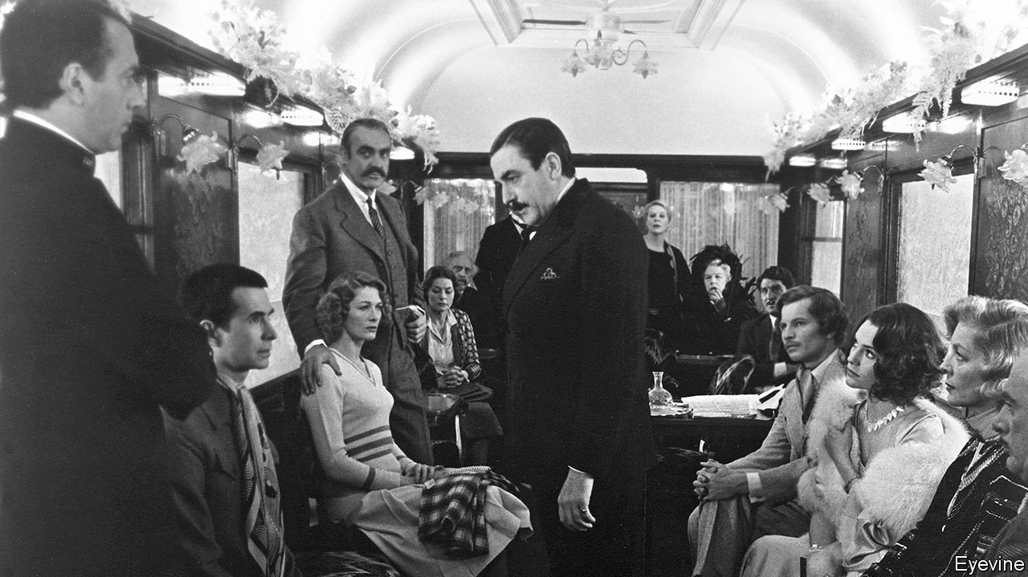

“HE WAS HARDLY more than five feet, four inches, but carried himself with great dignity. His head was exactly the shape of an egg…His moustache was very stiff and military.” With this description Agatha Christie introduced Hercule Poirot in October 1920 in her first novel, “The Mysterious Affair at Styles”. In the century since, Poirot’s mannerisms and catchphrases have become familiar around the world; back then, though, the retired Belgian policeman had fled his war-torn homeland and found himself quartered in a sleepy English village. Reunited by chance with his friend Captain Hastings, he is embroiled in the murder of a wealthy, elderly and recently remarried lady.

Poirot’s first rule of detective work is to avoid “the red fish”, and this case is full of them, from a false beard to a smashed coffee cup. But as he says, underneath it all “the simplest explanation is always the most likely”. It just takes the little grey cells, a fearsome memory and a bit of panache. As Poirot finds throughout his career, the most mundane clues can prove vital: a fire laid on a hot summer’s day, a bath run at an unusual hour, or a throwaway comment about a wasp sting. Anything that does not—how do you say it?—ring of the truth. Anything that appears to upset the natural order of things.

The pursuit of order is one of Poirot’s great, and most infuriating, missions in life. He grouches about boiled eggs of uneven sizes and people who fail to fold newspapers symmetrically. He flicks away an “imaginary speck of dust”. After all, a close eye for detail was absolument essentiel in becoming “probably the greatest detective in the world”. Self-belief was never in short supply, either.

In 1920 the Styles case propelled the “funny little man” to celebrity. He arrived at a disorienting time in Britain, amid rapid urbanisation and the loss and disillusionment bequeathed by the first world war: a perfect moment for a heavily accented continental to drop in and hold up a mirror. Yet Poirot’s foreignness was part of the bond Christie forged between the detective and her readers. Both he and they were outsiders in the cases he took on, given the same information and solving the same puzzles. She even provided floor plans and diagrams, so readers could try to crack the crimes alongside Mr P.

For murder seemed to follow him wherever he went, from rural England and the back alleys of London to the Orient Express and the River Nile. Bien sûr he made mistakes, and even had to dodge assassination attempts, but he always got his man—or woman. Or both. Given all the marital strife that he saw, it was little wonder that he had no time for romance. (Well maybe just the once, with an elusive countess, but it soon fizzled out.) He seemed content with bachelorhood, surrounded as he was by close friends including Hastings, his secretary Miss Lemon and the begrudgingly admiring Chief Inspector Japp of Scotland Yard.

He helped make Christie the world’s bestselling novelist, and it wasn’t long before he leapt, or waddled, from page to stage and screen. Albert Finney was nominated for an Oscar for his impersonation of the Belgian in Sidney Lumet’s “Murder on the Orient Express” (1974), a film boasting one of the starriest-ever casts. That was a fitting tribute to Poirot’s global prestige, even if the denouement was un peu over-the-top (the real sleuth did not lose his cool so easily). Other imitators included Charles Laughton and Sir Peter Ustinov. But David Suchet captured Poirot’s quirks best, playing him in a British television series from 1989 to 2013.

Despite his pedantry and eccentricity, Poirot remains one of the best loved characters in fiction. He is pompous, vain and often quite annoying, but endowed with enormous empathy and a powerful understanding of human nature. And he is always right. As Hastings remarks, “Sometimes, I feel sure he is as mad as a hatter; and then, just as he is at his maddest, I find there is a method in his madness.” Over 33 novels and 59 short stories, Poirot elicited the same unswerving faith from his fans.

Christie herself tired of him. She killed him off in a novel written during the second world war but published only in 1975, as her own health failed (the New York Times gave him a front-page obituary). But her exasperation with Poirot was a minority view. His books still sell royally. A glitzy new adaptation of “Death on the Nile”, directed by and starring Sir Kenneth Branagh, is due this autumn (his version of “Murder on the Orient Express” took $350m at the box office in 2017). Sophie Hannah, a British novelist, has resurrected Poirot in a series of new stories.

Perhaps, as he turns 100, what ultimately explains his staying power is that despite all the evil he sees and vanquishes, Poirot remains at heart an optimist. As he discovered all those years ago at Styles, friendship, loyalty and order are the keys to a happy life. With the odd murder thrown in to keep those little grey cells busy. ■

This article was downloaded by calibre from <https://www.economist.com/books-and-arts/2020/09/26/hercule-poirot-turns-100>

|  |  |  |  |
| --- | --- | --- | --- |
| Previous | Articles | Sections | Next |

|  |  |  |
| --- | --- | --- |
| Books & arts | Sections | Graphic detail |

Economic & financial indicators

Economic data, commodities and markets

.

|  |  |  |
| --- | --- | --- |
| Books & arts | Sections | Graphic detail |

|  |  |  |  |
| --- | --- | --- | --- |
|  | Articles | Sections | Next |

# Economic data, commodities and markets

Sep 26th 2020 |

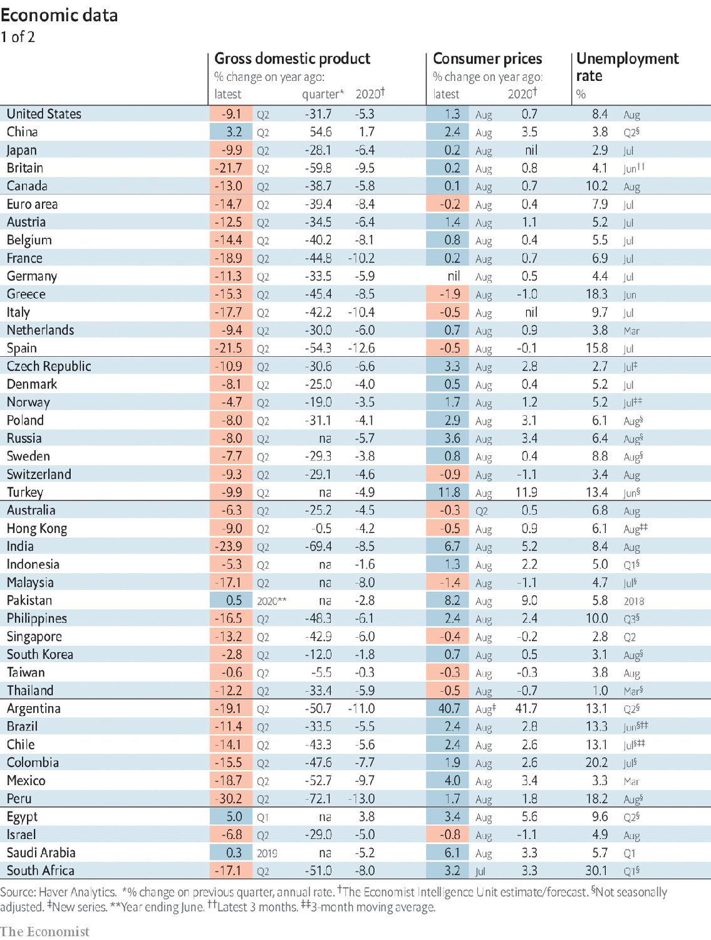

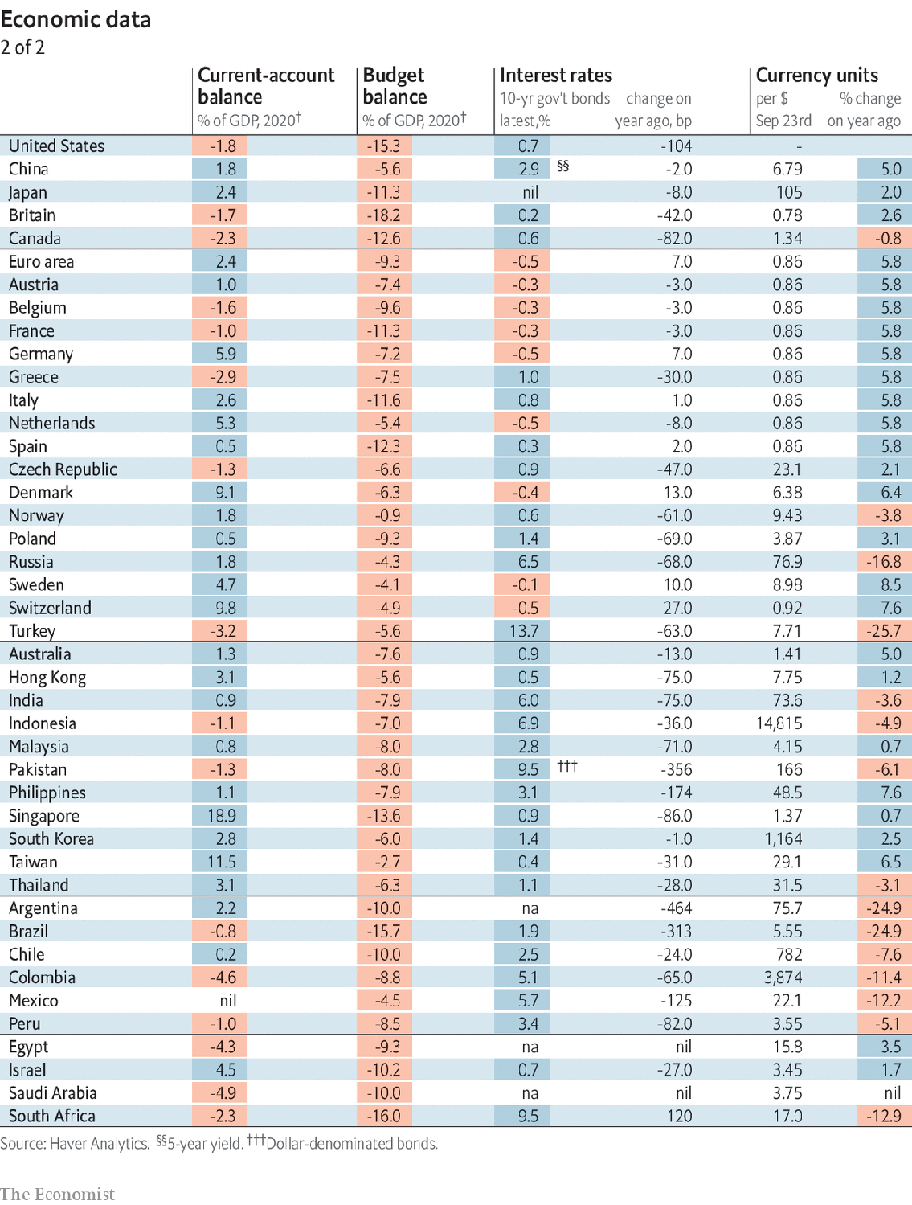

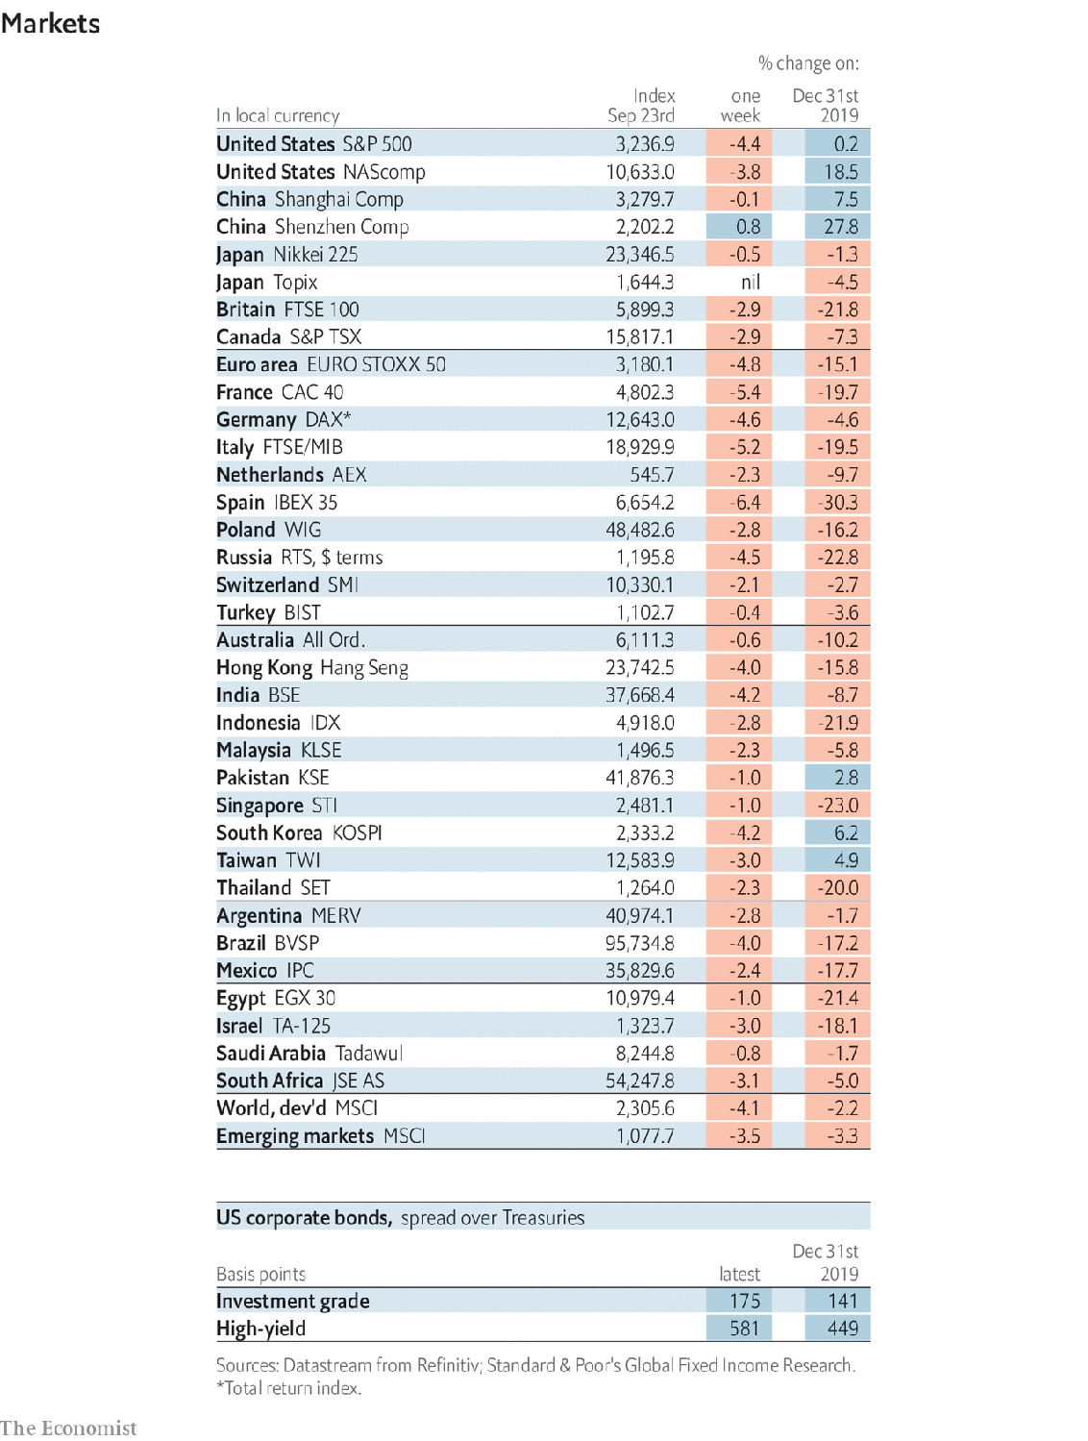

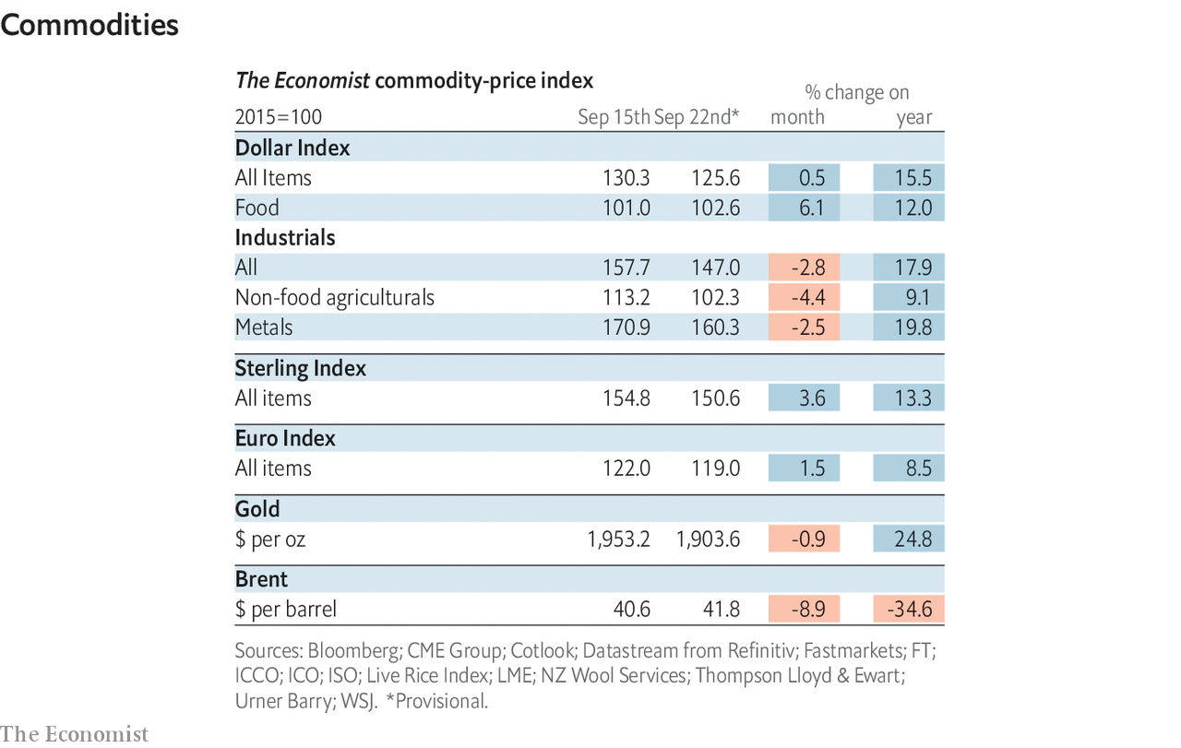

This article was downloaded by calibre from <https://www.economist.com/economic-and-financial-indicators/2020/09/26/economic-data-commodities-and-markets>

|  |  |  |  |
| --- | --- | --- | --- |
|  | Articles | Sections | Next |

|  |  |  |
| --- | --- | --- |
| Economic & ... | Sections | Obituary |

Graphic detail

America’s Senate: The Maine reason

.

|  |  |  |
| --- | --- | --- |
| Economic & ... | Sections | Obituary |

|  |  |  |  |
| --- | --- | --- | --- |
|  | Articles | Sections | Next |

#### The Maine reason

# Our new Senate model has inched towards Democrats in September

A flurry of recent polls make Susan Collins an underdog for re-election in Maine

Sep 23rd 2020 |



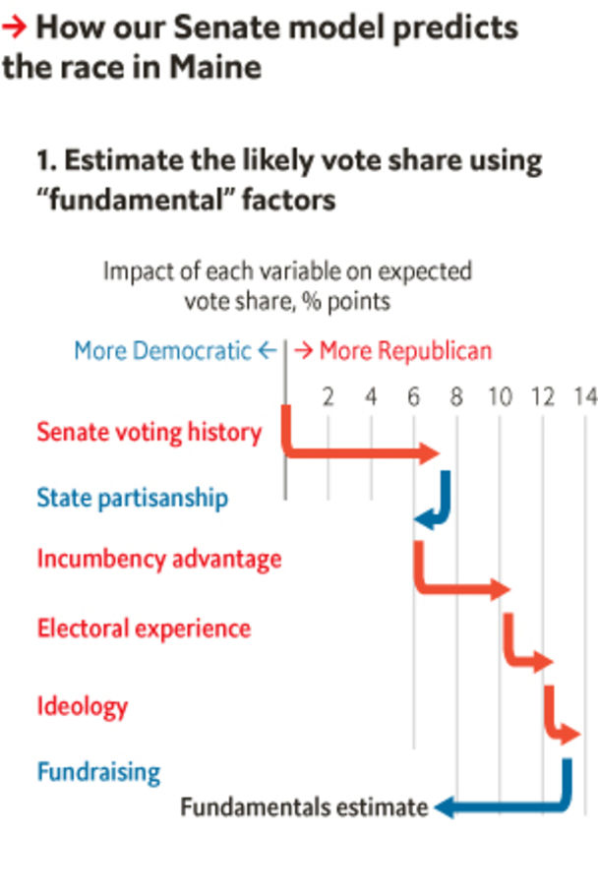

On september 23rd The Economist published our first-ever statistical forecast of the battle for control of America’s Senate. It makes the Democrats modest favourites, giving them a two-in-three shot at re-taking the upper chamber. Had we launched our model two weeks earlier, it would have shown an even closer race, with a 60% chance of Democratic control. The biggest driver of this movement has been a change in its analysis of Maine, one of the most likely states to give Democrats their 50th vote in the 100-seat chamber.

With the benefit of hindsight, it looks as if our forecast was too kind to Susan Collins, the Republican incumbent, from the start. In states with little polling, our model relies on “fundamental” factors like past voting records, which favoured Ms Collins. She won re-election in a landslide in 2014. Donald Trump came within three percentage points of winning her state. Voters have historically rewarded centrists, and Ms Collins is the Senate’s most moderate Republican. And incumbency tends to be most valuable in small states with lots of secular white voters, such as Maine.

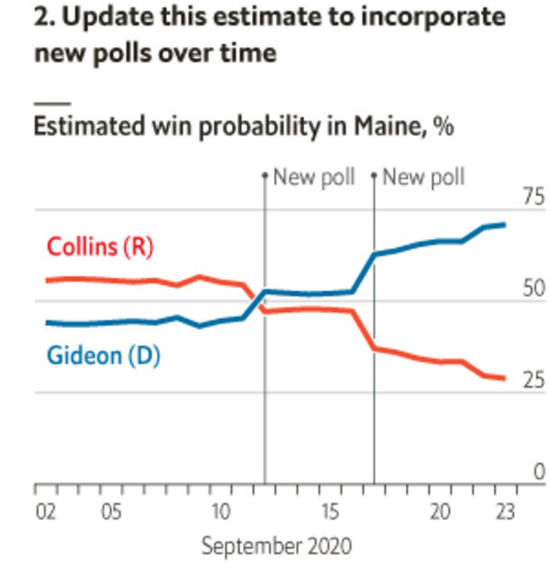

During the summer, a number of polls showed Ms Collins trailing Sara Gideon, the Democratic Speaker of Maine’s House of Representatives. However, Ms Gideon’s leads were modest, and surveys taken long before an election often turn out to have large errors. As September began, the model still placed nearly as much weight on the fundamentals as it did on the polls, and it saw Ms Collins as a narrow favourite.

However, in mid-September four different pollsters surveyed Maine. On average, they gave Ms Gideon a lead of eight percentage points. Given such consistent new data, the model trimmed Ms Collins’s expected share of votes cast either for her or for Ms Gideon from 50.5% to 48%. (Maine uses a ranked-choice voting system, but polls imply that the size of the gap between the top two candidates remains similar after third-party votes are re-allocated.)

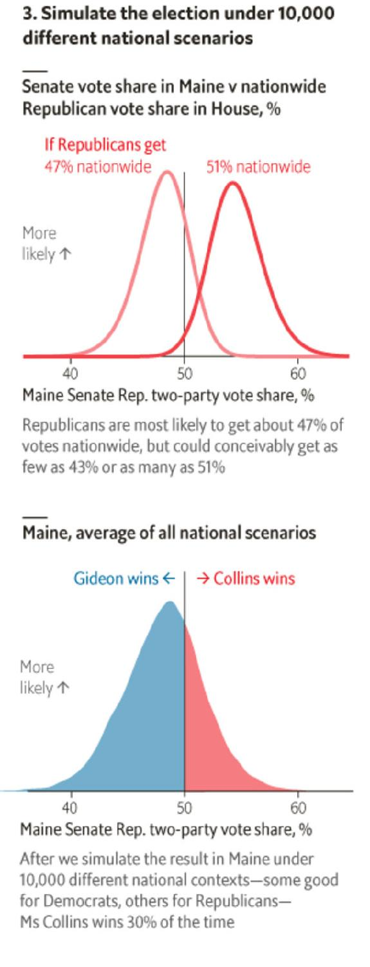

A shift of 2.5 percentage points might sound trivial. But when races are close, even small changes in the central point of a distribution of potential results can have a big impact on the share of those possibilities that wind up on one side of the decisive 50-50 line. When the model thought Ms Collins was most likely to get 50.5% of the vote, she won 55% of its simulations; now, she wins just 30%. If the facts change, our model changes its mind.

Source: The Economist

Dig deeper:  
Read the [best of our 2020 campaign coverage](https://www.economist.com/us-election-2020) and explore our [election forecasts](https://projects.economist.com/us-2020-forecast/president), then sign up for Checks and Balance, our [weekly newsletter](https://www.economist.com/checksandbalance/) and [podcast](https://play.acast.com/podcasts/2020/01/24/checks-and-balance-our-new-weekly-podcast-on-american-politics) on American politics.

This article was downloaded by calibre from <https://www.economist.com/graphic-detail/2020/09/23/our-new-senate-model-has-inched-towards-democrats-in-september>

|  |  |  |  |
| --- | --- | --- | --- |
|  | Articles | Sections | Next |

|  |  |  |
| --- | --- | --- |
| Graphic detail | Sections |  |

Obituary

Ruth Bader Ginsburg: Diva dissenter

.

|  |  |  |
| --- | --- | --- |
| Graphic detail | Sections |  |

|  |  |  |  |
| --- | --- | --- | --- |
|  | Articles | Sections | Next |

#### Diva dissenter

# Ruth Bader Ginsburg died on September 18th

The liberal conscience of America’s Supreme Court was 87

Sep 23rd 2020 |



ON THE EVENING of July 11th 2015, Ruth Bader Ginsburg went to the opera. There was nothing odd in that. Opera, after the law, was her great love, the only place where she could leave the legal world behind. When she worked on her opinions, often into the small hours if her husband Marty was not around to make her go to bed, she would usually have opera, or some other beautiful music, playing in the background. The talent she most coveted was to have a glorious voice, like Renata Tebaldi perhaps. As it was, she sang only in the shower and in her dreams.

This particular opera, however, “Scalia/Ginsburg”, by Derrick Wang, was about her. It featured Antonin Scalia, then the court’s most scathing conservative, and she, its most notorious liberal, duelling musically in the styles of Mozart, Verdi and Puccini. He had to go through various trials; she helped him out, at one point soaring through a glass ceiling in the character of the Queen of the Night from “The Magic Flute”.

She loved it all. She and Scalia, despite the legal zingers he tossed in her direction, had been best buddies since their days together on the DC federal appeals court in the 1980s. And America’s highest court could be just as dramatic, even if more sombrely arrayed. There she sat, this tiny little woman perched among the black-robed men, and there she disagreed. For all but three of her 27 years she had one or two sisterly colleagues, but her opinions still marked her out. She berated the court when, in 2014, it let employers foist their religious beliefs on their workers by not paying for cover for contraception. She was outraged when, in the Citizens United case of 2010, it refused to limit corporate funding of independent political broadcasts, as if America had all the democracy that money could buy. And she especially attacked the striking down, in 2013, of Section 5 of the Voting Rights Act in Shelby County v Holder, on the supposition that racism had waned enough to discard it. That, she wrote, was “like throwing away your umbrella in a rainstorm because you are not getting wet.”

Being contrary, she needed to be extra sharp. She took pride in the speed with which she wrote opinions, and in their clarity. Twice a week she lifted weights, did push-ups and generally honed herself into a lean, Armani-clad contender. In oral argument she liked to leap in first, keen to establish at the start whether the plaintiff had really been damaged, or not. (Her shy, soft, pause-filled delivery off the bench really speeded up then, to Brooklyn fast.) She often announced her dissents orally, from the bench, to show how much she disagreed, and in the trying 5-4 years when she regularly led the dissenters she made sure they spoke with one voice. On those days she wore her “dissenting collar”, a grey, stony, quietly menacing number. It fitted the occasion nicely.

Yet she did not see herself as disruptive, let alone an activist. If she became more of a dissenter with the years, it was because the court, after 2006, swung over to the activist right. At heart she was still what she had always been, a judicial minimalist. She was stunned by the lack of caution in the Roe v Wade ruling of 1973 that legalised abortion; though she certainly approved of the outcome, reform should have come through state legislatures, where it was slowly starting to appear. She was shocked too when the court, while upholding Obamacare, found it illegal under the commerce clause of the constitution; that had been Congress’s domain since the 1930s. In her dissents she sometimes appealed to Congress to correct the law and occasionally, to her delight, it did.

Her legal hero was an incrementalist: Thurgood Marshall, the first black justice on the court, who had laboured to dismantle segregation. Even when she was (as she operatically liked to say) a flaming feminist litigator, bringing cases before the Supreme Court in the 1970s on behalf of the Women’s Rights Project at the ACLU, she saw herself first as a teacher, instructing the all-male court how women felt about laws which “protected” and thus demeaned them. She could have been furious about the prejudice she had faced herself, being Jewish as well as a woman: failing, for example, to get job offers from any New York law firm after leaving Columbia Law School, though she became the first female tenured professor there. But she proceeded carefully, politely, case by case, and bad laws tumbled. When she joined the highest court her success rate fell, but her approach, as only the second woman there, was often the same: to explain to the male justices how it felt to be barred from the Virginia Military Institute or, as a teenage girl, to be strip-searched. Because the court just did not know these things.

The role of women’s champion was too narrow, though. Her arguments in discrimination cases were based squarely on the 14th Amendment’s guarantee of equal protection of the laws. Gross generalisations about “how women were” or “how men were” had to be forgotten. Her dream was a world in which men and women cared for their children equally and had equal opportunities themselves. And the constitution had to embrace everyone: Lilly Ledbetter, struggling to achieve equal pay; Stephen Wiesenfeld, trying as a widower to get the same benefits as a widow would; Maetta Vance, afraid to tell a racist supervisor to buzz off; the young men of 18 in Oklahoma who just wanted to buy a beer, as girls of 18 could. She spoke for all such everyday people.

As the court shifted steadily rightward she became more determined to stay on. She redoubled her exercises, despite her age and the bouts of cancer, colorectal and pancreatic, which annoyingly forced her one day to take part in oral arguments from her bed. She found herself becoming an icon, a face on T-shirts and the subject of biopics: Notorious RBG, mystifying but fun. What did not change was her regard for her colleagues, conservative or not, in the wonderfully civilised family that was the court. For each of them, after all, their basic motivation was the same. At the end of “Scalia/Ginsburg”, the two famous foes-and-friends sang together the aria which was her favourite: “Separate strands unite in friction/To protect our country’s core...And this is why we will see justice done./We are different;/We are one.”■

Correction (September 24th 2020): A previous version of this article stated that Ruth Bader Ginsburg was the first tenured professor at Columbia Law School. She was the first female tenured professor. Apologies.

This article was downloaded by calibre from <https://www.economist.com/obituary/2020/09/23/ruth-bader-ginsburg-died-on-september-18th>

|  |  |  |  |
| --- | --- | --- | --- |
|  | Articles | Sections | Next |